**Lecture_09_Activity_Life_Cycle**

**Mobile Computing (MC)**

**__________________________________________________________________**



**Submitted to:**

**Sir Haq Nawaz**

**Submitted by:**

**Muhammad Talha Madni**

**Roll no: BSEF18A_018**

**Punjab University College of Information Technology,**

**PUCIT (Old Campus),**

**LAHORE**

**Project Created:**

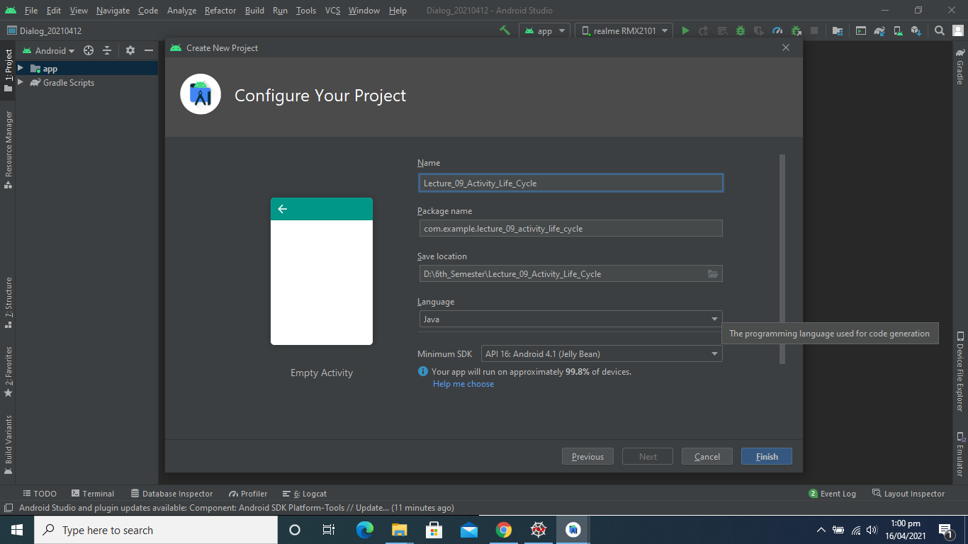

**Linear Layout Added:**

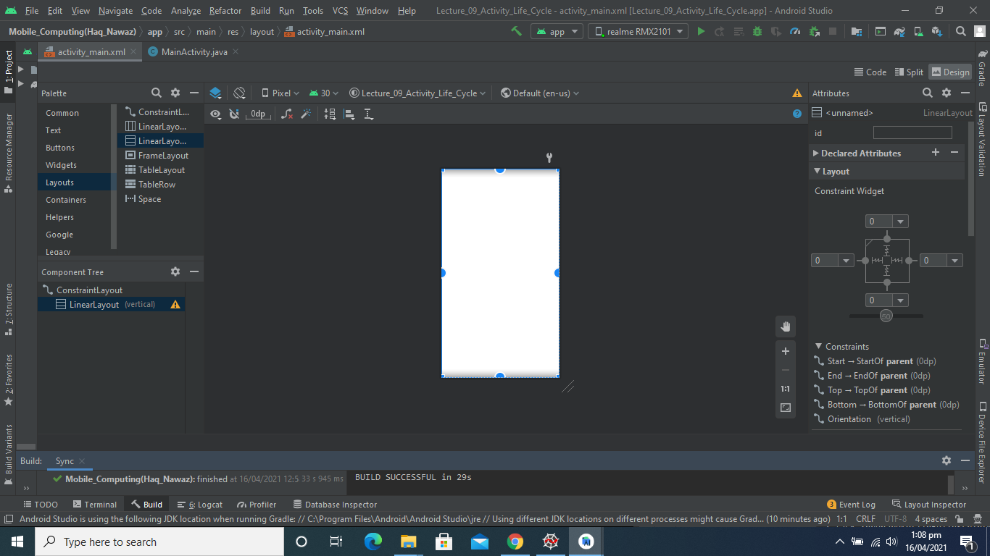

**TextView Added:**

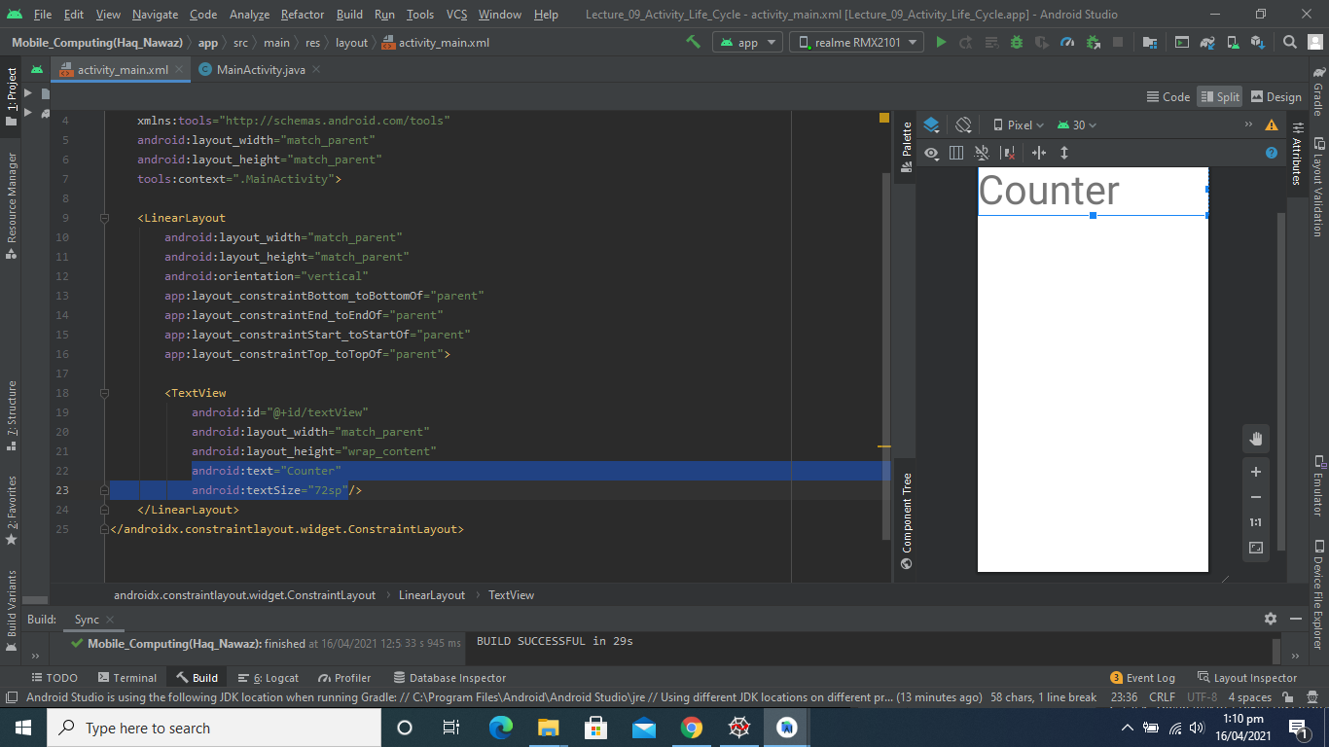

**One More Textview and Button Added:**

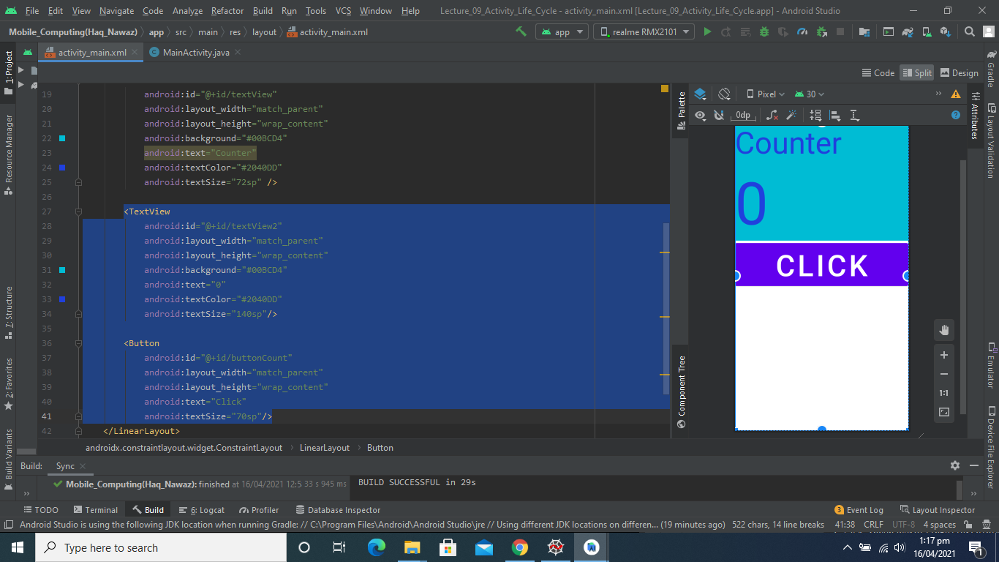

**Output:**

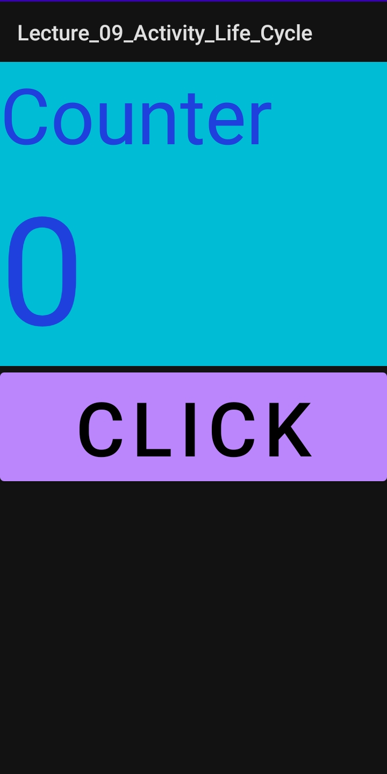

**Get Values and Create Function:**

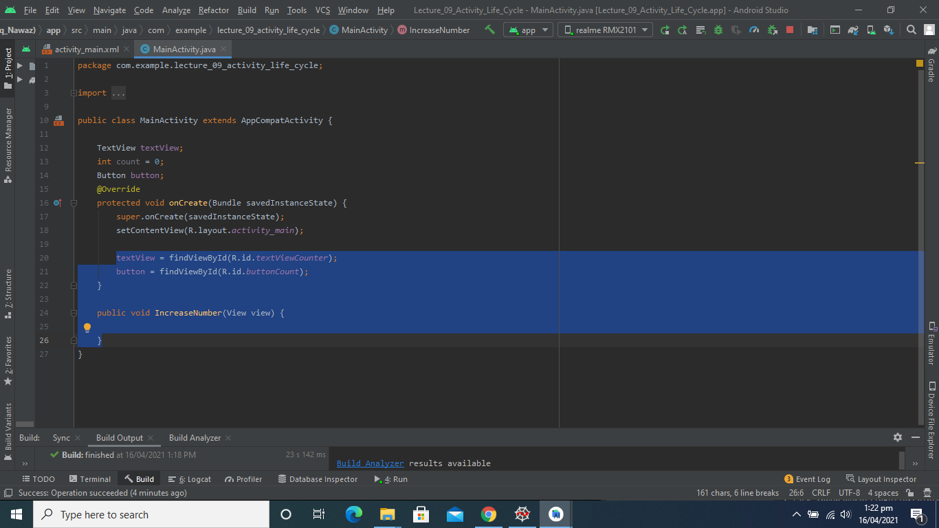

**Function Definition:**

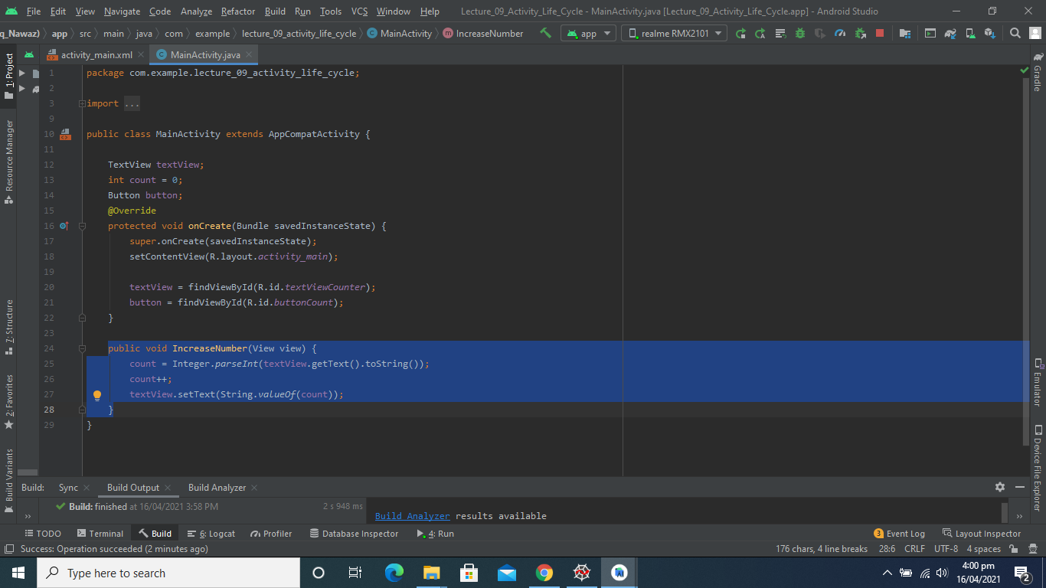

**Output:**

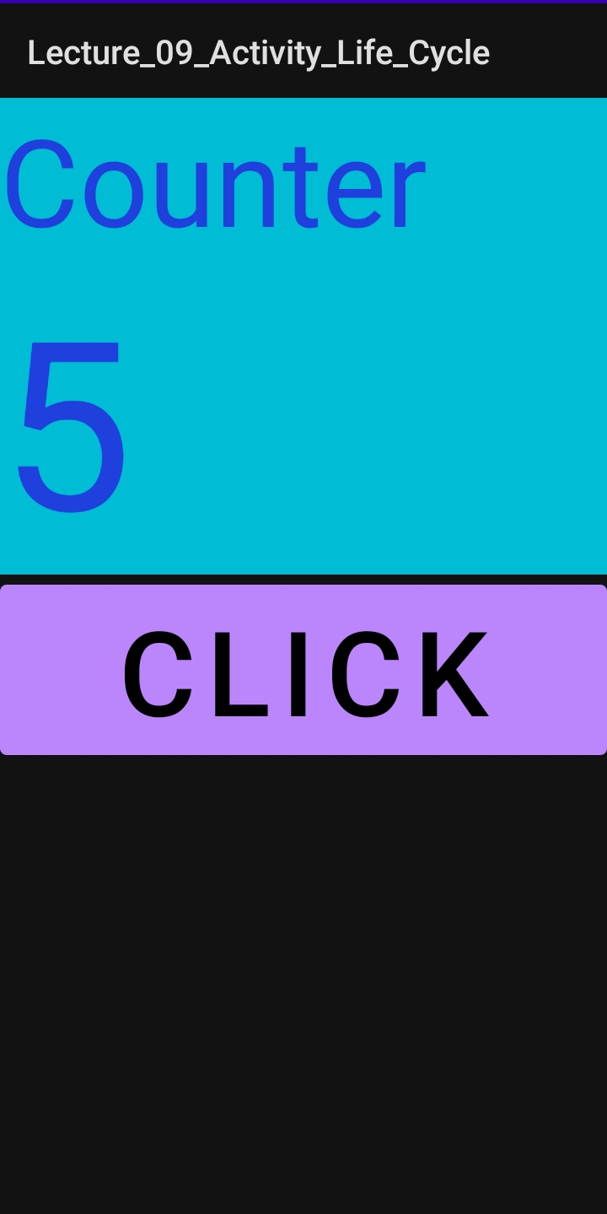

**Activity LifeCycle Functions Override:**

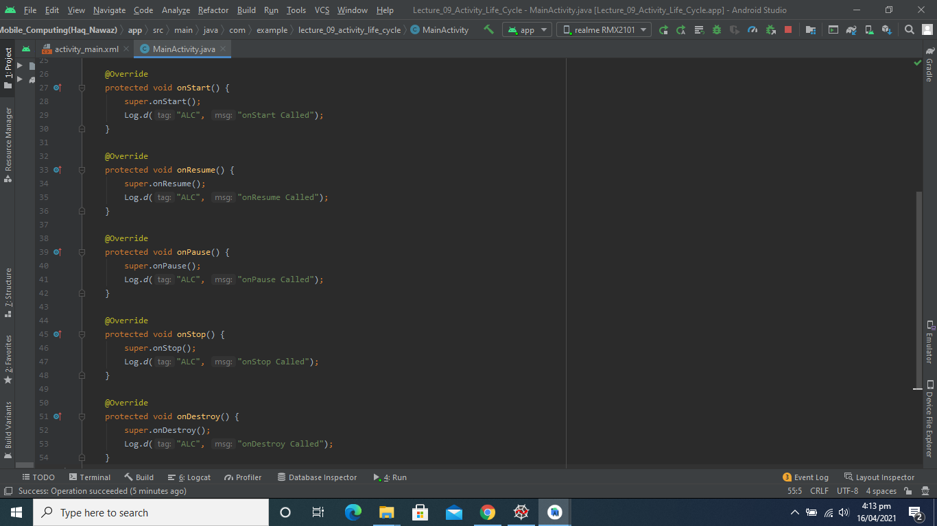

**Activity LogCat:**

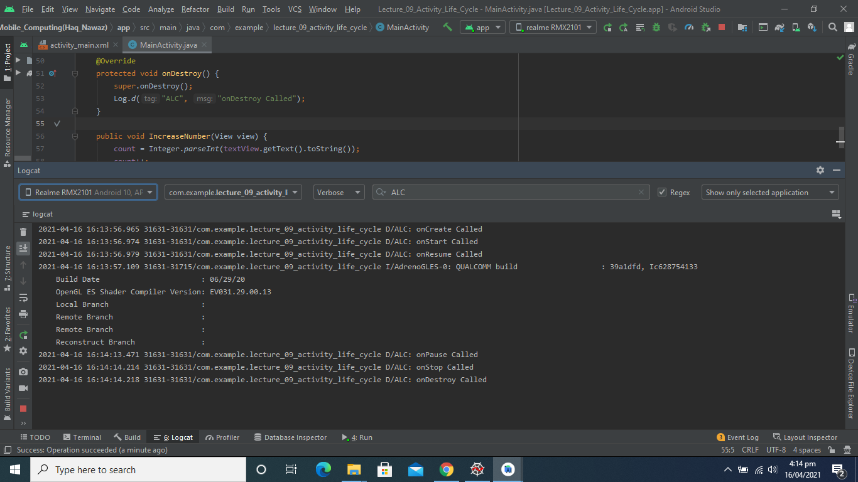

**New Activity Created:**

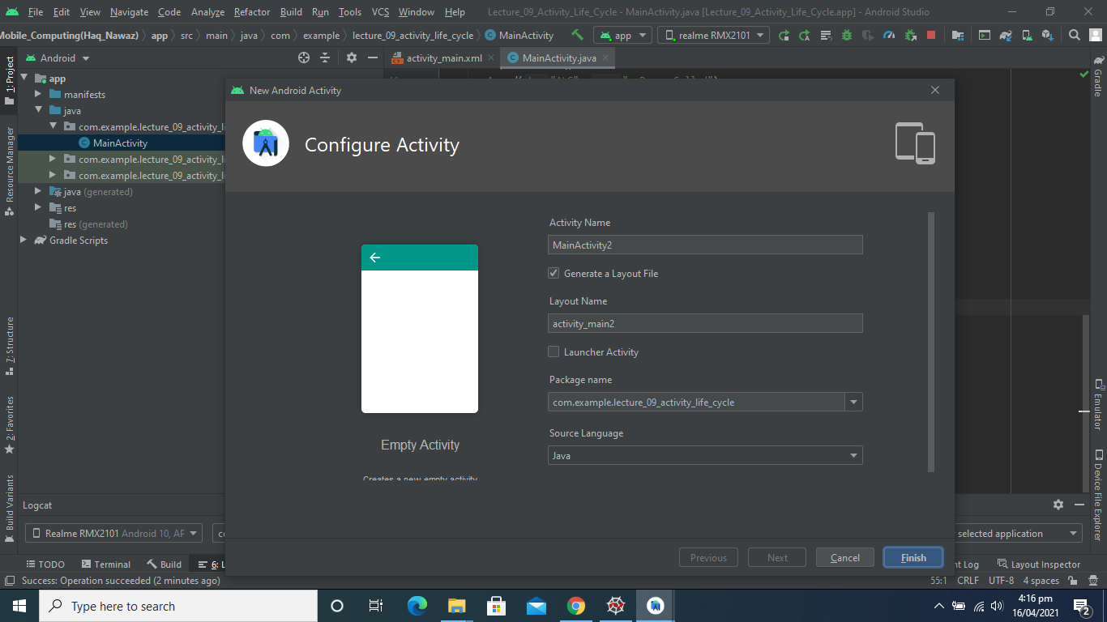

**One More Activity Created:**

T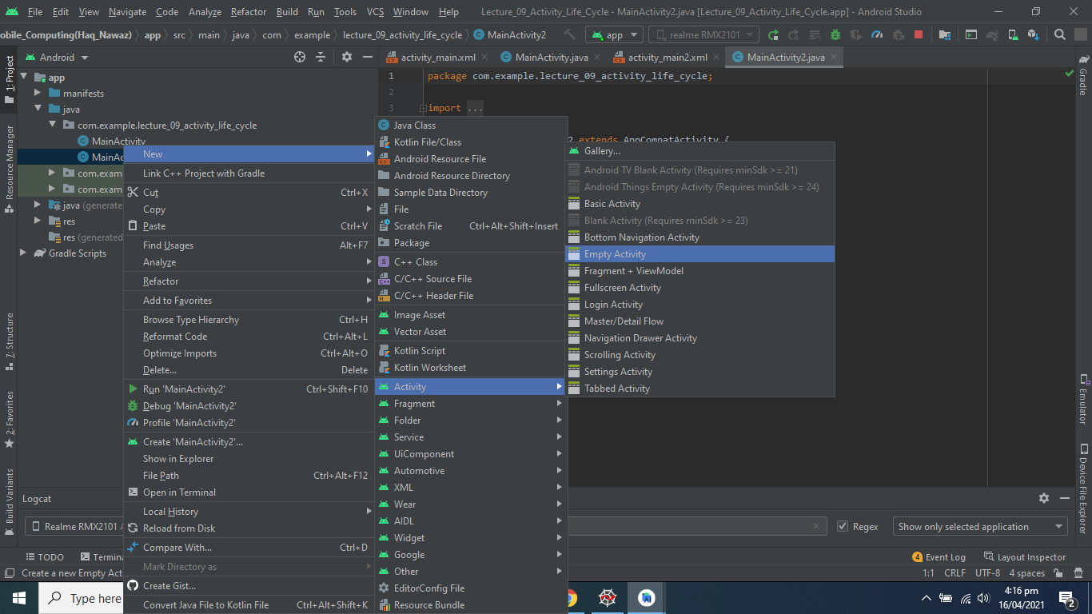

**Two More buttons Added Moving to Other Activities:**

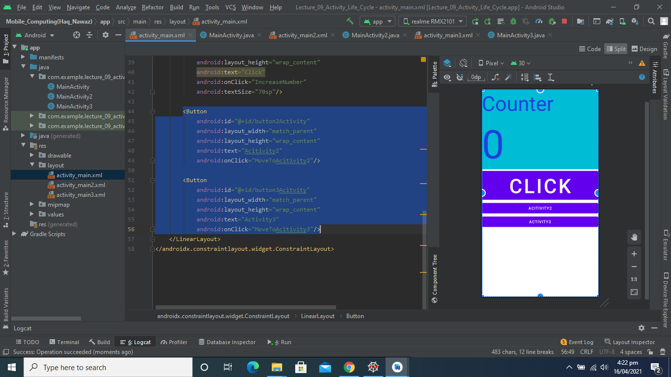

**Code for Moving to Other Activities:**

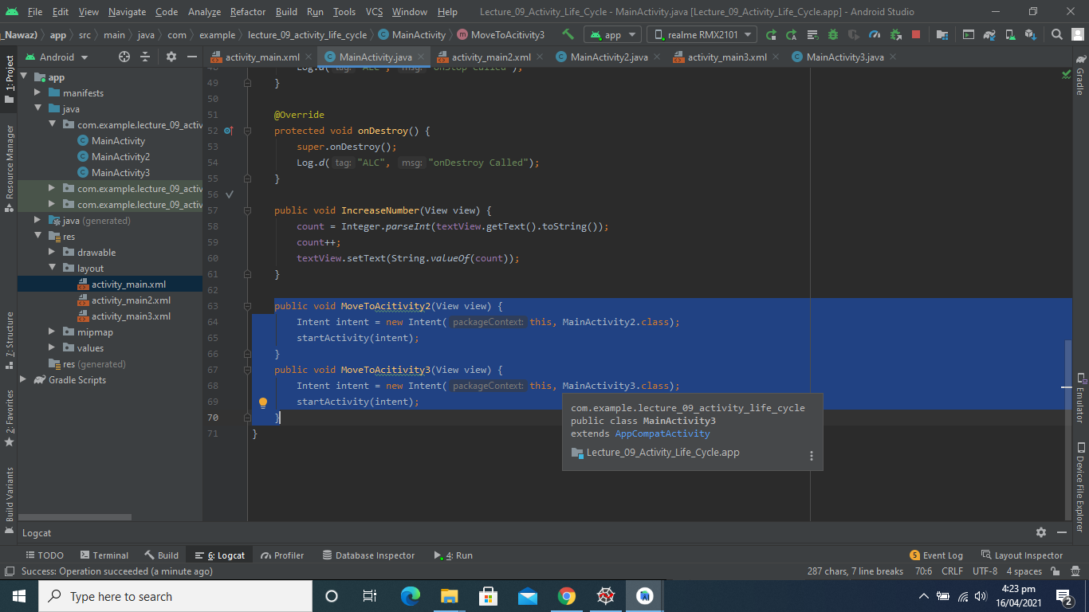

**Output:**

[Video Link](https://github.com/talha0606/MC_Progress/blob/master/L09V01.mp4)

**Activity2 LifeCycle Functions Override:**

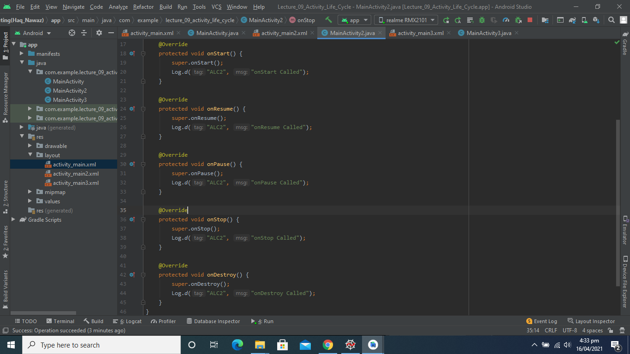

**Activity3 LifeCycle Functions Override:**

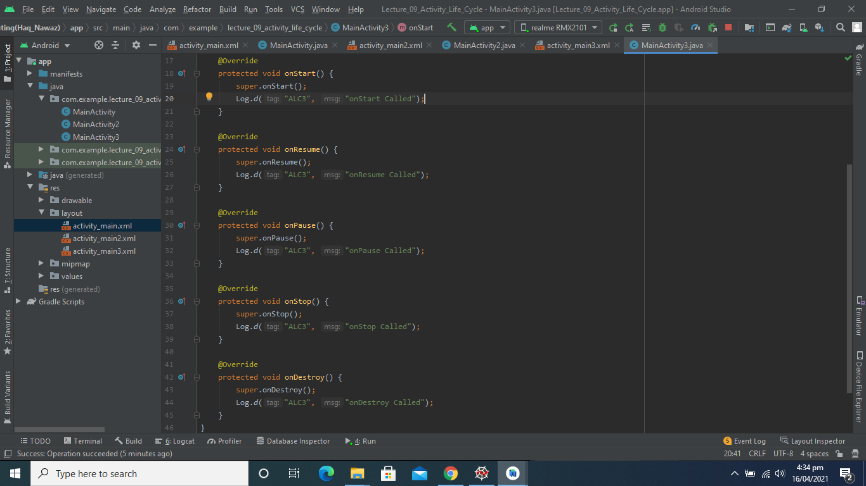

**Activity_lifecycle of Different Activities:**

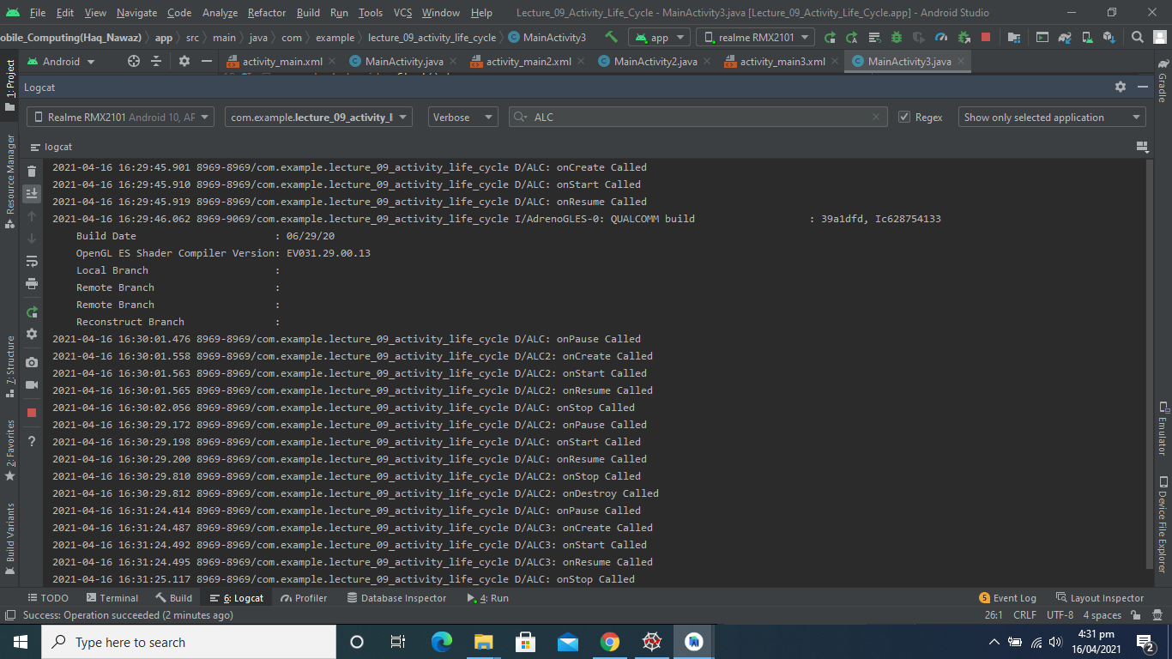

**Output:**

[Video 2 Link](https://github.com/talha0606/MC_Progress/blob/master/L09V02.mp4)