**Lecture_10_List_View**

**Mobile Computing (MC)**

**__________________________________________________________________**



**Submitted to:**

**Sir Haq Nawaz**

**Submitted by:**

**Muhammad Talha Madni**

**Roll no: BSEF18A_018**

**Punjab University College of Information Technology,**

**PUCIT (Old Campus),**

**In this lecture we will discuss about Simple List View in Android Studio**

**Android List View:**

Android **ListView** is a view which groups several items and display them in vertical scrollable list. The list items are automatically inserted to the list using an **Adapter** that pulls content from a source such as an array or database.

**Example:**

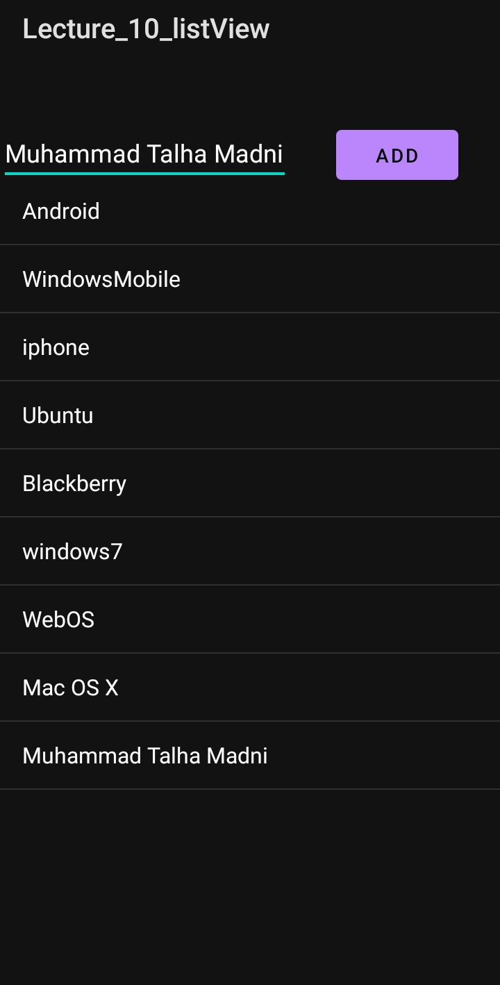

**Adapter:**

An adapter actually bridges between UI components and the data source that fill data into UI Component. Adapter holds the data and send the data to adapter view, the view can takes the data from adapter view and shows the data on different views like as spinner, list view, grid view etc.

The **ListView** and **GridView** are subclasses of **AdapterView** and they can be populated by binding them to an **Adapter**, which retrieves data from an external source and creates a View that represents each data entry.

Android provides several subclasses of Adapter that are useful for retrieving different kinds of data and building views for an AdapterView ( i.e. ListView or GridView). The common adapters are **ArrayAdapter**,**Base Adapter**, **CursorAdapter**, **SimpleCursorAdapter**,**SpinnerAdapter** and **WrapperListAdapter**. We will see separate examples for both the adapters.

**We can use this code to create Adapter:**

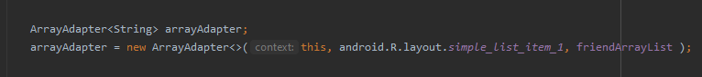

**Associate an Adapter with the list:**

To display the items in the list view we use setAdapter() function:



**Update A Record in ListView:**

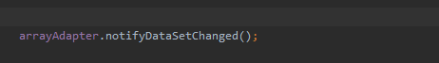

**Sort ListView Items:**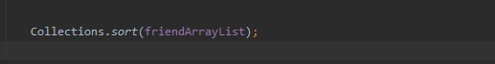

**Example:**

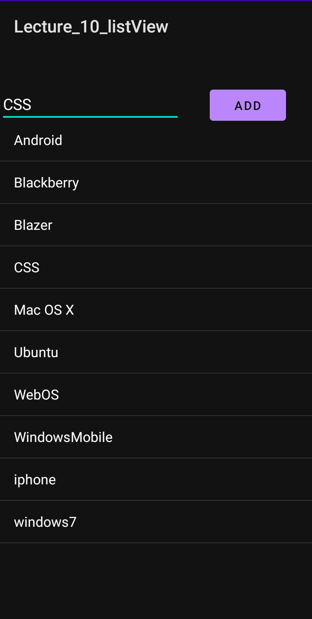

**SetOnItemClickListener:**

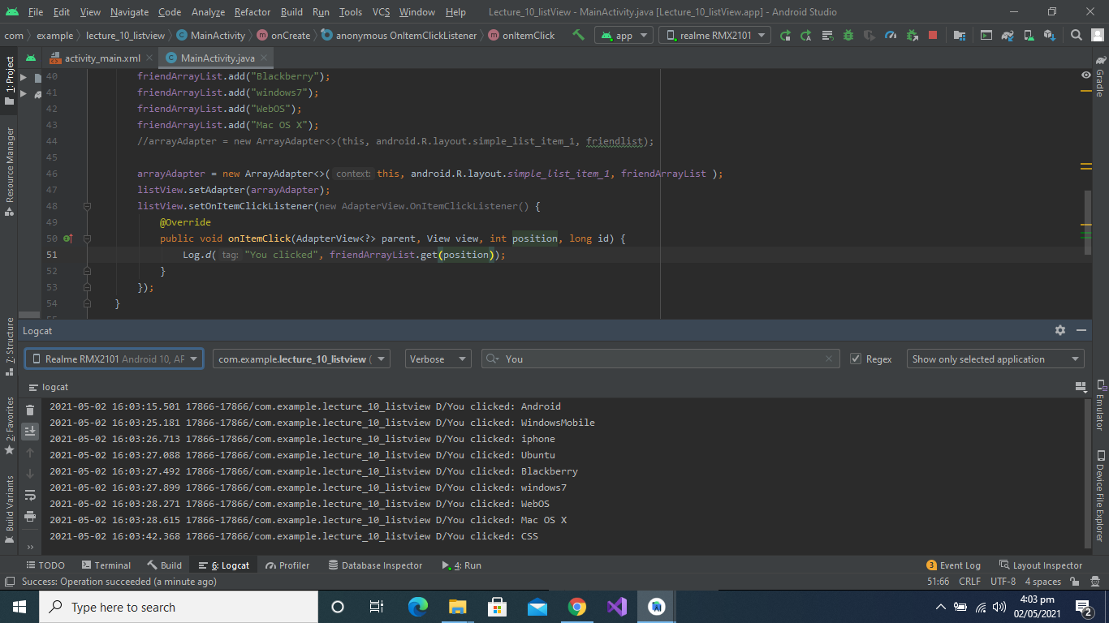

**You can Access the complete Program using this Repository Link:**

<https://github.com/talha0606/ListViewRepository/tree/master/Lecture_10_listView>