**Lecture_12_Animation**

**Mobile Computing (MC)**

**__________________________________________________________________**



**Submitted to:**

**Sir Haq Nawaz**

**Submitted by:**

**Muhammad Talha Madni**

**Roll no: BSEF18A_018**

**Punjab University College of Information Technology,**

**PUCIT (Old Campus),**

**Animation:**

Property Animation API was introduced by Google in Android 3.0 which gives us the flexibility to change object properties over a certain time interval. The Animations Framework allows us to create visually attractive animations and transitions in our apps. Using the animations, one can turn their good looking app into an excellent and highly usable app.

Animations are useful when the screen changes state, i.e when the content loads or new actions become available.

Animation is the process of creating motion and shape change. In this Tutorial we will show how simple animations encourage you to use them more freely and confidently.

Animations notify users about what’s going on in your app and improve the mental model of your app’s interface.

We can use different functions for different type of animations:

**To fade the Image:**

imageView.**animate**().alpha(0).setDuration(50);

**To move along X-axis:**

imageView.animate().translationXBy(250).setDuration(500);

**To move along Y-axis:**

imageView.animate().translationYBy(250).setDuration(500);

**For Rotation:**

imageView.animate().rotation(720).setDuration(2000);

**For Rotation with fade:**

imageView.animate().rotation(720).alpha(0).setDuration(2000);

**For Scaling along X-axis:**

imageView.animate().scaleX(0.5f);

**For Scaling along Y-axis:**

imageView.animate().scaleY(0.5f);

**Scaling w.r.t both Axis:**

imageView.animate().scaleX(0.5f).scaleY(0.5f);

**Rotation with Scalization:**

imageView.animate().rotation(720).scaleX(0.5f).scaleY(0.5f).setDuration(2000);

**For video we can use this Code:**

We Store videos in the resource/raw/ folder

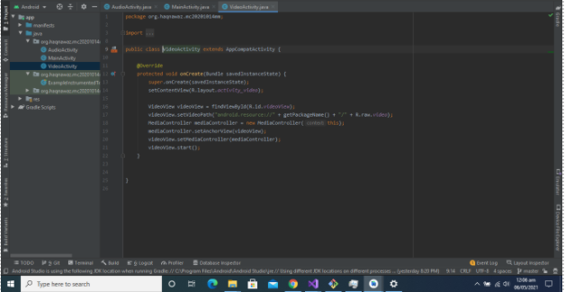

**Audio use this code:**

We Store audios in the resource/raw/ folder

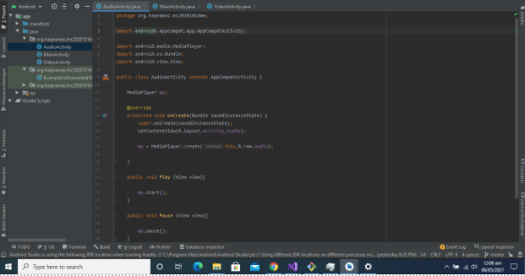

**Video Layout Code:**

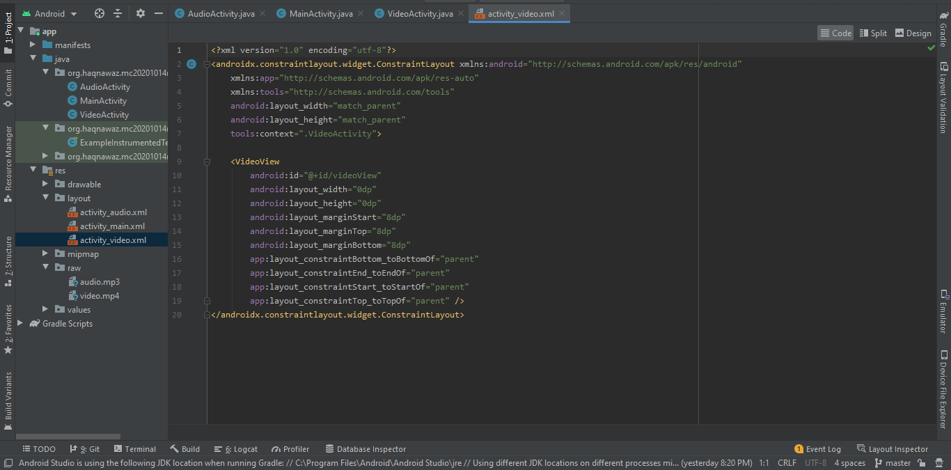

**Video Layout:**

Include videoView in the layout

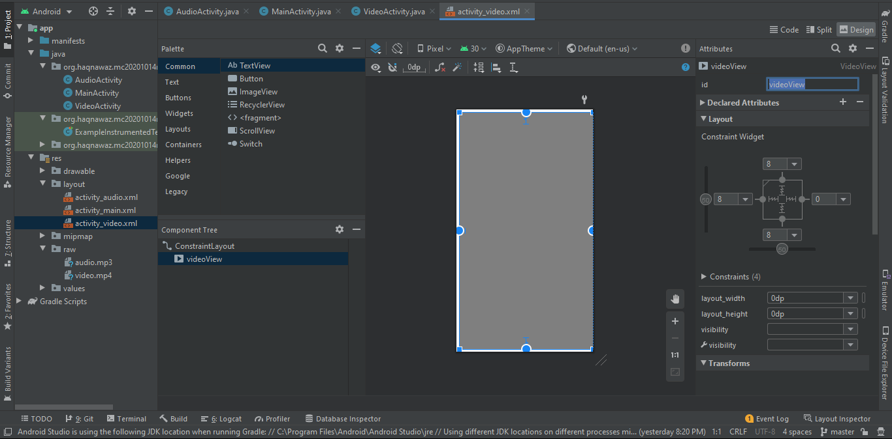

**Audio Layout Code:**

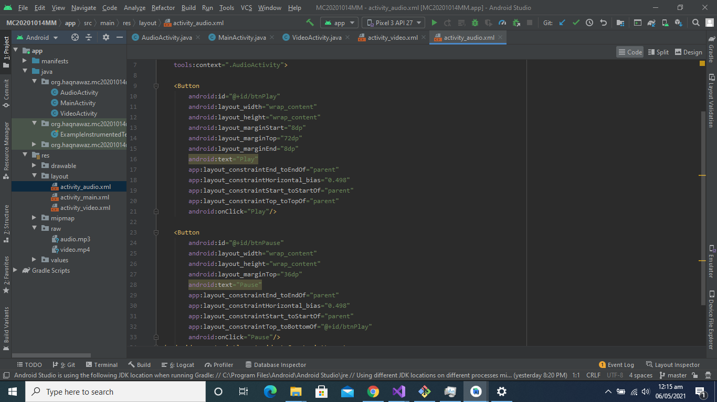

**Audio Layout:**

Add two buttons named as Play and Pause

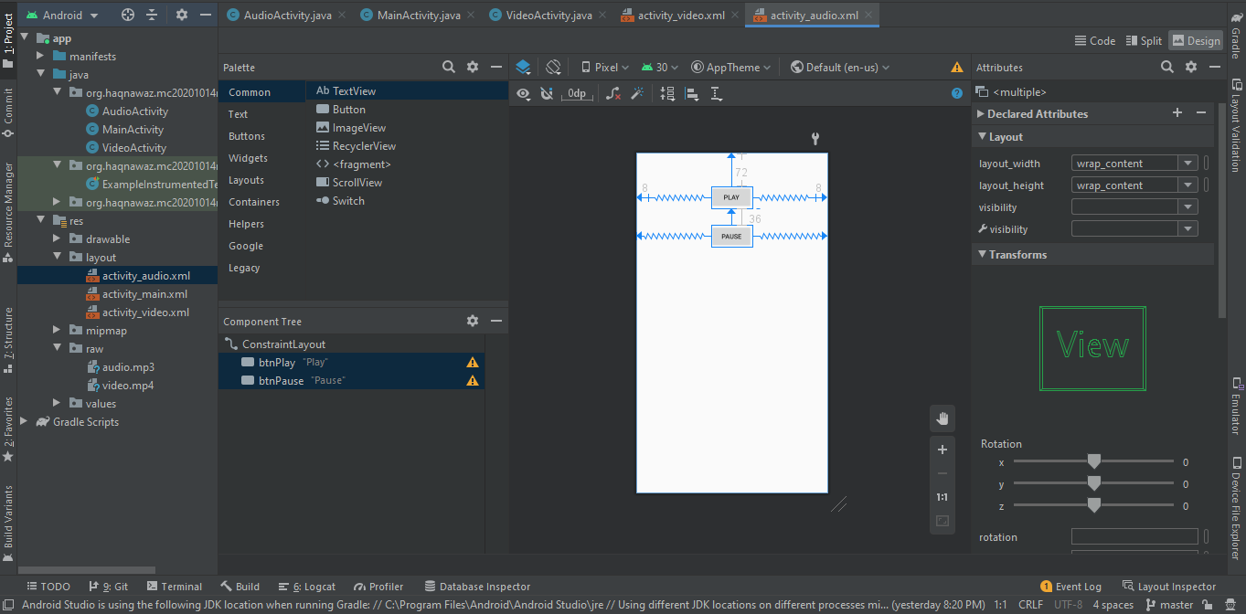

**Complete Program Link:**

[**https://github.com/talha0606/Animation/tree/master/AssignmentOne**](https://github.com/talha0606/Animation/tree/master/AssignmentOne)