**Fragments**

**Mobile Computing (MC)**

**__________________________________________________________________**



**Submitted to:**

**Sir Haq Nawaz**

**Submitted by:**

**Muhammad Talha Madni**

**Roll no: BSEF18A_018**

**Punjab University College of Information Technology,**

**PUCIT (Old Campus),**

**Fragments**

**Definition:**

A **Fragment** represents a reusable portion of your app's UI. A **fragment** defines and manages its own layout, has its own lifecycle, and can handle its own input events. **Fragments** cannot live on their own--they must be hosted by an activity or another **fragment**.

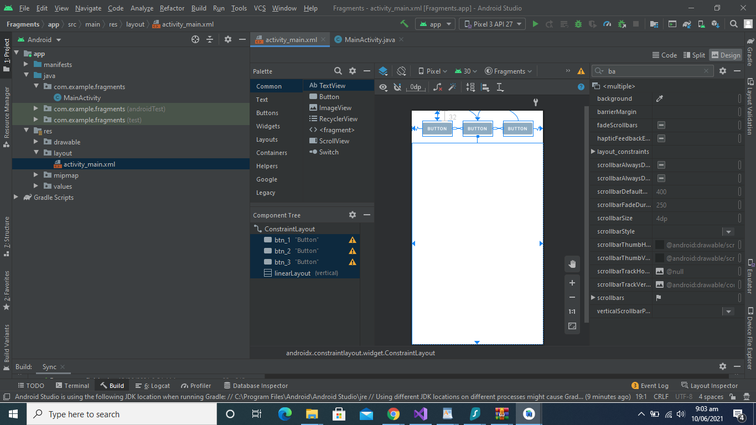

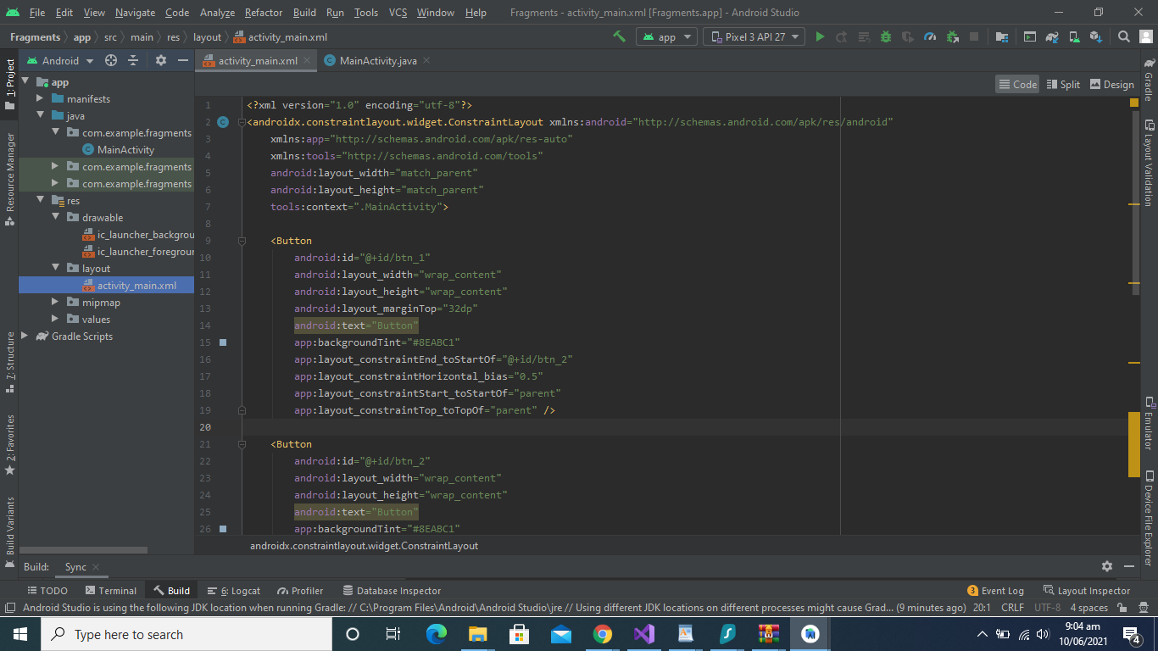

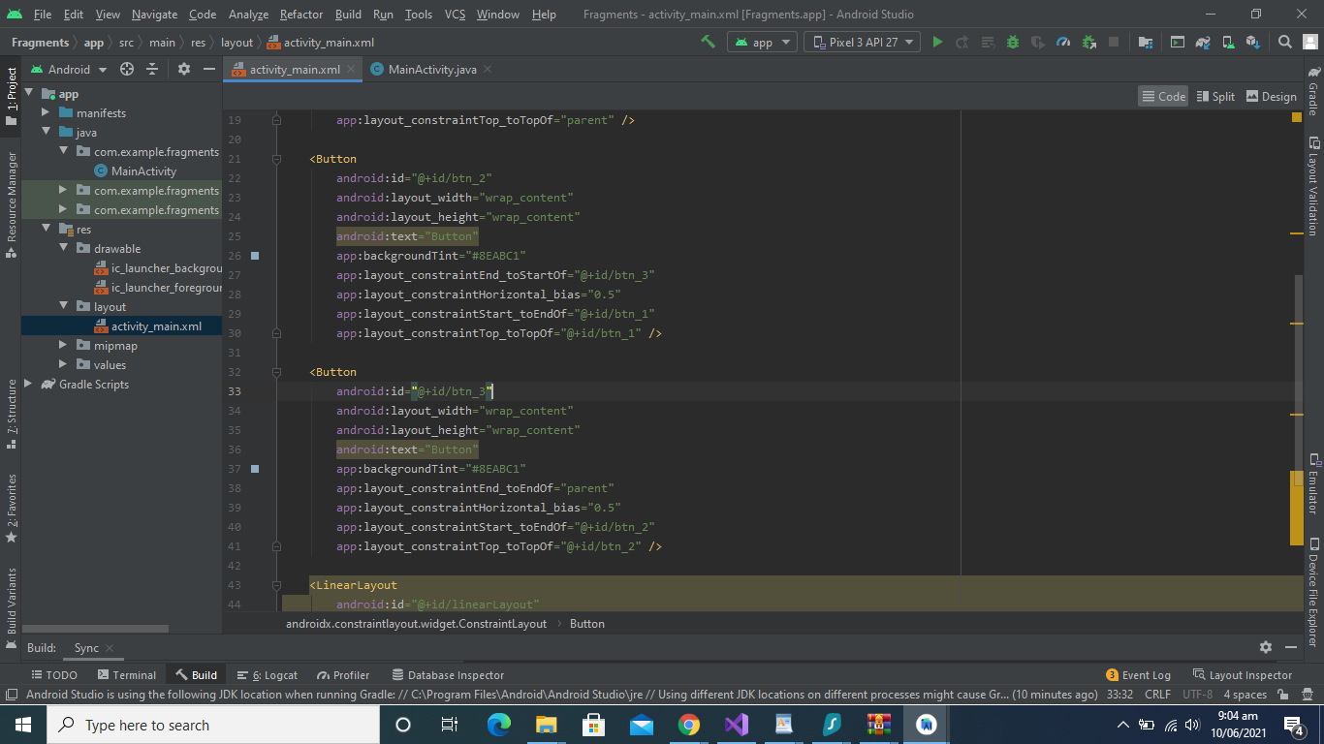

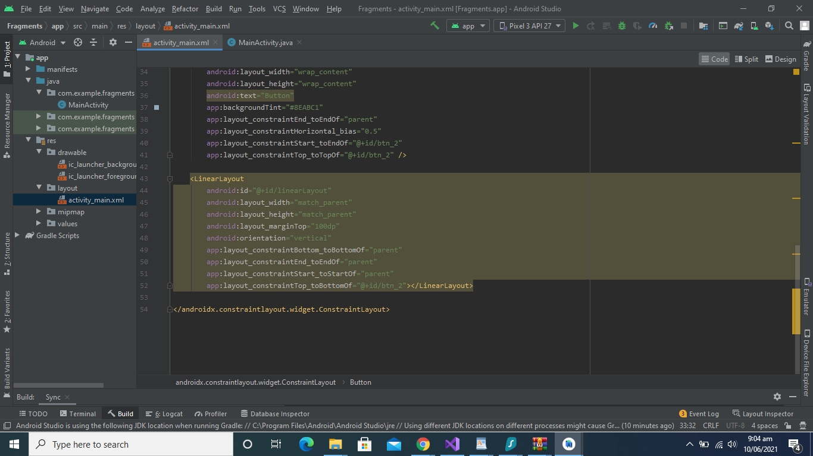



First Fragment Added:

