**Lecture_14_Dialog**

**Mobile Computing (MC)**

**__________________________________________________________________**



**Submitted to:**

**Sir Haq Nawaz**

**Submitted by:**

**Muhammad Talha Madni**

**Roll no: BSEF18A_018**

**Punjab University College of Information Technology,**

**PUCIT (Old Campus),**

**Definition:**

A **Dialog** is small window that prompts the user to a decision or enter additional information.

Some times in your application, if you wanted to ask the user about taking a decision between yes or no in response of any particular action taken by the user, by remaining in the same activity and without changing the screen, you can use Alert Dialog.

In order to make an alert dialog, you need to make an object of AlertDialogBuilder which an inner class of AlertDialog. Its syntax is given below

**AlertDialog.Builder alertDialogBuilder = new AlertDialog.Builder(this);**

Now you have to set the positive (yes) or negative (no) button using the object of the AlertDialogBuilder class. Its syntax is

**alertDialogBuilder.setPositiveButton(CharSequence text, DialogInterface.OnClickListener listener)alertDialogBuilder.setNegativeButton(CharSequence text, DialogInterface.OnClickListener listener)**

**In this Main_Layout we make a single dialog button.**

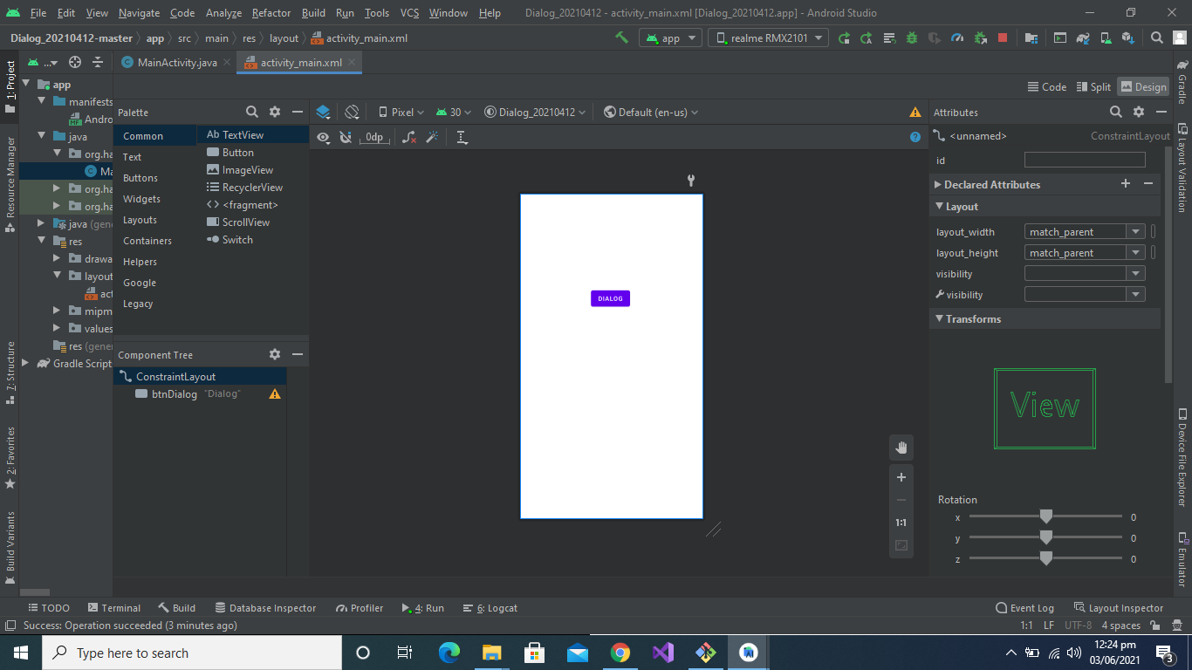

**Main.xml Code Part:**

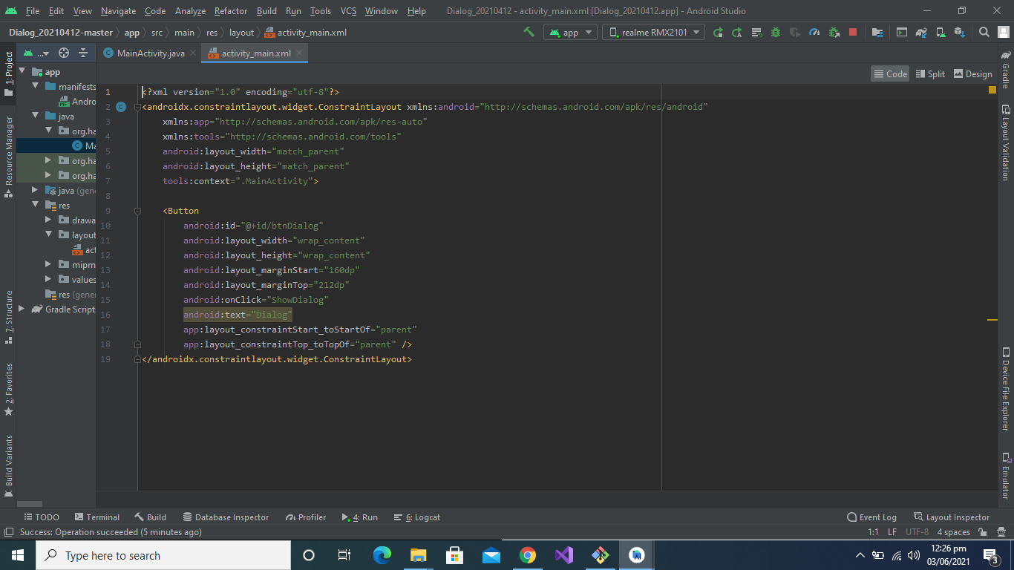

**MainActivity.java**

In MainActivity.java we have a showDialog() function. When user click on the dialog button this function called and dialog box will show to the user in which we have two buttons Named as Positive and Negative and a simple text. 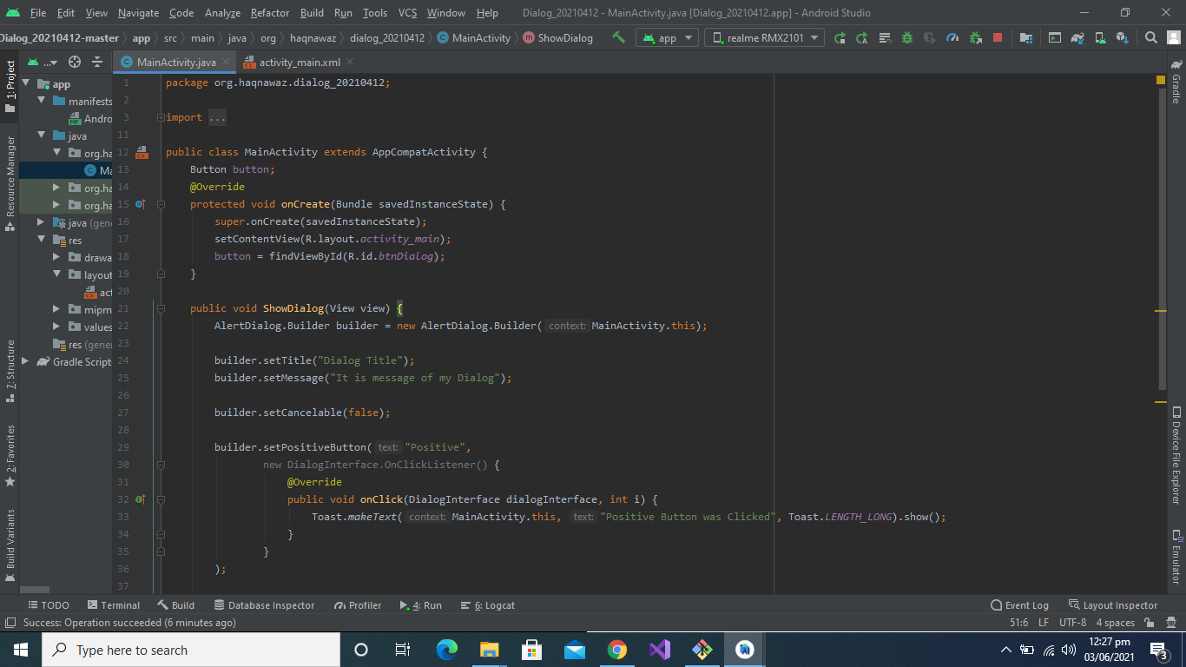**Positive and Negative Button code:**

When user click on the Positive button there will be toast show “**positive button clicked**” and when click Negative button there will be toast show “**Negative button clicked”**

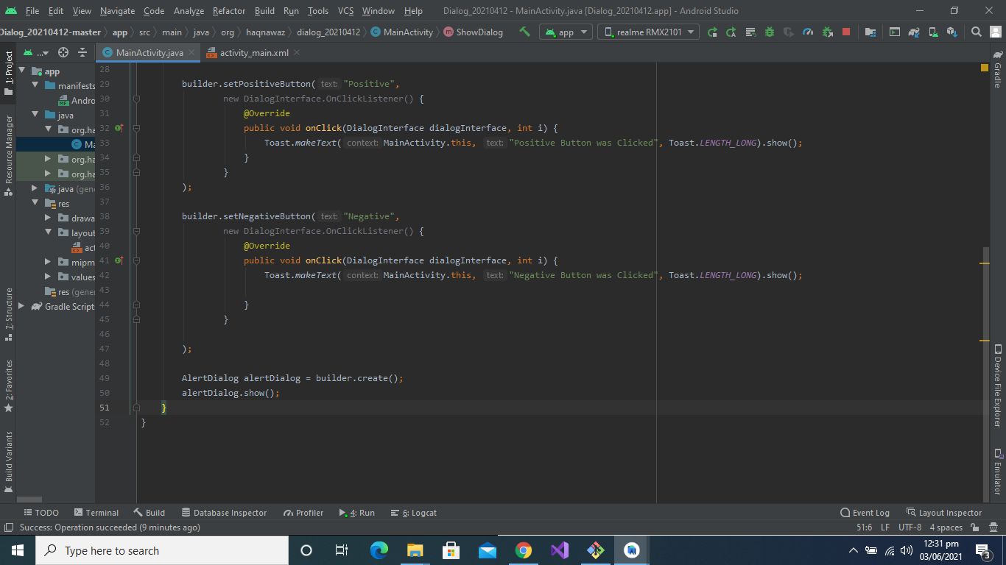

**Output**:

This output will be shown to the user.

