**Lecture_11_SQLite**

**Mobile Computing (MC)**

**__________________________________________________________________**



**Submitted to:**

**Sir Haq Nawaz**

**Submitted by:**

**Muhammad Talha Madni**

**Roll no: BSEF18A_018**

**Punjab University College of Information Technology,**

**PUCIT (Old Campus),**

**What is SQLite?**

**SQLite** is an **open-source relational database** i.e. used to perform database operations on android devices such as storing, manipulating or retrieving persistent data from the database.

It is embedded in android by default. So, there is no need to perform any database setup or administration task.

In this project we use listview as we discussed in Lecture 10. But the data source which we display in the list view is a SQLite Database instead of Array.

**Design Layout Page:**

**I**n this page we create two plaintext, one for name (which take name as an input from the user) and the other for age ( which take age as an input from the customer) and then we add switch button in the Layout Page (which will check the status of the Customer, Is he/she active or not?) and then we add two button named as “Add Record” and “View Record” to Add the customer detail in the database and to display all the records that are stored in database.

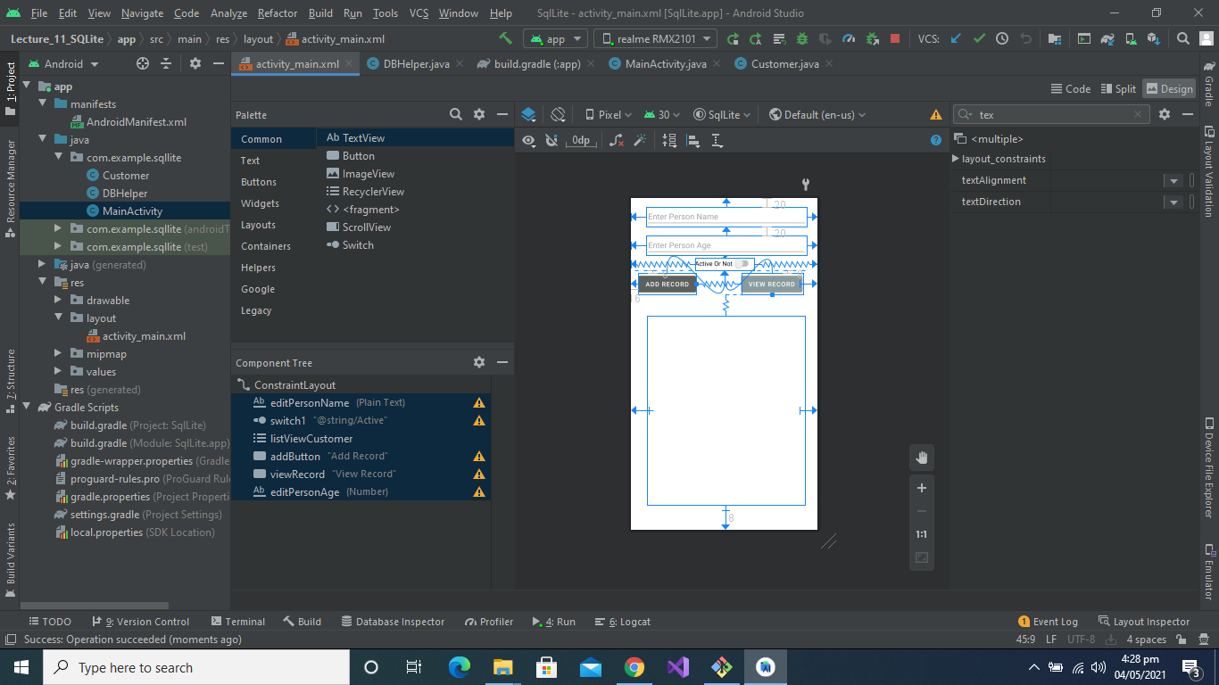

**Here is the Code Part:**

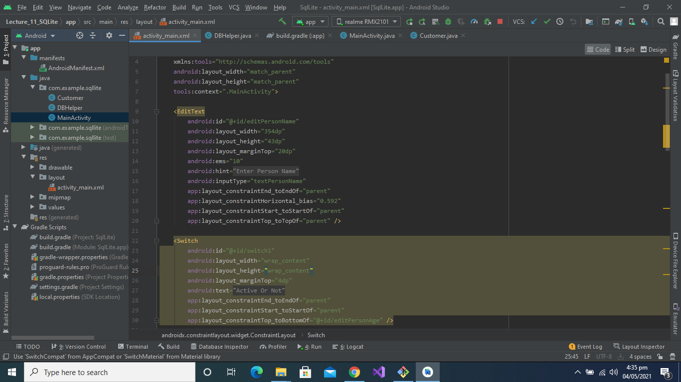

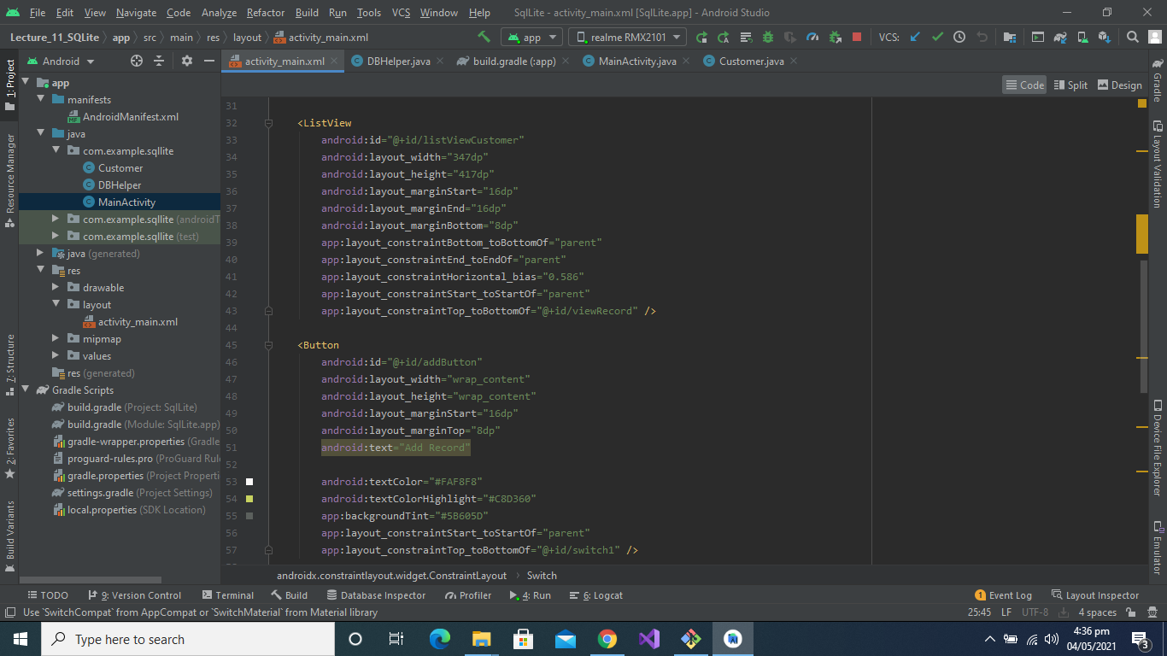

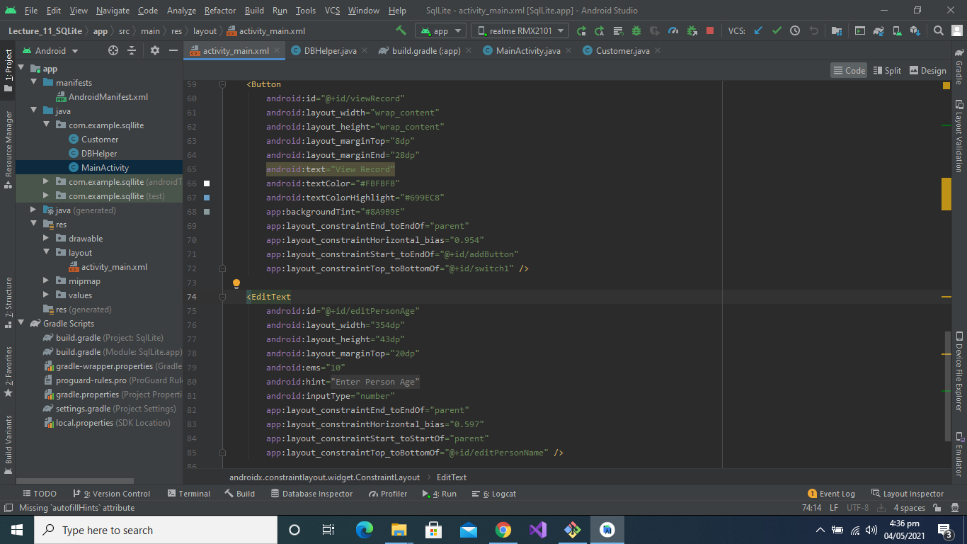

**Here is the Customer class code Part:**

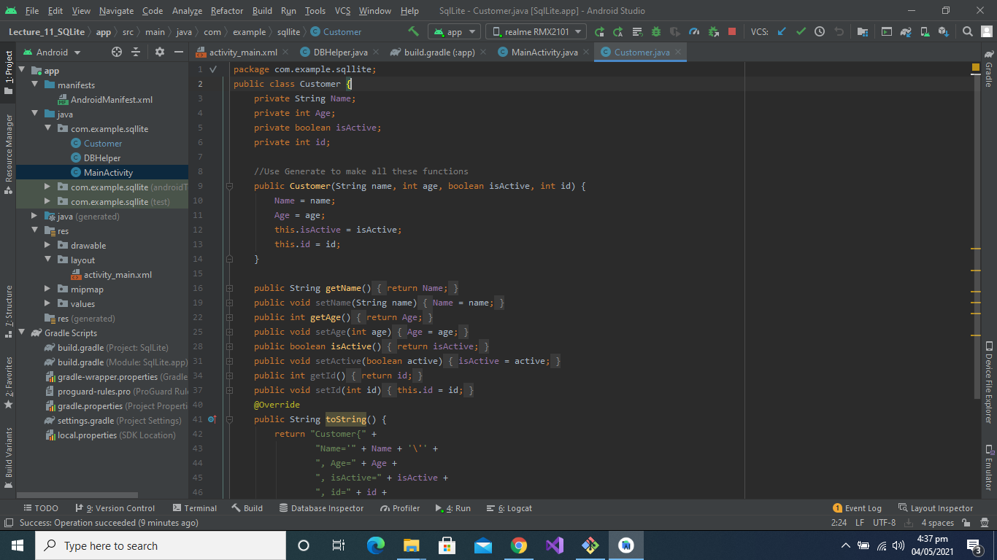

**Here is the Database code Part:**

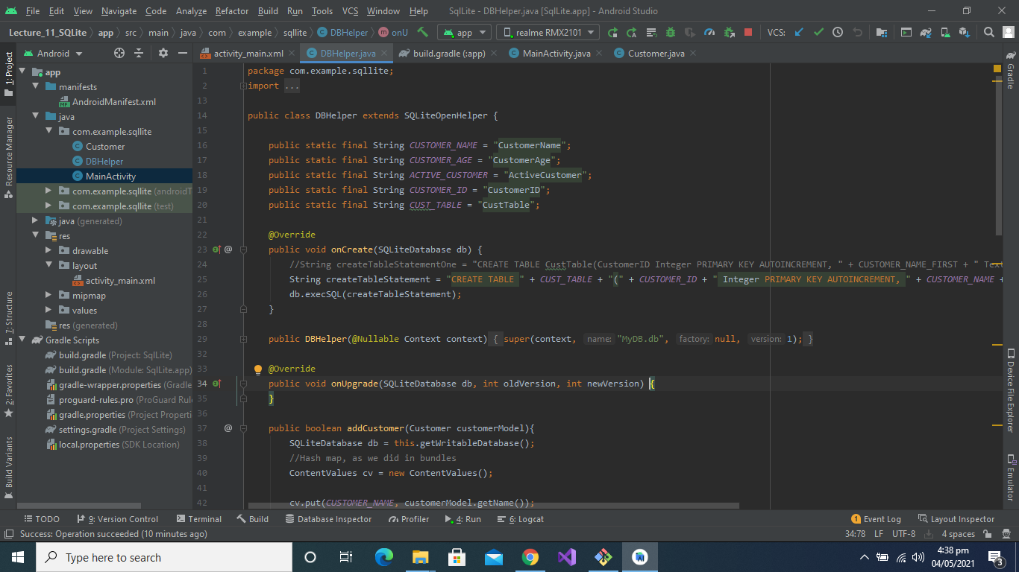

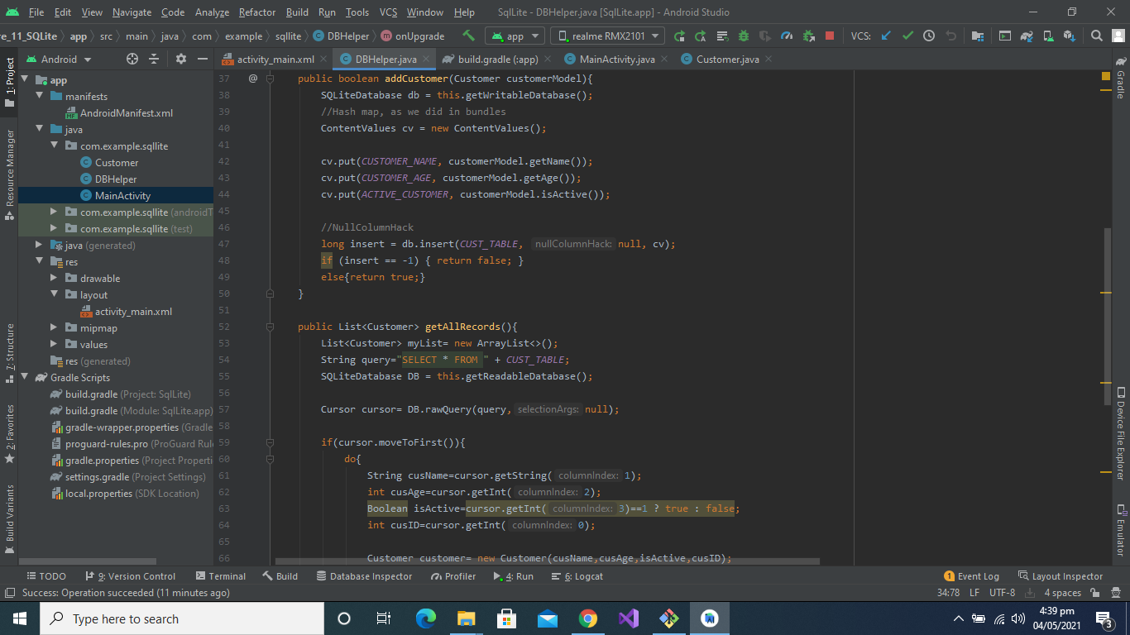

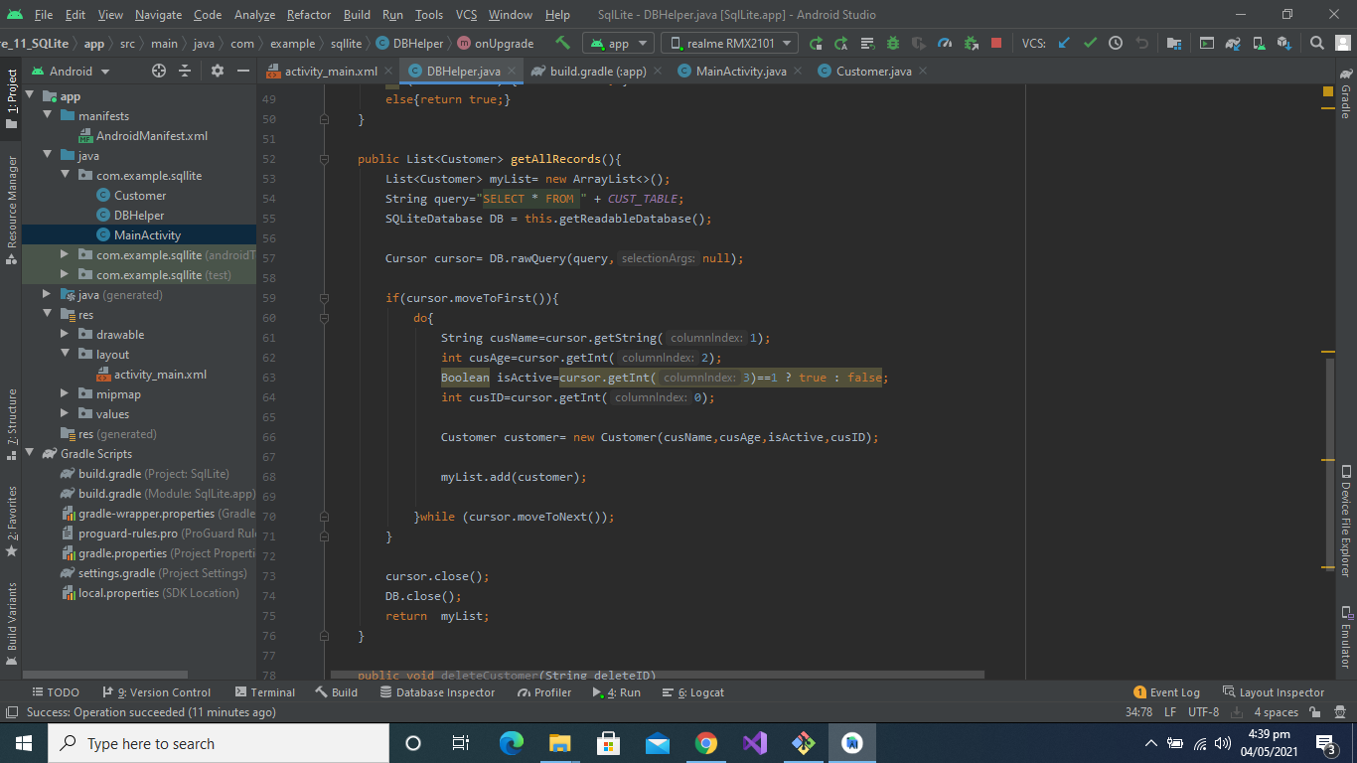

**You can get the complete program by this link:**

<https://github.com/talha0606/Lec_11_SQLiteDB/tree/master/Lecture_11_SQLite>