**Lecture_13_RecyclerView**

**Mobile Computing (MC)**

**__________________________________________________________________**



**Submitted to:**

**Sir Haq Nawaz**

**Submitted by:**

**Muhammad Talha Madni**

**Roll no: BSEF18A_018**

**Punjab University College of Information Technology,**

**PUCIT (Old Campus),**

**RecyclerView:**

In **Android**, **RecyclerView** is an advanced and flexible version of ListView and GridView. It is a container used for displaying large amount of data sets that can be scrolled very efficiently by maintaining a limited number of views.

This new widget is a big step for displaying data in Material Design because the ListView and GridView are one of the most commonly used UI widget. In [RecyclerView](https://abhiandroid.com/materialdesign/recyclerview) android provides a lots of new features which are not present in existing ListView or GridView.

In Android, [RecyclerView](https://abhiandroid.com/materialdesign/recyclerview) provides an ability to implement the horizontal, vertical and Expandable List. It is mainly used when we have data collections whose elements can change at run time based on user action or any network events.

In this program we made the list of 10 most beautiful cities in the world:

In **cities.xml** we make **imageView** and **two textViews.**

**City Design Code Part:**

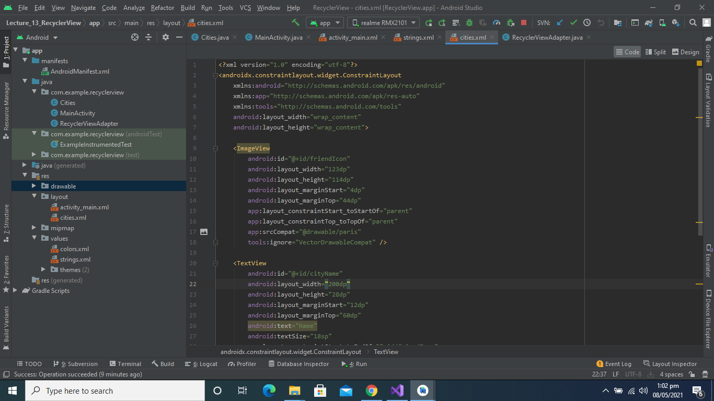

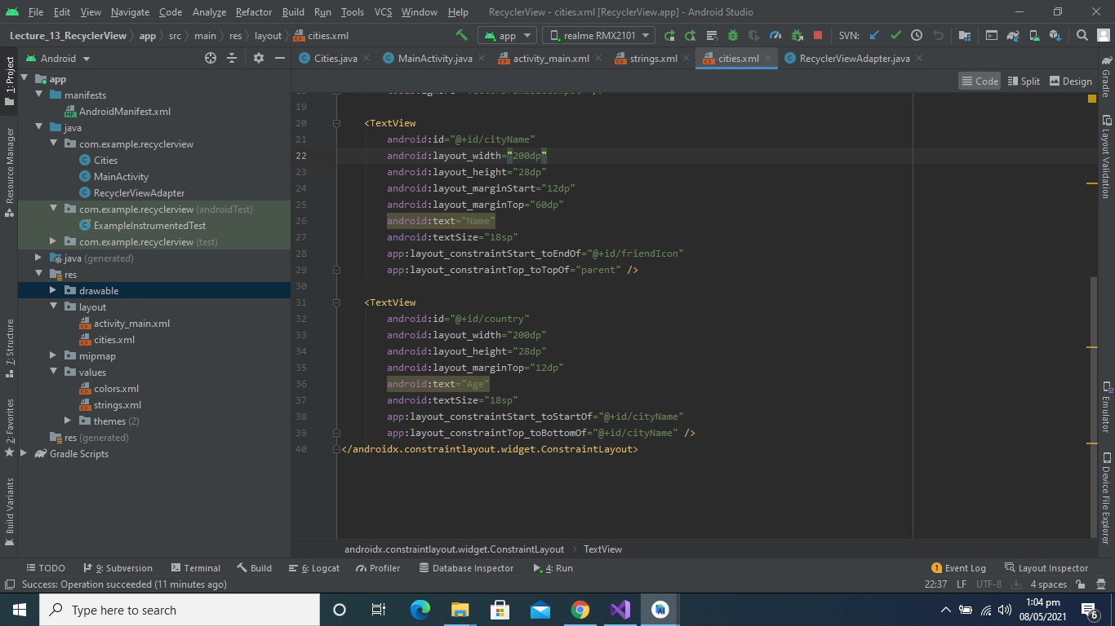

**City Design Page:**

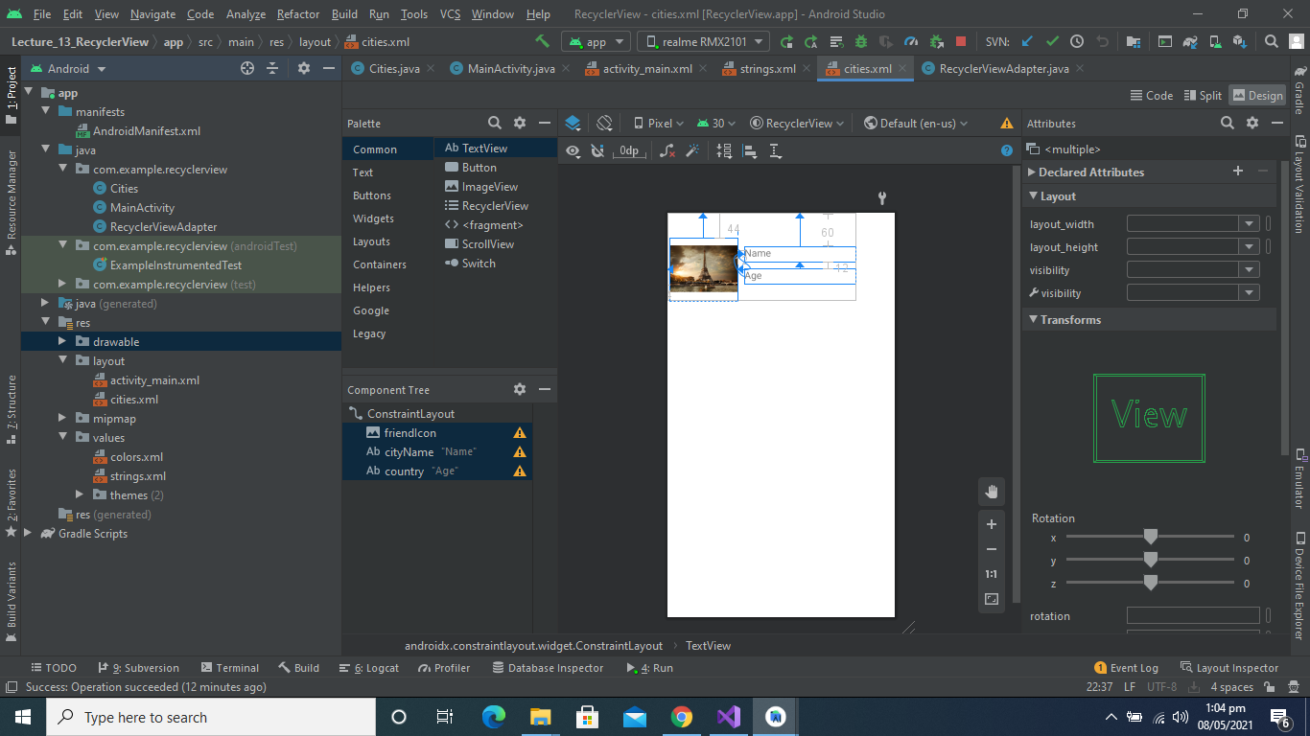

**Code of cities.java:**

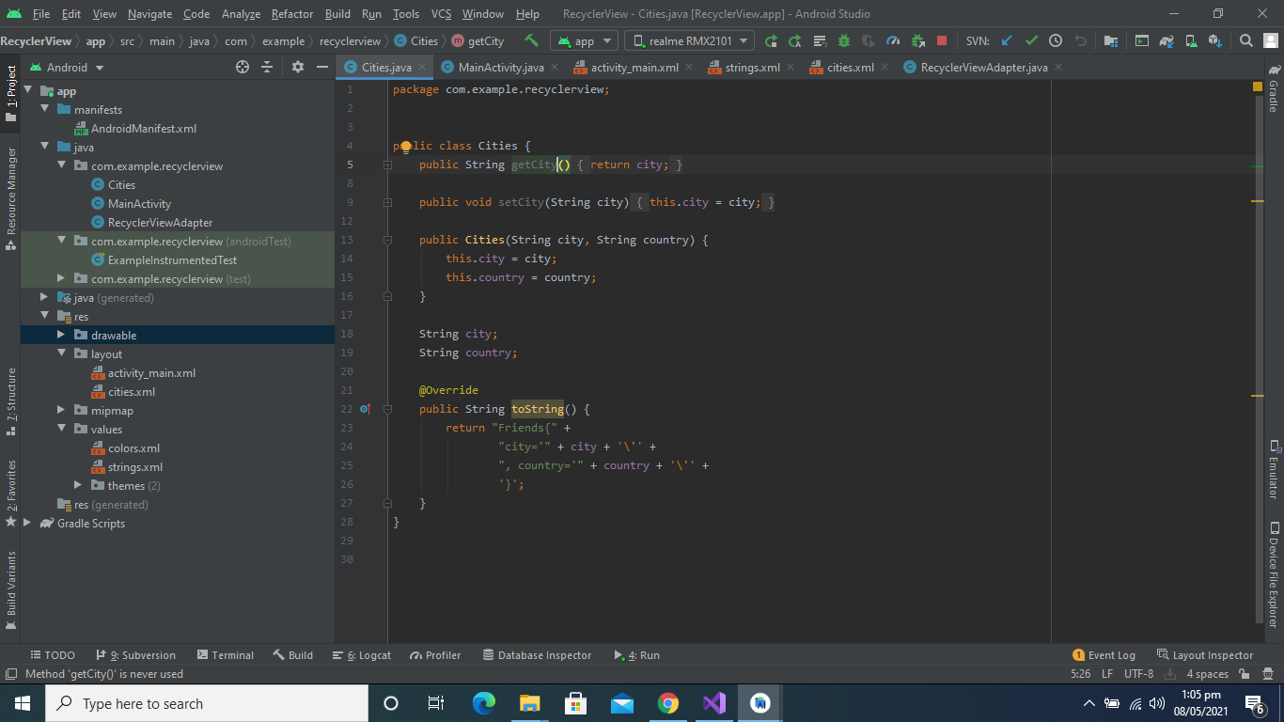

**RecyclerView.java class Code:**

In recyclerView class we make two classes RecyclerViewAdapter and citiesViewHolder.

As you see below

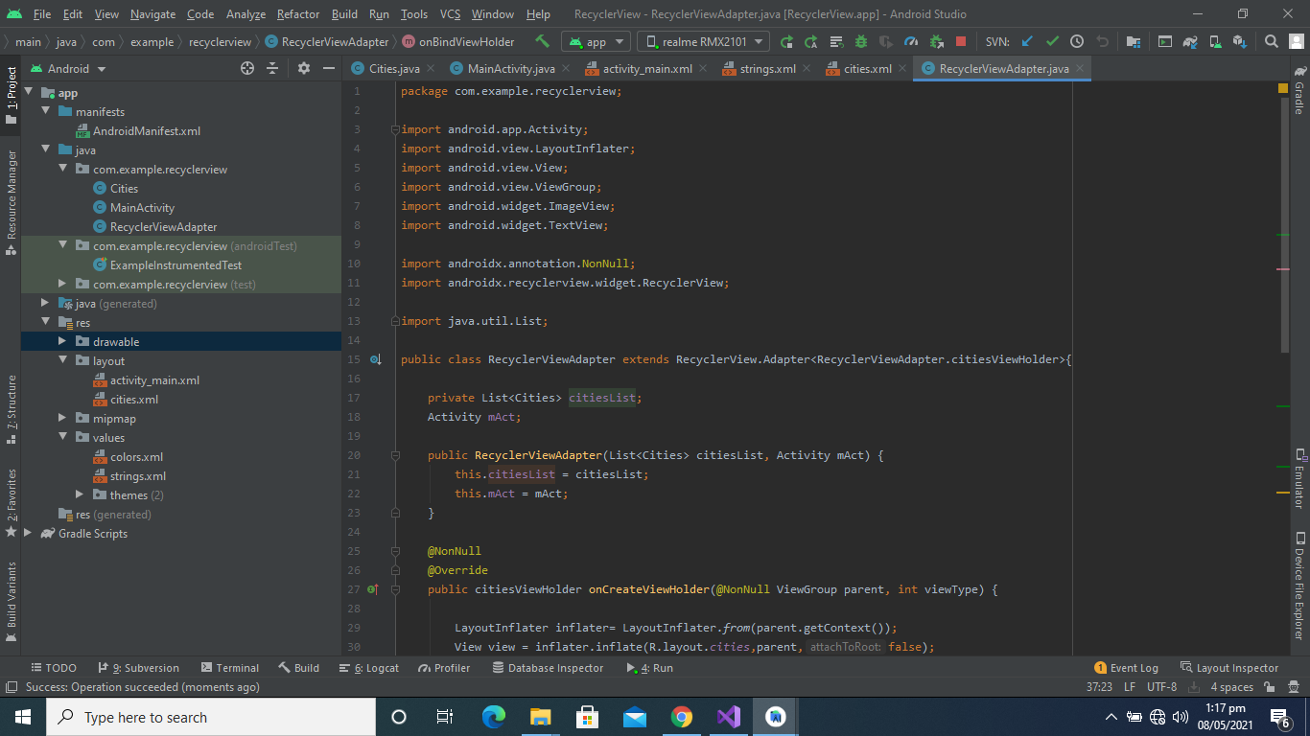

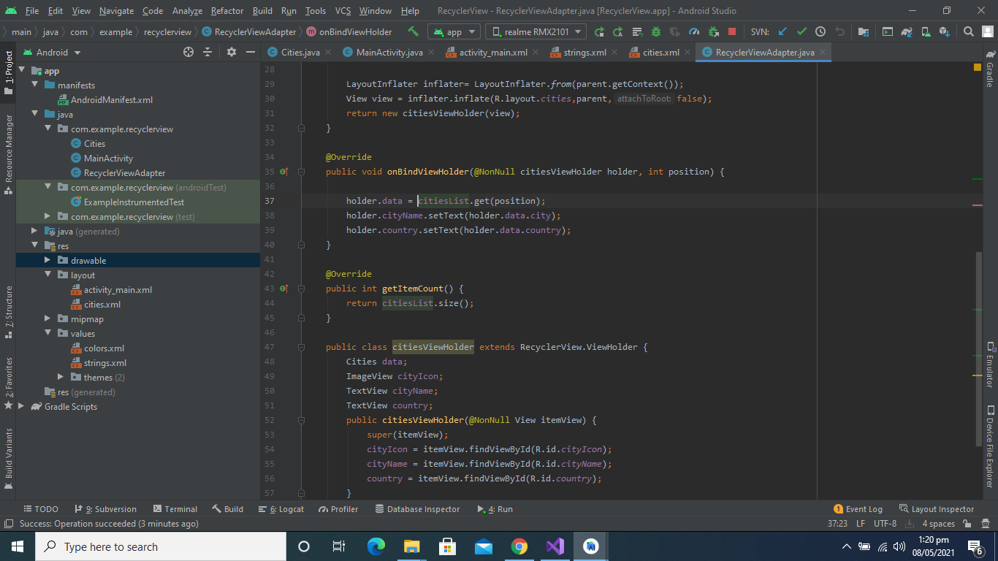

**MainActivity.Java Class:**

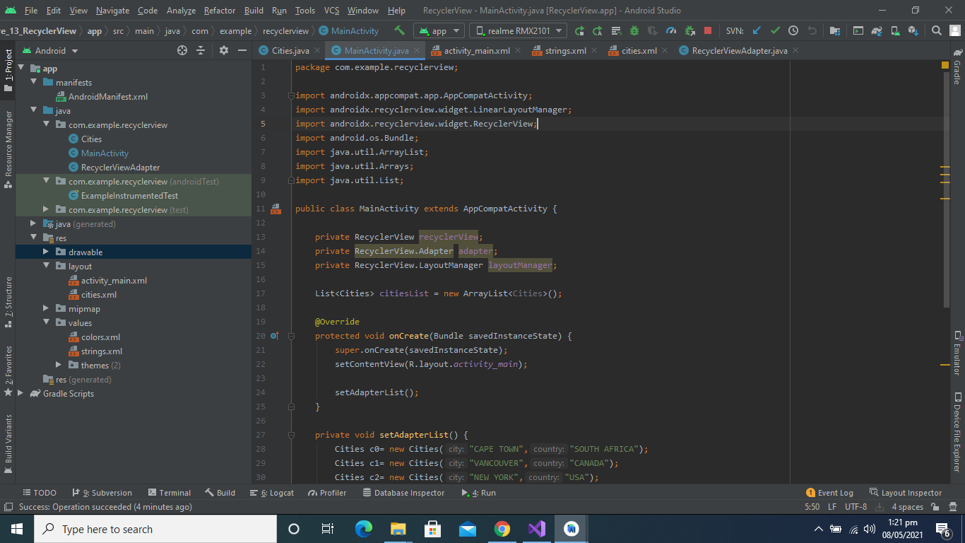

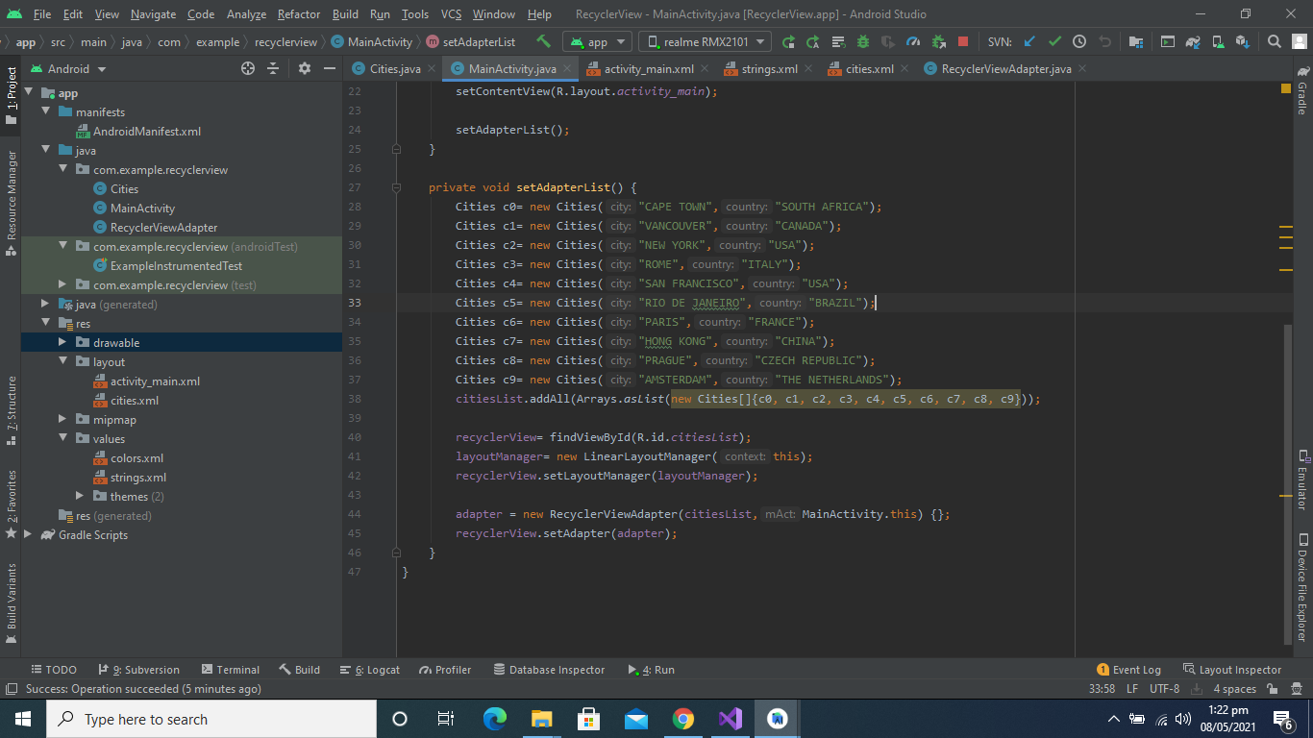

**Activity_main.xml Code:**

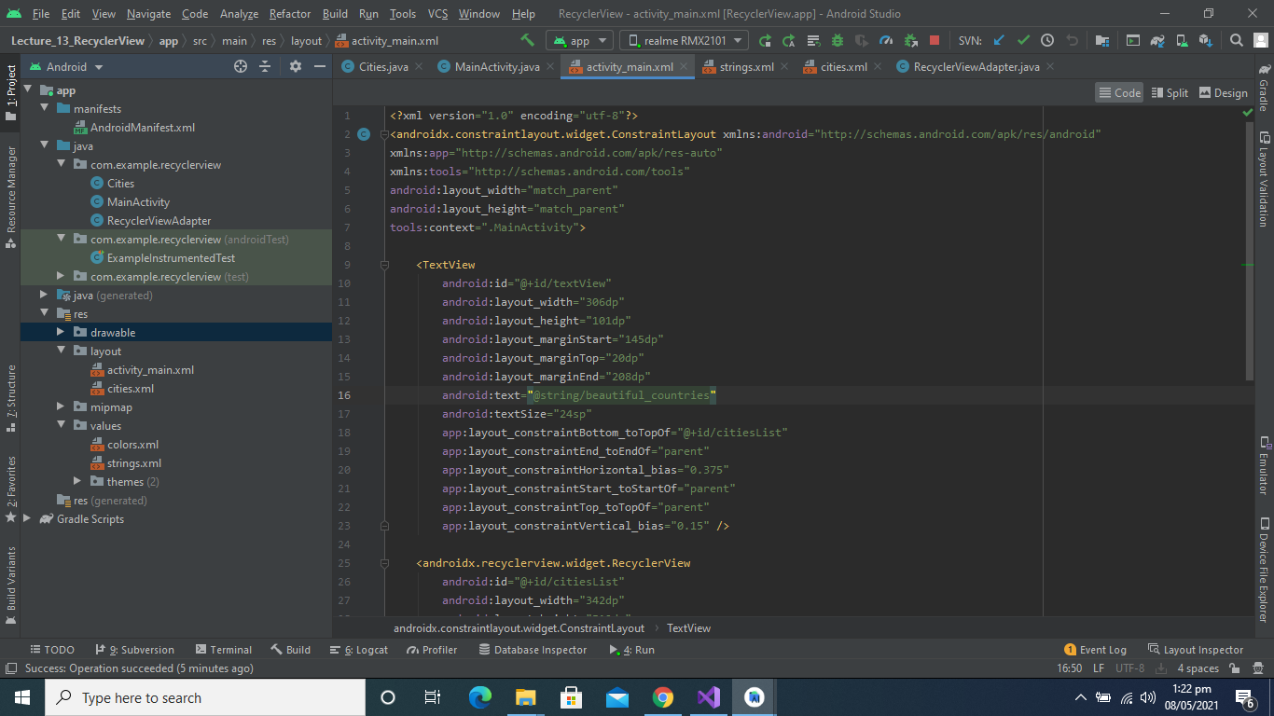

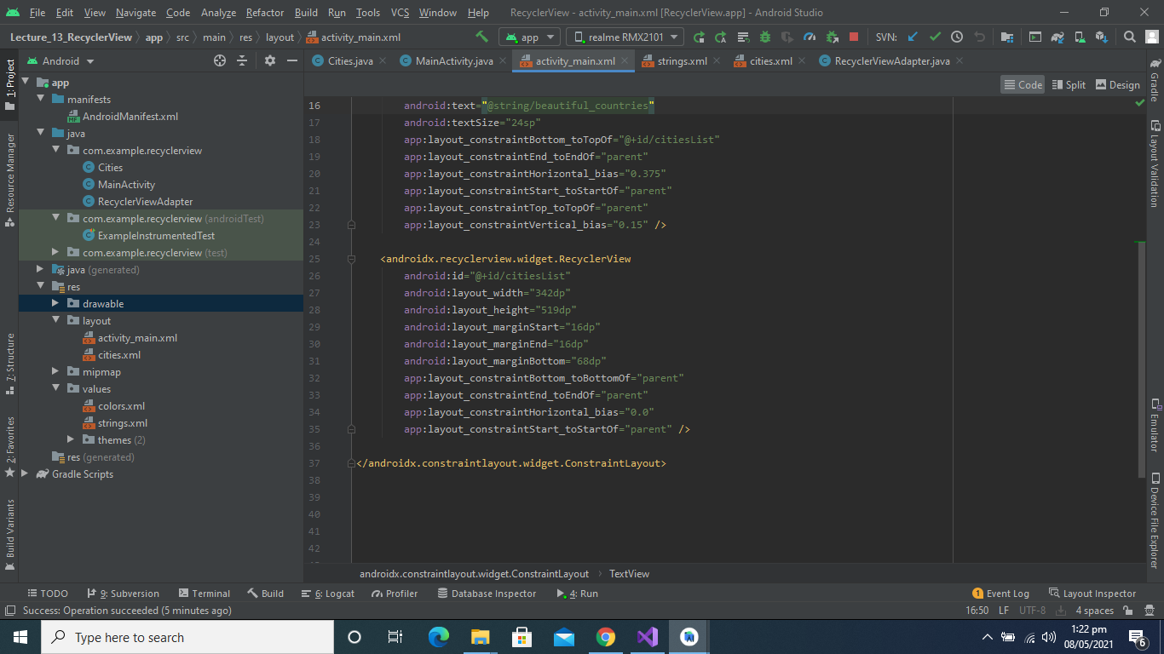

**Activity_main.xml Design:**

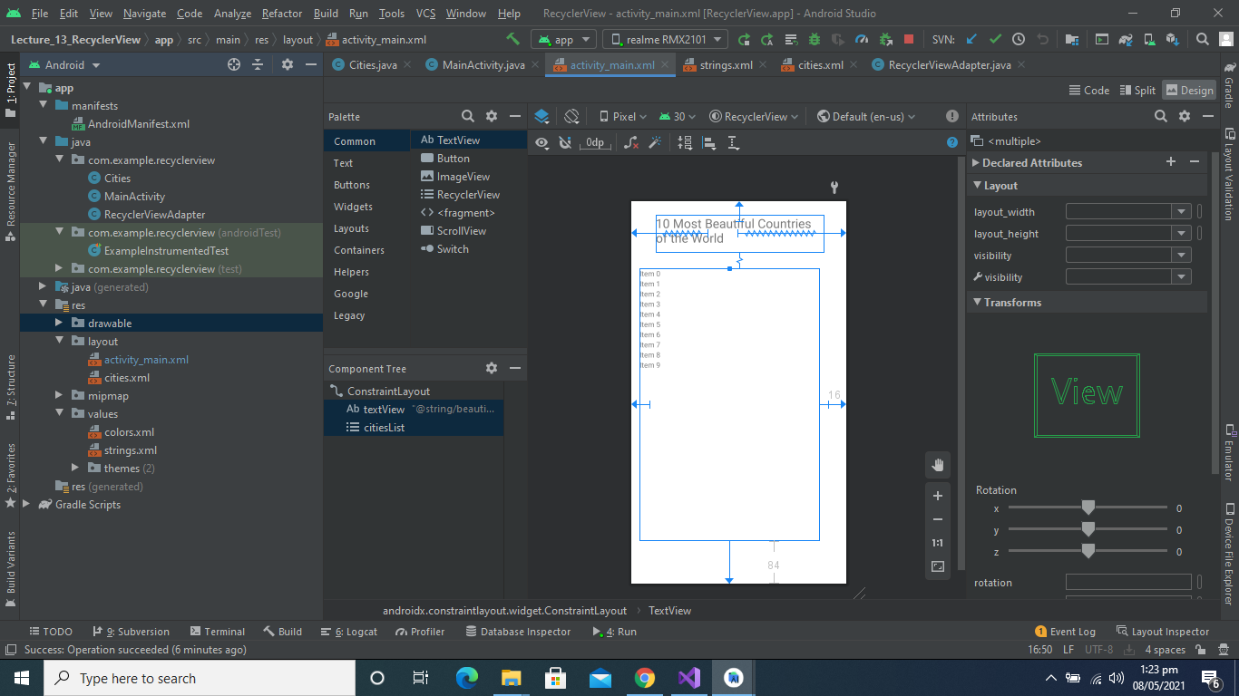

**Complete Program Link:**

<https://github.com/talha0606/Lecture_13_RecyclerView/tree/master/Lecture_13_RecyclerView>