1
E-PROJECT | FIRST SEMESTER
BAKERZ BITE
Where Smiles Are Served Daily
Project Documentation
TEAM MEMBERS
S.No | Name | Student ID
1 | Muhammad Talha | 1731374
2 | Muhammad Samad | 1729914
3 | Muhammad Shabir | 1731350
4 | Muhammad Usama | 1731082

Prepared by: Talha
Batch: 2605A
Course: E-Project, First Semester
Date: 10 October 2026

Table of Contents
1. Introduction 1
1.1 Project Information 1
2. Objectives and Scope 1
2.1 Objectives 1
2.2 Scope 1
2.3 Target Audience 1
3. Technologies Used 1
4. Site Map 1
4.1 Site Map Summary 1
5. Website Structure and Page Description 1
5.1 Navigation Bar 1
5.2 Home (Hero Section) 1
5.3 About Us 1
5.4 Specialities 1
5.5 Menu 1
5.6 Merchandise 1
5.7 Offers 1
5.8 Gallery 1
5.9 Reviews and Rating 1
5.10 FAQ 1
5.11 Contact 1
5.12 Footer 1
6. Sample Data: Menu Items 1
7. Sample Data: Merchandise 1
8. Features and Functionality 1
8.1 Shopping Cart and Ordering 1
8.2 Login and Sign Up 1
8.3 Other Interactive Features 1
8.4 Responsive Design 1
9. Design Guidelines 1
9.1 Color Palette 1
9.2 Typography 1
9.3 Layout Style 1
10. Sample Code 1
10.1 CSS Color Variables (style.css) 1
10.2 Product Card (index.html) 1
10.3 Adding an Item to the Cart (jQuery) 1
10.4 Star Rating (jQuery) 1
11. Sample User Scenario and Testing 1
11.1 Sample Scenario: Ordering a Cake 1
11.2 Test Cases 1
12. Limitations and Future Enhancements 1
12.1 Current Limitations 1
12.2 Future Enhancements 1
13. Conclusion 1

1. Introduction
Bakerz Bite is a responsive bakery website designed and developed as the first-semester E-Project. The website presents a bakery that sells cakes, pastries, cookies, brownies, croissants, cupcakes, pies and desserts, along with its own branded merchandise. Its slogan is "Where Smiles Are Served Daily."
A visitor can read about the bakery, browse the complete menu, view product details, add items to a cart, place an order, view offers and the gallery, read customer reviews, submit a rating, read frequently asked questions and contact the bakery, all from a single, easy-to-use website.

1.1 Project Information
Item | Details
Project Name | Bakerz Bite
Project Type | Bakery / E-commerce Website (front-end)
Slogan | Where Smiles Are Served Daily
Course | E-Project, First Semester
Batch | 2605A
Prepared By | Talha
Location Shown on Website | Karachi, Pakistan
Main Files | index.html, style.css, files/sitemap.html

2. Objectives and Scope

2.1 Objectives
- To build an attractive and professional website for a bakery business.
- To let customers view the full menu with prices and descriptions in one place.
- To provide a simple shopping cart so customers can select items and place an order.
- To promote the bakery through offers, a photo gallery, reviews and a branded merchandise store.
- To make the website work smoothly on mobile phones, tablets and laptops.
- To give customers an easy way to contact the bakery and to give feedback.

2.2 Scope
The project covers the design and front-end development of the website. It includes 8 main sections, a 7-category menu with 21 products, a merchandise store with 6 items, a cart, login and sign-up forms, a rating form, a contact form and a site map page.
The project does not yet include a back-end server or database. Login, sign-up, cart and order placement run in the browser to demonstrate the user experience. See Section 12 for future enhancements.

2.3 Target Audience
- Customers who want to order cakes and bakery items for daily needs or celebrations.
- Gift buyers looking for branded merchandise and cookie gift tins.
- New visitors who want to know about the bakery, its location and contact details.

3. Technologies Used
The website is built with standard web technologies and popular open-source libraries.
Technology | Purpose in the Project
HTML5 | Structure of all pages and sections (navigation, menu cards, forms, modals, footer).
CSS3 | Custom styling in style.css: colors, layout, hover effects, animations and responsive media queries.
Bootstrap 5.3.8 | Responsive grid system, navbar with dropdown, and modal windows (popups).
jQuery 3.7.1 | Interactivity: cart logic, quantity buttons, popups, form handling, scroll animations.
Font Awesome 7 | Icons for categories, buttons, cart and rating stars.
Google Fonts (Montserrat) | Main typeface used across the whole website.
Unsplash Images | Product, hero and gallery photographs loaded via image links.

4. Site Map
The site map gives visitors a complete overview of the website. It is available as a separate page (files/sitemap.html) and is linked from the footer as "Site Map". The structure is shown below.
Bakerz Bite
|
+-- Main Pages
| +-- Home
| +-- About Us
| +-- Merchandise
| +-- Offers
| +-- Gallery
| +-- Reviews
| +-- FAQ
| +-- Contact
|
+-- Menu
| +-- Full Menu
| +-- Cakes
| +-- Pastries
| +-- Cookies
| +-- Brownies
| +-- Croissants
| +-- Cupcakes
| +-- Pies & Desserts
|
+-- Shop & Account
| +-- Merchandise Store
| +-- Add Items to Cart
| +-- Login / Sign Up
| +-- View Cart & Place Order
|
+-- Contact Details
+-- Phone: +92 300 1234567
+-- Email: hello@bakerzbite.com
+-- Location: Karachi, Pakistan

4.1 Site Map Summary
Group | Pages / Links | Description
Main Pages | Home, About Us, Merchandise, Offers, Gallery, Reviews, FAQ, Contact | Core sections of the single-page website, reached from the top navigation bar.
Menu | Full Menu and 7 categories | Complete product list grouped by category.
Shop & Account | Merchandise Store, Cart, Login / Sign Up, Place Order | Shopping and account features opened from the home page.
Contact Details | Phone, Email, Location | Ways to reach the bakery.

Figure 1: Site Map page (sitemap.html)

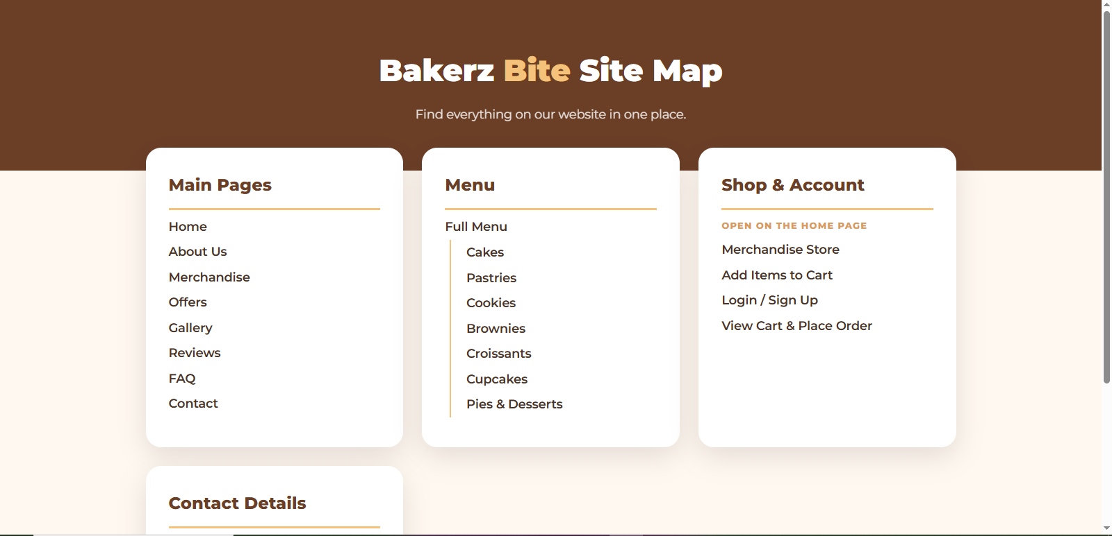

5. Website Structure and Page Description
Bakerz Bite is a single-page website. All sections are placed on index.html and the navigation bar scrolls smoothly to each section.

5.1 Navigation Bar
A fixed brown navigation bar stays at the top while scrolling. It contains the brand name, links to every section, a Menu dropdown with all 7 categories, a Login button and a cart icon with a live item counter. On mobile screens it collapses into a menu button, and it closes automatically after a link is tapped.
Figure 2: Navigation bar with Menu dropdown

5.2 Home (Hero Section)
The first screen shows a large banner with the heading "Where Smiles Are Served Daily" and the line "Freshly baked, every day." Two buttons guide the visitor: Explore Menu (scrolls to

the menu) and Visit Us (scrolls to contact). A scroll progress bar at the top shows how far the visitor has scrolled.

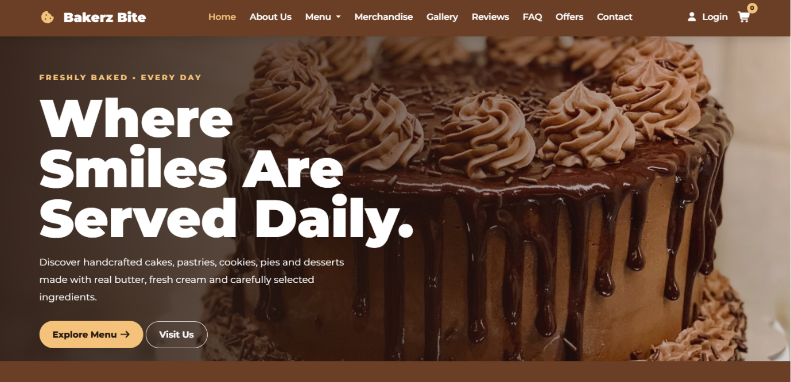

Figure 3: Home / hero section

5.3 About Us
This section introduces the bakery's story and values, which are quality ingredients, freshness and care. A "100% Freshly Baked" badge highlights the bakery's promise, and the button Explore Our Bakery leads to the menu.

5.4 Specialities
Four feature cards present the main categories with a starting price and the number of items: Cakes (from PKR 1,000), Pastries (from PKR 280), Cookies (from PKR 300) and Brownies (from PKR 300). Each card has a View Details button that opens a popup.

5.5 Menu
The menu is divided into seven categories: Cakes, Pastries, Cookies, Brownies, Croissants, Cupcakes and Pies & Desserts. Each category has three products, so there are 21 products in total. Every product card shows an image, name, short description and price, with two buttons: View Details and Add to Cart. The complete list is given in Section 6.

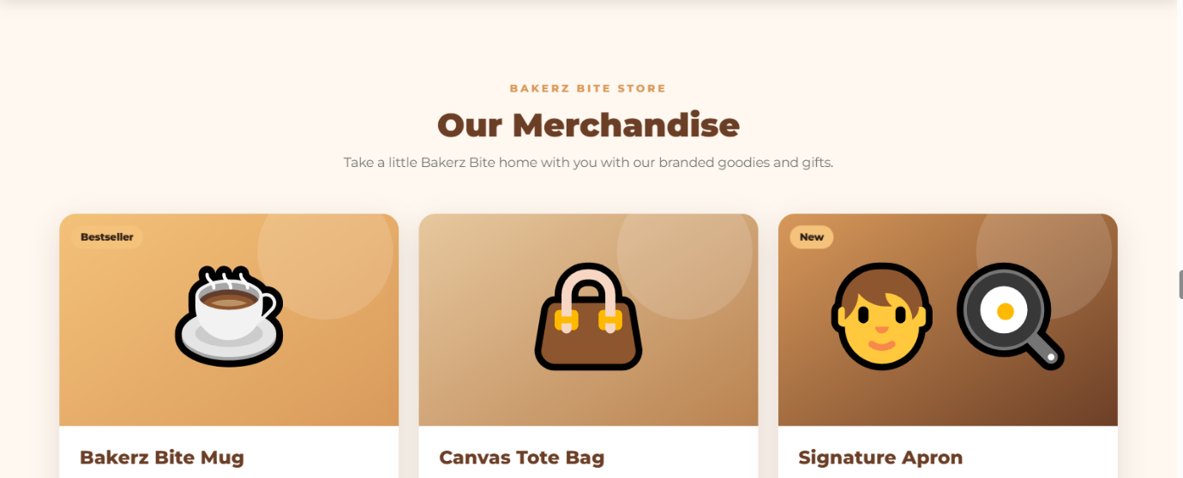

Figure 4: Menu section with product cards

5.6 Merchandise
The merchandise store sells branded goods such as a mug, tote bag, apron, T-shirt, cap and cookie gift tin. Cards may carry badges (Bestseller, New, Gift Pick). The full list is given in Section 7.

5.7 Offers
The Offers section shows the Weekend Special, "Sweeten Your Weekend." The View Details button opens a popup explaining the deal, with an Order Now link that takes the visitor to the menu.

5.8 Gallery
The gallery displays six photographs of freshly baked items in a responsive grid. Clicking an image opens it in a large popup viewer.

5.9 Reviews and Rating
Three customer reviews (Ali, Ahmed and Sara) are shown with star ratings. Below them, a rating form lets visitors select 1 to 5 stars and press Submit Rating. A thank-you message confirms the rating, and a warning appears if no star has been chosen.

5.10 FAQ
The FAQ is an accordion with four questions: what products the bakery offers, whether customized cakes are available, whether home delivery is offered, and how to place an order.

5.11 Contact
The contact section shows the phone number (+92 300 1234567), email (hello@bakerzbite.com) and location (Karachi, Pakistan). A contact form with name, email and message fields allows visitors to send a message; after sending, a confirmation message appears.

5.12 Footer
The footer repeats the brand slogan and has quick links grouped under Explore (Menu, Merchandise, Offers, Gallery, Reviews) and Company (FAQ, About Us, Contact Us, Site Map), followed by the copyright line.

6. Sample Data: Menu Items
The table below lists all 21 menu products with their category, description and price, as they appear on the website.
# | Category | Product | Description | Price (PKR)
1 | Cakes | Chocolate Cake | Rich chocolate cake with creamy chocolate frosting. | 1,200
2 | Cakes | Vanilla Cake | Soft vanilla sponge with delicious creamy layers. | 1,000
3 | Cakes | Red Velvet Cake | Classic red velvet cake with smooth cream cheese frosting. | 1,500
4 | Pastries | Cream Pastry | Soft pastry filled with fresh cream and sweet toppings. | 320
5 | Pastries | Butter Croissant | Golden, crispy and buttery French-style croissant. | 280
6 | Pastries | Chocolate Pastry | Chocolate layered pastry with creamy chocolate filling. | 350
7 | Cookies | Chocolate Cookies | Crunchy cookies loaded with chocolate chips. | 350
8 | Cookies | Butter Cookies | Classic buttery cookies, soft and crispy. | 300
9 | Cookies | Oat Cookies | Healthy and delicious cookies made with premium oats. | 380
10 | Brownies | Fudge Brownie | Rich and fudgy chocolate brownie with a soft center. | 300
11 | Brownies | Walnut Brownie | Chocolate brownie topped with crunchy walnuts. | 350
12 | Brownies | Caramel Brownie | Fudgy brownie with a delicious caramel topping. | 380
13 | Croissants | Classic Croissant | Light, flaky and perfectly golden classic croissant. | 280
14 | Croissants | Almond Croissant | Buttery croissant filled with almond cream. | 380
15 | Croissants | Chocolate Croissant | Flaky croissant filled with rich chocolate. | 350
16 | Cupcakes | Vanilla Cupcake | Soft vanilla cupcake topped with creamy frosting. | 220
17 | Cupcakes | Chocolate Cupcake | Moist chocolate cupcake with chocolate cream. | 250
18 | Cupcakes | Strawberry Cupcake | Sweet strawberry cupcake with fresh creamy topping. | 280
19 | Pies & Desserts | Apple Pie | Warm apple filling wrapped in a buttery golden crust. | 450
20 | Pies & Desserts | Glazed Donuts | Soft donuts covered with a sweet glossy glaze. | 250
21 | Pies & Desserts | Chocolate Dessert | Creamy chocolate dessert made for sweet cravings. | 400

Price range: the lowest-priced item is the Vanilla Cupcake at PKR 220 and the highest-priced item is the Red Velvet Cake at PKR 1,500.

7. Sample Data: Merchandise
Product | Description | Price (PKR) | Badge
Bakerz Bite Mug | Ceramic coffee mug with the cookie-bite logo. | 850 | Bestseller
Canvas Tote Bag | Sturdy cotton tote for bakery runs and groceries. | 1,200 | -
Signature Apron | Heavy-duty baker's apron with adjustable strap and pocket. | 1,800 | New
Classic T-Shirt | 100% cotton tee printed with the brand slogan. | 1,500 | -
Baker's Cap | Adjustable cap embroidered with the Bakerz Bite bite mark. | 700 | -
Cookie Gift Tin | Reusable branded tin filled with assorted cookies. | 2,200 | Gift Pick

8. Features and Functionality

8.1 Shopping Cart and Ordering
- View Details popup: shows the product image, name, description and price, with plus (+) and minus (-) buttons to change the quantity. The total price updates instantly.
- Add to Cart: adds the product from the menu card or from the popup. If the item is already in the cart, only its quantity increases.
- Cart counter: the cart icon in the navigation bar shows the total number of items.
- Your Order panel: lists each item with price x quantity, the line total, a remove button and the grand total in PKR.
- Place Order: disabled when the cart is empty; when pressed, it clears the cart and shows a thank-you message.
- Toast notification: a small message such as "Chocolate Cake added to cart" appears for about two seconds.

8.2 Login and Sign Up
A popup contains two tabs, Login and Sign Up. Fields are validated by the browser (required fields, valid email format, minimum 6-character password). After submitting, a welcome message appears and the Login button changes to the user's first name.

8.3 Other Interactive Features
- Gallery image viewer popup.
- Star rating with a live message ("You Selected 4 Stars").
- Contact form with reset and confirmation message.
- Scroll-reveal animations: cards fade in as the user scrolls.
- Scroll progress bar at the top of the page.
- Smooth scrolling to sections from the navigation bar.

8.4 Responsive Design
The layout adapts using Bootstrap's grid and custom CSS media queries at four breakpoints (1200px, 991px, 767px and 480px). Menu cards show three per row on large screens, two on tablets and one on phones. The CSS also respects the "reduced motion" setting for users who prefer fewer animations.

9. Design Guidelines

9.1 Color Palette
The website uses a warm brown and cream palette that reflects chocolate, caramel and baked goods. The colors are stored as CSS variables in style.css so the theme can be changed in one place.
Color | Hex Code | CSS Variable | Used For
Primary Brown | #6B3E26 | --primary | Navigation bar, headings, buttons
Secondary Caramel | #D99A5B | --secondary | Highlights, icons, hover effects
Accent Gold | #F4C27A | --accent | Borders, badges, accents
Cream | #FFF8F0 | --cream | Section backgrounds
Dark Chocolate | #2B1A12 | --dark | Footer, dark text
Text Brown | #4A3428 | --text | Body text

9.2 Typography
The whole website uses the Montserrat font from Google Fonts in weights from 400 (regular) to 900 (black). Headings use heavy weights (700 to 900) for a bold, friendly look, while body text uses lighter weights for easy reading.

9.3 Layout Style
- Rounded cards with soft shadows (20px radius) for menu items and information boxes.
- Plenty of white space and consistent section headings with a small label above the title.
- Hover effects on buttons and links to show interactivity.

10. Sample Code
The following short samples are taken from the project files to show how the main parts of the website work.

10.1 CSS Color Variables (style.css)
:root{
--primary:#6B3E26;
--secondary:#D99A5B;
--accent:#F4C27A;
--cream:#FFF8F0;
--dark:#2B1A12;
--text:#4A3428;
--radius:20px;
}

10.2 Product Card (index.html)
Each menu product is a Bootstrap card. The data-* attributes on the button store the product details used by the popup and the cart.
<div class="col-lg-4 col-md-6 reveal">
<div class="menu-card">
<img src="..." alt="Chocolate Cake">
<div class="menu-content">
<h3>Chocolate Cake</h3>
<p>Rich chocolate cake with creamy chocolate frosting.</p>
<div class="menu-bottom">
<strong>PKR 1,200</strong>
<button class="menu-btn" data-bs-toggle="modal"
data-bs-target="#productModal"
data-name="Chocolate Cake" data-price="1200">
View Details
</button>
</div>
</div>
</div>
</div>

10.3 Adding an Item to the Cart (jQuery)
$(".cart-add").click(function(){
let d = $(this).siblings(".menu-btn").data();
let name = d.name, price = Number(d.price);

let found = cart.find(function(x){ return x.name === name; });

if(found){ found.qty += 1; }
else { cart.push({name: name, price: price,
image: d.image, qty: 1}); }

renderCart();
showToast(name + " added to cart");
});

10.4 Star Rating (jQuery)
$(".rating-stars i").click(function(){
selectedRating = $(this).data("rating");
$(".rating-stars i").removeClass("active");
$(".rating-stars i").each(function(){
if($(this).data("rating") <= selectedRating){
$(this).addClass("active");
}
});
$("#ratingtext").text("You Selected " + selectedRating + " Stars");
});

11. Sample User Scenario and Testing

11.1 Sample Scenario: Ordering a Cake
The following steps show how a customer uses the website to order two items.
Step | User Action | System Response
1 | Opens the website. | Home page with hero banner is displayed.
2 | Clicks Menu > Cakes. | Page scrolls to the Cakes category.
3 | Clicks View Details on Chocolate Cake. | Popup opens showing image, description and price PKR 1,200.
4 | Presses + to make the quantity 2. | Total changes to PKR 2,400.
5 | Clicks Add to Order. | Item is added, toast message appears, cart counter shows 2.
6 | Clicks Add to Cart on Butter Cookies. | Cart counter increases to 3.
7 | Opens the cart (Your Order). | Items and total PKR 2,700 are displayed.
8 | Clicks Place Order. | Cart is cleared and a thank-you message is shown.

[ Insert screenshot here ]
Figure 5: Product popup and cart (Your Order)
Figure 5: Product popup and cart (Your Order)

11.2 Test Cases
ID | Feature | Test Steps | Expected Result
T1 | Navigation | Click each link in the navigation bar. | Page scrolls smoothly to the correct section.
T2 | Menu dropdown | Open Menu and choose Cupcakes. | Page scrolls to the Cupcakes category.
T3 | Product popup | Click View Details on any product. | Popup shows the correct name, image, description and price.
T4 | Quantity | Press + three times, then - once. | Quantity is 3 and the total updates; quantity never goes below 1.
T5 | Add to cart | Add the same item twice. | One row with quantity 2; counter shows 2.
T6 | Remove item | Click the X button on a cart row. | Item is removed and the total is recalculated.
T7 | Place order | Click Place Order with items in the cart. | Cart clears and a thank-you message appears.
T8 | Empty cart | Open the cart with no items. | "Your order is empty" message; Place Order button is disabled.
T9 | Sign up | Enter name, email and a 6+ character password. | Welcome message appears and the Login button shows the name.
T10 | Rating | Press Submit without selecting stars. | "Please select a rating!" message appears.
T11 | Contact form | Fill all fields and press Send Message. | Confirmation message appears and the form is cleared.
T12 | Responsive | Open the site on a phone-size screen. | Layout becomes one column and the navbar collapses into a menu button.

12. Limitations and Future Enhancements

12.1 Current Limitations
- There is no back-end or database, so accounts, orders and ratings are not saved after the page is refreshed.
- Login and sign-up show a welcome message only; there is no real authentication.
- Online payment and delivery tracking are not included.
- Product and gallery images are loaded from the internet, so they need an internet connection.

12.2 Future Enhancements
- Connect a back-end and database to save users, orders and reviews.
- Add secure login and an order history page.
- Add online payment options such as card or cash-on-delivery confirmation.
- Add a custom cake order form with design, flavor and date selection.
- Add product search, filters and a wish list.
- Add an admin panel to manage products, offers and orders.

13. Conclusion
Bakerz Bite successfully brings a bakery's information, menu, merchandise, offers, gallery, reviews, FAQ and contact details into one modern, responsive website. The cart, product popups, forms, animations and a dedicated site map make the website easy to use and pleasant to browse. Through this project, the team practiced HTML, CSS, Bootstrap and jQuery and learned how to plan, design and document a complete website. With a back-end added in the future, Bakerz Bite can grow into a fully working online bakery store.

