Team Composition:

Muhammad Umer (23L-3085)

Talha Farooq (23L-3043)

Usama Iqbal (21L-5752)

- Tables:

- View Of All Tables:

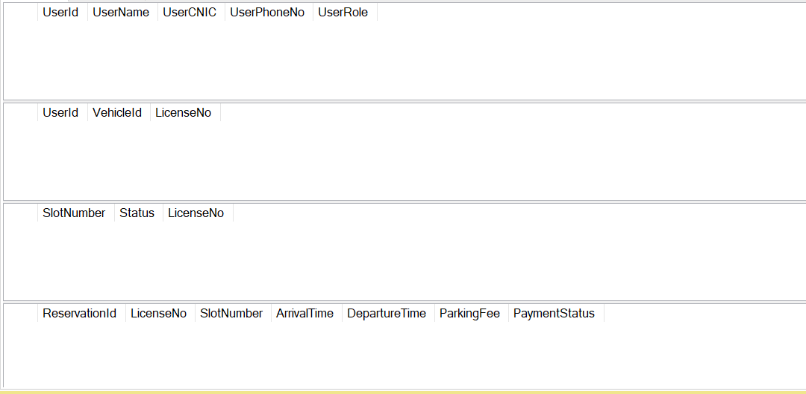

- Users Table:

- Vehicles Table:

- ParkingSlots Table:

- Reservations Table:

- Connections:

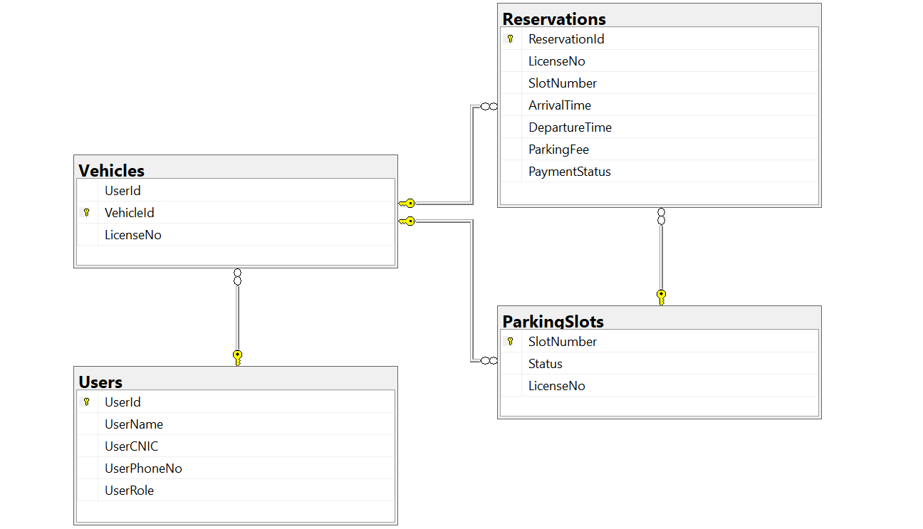

- SQL:

create database ParkSlotMasterDB
use ParkSlotMasterDB

Create Table Users
(
UserId int Identity(1,1) not null ,
UserName varchar(100) not null ,
UserCNIC varchar(20) unique not null ,
UserPhoneNo varchar(15) unique not null ,
UserRole varchar(10) check ( UserRole IN ('Admin', 'User')) not null default 'User',
Constraint PrimaryKey_Users Primary Key (UserId)
);

Create Table Vehicles
(
UserId int not null ,
VehicleId int Identity(1,1) not null ,
LicenseNo varchar(20) unique not null ,
Constraint ForeignKey_UserId Foreign Key (UserId) References Users(UserId)
on delete cascade on update cascade ,
Constraint PrimaryKey_Vehicles Primary Key (VehicleId)
);

Create Table ParkingSlots
(
SlotNumber int not null ,
[Status] varchar(10) Check ( [Status] IN ('Available', 'Occupied' , 'InActive' ))
not null default 'Available' ,
LicenseNo varchar(20) null ,
Constraint ForeignKey_LicenseNo_PS Foreign Key (LicenseNo) References Vehicles(LicenseNo)
on delete set null on update cascade ,
Constraint PrimaryKey_ParkingSlots Primary Key (SlotNumber)
);

Create Table Reservations
(
ReservationId int Identity(1,1) not null ,
LicenseNo varchar(20) null ,
SlotNumber int not null ,
ArrivalTime datetime default getDate() ,
DepartureTime datetime null ,
ParkingFee Decimal(10,2) null ,
PaymentStatus varchar(10) Check (PaymentStatus IN ('Paid', 'Unpaid'))
not null default 'Unpaid' ,
Constraint ForeignKey_LicenseNo_R Foreign Key (LicenseNo) References Vehicles(LicenseNo)
on delete set null on update cascade ,
Constraint ForeignKey_SlotNumber Foreign Key (SlotNumber) References ParkingSlots(SlotNumber)
on delete no action on update no action ,
Constraint PrimaryKey_Reservations Primary Key (ReservationId)
);

