* **ٍEDUTAINERS**

**Series - I Specialist of Sciences Date: 02/01/18**

**English T1 1st year Time: 1hr 15 min Marks: 40**

**Name: _________________________ Objective**

**Q: 1 Choose the best Answer**

**i Norma whirled with a gasp ?**  
 (a) ran(b) jumped (c) moved (d) turned around

**ii She gestured voguely** (a) shook (b) nodded (c) indicated (d) made a sign

**iii Arthur stared at her in dismay**  
 (a) looked angrily (b) looked fixedly (c) pointed (d) looked seriously

**iv A shoving crowd pushed him.**  
 (a) pushing (b) kicking (c) hitting (d) attacking

**v A wondrous light will fill__________.**

(a) each dark , round drop (b) delight (c) bright (d) light

**Vi Giving the poor beneath drop after drop**

(a) down (b) beside (c) next (d) all

**Vii The writer of the poem ‘’The Rain**’’

(a) T.S Eliot (b) A.E Houseman (c) W.H Davies (d) J.Keats

**Viii Pulling up Beattock, a steady climb**

(a) slowing down at (b) stepping at (c) reaching (d) going towards

**Ix Snorting noisily she passes**

(a) Steaming (b) crying (c) shouting (d) whistling

**X “The night mail” is written by**

(a) W.H Auden (b) T.S Eliot (c) A.E Housman (d) W.H Davies

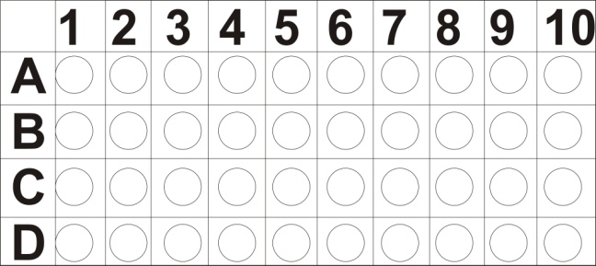

**Subjective**

**Q: 2. Write a Story “All that glitters is not gold” (10)**

**Q: 3. Translate into Urdu (10)**

“You think it’s a practical joke?” she asked as they went to room “If it’s a sick one” Norma sat on her chair and said after a moment “May be some eccentric millionaire is doing it”

**Q: 4. Punctuate the given lines (5)**

Mr. steward looked embarrassed i am afraid i m not at liberty to tell you that he said however i assure you the organization is of international scope

**Q: 5. Answer the question (10)**

**1** Why did Arthur disagree with his wife?

2 Why did Mr. Steward Persuade Norma?

3 Did Norma remain normal on hearing the news of her husband?

4 What are duties of night mail?

5 What happens when the sun shines brightly?

**Q: 6. Pair of words: (5)**

(1)Abject, object (2) Alter, Altar (3) Allusion, Illusion (4) Accede, exceed (5) Accept, except