**Merging Two Singly Linked Lists**

In this program, two singly linked lists are created and populated with sorted elements. The mergeLists function merges them into a single sorted list by comparing node values and linking them accordingly. The merged list is then displayed sequentially.

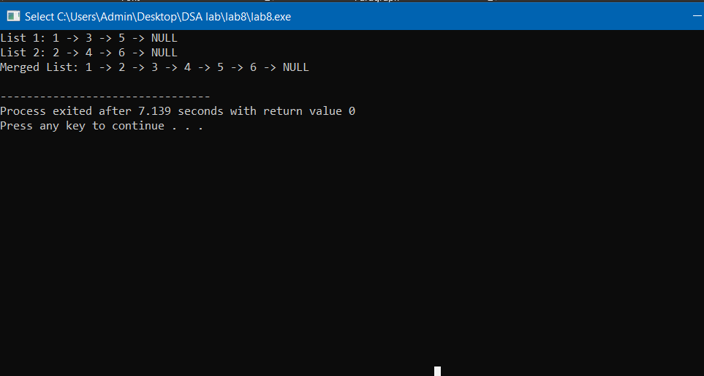

**Merging Two Doubly Linked Lists**

This program creates two sorted doubly linked lists and merges them while maintaining order. The mergeLists function links nodes correctly, ensuring both next and prev pointers are updated. The final merged list is displayed in forward order.

