Assignment Docker

Completed by Muzammil Mehmood & Muhammad Talha & Maaz Javaid

Problem Statement

* **Build an image based on Jupyter Notebook (jupyter/minimal-notebook) with Pandas installed (pip install pandas)**
* **Create a container from this image and use the NOTEBOOK_ARGS=-- port=8889 environment variable to change the port Jupyter is exposed on**
* **Verify you can access it on port 8889 and that Pandas is installed (type import pandas in a notebook).**

Solution

Firstly we have created Dockerfile, to pull image of jupyter minimal notebook from dockerhub and install pandas into that container. The environment variable is NOTEBOOK_ARGS=--port=8889.

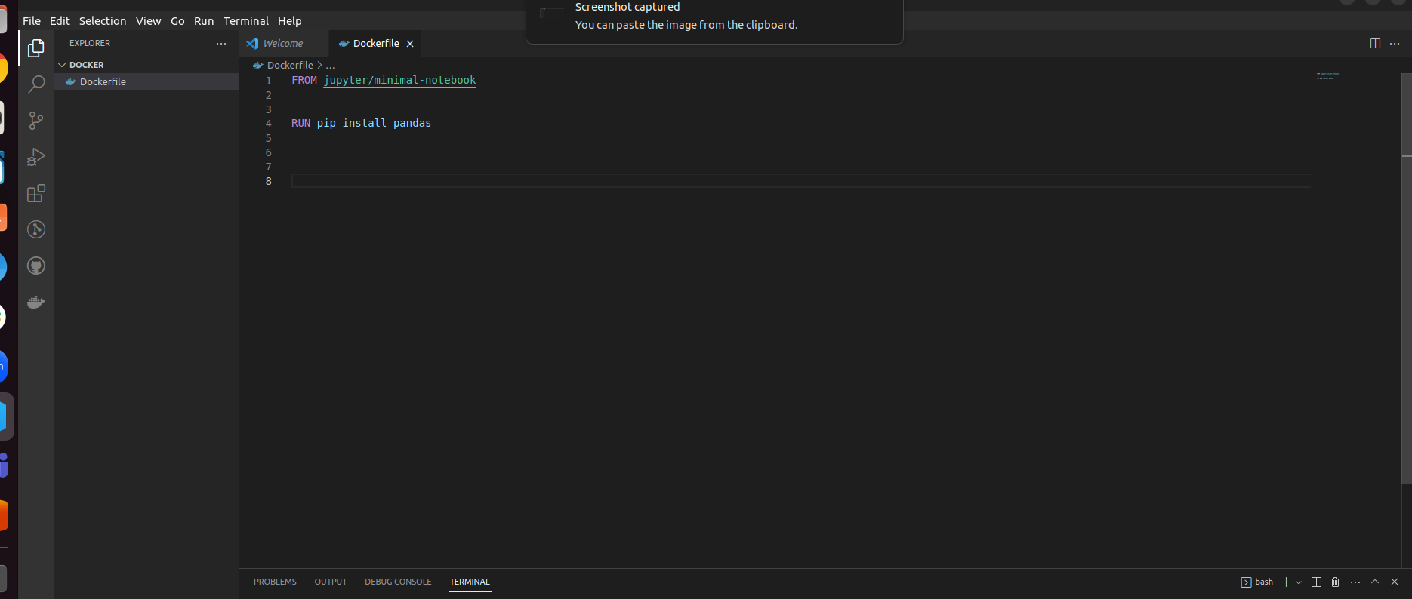

Step 2 Building Docker Container

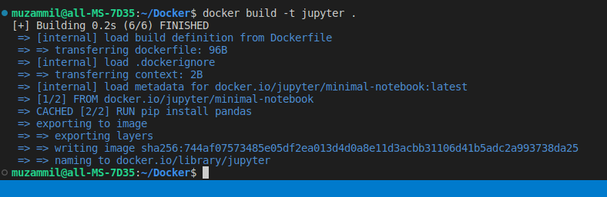

Step 3 Running Docker Container

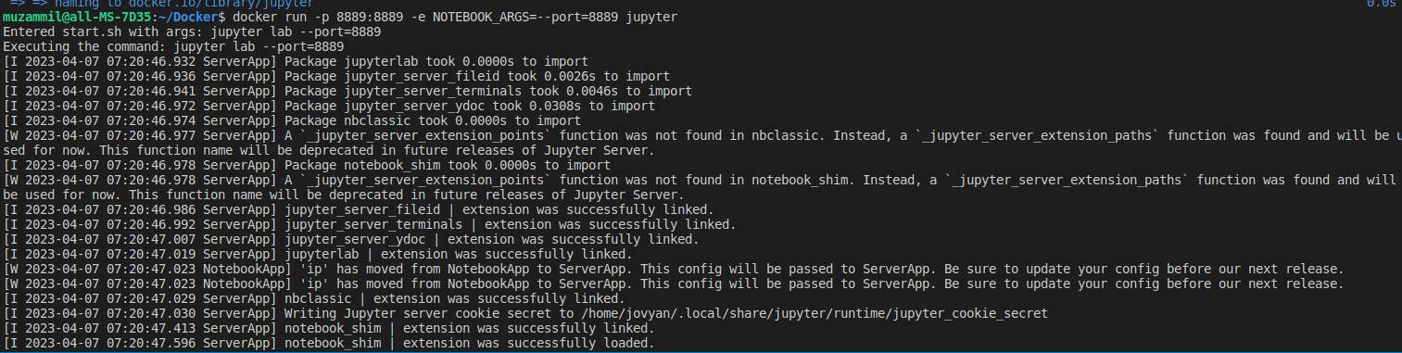

Step 4 Creating Jupyter Notebook

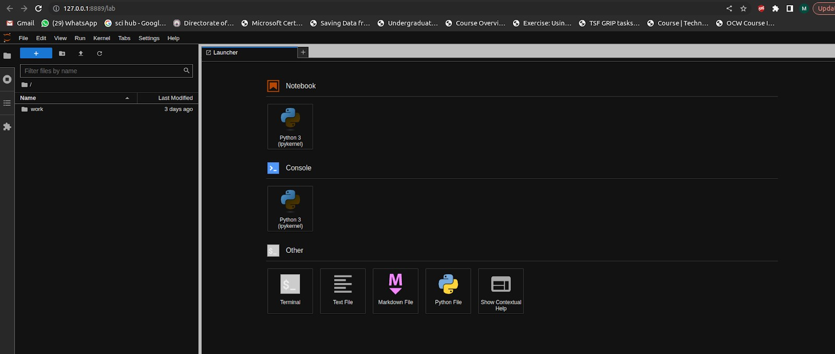

Step 5 Importing Pandas as pd

