Display logs of a running MongoDB container. Add a document to the DB via Mongo Express frontend. Get into the pod and verify the document's existence via mongosh.

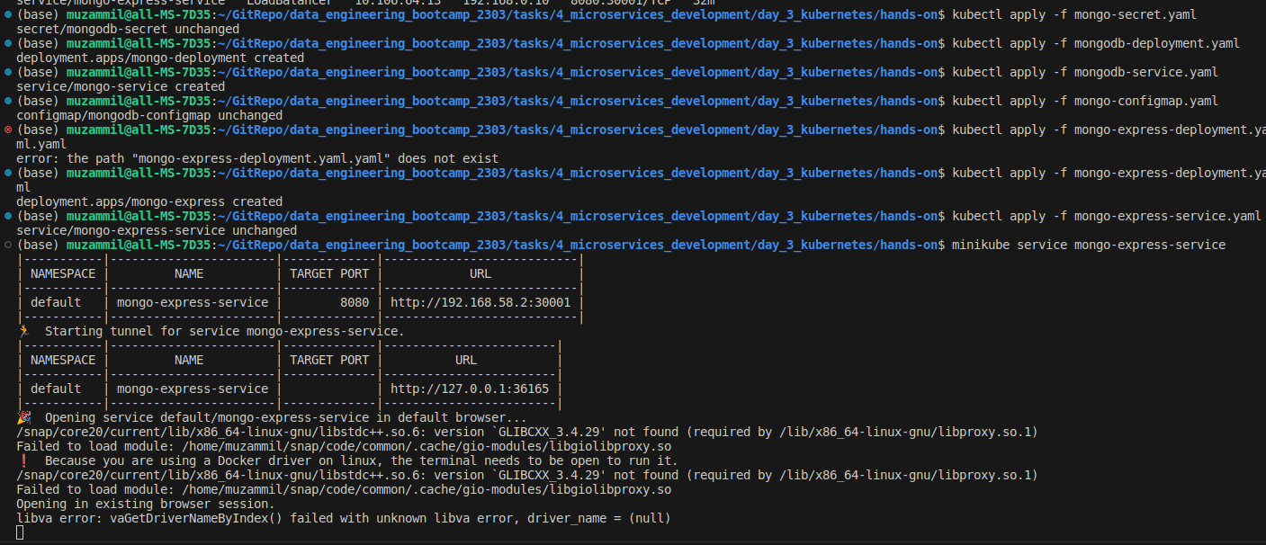
Step 1:
Applying the yaml file to run the containers

Step 2:
mongo-service and mongo-express-service deployed (list, pods, deployments, services and configmaps)
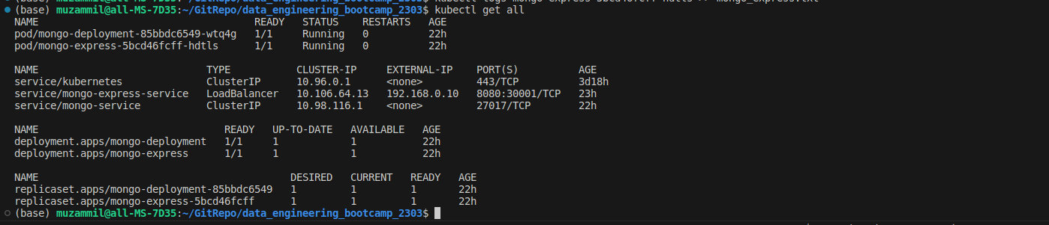
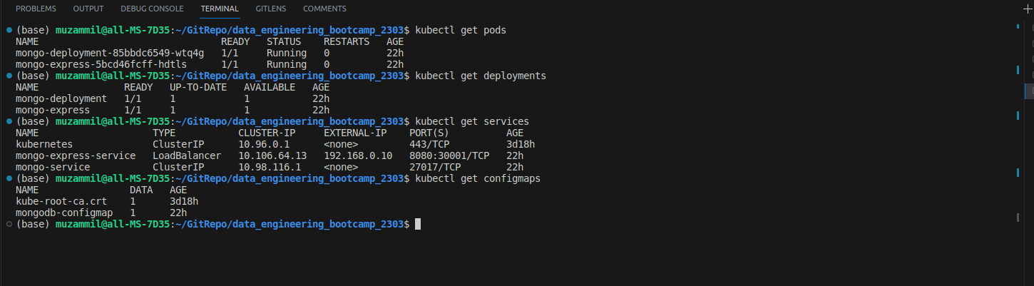
Step 3
Describe on a deployment, pod, service, configmap
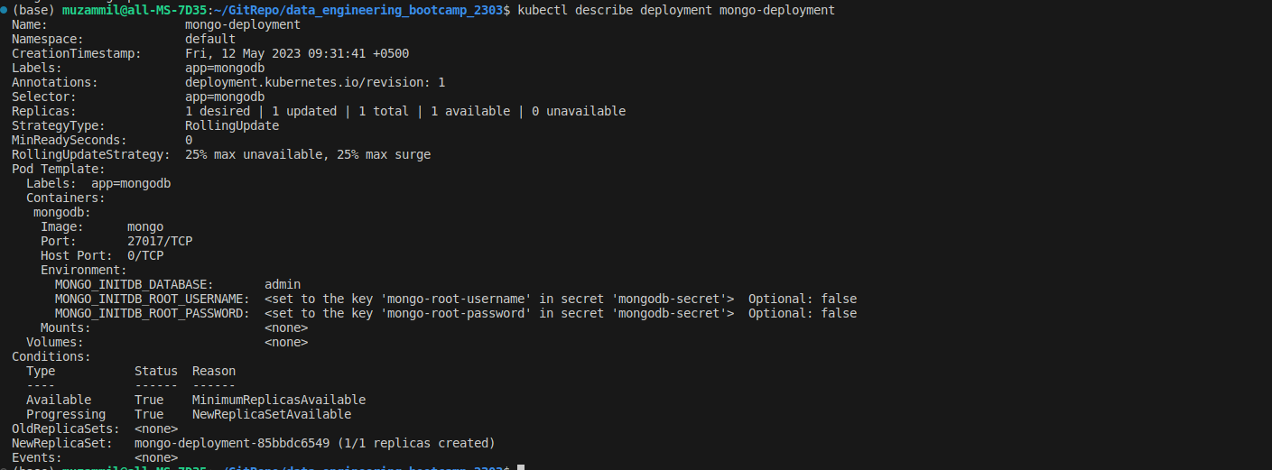
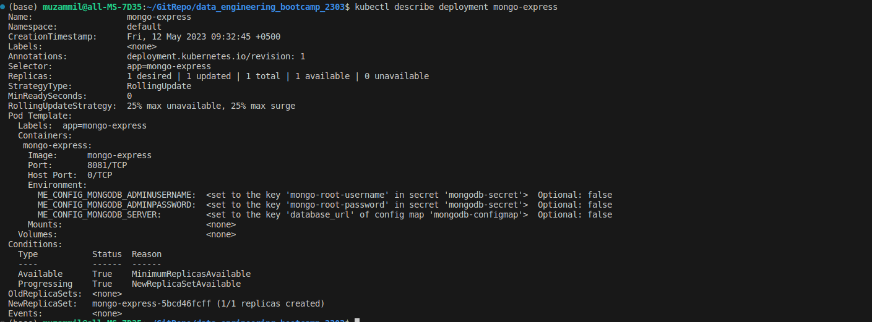

Step 4
Add db, collection and a document in the WebUI
Created the Database name MT
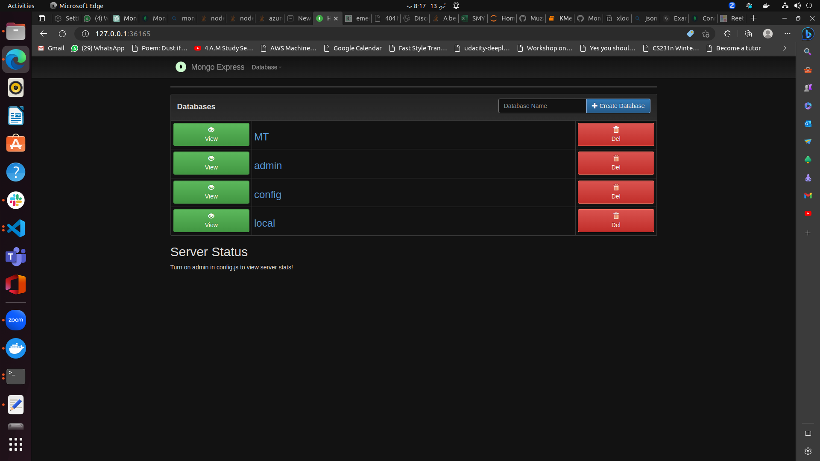
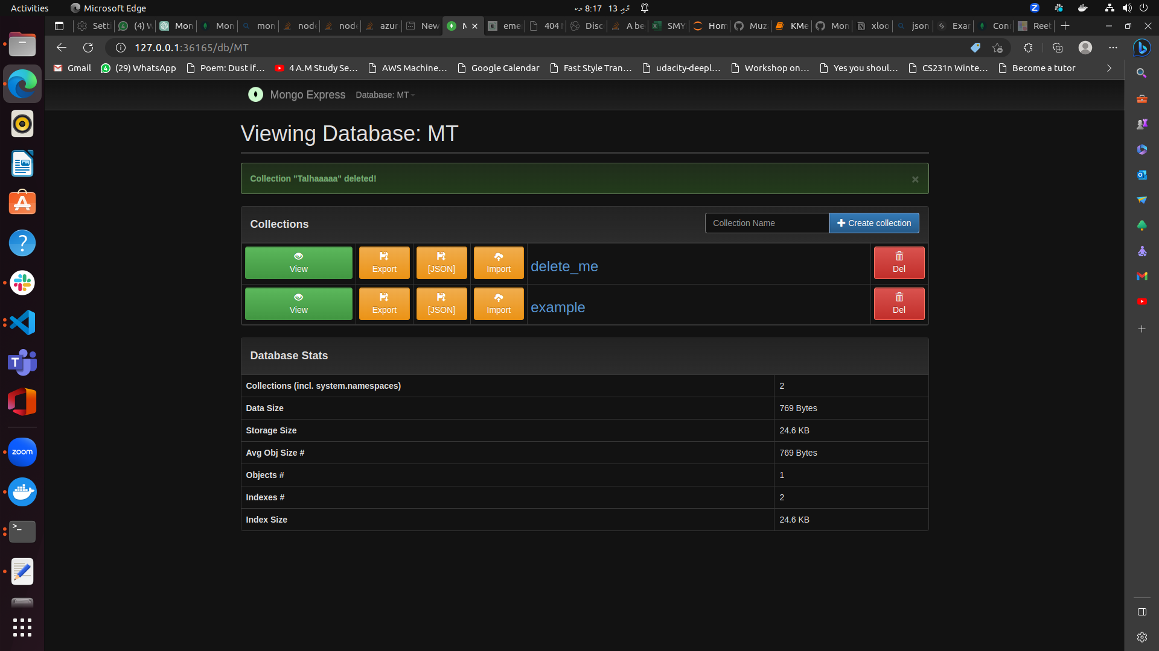
Added collection name Example

Added this document
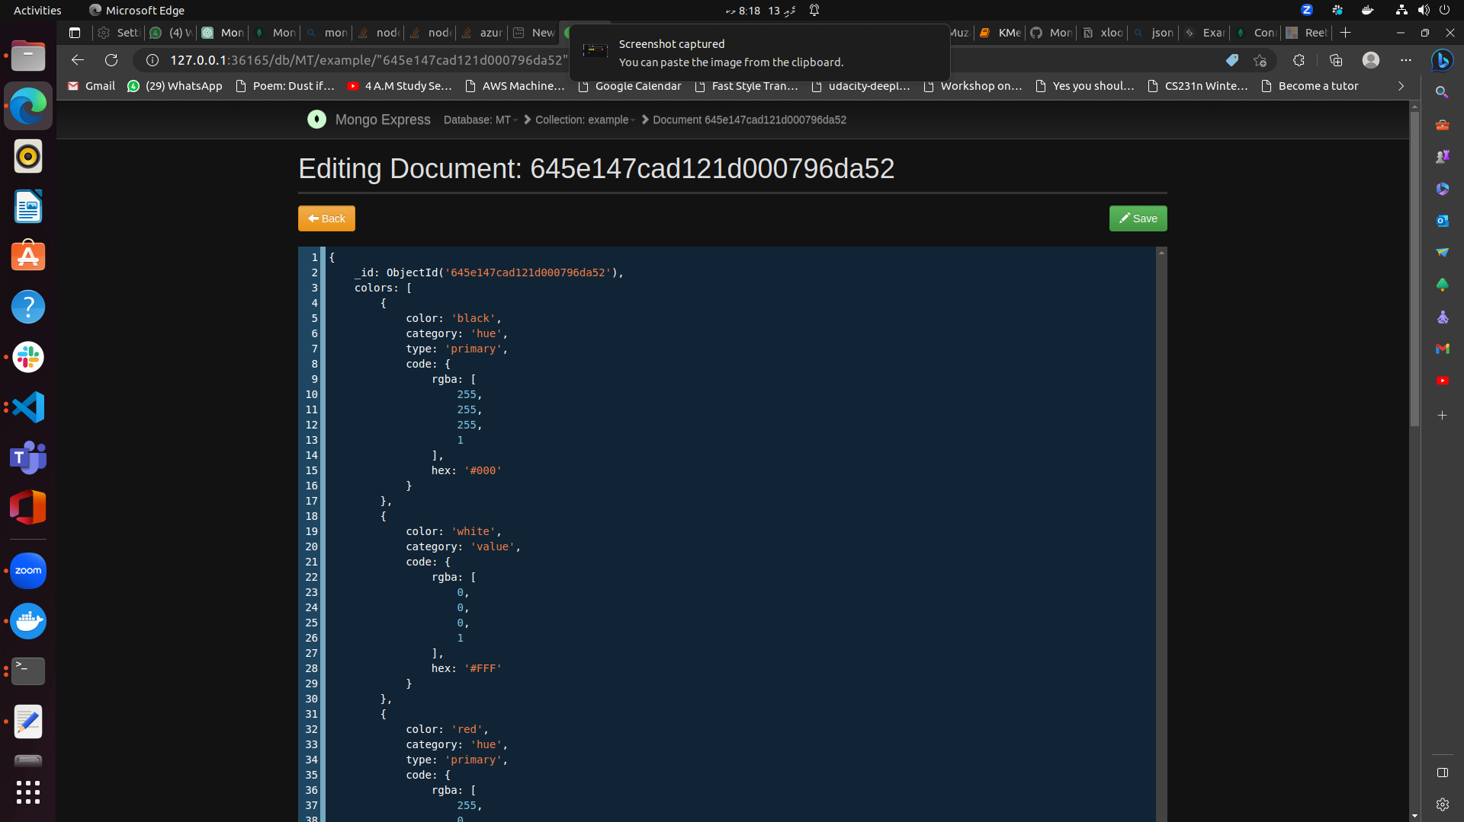
Step 5
Enter the pod for mongodb run mongosh
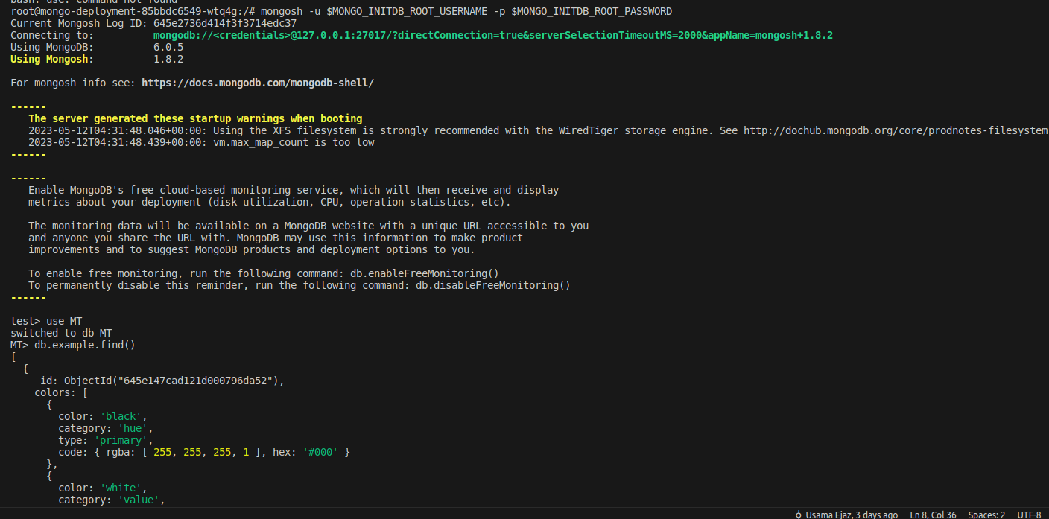
Accessing the database and collection

Viewing the document
