Assignment
Submitted by Muzammil Mehmood & Muhammad Talha

Problem Statement:

Write a bash command which formats markdown
cells in file my_notebook.ipynb (nbqa github page might
be helpful).
nbqa blacken-docs my_notebook.ipynb –nbqa-md

Solution

Before Formating
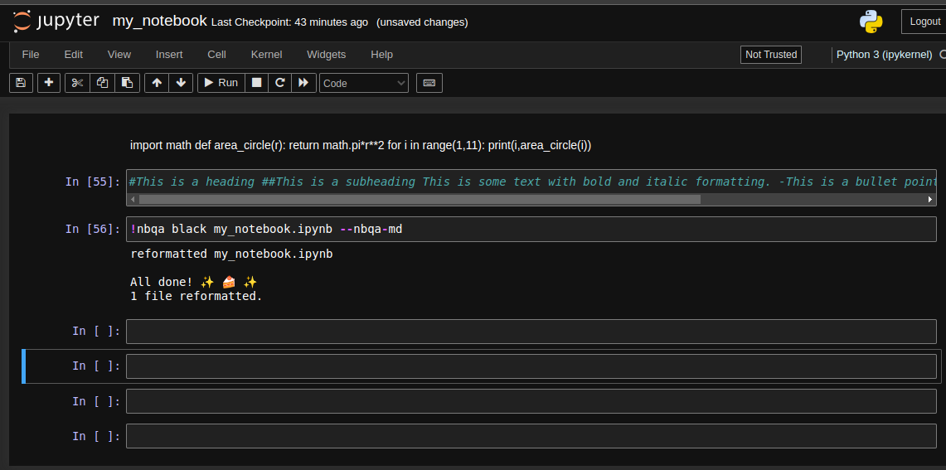
After Formating
