|  |  |
| --- | --- |
| **Activity/24 hrs** | **Total Food intake in lbs.** |
| 2 | 14 |
| 4 | 22.5 |
| 6 | 25 |
| 8 | 37 |
| 10 | 47.5 |

**Linear regression**

Here we have two variables first is the hours of activity chimps perform in 24 hours. Second one is their total food intake.

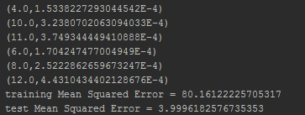

**K means Clustering**

Here we are trying to cluster chimps based on their age in years, their food intake and the total time they take doing any sort of activity(playing, running, jumping) excluding sleeping. We can then categorize our chimps into **healthy and unhealthy** ones.

|  |  |  |
| --- | --- | --- |
| **Age of a Chimp** | **Food intake** | **Total time doing Activity** |
| 15 | 5 | 10 |
| 20 | 3 | 5 |
| 40 | 2 | 2 |
| 20 | 8 | 2 |
| 10 | 3 | 10 |
| 25 | 10 | 2 |

1= Healthy 0=Unhealthy

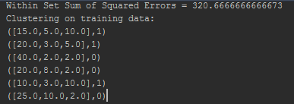

Q.2) Summary of the video using word count

