**Question 1: Iris Dataset Softmax Classification:**

For our Softmax classification in tensorflow the Iris dataset was used. It had 3 classes. A CSV file was used to import the data. The labels were converted to the one-hot format. Here are some visualizations of the results.

**Accuracy:**

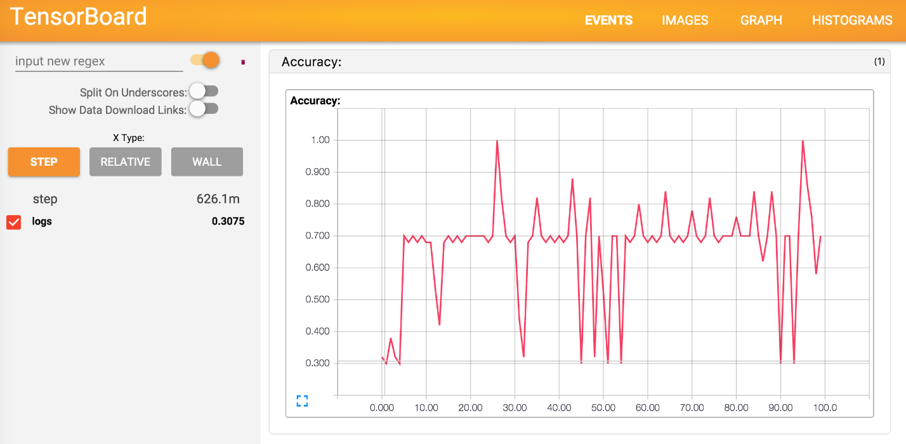

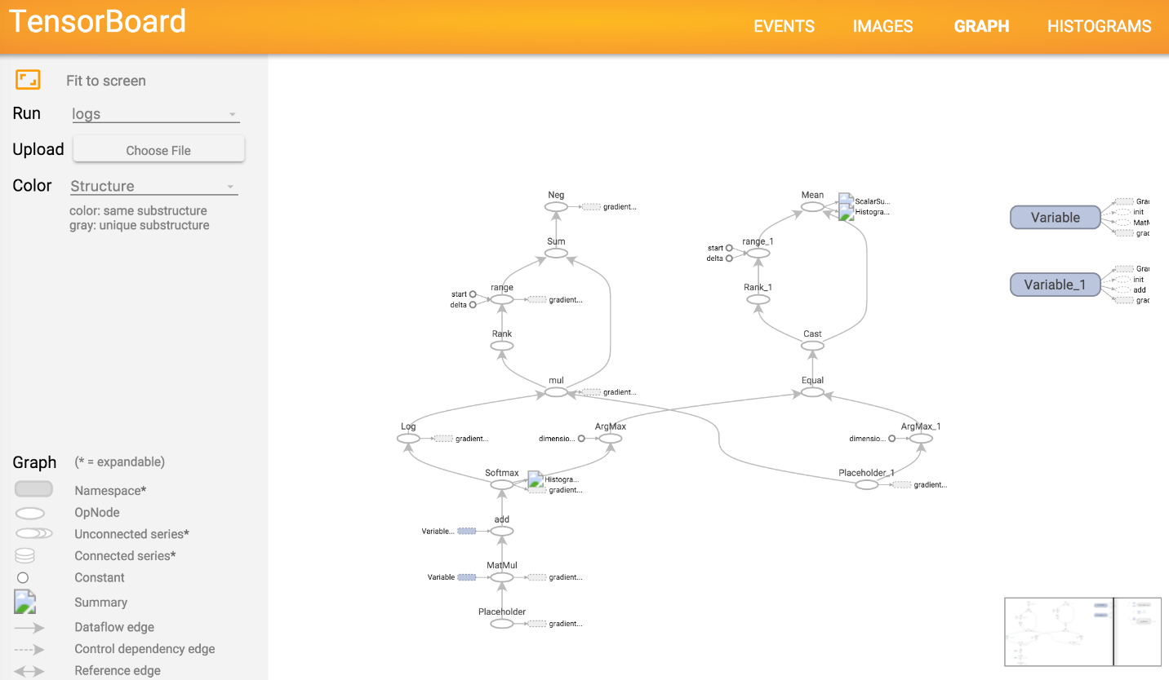

**Bias:**

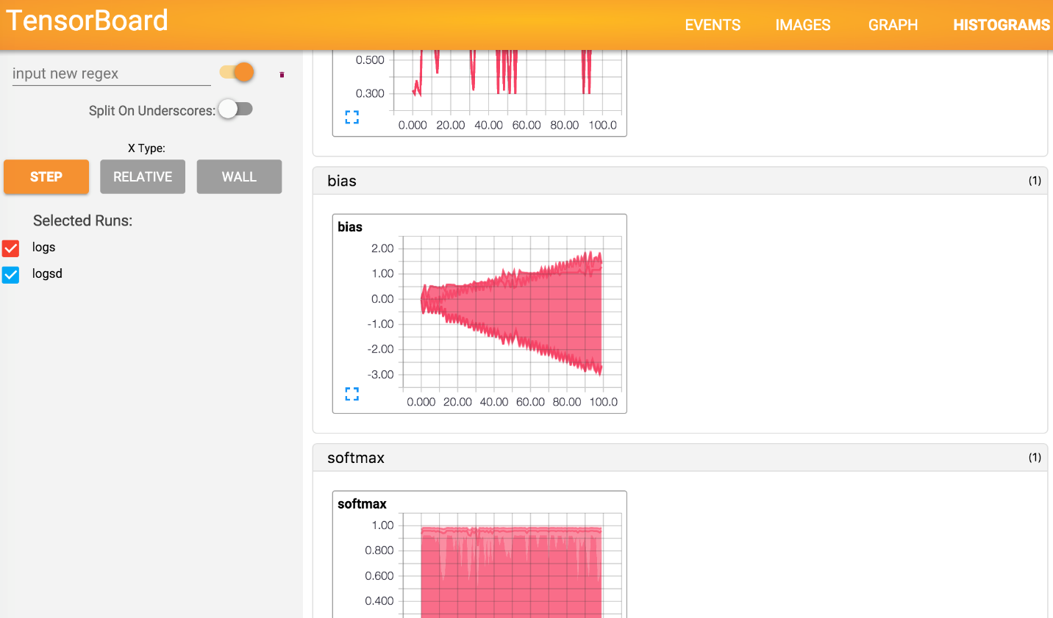

**Question 2: VR app:**

For the VR app the additional feature that I chose was the User input event handling. When the cardboard trigger becomes active it will display a toast. This was done by extending the GRActivity class.

