LegalMind Agentic Research Design
  - Extension plan after the RAG foundation is validated
Add an optional Research mode that can perform several authorized searches and read surrounding sections before producing cited findings. Reuse the lawyer panel, ingestion pipeline, hybrid retrieval, reranker and citation system defined in LegalMind_RAG_Design.docx. Keep Quick Answer available for straightforward questions.

1 Purpose and entry conditions
An agentic workflow lets an LLM choose tools and follow-up retrieval steps based on observed results [A1]. For LegalMind, use one bounded research agent. Multiple agents, autonomous external actions and a new training pipeline are not prerequisites.
- Start only after ordinary RAG works, source references are stable, and authorization and document lifecycle tests pass.
- Use Research mode for questions requiring comparisons, multiple documents or investigation of missing references.
- Keep the first release limited to uploaded documents in one selected case. External law and precedent search requires a separately curated corpus and scope rules.
Good use case | Expected behavior
Compare contract obligations with receipts | Find obligations and matching records; investigate amendments; report gaps.
Compare accounts across statements | Identify supported differences and cite both sources without declaring which account is true.
Follow a reference to an annexure | Search for the annexure, read it if available, or identify it as missing.

Scope boundaries
The agent may search, read and perform constrained calculations. It cannot change cases, delete files, message clients, submit court documents or browse the open web in this release. It must not infer that missing evidence proves an event did not occur.

Expected benefit and tradeoff
The potential benefit is better evidence coverage for complex questions. The tradeoff is extra latency, cost and failure paths. Adoption depends on evaluation against the fixed RAG baseline, not on the presence of an agent label.

2 Research workflow and execution controls
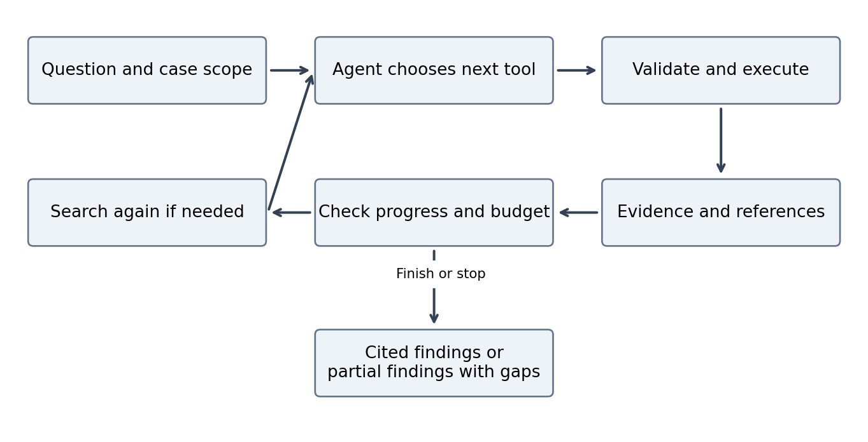
The same Python service hosts the loop. A small explicit state machine is sufficient; an orchestration framework is optional. The application controller owns permission checks, budgets and stop conditions. Model requests never bypass those controls.

Execution sequence
- Accept question, caseId and optional document selection. Resolve authorized scope and pin the active version set for the run.
- Ask the model to choose a permitted tool with schema-valid arguments or provide a final response. Require evidence retrieval before documentary findings.
- Execute the tool after permission and budget checks. Return bounded evidence with stable source IDs, not unrestricted database records.
- Accumulate and deduplicate evidence. Allow the model to choose another query or read a section when the returned material reveals a gap.
- Stop on completion, cancellation, repeated identical calls, unavailable required evidence, or exhausted budget. Return partial findings and explicit gaps when appropriate.
- Check citation identity and authorization again before displaying the result. If a pinned source is deleted or invalidated, remove it and report the limitation.

Proposed initial limits
Start with a maximum of 5 tool calls and 6 model calls per run, a 60-second wall-clock deadline, and a 12,000-token accumulated evidence budget. Enforce a separate provider-cost cap after selecting the model. These are configurable starting values; deadline and cost limits override any remaining call allowance.
Count retries toward budgets. Permit at most one retry for a transient tool failure; reject repeated identical successful calls that add no evidence. Cancellation stops scheduling new calls and cancels in-flight requests where supported.

3 Tools data and interface contracts
Tool | Inputs and bounded output
list_case_documents | No model-supplied owner. Return authorized document IDs, titles, versions and readiness status.
search_case_documents | Query and optional allowed document IDs. Reuse hybrid retrieval and reranking; return evidence passages with page references.
read_document_section | Document ID, version and section ID from known evidence. Return authorized surrounding text within a token cap.
calculate | Validated arithmetic expression with numeric operands. Use a restricted parser, never eval or shell execution. Return result and inputs.

The controller injects the case and owner scope into every tool. Reject unknown tool names, malformed arguments, out-of-scope document IDs and arbitrary URLs or filesystem paths. Future legal-library search must filter jurisdiction and document dates and expose source versions; it is not part of the initial tool set.

Research run record
Persist runId, ownerId, caseId, question, selected document versions, status, timestamps, tool/model call counts, token/cost usage, evidence IDs, final findings and stopReason. States are queued, running, completed, partial, cancelled and failed. Keep sanitized tool events for debugging; do not expose private internal reasoning.

Public API and panel behavior
POST /cases/:id/research creates a run and returns HTTP 202 plus runId. GET /research/:runId returns status and results. POST /research/:runId/cancel requests cancellation. Authorize every endpoint. Poll initially; streaming progress can be added later without changing the result contract.
Research mode shows a brief cost/latency expectation, progress such as Searching contract or Reading amendment, a cancel control, and final findings alongside source pages. Display partial or failed runs clearly. Progress messages describe executed actions, not hidden chain-of-thought.

Result contract
Return status, findings, citations, conflicts, missingEvidence and stopReason. Every documentary claim references server-issued evidence IDs. Preserve the source document version and page reference. Numerical findings also link the source operands, not just the calculator output.

Document instruction resistance
Treat retrieved content as quoted evidence. Ignore embedded instructions to reveal secrets, change scope or invoke tools. Enforce this with tool allowlists and server checks in addition to prompts. Test with malicious instructions inside PDFs and with model-generated unauthorized tool requests.

4 Evaluation rollout and decision criteria
Potential benefit | Risk and control
Follow references and investigate gaps | Unproductive loops; enforce budgets, deduplication and stop reasons.
Combine evidence across documents | Early assumptions can bias searches; test balanced evidence coverage and contradiction handling.
Adapt searches to the question | Higher latency and spend; keep Quick Answer and measure per-run cost.
Read missing surrounding context | More context can still mislead; retain citations and manually check claim support.
Flexible tool selection | Larger security surface; enforce case scope and allowlisted read-only tools.

Build sequence
- Wrap existing retrieval and source-reading functions as schema-validated tools; test them without an agent.
- Implement one controller loop with budgets, cancellation, event logging and explicit terminal states.
- Connect Research mode to the panel and return the shared citation format.
- Run side-by-side evaluation and adversarial tests before enabling the feature beyond development.

Evaluation and proposed promotion gate
Reuse the baseline evaluation corpus and add at least 20 complex held-out questions covering comparisons, annexures, contradictory records and missing evidence. Repeat each agent question three times to measure variability. Keep the generation model and source collection the same where possible.
Measure evidence coverage, supported-claim rate, citation validity, correct handling of gaps, completion rate, budget adherence, p50/p95 latency and total cost. Report failed and partial runs rather than excluding them. Human reviewers should score outputs without knowing which workflow produced them.
Proposed promotion gate: at least a 10 percentage-point gain in evidence coverage on complex questions, no reduction in supported-claim rate versus the fixed baseline, 100% valid citation IDs and enforced budget checks, and zero unauthorized accesses in the test suite. Set acceptable cost and latency ceilings before the experiment. These are targets, not measured outcomes.

When to keep the simpler workflow
If quality does not improve enough to justify the extra cost and latency, retain the fixed RAG pipeline as the default and keep Research mode experimental. Improve extraction, retrieval and test coverage before adding further agents or tools.

References and dependencies
A1. LangChain documentation, Retrieval and RAG architectures, accessed 30 October 2026. https://docs.langchain.com/oss/python/deepagents/retrieval
A2. LegalMind_RAG_Design.docx, companion design, version 1.0. Defines storage, document lifecycle, retrieval, source citations and release gates.
The specific tool set, execution limits, endpoints and evaluation targets above are proposed design choices for LegalMind.

