LegalMind Lawyer Panel and RAG Design
  - Implementation plan before agentic research
Build a working lawyer-only application first, then improve its document question answering through measured retrieval upgrades. This document defines the initial implementation through hybrid retrieval, reranking, source citations, and evaluation. Agentic research is specified separately and is not required to complete this release.

1 Scope and assumptions
The uploaded LegalMind proposal is the starting reference. The scope below replaces its broader three-role platform for this phase. All architecture choices, parameters, and release targets are proposed engineering decisions, not claims that the system has already been implemented or validated.
Build now | Defer
Lawyer login, case CRUD, document upload and status | Client and administrator panels
Case-scoped questions, source viewer, saved answers | Client messaging and deadline automation
Basic vector RAG followed by hybrid search and reranking | Agentic research, GraphRAG and external legal database integrations
Access isolation, indexing lifecycle, evaluation | Outcome prediction and full-document summarization

Initial operating assumptions
- English PDFs are the first supported input. Add OCR for scanned pages before claiming support for scanned documents. Urdu and mixed-language accuracy require a separate evaluation.
- Each case belongs to one lawyer in this release. Sharing and firm membership are future changes. A lawyer can manage many cases, but each question has an explicit case scope.
- Answers use uploaded documents. The application does not claim comprehensive or current legal research beyond that collection.
- Start with a small curated development corpus. Model provider, hosting region, file limits and production capacity remain configurable decisions.

Completion definition
A lawyer can create a case, upload a PDF, wait for successful indexing, ask a question, inspect supporting pages, save the answer, and delete the document. Answers handle missing evidence explicitly. Unauthorized and deleted content cannot be retrieved.

2 Application architecture and screens
Use React with TypeScript, an Express application backend, and a Python RAG service. Keep authentication and case management in one modular backend. Run document ingestion as a background worker so uploads do not wait for OCR or embedding calls. No separate service per feature is needed.
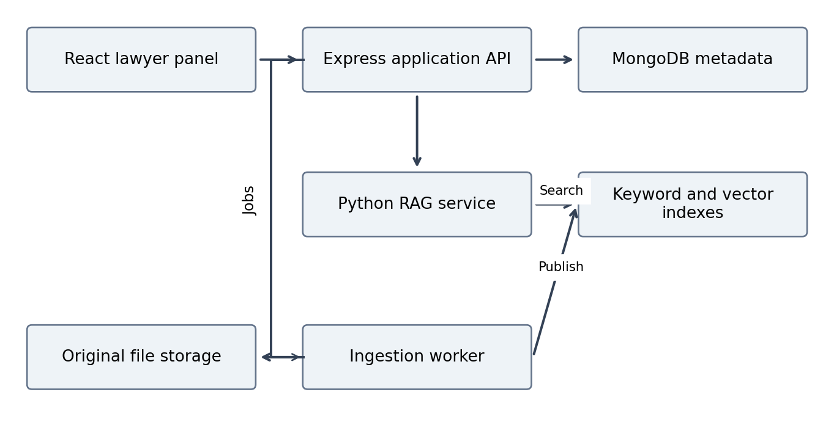
The diagram shows component responsibilities, not a required cloud vendor. The worker can share the Python codebase with the RAG service. The browser calls Express; AI credentials and private storage access remain server-side.
Component | Proposed implementation
Frontend | React, TypeScript and the existing preferred UI library; case list, case workspace and source panel.
Application API | Node.js and Express; session handling, ownership checks, document metadata and saved answers.
AI and ingestion | Python API such as FastAPI; parsing, chunking, embeddings, retrieval, reranking and generation.
Storage | MongoDB for records; object storage for originals; a replaceable vector store plus BM25 keyword index.
Jobs | Durable job queue with retries. For the prototype, a MongoDB job collection with atomic claims and worker leases is sufficient.

Screen behavior
The case workspace contains Documents, Ask Documents and Saved Answers. Ask Documents shows the selected case and optional document filters above the question field. Display answers beside source excerpts; clicking a citation opens the corresponding physical PDF page. Show processing failures, partial indexing, empty results and service errors as separate states.

3 Document ingestion and data design
Upload → validate and store → enqueue job → extract text or OCR → split sections → embed and index → publish the active document version. Only a fully published version is searchable.

Ingestion rules
- Validate file signature, size and ownership. Reject encrypted or unreadable PDFs with a useful error. Proposed starting limits are 20 MB and 200 pages per document; tune after profiling.
- Extract per page and preserve physical page number, printed page label where available, section title and text offsets. Use OCR on scanned pages and flag unreliable extraction for review.
- Start with section-aware chunks of roughly 500 tokens and 80 tokens of overlap. Treat these as tuning values; preserve tables and numbered clauses where possible.
- Store parent section links. Small chunks locate evidence; surrounding sections provide definitions and exceptions within a bounded context budget.
- Version every ingestion with a content hash, parser version, chunking version and embedding model identifier. The query embedding model must match the indexed embedding space.
- Use idempotent jobs and bounded retries. Mark failures explicitly. For replacement, build new indexes before switching the active version; never expose a partly built version.
Record | Minimum fields
Lawyer | id, email, password hash or identity-provider subject, createdAt
Case | id, ownerId, title, description, createdAt, updatedAt
Document | id, caseId, ownerId, storageKey, hash, activeVersion, status, pageCount, deletedAt
Chunk | id, documentId, version, caseId, ownerId, text, physicalPageStart/End, sectionId, parentId, embeddingModel
Job | id, documentId, version, state, attemptCount, leaseUntil, errorCode
Conversation and answer | id, ownerId, caseId, question, answer, citations, retrievalConfigVersion, timestamps

Deletion and isolation
Tombstone a deleted document immediately and exclude it from every query and source fetch. Then remove chunks, indexes, object bytes and caches asynchronously. Recheck active version and ownership before sending evidence to the model. Saved citations retain their version reference but become unavailable when the source is deleted; never silently redirect them to replacement text.

4 RAG pipeline and answer contract

Baseline workflow
Authenticate → resolve authorized case and documents → embed question → retrieve vector matches → assemble evidence → generate a cited answer → validate references → display answer and sources. This fixed workflow is the first end-to-end milestone.

Improved workflow
Run BM25 keyword retrieval and vector retrieval over the same authorized active documents. Merge and deduplicate candidates using reciprocal rank fusion. Rerank candidates against the question, expand useful parent context, and fit the strongest evidence into the model context budget. Hybrid retrieval combines exact matching and semantic matching [R2].
Setting | Starting configuration to evaluate
Candidate retrieval | Top 20 keyword results and top 20 vector results
Fusion and reranking | Deduplicate by chunk ID; rerank up to 30 fused candidates
Evidence selection | Keep approximately 6 to 10 passages, with bounded parent expansion
Context budget | Start with 6,000 evidence tokens; reserve space for instructions, question and answer
Fallback | No eligible evidence: return insufficient_evidence. Retrieval outage: return error, not an unsupported answer.

These values are hypotheses, not accuracy guarantees. Scores from keyword search, vector search and reranking have different meanings. Calibrate evidence checks against labeled questions; do not interpret a similarity score as legal confidence.

Generation and citation rules
Give the model source passages with server-issued IDs such as S1 and S2. Require material factual claims to cite those IDs and distinguish direct source statements from inferences. Highlight conflicts and missing records. Do not invent authorities, pages or documents. Document content is untrusted evidence and cannot override system instructions.
Return status (answered, partial, insufficient_evidence or error), answer, citations and limitations. Each citation resolves server-side to documentId, version, chunkId, physical page and an excerpt. Validate that every cited ID came from this request. Citation existence alone does not prove that the passage supports the claim; evaluate support separately.

Conversation handling
Resolve follow-up references against a short case-local history. If the reference is ambiguous, request clarification. Never treat a prior generated answer as documentary evidence. Keep research mode and autonomous tool loops outside this implementation.

5 API boundaries and failure handling
All public routes require an authenticated lawyer except registration and login. Express derives owner identity from the verified session and resolves authorized case scope. Neither browser input nor model output can override that identity. The Python service accepts authenticated internal requests only.
Route | Contract
POST /cases | Create a case; return caseId.
POST /cases/:id/documents | Accept upload after validation; return documentId, jobId and queued status with HTTP 202.
GET /documents/:id/status | Return queued, extracting, indexing, ready, failed or deleting.
POST /cases/:id/questions | Input question and optional documentIds. Reject IDs outside the authorized case. Return the structured RAG answer.
GET /documents/:id/source | Authorize document and version; serve the requested source or short-lived file URL.
POST /cases/:id/saved-answers | Save answer text plus source version references.
DELETE /documents/:id | Tombstone immediately and enqueue cleanup. Return HTTP 202.

Internal retrieval interface
Define retrieve(query, authorizedScope, configVersion) → evidence[]. Each evidence item contains chunkId, documentId, version, page references, text and retrieval scores. The authorizedScope is built by backend code. Keep this interface stable so future agent tools can reuse retrieval without changing indexing.

Operational behavior
- Use secure, HttpOnly session cookies with appropriate CSRF protection, or an equivalently reviewed token design. Hash passwords; enforce rate limits and keep provider keys server-side.
- Log request ID, stage timings, model/config versions, token usage and error codes. Avoid raw private document text in routine logs.
- Store cache entries by owner, case, active document versions, query and retrieval configuration. Invalidate on deletion and replacement.
- On OCR failure, show a retry or replacement action. On provider timeout, return a retryable error. Never label an infrastructure failure as absence of evidence.
- Before sending confidential documents to an external model, select a provider configuration with acceptable retention and access controls. Use synthetic or authorized sample documents during development.

Example answer behavior
Question: What notice does this contract require before termination? The answer names the requirement only if supported by retrieved clauses, cites the pages, and reports any unresolved amendment reference. If the contract is absent, the answer requests the document rather than relying on general model knowledge.

6 Implementation milestones and release checks
Milestone | Exit condition
1 Working structure | Login, case CRUD, upload, document list and source viewing work with real storage.
2 Ingestion | A PDF becomes searchable with stable page references; failed uploads and reprocessing are visible.
3 Basic RAG | Vector retrieval answers questions end to end with citations and missing-evidence behavior.
4 Retrieval upgrade | Hybrid search, reranking and bounded context expansion are compared against the baseline.
5 Release hardening | Isolation, deletion, retries, observability and evaluation gates pass.

Evaluation plan
Create at least 50 held-out questions over authorized sample documents: 15 direct facts, 10 exact references, 10 cross-section questions, 5 cross-document comparisons and 10 unanswerable questions. Record expected answer points and supporting pages. Keep tuning questions separate from the final evaluation set.
Compare vector-only, hybrid, and hybrid-plus-reranking configurations using the same generation model and prompts. Record evidence recall at 10, supported-claim rate, citation validity, correct abstention, p50/p95 latency and cost per question. Human-review source support; an LLM judge may assist but is not the sole evaluator.
Proposed release gate | Target
Authorization and deletion tests | Zero unauthorized or tombstoned passages in tested retrieval and source endpoints
Citation identity | 100% of returned citation IDs resolve to evidence from the request
Evidence recall at 10 | At least 85% on the held-out answerable set
Supported material claims | At least 90% in manual review
Unanswerable handling | At least 9 of 10 correctly report insufficient evidence
Latency and cost | Measure on selected hardware/provider; set an explicit budget before deployment

These are proposed acceptance targets, not measured results. Add adversarial document instructions, duplicate uploads, replacement races, worker crashes and model timeouts to integration tests. Fix evidence and extraction failures before adding agentic research.

7 Configuration decisions and terminology

Decisions still to finalize
Choose the embedding and generation models, vector store, OCR engine, deployment environment and monthly budget using a representative sample. A local vector store plus a case-filtered BM25 index is enough for the prototype; larger workloads need a search backend that enforces filters efficiently.

Implementation terminology
Term | Meaning in this implementation
Embedding | A numeric representation of text used to search for similar meaning.
Chunk | A retrievable part of a document, linked to its original page and version.
BM25 | A keyword ranking method that complements semantic retrieval.
Reranker | A model that compares candidate passages against the question and reorders them.
Parent context | The larger section around a retrieved chunk, used to preserve definitions and exceptions.
Evidence recall at 10 | The fraction of labeled supporting evidence units found among the top 10 retrieved items, averaged over answerable questions.
Supported claim rate | The proportion of material answer claims supported by cited evidence, assessed by a reviewer.
Abstention | Explicitly stating that the available evidence cannot answer the question.

Next implementation action
Create the application skeleton and complete milestone 1 before adding model calls. Use synthetic sample PDFs to exercise the full upload and source-viewing journey. Then connect ingestion and a vector-only answer endpoint, preserving a repeatable baseline for later retrieval upgrades.

References and provenance
R1. Legal_Mind_Proposal_Docs.pdf, supplied by the user. Scope is deliberately narrowed by the subsequent conversation.
R2. Microsoft Learn, Hybrid search overview, accessed 30 October 2026. https://learn.microsoft.com/en-us/azure/search/hybrid-search-overview
R3. LangChain documentation, Retrieval and RAG architectures, accessed 30 October 2026. https://docs.langchain.com/oss/python/deepagents/retrieval
All implementation parameters and acceptance gates in this document are proposed for LegalMind.

