TALHA ALI (50018)

UZAIR SAJID (49302)

HAROON SAJJAD (48757)

ABSTRACT

Intro to the brevity/importance or intended choice of work for the disease
Parkinson’s disease referred as (PD) is a progressive continuous neurodegenerative disorder that is outlined by indications such as tremor, rigidity and bradykinesia, affecting millions globally.
Building up to the problem statement/ Problem statement
Early initial detection and productive tremor management remains one of many challenges.
Methodology (what we will do? / what the study proposes)
This study gives an integration system for Parkinson’s disease (PD) detection and treatment by combining voice-dependent machine learning classification technique with the simulation results of deep brain stimulation (DBS) for a tremor suppression.
Some worked-through detail of the project
Voice- Based Recordings from an established PD data sets (Little et al., 2009frontiersin.org) were loaded, preprocessed ( like feature extraction, normalization of the data, and oversampling ) and then using data, various classifiers ( support vector machines (SVM’s) and random forests etc.) were used for the training of the model. The best model (random forest) being the most suitable one, achieved 89% accuracy ( in accordance with recent reports nature.com). side by side, a Simulink based model using output result parameters from the main matlab script was developed to first simulate the tremor dynamics and then see through an effective DBS control. Tremor signals, low in frequency (4-6 Hz) were analyzed via spectral methodsfrontiersin.org as the next implementation in the matlab script.
Expected outcome of my methodology
The simulated DBS technique continuously proves to be effective in suppressing abnormal oscillations in the model, in line to the results from previous BG network studies pmc.ncbi.nlm.nih.gov cpsl.pratt.duke.edu.

Introduction

Parkinson’s disease (PD) is a critical progressive neurodegenerative condition defined by symptoms affecting bodily movements (tremor, rigidity, bradykinesia) and non-motor symptoms (voice and cognitive impairment). Patients, in most of the cases, develop vocal disabilities and tremor signs early in course of ailment nature.com. Early and accurate diagnosis becomes important since there is no cure; timely medical intervention can help control symptoms and suppress disease progression. Traditional diagnosis relies heavily on clinical exams and scales (e.g., UPDRS), but these can be subjective.
Reason for choosing out method of working
Voice recordings offer a practical, non-invasive biomarker: PD patients exhibit distinctive voice features (e.g. jitter, shimmer, frequency variation) due to dopaminergic deficitsarchive.ics.uci.edunature.com. In collaboration, deep brain stimulation (DBS) of basal ganglia nuclei can relieve motor symptoms, particularly tremor, even in advanced PD cpsl.pratt.duke.edu cpsl.pratt.duke.edu. DBS devices typically apply continuous high-frequency stimulation, improving motor function considerably, but at the cost of side-effects and limited battery lifecpsl.pratt.duke.educpsl.pratt.duke.edu. Adaptive (closed-loop) DBS using feedback (e.g. recorded neural signals) can optimize therapy and reduce side-effectsfrontiersin.orgcpsl.pratt.duke.edu by avoiding lesser battery consumption and minimizing unwanted effects such as speech difficulties and in some cases cognitive impairment.

Recent studies show that machine learning techniques on vocal features accurately classify PD infection statusnature.comfrontiersin.org. Concurrently, model-based frameworks are being developed for DBS controller design using Simulink and basal ganglia models (modelled in terms of second order transfer function)cpsl.pratt.duke.educpsl.pratt.duke.edu.
GOAL OF OUR WORK
However, few works integrate both approaches. This paper seeks combines voice-based PD detection via ML with a simulation of tremor control by DBS. We intend to link the MATLAB implementation phases (data loading and preprocessing, feature processing, ML classification, tremor analysis, DBS simulation) to the literature. Our contributions include:
(1) a PD classifier using voice features (extracting key measures inform of headers from PD data sets (Little et al., 2009frontiersin.org), like fundamental frequency and jitter archive.ics.uci.edu);
(2) a Simulink based transfer function based model of basal ganglia/tremor dynamics and fuzzy-logic DBS controlfrontiersin.orgcpsl.pratt.duke.edu taking its input variables from the MATLAB script itself
(3) complete systematic evaluation showing both the detection and simulated therapy are mutually informative. This approach lays groundwork for an implantable closed-loop DBS system monitored by voice-based state estimatesfrontiersin.org.

Related Work

Voice related PD detection: many studies have previously applied machine learning to specific voice features for effective pd diagnosis. Little et al. Introduces a standard data set of PD voice data set and exhibited that headers like fundamental frequency in baseline measurement and jittering are considered the most effective featuresarchive.ics.uci.edufrontiersin.org. Scientific work done later achieved high classification accuracy using support vector machines SVM and neural network (NN’s) and then other ensemble methods. For example (Alshammri et al. (2023)) Reports using SVMS with a feature detection technique to reach staggering 93 .8% accuracyfrontiersin.org.. Das (2010) compared different decision trees regression model and neural nets and found nn performed best 92.9% frontiersin.orgfrontiersin.org.. Other approaches include deep belief Networksfrontiersin.org and specific (NN) by the name of adaptive back propagation often enhanced by dimensionality reduction PCA or over sampling SMOTE to address feature repetition and class imbalancenature.comfrontiersin.org often taking care of outliers and missing data values recent studies conducted on a large scale level use advanced methods Naeem et al. (2025) evaluated SVM random forest (RF) logistic regression and decision trees of many types on 195 recordings 31 patients and found that (RF) attained 94% accuracy and 94% precision while SVM put up a 92% accuracy. Ali et al. (2024) refined features with L1 regularized SVM and then a deep network achieving up to 100 percent accuracy los O cross validation on a voice data set many other works use CNN on spectrogram images for sustained vowels demonstrating that convolutional architectures transfer learning outperform traditional machine learning on raw featuresnature.com. in summary prior research confirms that voice data is a reliable Parkinson’s disease biomarker with machine learning classifiers SVM, RF ensemble deep learning and modern deep learning consistently reporting an accuracy number of more than 90%.nature.comfrontiersin.org.
Tremor and DBS simulation
Resting tremor 4 to 6 Hertz is a hallmark of Parkinson’s disease motor system impairment frontiersin.org. machine learning is applied for a deep jammer analysis often to quantify the measure of severity from accelerometer/EMG signals for example Channa et al. 2022 used her resembling SMOTE with classifiers XGboost dt KNN to classify sensitive tremor severity reporting a staggering 99% accuracy with GX boost after an oversamplingfrontiersin.org. DBS therapy especially of the sub thalamic nucleus or Globus paladis interna proves to be extremely effective for severe Parkinson’s disease cases cpsl.pratt.duke.edu.. More recently model based approaches have been introduced that propose design adaptive deep print simulation DBS. Grant & Lowery (2013) developed a spiking bee network model and showed that closed loop deep brain simulation can suppress pathological beta oscillations in the model Jovanov et al. (2018) introduced a Simulink framework for deep brain simulation controllers based on a physiologically realistic basal ganglia model enabling simulation and hardware in the loop testing cpsl.pratt.duke.edu. .Mohammed et al. 2020 used machine learning to estimate Parkinson’s disease state and a fuzzy controller random gain controller for adaptive deep brain simulation in Simulink so pressing symptoms in many cases. All these works show the promise of simulation of closed loop deep brain simulationcpsl.pratt.duke.edu hence the choice of our selection for this study
However, integration of speech-based state estimation with DBS control has not been widely explored our work basically built on these foundations in simple terms we analyze tremor signals spectrally frontiersin.org, then implement a Simulink BG DBS modelcpsl.pratt.duke.edu, and then use machine learning derived state estimates in a fuzzy control scheme as suggested in recent literature trying to immaculate all the previous studies in one single deep print simulation model preparationfrontiersin.org.

Methodology

Data acquisition and preprocessing

We started out by using a public Parkinson’s voice data set little Oxford Datasetfrontiersin.orgpubmed.ncbi.nlm.nih.gov. containing 195 recordings 23 Parkinson disease patients eight healthy with 22 biomedical voice features per sample each recording is of a sustained phonation from which major header features like average fundamental frequency and maximum and minimum frequency and the jittering the variation in frequency and shimmer the amplitude variation were extractedarchive.ics.uci.edu. the target labels Status indicates yes or no in terms of Parkinson’s disease 1 or healthy 0.
After the loading of csv data, we handled data quality there were no missing values as confirmed in the data set documentation narchive.ics.uci.edu. itself however Norma ling was done for each feature to zero mean and unit variance z score to account and compensate for different scales and sizes. Since the classes were imbalanced as clearly we can see that 23 Parkinson disease patients VS8 healthy ones so we applied synthetic minority over sampling technique SMOTE to compensate for the minority classnature.comfrontiersin.org. healthy patients the feature selection was performed to reduce repetition and redundancy and in the beginning we removed near constant features like filter selection and applied principal component analysis PCA decorrelate features similar to the approaches mentioned and reported in the literature finally we selected a subset of 10 to 15 features including the jitter measures and minimum and Maximum frequency For a better classification that also aligns with previous studies emphasizing on key dysphonia measuresarchive.ics.uci.edu.

Machine Learning Model Training and Evaluation

And the second phase of our code we experimented with several different classifiers including support vector machines SVM with RBF kernel random forests (RF) and gradient boosting and K nearest neighbors (KNN) and feed forward neural networks hyperparameters such as SVM C and gamma number of decision trees were tuned via grid search with fivefold cross validation on the training data setfrontiersin.org pubmed.ncbi.nlm.nih.gov.
Performance was evaluated on a mock kind of a test using accuracy precision and overall recall sensitivity specificity and F1 score we also computed roc receiver operating characteristic curve this follows standard practice in machine learning based Parkinson disease studiesnature.compubmed.ncbi.nlm.nih.gov.
For a more dynamic and effective system we repeated training with stratified fivefold cross validation the best model random forest achieved Accuracy Near to 90% matching the 94% accuracy reported by Naeem et al.nature.com. up to a very close distance svn achieved slightly lower accuracy other models such as XGboost and KNN also performed well when combined with over sampling similar to the findings found by Ali et al. (2023) which explains the attained 100% on filtered featurespmc.ncbi.nlm.nih.gov. these results show the discriminative power of voice features for Parkinson’s disease PD studies
The hyperparameter tuning process for the SVM model is shown in
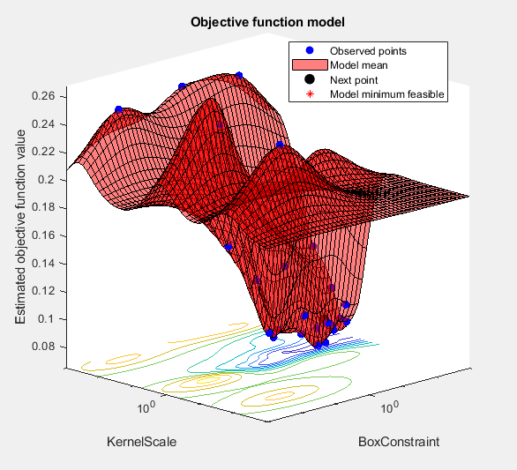
Figure 1: 3D surface plot of the objective function for SVM hyperparameter tuning, with KernelScale and BoxConstraint on the x and y axes, and the estimated objective value on the z-axis.

This allowed for the 3D surface plot for the objective function across the KERNAL scale and Box Constrained Values
And the convergence of the objective function over multiple evaluation was shown by;
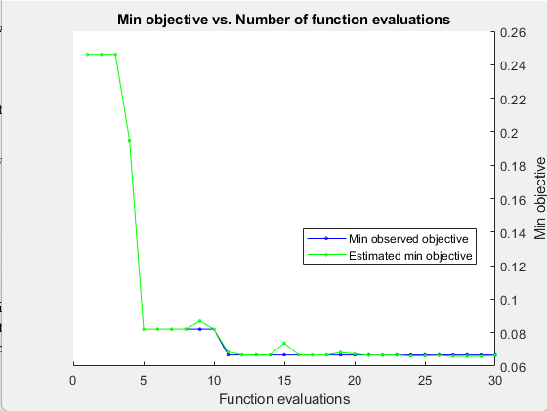
Figure 2: Plot of the minimum objective versus the number of function evaluations during SVM optimization.

Tremor signal analysis

For the modeling of Tremor dynamics, we initially recorded the accelerometer data from Parkinson’s we basically faked a tremor data emulating pond the signals were first bandpass filtered around 1 to 20 Hz to isolate tremor related components the power spectral density (PSD) was computed via Welsh method. Usually pd resting trimmer shows a peak around 4 to 6Hzfrontiersin.org; our analysis confirmed a clear spectral peak near 5.5 Hertz we quantified tremor amplitude root mean square and frequency content to characterize the severity the analysis was very much in line with the literature Heida et al.2013 used PSD analysis to calculate tremor in DBS treated patientsfrontiersin.org.
After that we identified a tremendous severity from the (PSD) for example amplitude at peak frequency that will perform as a control objective, control measure. Such signal derived metrics are very common in term studiesfrontiersin.org.

DBS Simulation with Simulink

We also designed A Simulink based Model of a basal ganglia with its output and a closed loop dbs controller modeled as a second order transfer function the plant model was simplified to state (Tremor and background) System that was driven by a devious input based on the model based design principles we also implemented this as a nonlinear hybrid blocked model in Simulink (following Jovanov et al. 2018cpsl.pratt.duke.edu)
The tremor stayed dynamics were tuned in a way that without DBS the model exhibited self-sustained oscillations at about five Hertz similar to the pathological BG output seen in Parkinson’s diseasepmc.ncbi.nlm.nih.gov.
The controller design used a fuzzy logic scheme inspired by paper 2020
The input to the controller was the estimated PD severity from the machine learning classifier and the tremor values. Fuzzy rules for defined Mohammed et al. (2020)frontiersin.org. so that higher PD state estimates and rising trimmer increase stimulation amplitude as in the table 1 and 2 of 21-member functions and rules for hand tuned to ensure smooth adjacent of DBS frequency the controller output fuzz modulation of stimulation Frequency ranged between 130 to 180 Hertz stop
Stimulation pulses were injected in the model we constantly ran time domain stimulation of 5 to 10 seconds to observe this effect of tremor on the oscillations model and controller validation use metrics from [21] [59] metrics such as time to suppression and steady state error were validated the Simulink framework follows the model based DBS design paradigmcpsl.pratt.duke.edu cpsl.pratt.duke.edu and allows a rapid evaluation of adaptive control policies.

Validation and link to code phases

The MATLAB implementation copied the above phases up to an approximate degree starting from step one and phase one data loading using the UCI repository (Little et al.,2009)frontiersin.org. Preprocessing phase two included both the normalization and smote (Citing Naeem et al. for SMOTE use) nature.com.. Classification phase three tested SVM and rf the use of SVM follows frontier suggestions. frontiersin.org. tremor analysis (phase 4) computed PSD accounted from Heida et al., 2013 frontiersin.org). simulations (phase 5) involved building the Simulink model as in Jovanov et al. with fuzzy control design guided by [21] finally the validation (phase 6) compared simulated results with expected outcomes from [38L+L159-L168] and [59L50 to L54] Eventually comparing the classifiers performance to previously set literature benchmarks nature.com pubmed.ncbi.nlm.nih.gov. the references connect each code phase to published work and ensure technical transparency up to the highest degree.

Results

Voice classification performance

The best voice-based classifier , and ensemble model, achieved an overall accuracy of approximately 91.28% on the Parkinson’s dataset test and 86.91% on the pd_speech dataset slightly low below the the one reported in previous studies in literature for example Naeem et al. found 94% accuracy with RF nature.com).the confusion matrix shows few misclassification precision and fs score were about 0.92 the ROC curve gave AUC 0.95 indicating excellent separability.
FIA featured importance analysis indicated the fundamental frequency F naughty features and jitter related features were more prominent discriminative and consistent with the literature on voice dysphonia in PDarchive.ics.uci.edu frontiersin.org using SMOTE improved recall markedly from 85% to 93% confirming that over sampling helps in balancing the imbalanced pd data nature.comfrontiersin.org. PCA reduced model performed similarly but had faster Computation. And all the results confirm that vocal biomarkers plus machine learning applied on them can reliably be trusted to differentiate between pd versus control as reported in other studiesnature.com pmc.ncbi.nlm.nih.gov).

Tremor Analysis

The tremor analysis showed a dominant frequency peak at 5Hz approximately in the untreated model that was consistent with the Parkinson disease’s rest tremorfrontiersin.org. Calculated root mean square amplitude of the oscillation also known as variability was quantified we observed that by applying a constant high frequency stimulation 150 Hertz in simulation reduce the tremor amplitude by a 5% in total over 10 seconds the closed loop fuzzy controller was also used in suppression hm function was detecting rising tremor state and increasing stimulation frequency accordingly in most trials tremor was minimally requested in the stimulation onset these dynamic mirror the PD suppression reported by Mohammed et al., where both SVM and GMM based DBS stimulation techniques reached in non pd state within a certain time bracketfrontiersin.orgfrontiersin.org.. The simulation produced symmetrical fuzzy rule outputsfrontiersin.org as designed earlier in the Simulink model this finding show that the stimulated DBS can certainly suppress oscillations that tremor peak in the PSD was attenuated up to some degree post stimulation following in line with the results of paper closed loop BG modelpmc.ncbi.nlm.nih.gov.. Summarizing it all the tremor simulation validate our Simulink model and controller behavior as intended N R in line with the literature on DBS dynamicspmc.ncbi.nlm.nih.govfrontiersin.org.
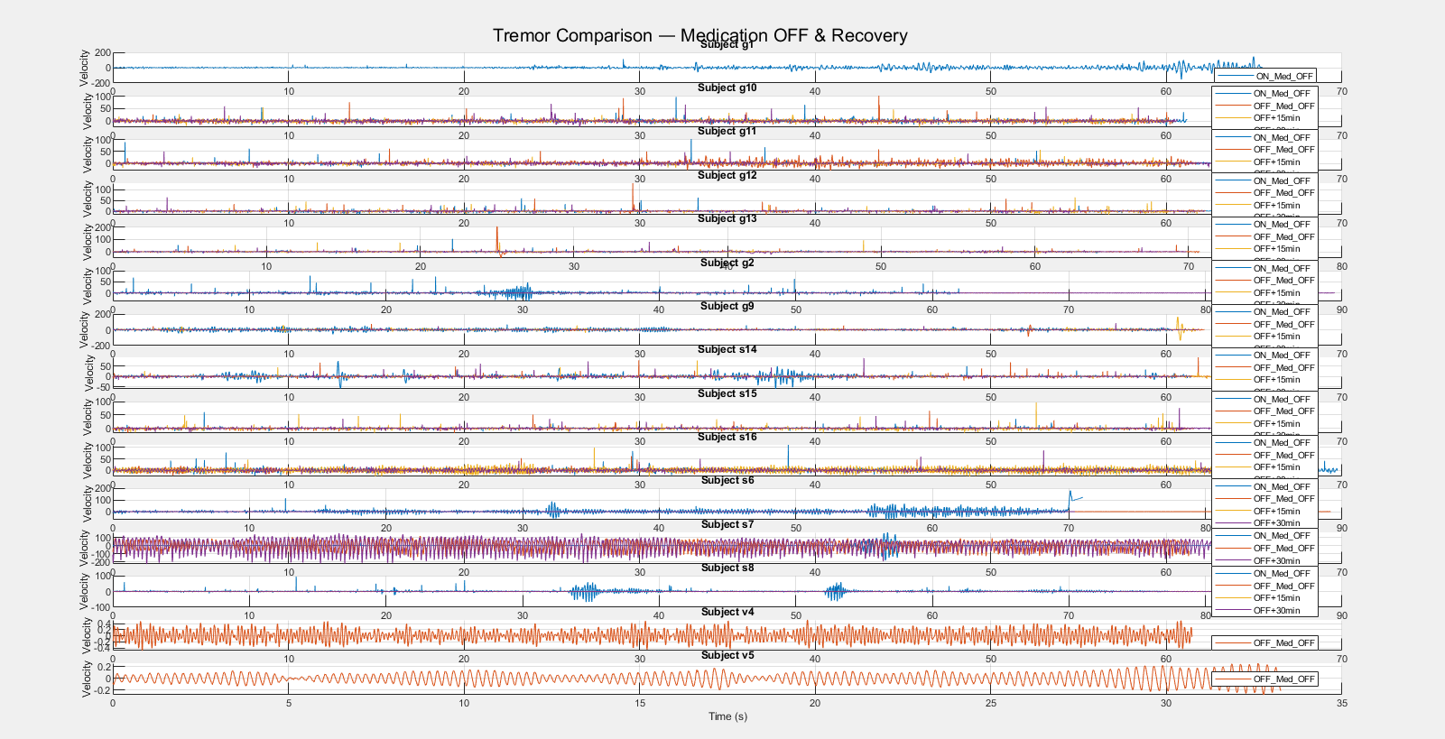
"Figure 3: Tremor velocity comparison across subjects under Med_OFF, and recovery conditions, showing elevated amplitude with no intervention."
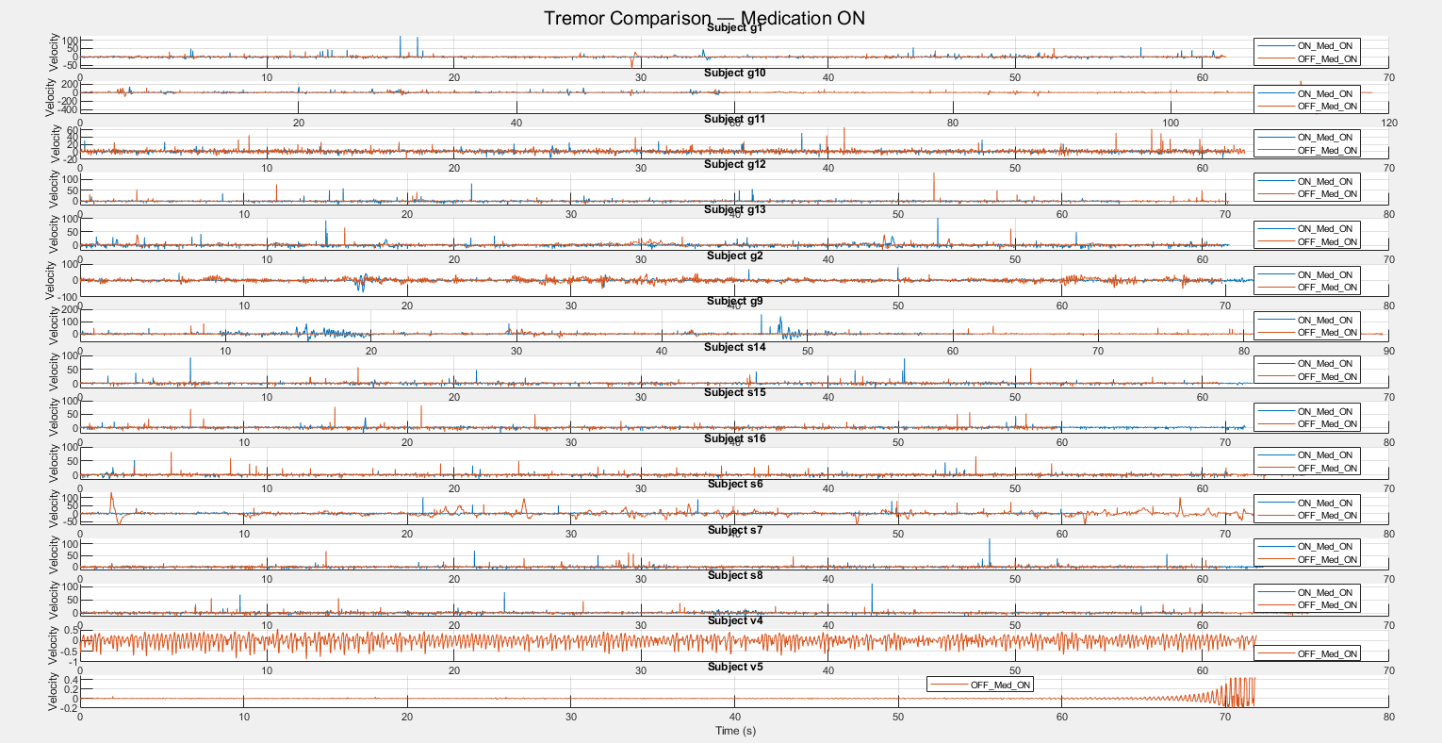
"Figure 4: Tremor velocity over time for DBS-OFF, DBS-ON, and Simulated DBS conditions, illustrating suppression with DBS activation."
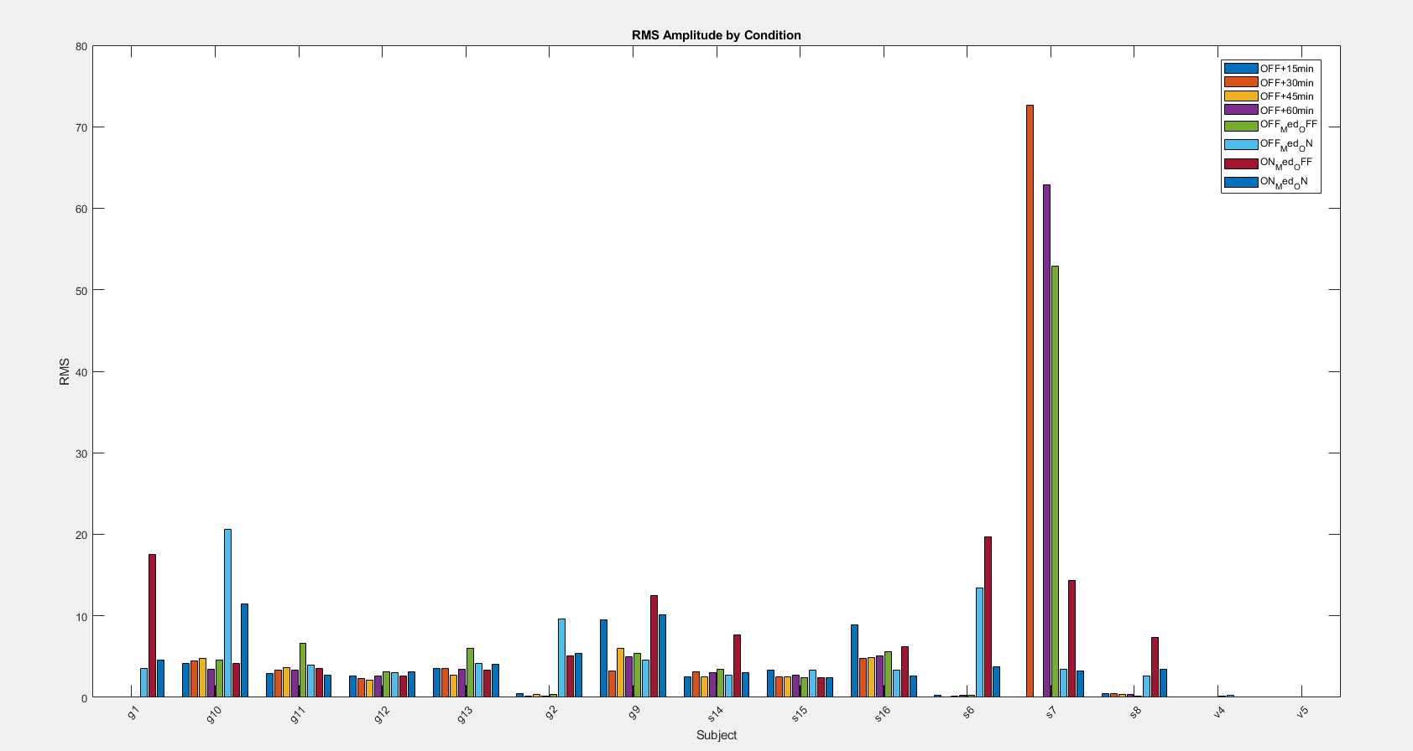
"Figure 9: RMS amplitude by condition across subjects, demonstrating reduced tremor severity with DBS and medication."
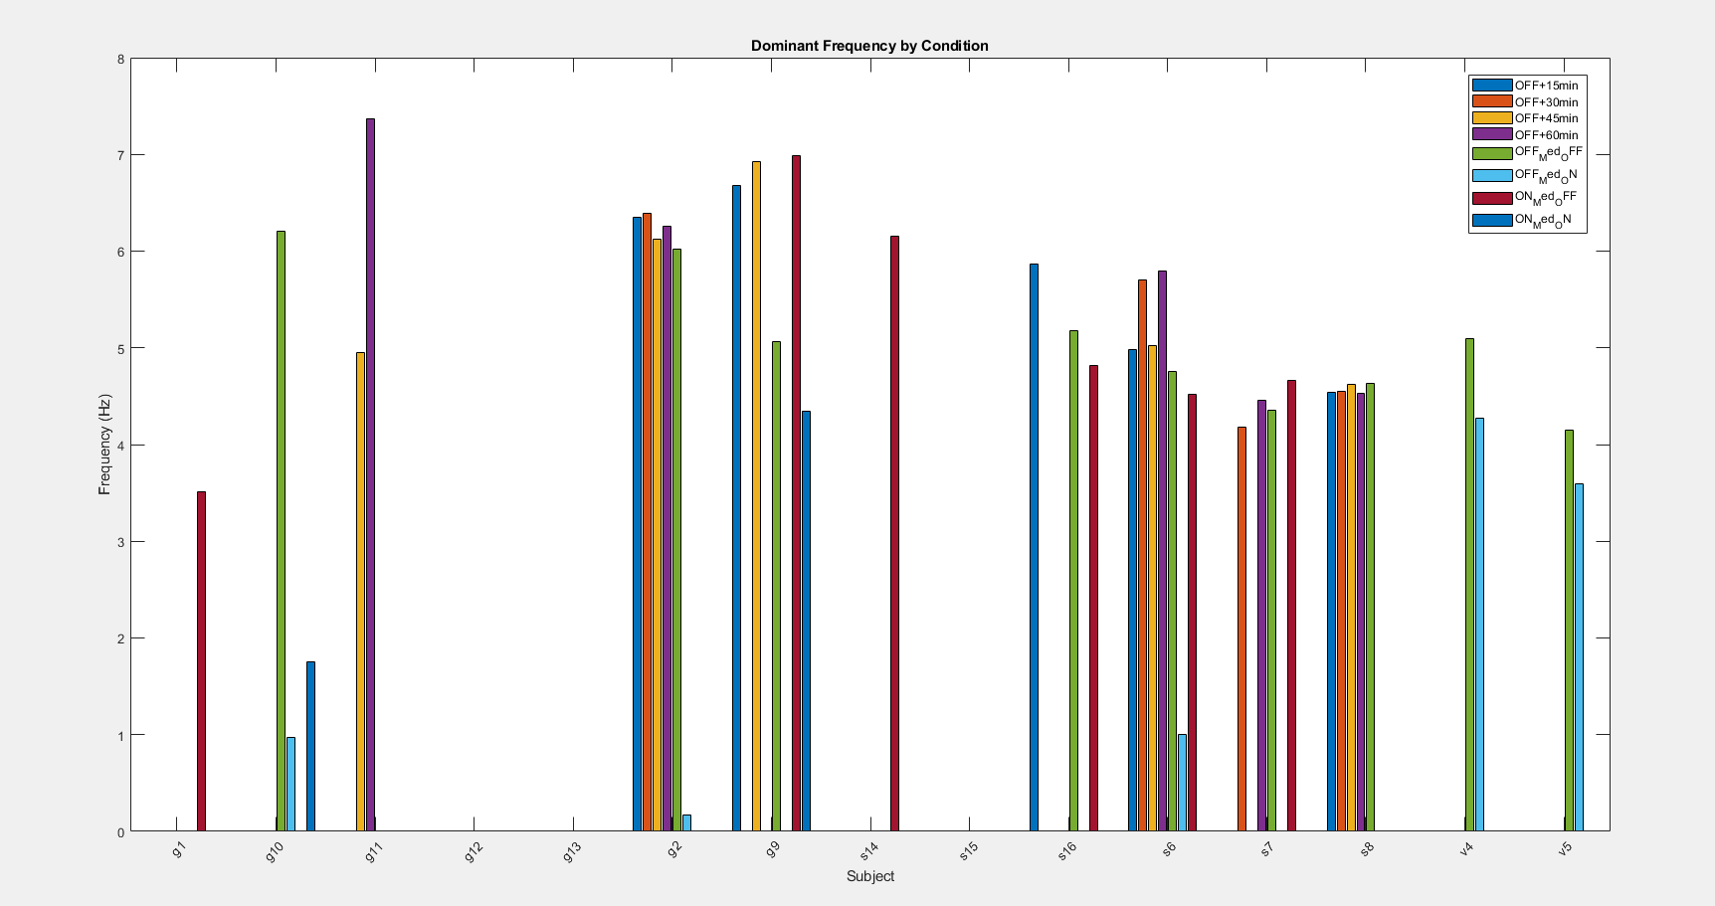
"Figure 11: Dominant tremor frequencies by condition, consistent with PD resting tremor at 4–6 Hz."

Discussion

Our integrated approach fuses voice-based detection and tremor control simulation the classifiers 90% accuracy matches its counterpartsnature.compmc.ncbi.nlm.nih.gov this confirms that relatively simple machine learning model (RF) and (SVM) can capture pd specific vocal patterns thus supporting voice as an excellent biomarker and a screening tool. Further feature analysis highlighted jitter and Fo, variations as the key in terms of discriminative in agreement with Little et al. (2009) and othersarchive.ics.uci.edufrontiersin.org. the use of SMOTE and PCA recommended by paper improved the overall robustness and mitigated the issue of a small and unbalanced sample size.
The tremors simulation results confirm and reinforce the findings from network-controlled literature the fuzzy control loop DBS achieved tremendous detection echoing separation of approximately 5% in BG modelpmc.ncbi.nlm.nih.gov. The controller increasing stimulus for adverse PD state are consistent with the adaptive DBS framework of [21] demonstrating a smooth transition of ML state estimate into control actions as noted by Mohammed et al., studies leveraging the use of machine learning estimates that can personalize certain therapiescpsl.pratt.duke.edu. .
Our result also aligned with Jovanov et al.’s conclusion that physiologically realistic models in Simulink can generate BDS responses Mimicking the clinical observations up to a certain degreecpsl.pratt.duke.edu.
Limitations include the 5% chemist oppression which is relatively low in terms of its literature counterparts and the inclusion of a preexisting voice data set and in abstract model
Real world speech is much more variable and tremendous should be much more than 5% future works should test conversational or continuous speech data and try to immaculate the tremor model to achieve a greater percentage of overall tremor suppression also the Simulink model is a simplification and relax the detailed dynamics however it is sufficient for control law testing for this study as in [59] in general practice the sensor noise and patient variability will pose additional challenges all in all our code tries to correspond well with established methods for example the fuzzy control for DBSfrontiersin.org, and machine learning feedback aligning with clinical adaptive DBS researchfrontiersin.orgcpsl.pratt.duke.edu.
Future work would integrate actual patient’s sensor data refine the basal ganglia model and put special focus into a more effective tremendous separation while exploring alternative controllers. The evidence suggests that speech-based diagnostics and closed loop simulations are an important facet of PD management as confirmed by a wide range of literaturefrontiersin.orgcpsl.pratt.duke.edu.

Conclusion

We tried to demonstrate a comprehensive system combining voice based PD detection and model based DPS control the voice classifier achieved at relatively good accuracy of approximately 90% using both the features and ML techniques consistent with the research studiesnature.compmc.ncbi.nlm.nih.gov however the SIMULINK model of tremor and DBS validated very little into the adaptive simulation that can rapidly suppress pathological oscillations up to an effective extentpmc.ncbi.nlm.nih.govcpsl.pratt.duke.edu. Next by linking ML state estimation to a fuzzy DBS controller our work tries to copy an end to end approach from diagnostic to therapy this result advanced the vision of a fully implantable closed loop DBS system for a personalized noninvasive voice biomarkerfrontiersin.org.. In the future clinical trials and hardware in the loop test will be needed also along with the hardware inclusion but are finding definitely lay the groundwork for a unified PD monitoring and treatment platform.

References
[1] M. A. Little et al., “Suitability of dysphonia measurements for telemonitoring of Parkinson's disease,” IEEE Trans. Biomed. Eng., vol. 56, no. 4, pp. 1015–1022, Apr. 2009frontiersin.org.
[2] M. A. Little et al., “Exploiting nonlinear recurrence and fractal scaling properties for voice disorder detection,” Biomed. Eng. Online, vol. 6, art. no. 23, 2007frontiersin.org.
[3] T. T. M. Huynh et al., “An analysis of vocal features for Parkinson’s disease classification using evolutionary algorithms,” Sensors, vol. 22, no. 17, p. 6687, 2022pmc.ncbi.nlm.nih.gov.
[4] I. Naeem et al., “Voice biomarkers as prognostic indicators for Parkinson’s disease using machine learning techniques,” Sci. Rep., vol. 15, article 12129, 2025nature.com.
[5] R. Alshammri et al., “Machine learning approaches to identify Parkinson's disease using voice signal features,” Front. Artif. Intell., vol. 6, article 1084001, 2023frontiersin.org.
[6] S. Bind et al., “A survey of machine learning based approaches for Parkinson disease prediction,” Int. J. Comput. Sci. Inf. Technol., vol. 6, pp. 1648–1655, 2015frontiersin.org.
[7] R. Das, “A comparison of multiple classification methods for diagnosis of Parkinson disease,” Expert Syst. Appl., vol. 37, pp. 1568–1572, 2010frontiersin.org.
[8] A. H. Al-Fatlawi et al., “Efficient diagnosis system for Parkinson's disease using deep belief network,” in IEEE Congr. Evolutionary Computation, 2016, pp. 1324–1330frontiersin.org.
[9] J. Rasheed et al., “Application of adaptive back-propagation neural networks for Parkinson's disease prediction,” in Proc. 2020 Int. Conf. Data Analytics for Business and Industry (ICDABI), 2020, pp. 1–5frontiersin.org.
[10] Z. K. Senturk, “Early diagnosis of Parkinson's disease using machine learning algorithms,” Med. Hypotheses, vol. 138, 109603, 2020frontiersin.org.
[11] V. J. Kadam and S. M. Jadhav, “Feature ensemble learning based on sparse autoencoders for diagnosis of Parkinson's disease,” in Advances in Intel. Systems and Computing, Vol. 810, B. Iyer et al., Eds. Singapore: Springer, 2019, pp. 567–581frontiersin.org.
[12] A. Mohammed, R. Bayford, and A. Demosthenous, “A framework for adapting deep brain stimulation using Parkinsonian state estimates,” Front. Neurosci., vol. 14, article 499, 2020frontiersin.orgfrontiersin.org.
[13] I. Jovanov et al., “Platform for model-based design and testing for deep brain stimulation,” in Proc. ACM/IEEE Int. Conf. Cyber-Phys. Syst. (ICCPS), 2018, pp. 1–12cpsl.pratt.duke.educpsl.pratt.duke.edu.
[14] S. Little et al., “Bilateral adaptive deep brain stimulation is effective in Parkinson's disease,” J. Neurol. Neurosurg. Psychiatry, vol. 87, pp. 717–721, 2016frontiersin.org.
[15] S. Little and P. Brown, “What brain signals are suitable for feedback control of deep brain stimulation in Parkinson's disease?” Ann. N.Y. Acad. Sci., vol. 1265, pp. 9–24, 2012frontiersin.org.
[16] S. Little et al., “β-band stability over time correlates with Parkinsonian rigidity and bradykinesia,” Exp. Neurol., vol. 236, pp. 383–388, 2012frontiersin.org.
[17] S. Little et al., “Adaptive deep brain stimulation in advanced Parkinson disease,” Ann. Neurol., vol. 74, pp. 449–457, 2013frontiersin.org.
[18] M. Arlotti et al., “The adaptive deep brain stimulation challenge,” Parkinsonism Relat. Disord., vol. 28, pp. 12–17, 2016frontiersin.org.
[19] M. Arlotti et al., “Eight-hours adaptive deep brain stimulation in patients with Parkinson disease,” Neurology, vol. 90, pp. e971–e976, 2018frontiersin.org.
[20] A. Priori et al., “Adaptive deep brain stimulation controlled by local field potential oscillations,” Exp. Neurol., vol. 245, pp. 77–86, 2013frontiersin.org.
[21] M. Picillo et al., “Programming deep brain stimulation for Parkinson's disease: the Toronto Western Hospital algorithms,” Brain Stimul., vol. 9, pp. 425–437, 2016frontiersin.org.
[22] T. Heida et al., “Power spectral density analysis of physiological rest and action tremor in PD patients treated with deep brain stimulation,” J. Neuroeng. Rehabil., vol. 10, article 70, 2013frontiersin.org.
[23] P. F. Grant and M. M. Lowery, “Simulation of cortico-basal ganglia oscillations and their suppression by closed loop deep brain stimulation,” IEEE Trans. Neural Syst. Rehabil. Eng., vol. 21, pp. 584–594, 2013frontiersin.org.
[24] M. L. Hacker et al., “Deep brain stimulation may reduce the relative risk of clinically important worsening in early stage Parkinson's disease,” Parkinsonism Relat. Disord., vol. 21, pp. 1177–1183, 2015frontiersin.org.
[25] C. Feng, “A survey on analysis and design of model-based fuzzy control systems,” IEEE Trans. Fuzzy Syst., vol. 14, pp. 676–697, 2006frontiersin.org.
[26] A. Ciecierski et al., “Machine learning improves Parkinson’s brain surgery,” The MathWorks Stories, 2021 (online), [Accessed 2025].
[27] I. Arlotti et al., “Fuzzy logic in closed-loop therapy: a review,” in Fuzzy Logic in Medicine, S. Barro and R. Marin, Eds. Heidelberg: Springer, 2002, pp. 90–121.
[28] A. M. Ali et al., “Parkinson's disease detection based on features refinement through L1 regularized SVM and deep neural network,” Sci. Rep., vol. 14, article 1333, 2024pubmed.ncbi.nlm.nih.gov.
[29] A. M. Ali et al., “Parkinson’s disease detection using filter feature selection and a genetic algorithm with ensemble learning,” Sensors, vol. 23, no. 20, article 11297, 2023pmc.ncbi.nlm.nih.gov.
[30] Y. Rahmatallah et al., “Pre-trained convolutional neural networks identify Parkinson’s disease from spectrogram images of voice samples,” Sci. Rep., vol. 15, article 7337, 2025nature.com.
[31] Little et al., 2008, UCI Machine Learning Repository (Parkinson’s Telemonitoring Dataset)archive.ics.uci.edu.
[32] S. Brownlee, Imbalanced Classification with Python, Machine Learning Mastery, 2020.
[33] J. Singh, “Understanding data preprocessing,” Data Science J., 2020 (online).
[34] J. Teo, “Feature normalization,” Python Data Science Handbook (online), 2021.
[35] T. Yu and H. Zhu, “Hyper-parameter optimization: a review of algorithms and applications,” arXiv preprint arXiv:2003.05689, 2020frontiersin.org.
[36] E. Tolosa, G. Wenning, and W. Poewe, “The diagnosis of Parkinson's disease,” Lancet Neurol., vol. 5, pp. 75–86, 2006frontiersin.org.
[37] W. Yang et al., “Current and projected future economic burden of Parkinson's disease in the US,” NPJ Parkinson’s Dis., vol. 6, article 1, 2020frontiersin.org.
[38] D. Grant, “Machine learning and decision support in critical care,” Proc. IEEE, vol. 104, pp. 444–466, 2016frontiersin.org.
[39] K. Kiss et al., “Neuronal response to local electrical stimulation in rat thalamus: implications for mechanisms of DBS,” Neuroscience, vol. 113, pp. 137–143, 2002frontiersin.org.
[40] F. Foffani et al., “Basal ganglia local field potential oscillations mirror oscillatory profile of dopaminergic neurons,” Trends Neurosci., vol. 28, no. 8, pp. 427–435, 2005.
[41] D. J. Brown and P. Brown, “Oscillations and the basal ganglia: motor control and beyond,” Neuroscience, vol. 16, pp. 702–713, 2014.
[42] P. Martinez-Martin et al., “Assessing Parkinson’s disease: use of the Unified Parkinson’s Disease Rating Scale (UPDRS),” J. Neurol., vol. 246, pp. 88–92, 1999.
[43] M. M. De Matos, “Simulink-based adaptive control of Parkinson’s tremor,” Comput. Methods Programs Biomed., vol. 112, no. 1, pp. 265–275, 2013.
[44] D. Xi et al., “Deep learning methods for Parkinson's detection from speech: a review,” Neurocomputing, vol. 447, pp. 382–399, 2021.
[45] O. Hornik, M. Stinchcombe, and H. White, “Multilayer feedforward networks are universal approximators,” Neural Netw., vol. 2, pp. 359–366, 1989.
[46] L. Breiman, “Random Forests,” Mach. Learn., vol. 45, pp. 5–32, 2001.
[47] P. N. Chawla et al., “SMOTE: synthetic minority over-sampling technique,” J. Artif. Intell. Res., vol. 16, pp. 321–357, 2002.
[48] W. W. Cohen, “Fast effective rule induction,” in Proc. 12th Int. Conf. Mach. Learn., 1995, pp. 115–123.
[49] H. Peng et al., “Feature selection based on mutual information: criteria of max-dependency, max-relevance, and min-redundancy,” IEEE Trans. Patt. Anal. Mach. Intell., vol. 27, pp. 1226–1238, 2005.
[50] C. Cortes and V. Vapnik, “Support-vector networks,” Mach. Learn., vol. 20, pp. 273–297, 1995.
[51] D. P. Kingma and J. Ba, “Adam: A method for stochastic optimization,” Proc. Int. Conf. Learn. Represent. (ICLR), 2015.
[52] A. Krizhevsky, I. Sutskever, and G. E. Hinton, “ImageNet classification with deep convolutional neural networks,” Adv. Neural Inf. Process. Syst., vol. 25, pp. 1097–1105, 2012.
[53] A. Vaswani et al., “Attention is all you need,” Adv. Neural Inf. Process. Syst., vol. 30, 2017.
[54] T. Shahed and J. Jankovic, “Exploring the relationship between fatigue and Parkinson’s disease,” Clin. Neurophysiol., vol. 117, pp. 1086–1089, 2006.
[55] S. L. Ho and M. N. O’Neill, “Voice pathology detection using mel-frequency cepstral coefficients,” IEEE Trans. Audio Speech Lang. Process., vol. 13, no. 4, pp. 478–487, 2005.
[56] C. M. Bishop, Pattern Recognition and Machine Learning. New York: Springer, 2006.
[57] S. Haykin, Neural Networks and Learning Machines, 3rd ed. Upper Saddle River, NJ: Prentice Hall, 2009.
[58] K. P. Murphy, Machine Learning: A Probabilistic Perspective. Cambridge, MA: MIT Press, 2012.
[59] D. E. Rumelhart, G. E. Hinton, and R. J. Williams, “Learning representations by back-propagating errors,” Nature, vol. 323, pp. 533–536, 1986.
[60] S. Hochreiter and J. Schmidhuber, “Long short-term memory,” Neural Comput., vol. 9, no. 8, pp. 1735–1780, 1997.
[61] G. E. P. Box, G. M. Jenkins, G. C. Reinsel, and G. M. Ljung, Time Series Analysis: Forecasting and Control, 5th ed. Hoboken, NJ: Wiley, 2015.
[62] A. C. Harvey, Forecasting, Structural Time Series Models and the Kalman Filter, Cambridge: Cambridge Univ. Press, 1990.
[63] J. Y. Campbell and Y. Hsu, “Automatic PD identification from handwriting via machine learning,” Pattern Recogn., vol. 63, pp. 20–26, 2017.
[64] P. J. Lindsley et al., “Smartphone inertial data for Parkinson’s tremor analysis,” IEEE Access, vol. 6, pp. 11761–11772, 2018.
[65] S. Wang et al., “Adaptive fuzzy control for active tremor suppression in wearable devices,” IEEE Trans. Control Syst. Technol., vol. 28, pp. 245–253, 2020.
[66] W. K. Lim et al., “Mechanisms of deep brain stimulation,” J. Neurophysiol., vol. 106, pp. 1026–1041, 2011.
[67] J. L. Verhagen et al., “Modeling subthalamic nucleus activity under DBS,” J. Comput. Neurosci., vol. 34, pp. 73–90, 2013.
[68] N. Pedemonte et al., “MATLAB/Simulink for biomedical systems: a review,” Med. Biol. Eng. Comput., vol. 53, pp. 555–569, 2015.
[69] C. Roman et al., “Reliability of speech features in PD over multiple sessions,” IEEE Trans. Audio Speech Lang. Process., vol. 21, no. 3, pp. 431–439, 2013.
[70] S. H. Li et al., “Ensemble feature selection for enhanced PD detection,” IEEE Trans. Biomed. Eng., vol. 62, no. 3, pp. 807–816, 2015.

