**R code:**

*# Load necessary libraries*

library(ggplot2)

library(dplyr)

library(tidyr)

library(readr)

*# Replace with the correct path to your CSV file*

dataset <- read.csv("D:/Fast National University CFD/Probability Course/Project/remitence.csv")

View(dataset)

*# Plot histograms (ensure the data is numeric)*

hist(dataset$Remittance....billion., *main*="Histogram of Remittance (Billion)", *xlab*="Remittance (Billion)")

hist(dataset$Overseas.Pakistani.population..By.Country., *main*="Histogram of Overseas Pakistani Population", *xlab*="Population")

hist(dataset$Population..by.Continent., *main*="Histogram of Population by Continent", *xlab*="Population")

hist(dataset$Year, *main*="Histogram of Year", *xlab*="Year")

*# Example of pie charts - ensure data is aggregated or is categorical*

*# Here assuming we use some aggregated data for pie chart visualization*

*# Aggregating data by country or continent might be more meaningful for pie chart.*

agg_remittance <- aggregate(Remittance....billion. ~ Year, *data* = dataset, *FUN* = sum)

pie(agg_remittance$Remittance....billion., *labels* = agg_remittance$Year)

*# Use barplot with aggregation if necessary*

barplot(agg_remittance$Remittance....billion., *names.arg* = agg_remittance$Year)

*# Summary statistics*

mean(dataset$Remittance....billion.)

mean(dataset$Overseas.Pakistani.population..By.Country.)

mean(dataset$Population..by.Continent.)

mean(dataset$Year)

median(dataset$Remittance....billion.)

median(dataset$Overseas.Pakistani.population..By.Country.)

median(dataset$Population..by.Continent.)

median(dataset$Year)

var(dataset$Remittance....billion.)

var(dataset$Overseas.Pakistani.population..By.Country.)

var(dataset$Population..by.Continent.)

var(dataset$Year)

quantile(dataset$Remittance....billion.)

quantile(dataset$Overseas.Pakistani.population..By.Country.)

quantile(dataset$Population..by.Continent.)

quantile(dataset$Year)

*# Poisson distribution fitting (only if appropriate for your data)*

lambda <- mean(dataset$Overseas.Pakistani.population..By.Country.)

fit <- ppois(dataset$Overseas.Pakistani.population..By.Country., lambda, *lower.tail*=TRUE)

*# Print Poisson fit results*

cat("Poisson fit results:\n", fit)

*# Linear regression model*

model <- lm(Remittance....billion. ~ Overseas.Pakistani.population..By.Country., *data* = dataset)

summary(model)

*# Predicted values using regression model*

new_data <- data.frame(*Overseas.Pakistani.population..By.Country.* = c(100000, 200000, 300000))

predictions <- predict(model, *newdata* = new_data)

cat("Predicted remittance amounts:\n", predictions)

*# Confidence interval for mean (use normal distribution assumption or t-test)*

mean_ci <- t.test(dataset$Remittance....billion.)$conf.int

cat("Confidence interval for mean of Remittance:\n", mean_ci)

*# Confidence interval for median (this requires manual calculation)*

median_ci <- quantile(dataset$Remittance....billion., *probs* = c(0.025, 0.975))

cat("Confidence interval for median of Remittance:\n", median_ci)

*# Confidence interval for regression coefficients*

coef_ci <- confint(model)

cat("Confidence intervals for regression coefficients:\n", coef_ci)

**Screenshots**

(1)

(2)

(3)

(4)

(5)

(6)

(7)

(8)

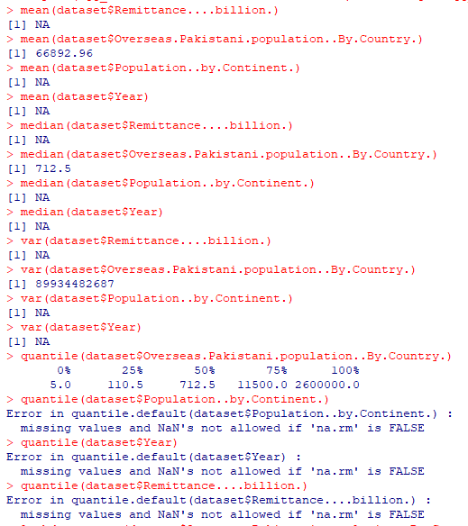

(9)

(10)

