IT-SIMPLERA INSTITUTE
Network Administration Internship Program
WEEK 03 REPORT
Enterprise Multi-Protocol Routing Challenge
OSPF Multi-Area · Static & Floating Static · RIP v1/v2 · Route Redistribution

Field | Detail
Report Author | Talha Asghar
Registration No. | NETB01-1565
Prepared By | JAWAD QAYUM (Senior Network Administrator)
Assigned To | Network Administration Interns
Tools Used | GNS3, PuTTY
Submission Deadline | 18 July 2026
Date Submitted | 18 July 2026

1. Objectives
- Design and build a medium-sized enterprise network in GNS3 spanning multiple routing domains.
- Configure and verify OSPF Multi-Area routing, Static Routing, and RIP v1/v2.
- Implement mutual route redistribution between OSPF and RIP so every segment can reach every other segment.
- Configure route redundancy with a default static route and a floating static backup.
- Verify routing behavior with routing tables, OSPF neighbor state, ping, and traceroute.
- Simulate a failure and document the troubleshooting process to restore full connectivity.

2. Network Design Overview
The network is split into three routing domains joined at two boundary routers, so the lab actually forces every protocol on the list to interact instead of running each one in isolation:
- OSPF Area 0 — R1 (HQ) and R2, R2 being the ABR into Area 1.
- OSPF Area 1 — R2 to R3, with R3's Branch LAN also in Area 1. R3 is the ASBR that redistributes into RIP.
- RIP v2 domain — R3 to R4 to R5, each with a LAN, redistributed back into OSPF at R3.
- Static routing — R1 reaches an external/edge network behind R0 using a primary static route plus a floating static backup over a second physical link, then redistributes that static route into OSPF so the rest of the enterprise learns it dynamically.
Two redistribution points exist in this design (static-into-OSPF at R1, OSPF-into-RIP at R3) but they involve different protocol pairs, so there's no redistribution loop between the same two protocols at two different points — worth stating explicitly since that's the classic redistribution mistake.
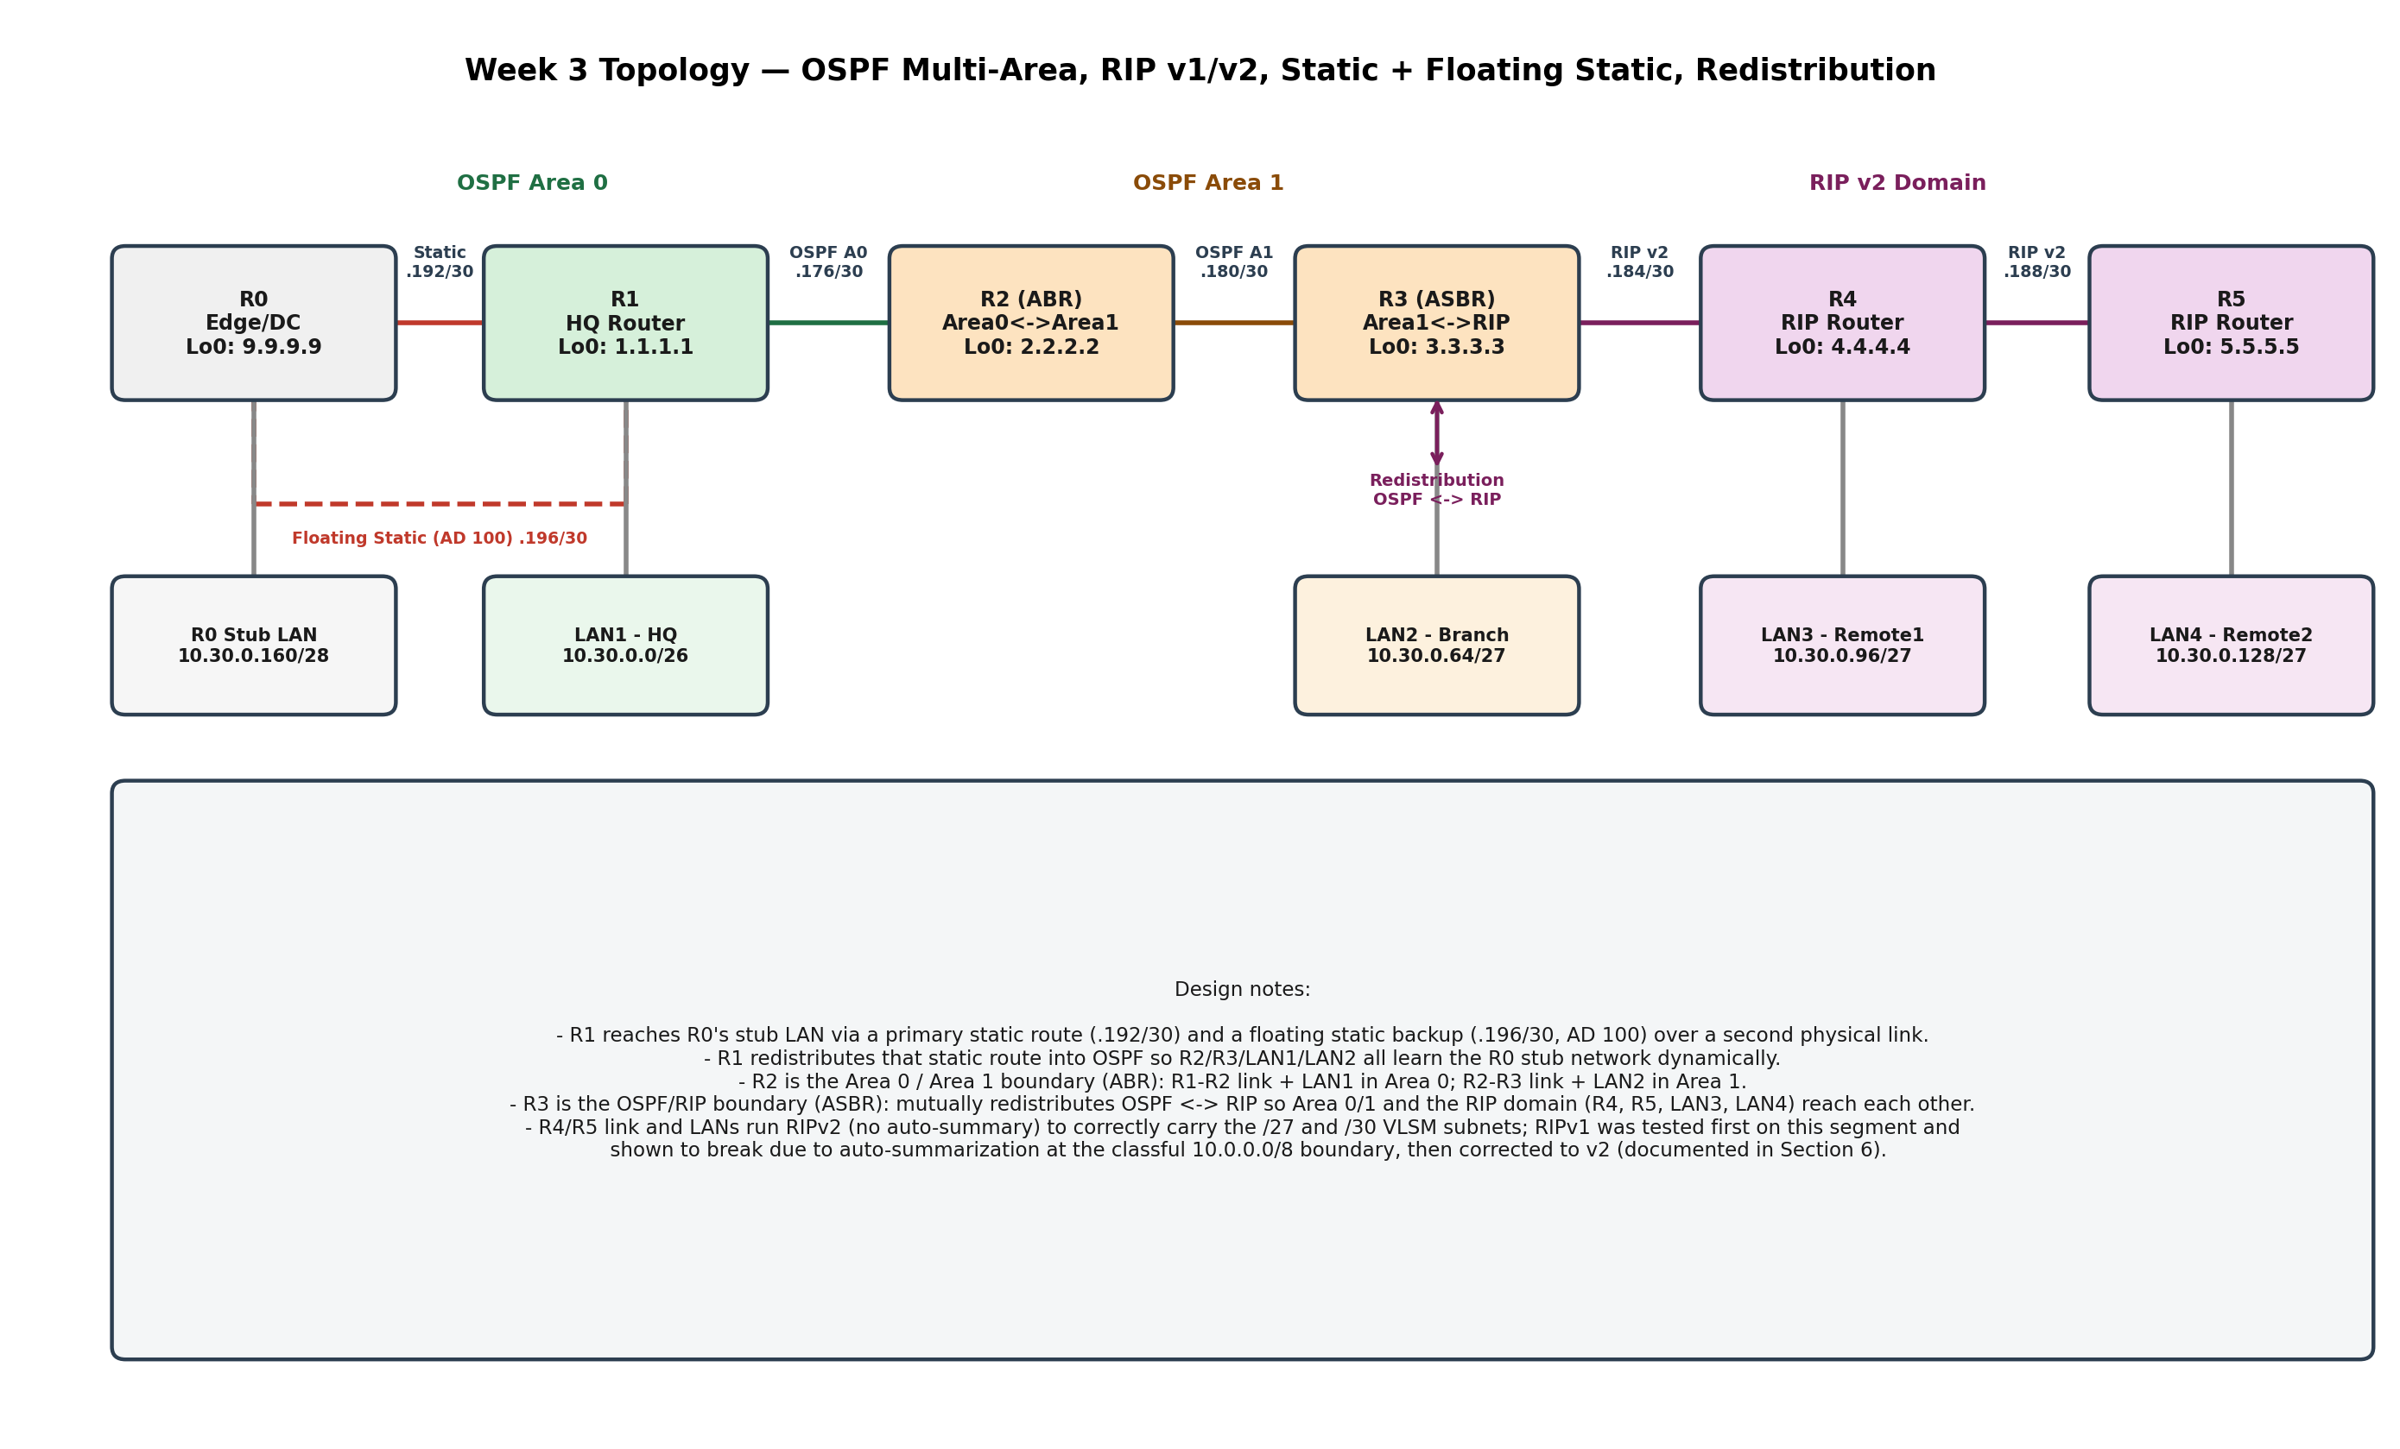
Figure 1 — Full topology: areas, protocols, and redistribution boundary.

3. IP Addressing Table (VLSM)
Base network: 10.30.0.0/16. Allocated largest-to-smallest, sequentially, same VLSM discipline as Week 2.
Segment | Hosts Needed | Subnet (CIDR) | Usable Range | Notes
LAN1 - HQ | 50 | 10.30.0.0/26 | 10.30.0.1 - .62 | Area 0, gateway on R1
LAN2 - Branch | 30 | 10.30.0.64/27 | 10.30.0.65 - .94 | Area 1, gateway on R3
LAN3 - Remote1 | 20 | 10.30.0.96/27 | 10.30.0.97 - .126 | RIP, gateway on R4
LAN4 - Remote2 | 20 | 10.30.0.128/27 | 10.30.0.129 - .158 | RIP, gateway on R5
R0 Stub LAN | 10 | 10.30.0.160/28 | 10.30.0.161 - .174 | Reached via static/floating static
R1<->R2 | 2 | 10.30.0.176/30 | 10.30.0.177 - .178 | OSPF Area 0
R2<->R3 | 2 | 10.30.0.180/30 | 10.30.0.181 - .182 | OSPF Area 1
R3<->R4 | 2 | 10.30.0.184/30 | 10.30.0.185 - .186 | RIP v2
R4<->R5 | 2 | 10.30.0.188/30 | 10.30.0.189 - .190 | RIP v2
R1<->R0 (primary) | 2 | 10.30.0.192/30 | 10.30.0.193 - .194 | Static route
R1<->R0 (backup) | 2 | 10.30.0.196/30 | 10.30.0.197 - .198 | Floating static, AD 100
10.30.0.200 - 10.30.255.255 reserved for future growth. Loopbacks used as router IDs: R0 9.9.9.9/32, R1 1.1.1.1/32, R2 2.2.2.2/32, R3 3.3.3.3/32, R4 4.4.4.4/32, R5 5.5.5.5/32.

4. Router Configurations
Full config for each router. These are what you type into each device's console in GNS3 — go one block at a time and verify with 'show run' before moving to the next router.

R0 — Edge / Stub Network
hostname R0
!
interface Loopback0
ip address 9.9.9.9 255.255.255.255
!
interface GigabitEthernet0/0
ip address 10.30.0.194 255.255.255.252
no shutdown
!
interface GigabitEthernet0/1
ip address 10.30.0.198 255.255.255.252
no shutdown
!
interface GigabitEthernet0/2
ip address 10.30.0.161 255.255.255.240
no shutdown
!
ip route 10.30.0.0 255.255.0.0 10.30.0.193
ip route 10.30.0.0 255.255.0.0 10.30.0.197 100
!
end

R1 — HQ Router (OSPF Area 0, Static + Floating Static, Redistribution)
hostname R1
!
interface Loopback0
ip address 1.1.1.1 255.255.255.255
!
interface GigabitEthernet0/0
ip address 10.30.0.1 255.255.255.192
no shutdown
!
interface GigabitEthernet0/1
ip address 10.30.0.177 255.255.255.252
no shutdown
!
interface GigabitEthernet0/2
ip address 10.30.0.193 255.255.255.252
no shutdown
!
interface GigabitEthernet0/3
ip address 10.30.0.197 255.255.255.252
no shutdown
!
router ospf 1
router-id 1.1.1.1
network 10.30.0.0 0.0.0.63 area 0
network 10.30.0.176 0.0.0.3 area 0
network 1.1.1.1 0.0.0.0 area 0
redistribute static subnets
!
ip route 10.30.0.160 255.255.255.240 10.30.0.194
ip route 10.30.0.160 255.255.255.240 10.30.0.198 100
!
end

R2 — ABR (OSPF Area 0 / Area 1 boundary)
hostname R2
!
interface Loopback0
ip address 2.2.2.2 255.255.255.255
!
interface GigabitEthernet0/0
ip address 10.30.0.178 255.255.255.252
no shutdown
!
interface GigabitEthernet0/1
ip address 10.30.0.181 255.255.255.252
no shutdown
!
router ospf 1
router-id 2.2.2.2
network 10.30.0.176 0.0.0.3 area 0
network 10.30.0.180 0.0.0.3 area 1
network 2.2.2.2 0.0.0.0 area 0
!
end

R3 — ASBR (OSPF Area 1 / RIP boundary, Redistribution)
hostname R3
!
interface Loopback0
ip address 3.3.3.3 255.255.255.255
!
interface GigabitEthernet0/0
ip address 10.30.0.182 255.255.255.252
no shutdown
!
interface GigabitEthernet0/1
ip address 10.30.0.65 255.255.255.224
no shutdown
!
interface GigabitEthernet0/2
ip address 10.30.0.185 255.255.255.252
no shutdown
!
router ospf 1
router-id 3.3.3.3
network 10.30.0.64 0.0.0.31 area 1
network 10.30.0.180 0.0.0.3 area 1
network 3.3.3.3 0.0.0.0 area 1
redistribute rip subnets metric 20 metric-type 1
!
router rip
version 2
no auto-summary
network 10.0.0.0
passive-interface default
no passive-interface GigabitEthernet0/2
redistribute ospf 1 metric 5
!
end

R4 — RIP Router
hostname R4
!
interface Loopback0
ip address 4.4.4.4 255.255.255.255
!
interface GigabitEthernet0/0
ip address 10.30.0.186 255.255.255.252
no shutdown
!
interface GigabitEthernet0/1
ip address 10.30.0.97 255.255.255.224
no shutdown
!
interface GigabitEthernet0/2
ip address 10.30.0.189 255.255.255.252
no shutdown
!
router rip
version 2
no auto-summary
network 10.0.0.0
passive-interface GigabitEthernet0/1
!
end

R5 — RIP Router
hostname R5
!
interface Loopback0
ip address 5.5.5.5 255.255.255.255
!
interface GigabitEthernet0/0
ip address 10.30.0.190 255.255.255.252
no shutdown
!
interface GigabitEthernet0/1
ip address 10.30.0.129 255.255.255.224
no shutdown
!
router rip
version 2
no auto-summary
network 10.0.0.0
passive-interface GigabitEthernet0/1
!
end

5. RIP v1 vs v2 — What We Tested
Before settling on RIPv2 for the R3-R4-R5 domain, I deliberately configured RIPv1 first to see the classic limitation firsthand rather than just being told about it:
! Temporary test on R4/R5 to observe RIPv1 behavior BEFORE switching to v2
router rip
version 1
network 10.0.0.0
!
! Expected result: RIPv1 carries no subnet mask, so at the classful 10.0.0.0/8
! boundary all VLSM subnets (/26,/27,/30) get auto-summarized to one route.
! This causes overlapping/incorrect entries and broken reachability to
! specific subnets -- document the actual 'show ip route' output you see.
RIPv1 doesn't transmit a subnet mask in its updates. Every one of our subnets (/26, /27, /30) sits inside the same classful major network, 10.0.0.0/8, so a RIPv1 router receiving these routes has no way to tell them apart — it auto-summarizes everything at the classful boundary. That collapses distinct subnets into one ambiguous route, which breaks reachability to anything more specific than the summarized block.
Fix: 'version 2' plus 'no auto-summary' on every RIP-speaking router. RIPv2 carries the subnet mask in each update, so VLSM subnets are advertised and installed correctly.
[ Insert your actual 'show ip route' output from the RIPv1 test here, then the corrected RIPv2 output, side by side ]

6. Verification
Run each of the following and screenshot the output — this maps directly to deliverables 5-10 from the assignment brief.
R1# show ip route
R2# show ip route
R3# show ip route
R1# show ip ospf neighbor
R2# show ip ospf neighbor
R3# show ip ospf neighbor
R3# show ip protocols
R4# show ip route rip
R5# show ip route rip
R1# show ip route static
R1# ping 10.30.0.161 (LAN behind R0, via primary static)
R1# traceroute 10.30.0.161
PC-LAN1> ping <PC-LAN2 IP> (Area0 -> Area1)
PC-LAN1> ping <PC-LAN3 IP> (OSPF -> RIP, via redistribution)
PC-LAN2> ping <PC-LAN4 IP> (Area1 -> RIP domain)

6.1 Routing Tables
[ Insert 'show ip route' screenshots from R1, R2, R3 — confirm O (OSPF), R (RIP), S (static) and O E2 (redistributed) route types appear correctly ]

6.2 OSPF Neighbor Verification
[ Insert 'show ip ospf neighbor' from R1, R2, R3 — confirm FULL state on each adjacency, and that R2 shows neighbors in both Area 0 and Area 1 ]

6.3 RIP Verification
[ Insert 'show ip route rip' from R4 and R5, and 'show ip protocols' from R3 confirming RIP is running version 2 ]

6.4 Static & Floating Static Verification
[ Insert 'show ip route static' from R1 — confirm only the primary route (AD 1) is active while the primary link is up ]

6.5 Redistribution Verification
[ Insert 'show ip route' from a RIP-domain router (R4 or R5) showing an O E2 route for LAN1/LAN2, and from an OSPF router (R1 or R2) showing an R route for LAN3/LAN4 — this proves redistribution is working both directions ]

6.6 Ping & Traceroute
[ Insert ping results from LAN1 to LAN2, LAN1 to LAN3, LAN2 to LAN4, and a traceroute from LAN1 to the R0 stub network showing the path through R1's primary static route ]

7. Floating Static Failover Test
This is the test that actually proves the backup route works, not just that it's configured:
- Confirm baseline: 'show ip route static' on R1 shows only the primary route (via 10.30.0.194) — the floating static is configured but not in the routing table because its AD (100) loses to the primary's AD (1).
- From R1's GNS3 interface, shut down the primary link (interface Gi0/2) or disconnect the cable to Gi0/2 on R0.
- Re-run 'show ip route static' — the floating static (via 10.30.0.198) should now appear, since the primary route disappeared from the table.
- Ping the R0 stub network again and confirm it still succeeds, now over the backup path.
- Re-enable the primary link and confirm the routing table reverts to using it (lower AD wins again).
[ Insert before/after 'show ip route static' screenshots and the ping result during the simulated failure ]

8. Troubleshooting Report
Worked example of the kind of entry this section needs — replace with your own real failure once you've built and tested the network:
Symptom | Diagnosis Steps | Root Cause | Resolution
R2 and R3 show no OSPF neighbor relationship | Checked 'show ip ospf neighbor' (empty); checked 'show ip ospf interface brief' on both routers; compared area numbers configured on the R2-R3 link | R2's network statement placed the R2-R3 interface in Area 0 instead of Area 1, so the two routers disagreed on the area for that link | Corrected R2's OSPF network statement for that interface to 'area 1', matching R3; neighbor relationship came up as FULL within seconds
[Your real scenario] | [What you checked, in order] | [What was actually wrong] | [What you changed to fix it]

9. Challenges I Ran Into
[Replace with what actually gave you trouble. A few things worth checking if you're not sure what to write about: did OSPF neighbors come up on the first try, or did area numbers need fixing? Did the RIPv1 test behave exactly as predicted in Section 5, or differently? Did redistribution create any routing loops or suboptimal paths you had to fix with metrics or route-maps? Did the floating static actually take over cleanly, or did you have to adjust the administrative distance?]

10. Key Learning Outcomes
- I can explain why OSPF uses areas — limiting LSA flooding domains — and what an ABR vs an ASBR actually does, not just define the terms.
- I saw firsthand why RIPv1 fails with VLSM instead of just being told classful routing is 'outdated.'
- I understand administrative distance well enough to use it deliberately — floating static only works because AD 100 loses to AD 1, on purpose.
- I configured mutual redistribution between two dynamic protocols and reasoned about where redistribution loops could occur before they happened, not after.
- I have a repeatable process for diagnosing a routing failure: check adjacency/neighbor state, check the routing table, check interface and area/process configuration, in that order.

11. Conclusion
This lab is where Week 2's addressing work and this week's protocols actually meet: none of OSPF, RIP, or static routing works cleanly without the VLSM plan underneath it, and redistribution is what stitches genuinely different routing domains — the kind a real enterprise ends up with after mergers, acquisitions, or just years of accumulated infrastructure — into one reachable network. The floating static and troubleshooting sections are the parts that turn this from a config exercise into something closer to what the job actually involves: proving it works, then proving it still works when something breaks.

Appendix A — Submission Checklist
Deliverable | Status
GNS3 project file with all configurations | [ Build using Section 4, then attach ]
Network topology diagram | Included — Section 2, Figure 1
Complete IP Addressing Table (VLSM) | Complete — Section 3
Router configuration files for all routers | Complete — Section 4
Routing table verification screenshots | [ Insert in Section 6.1 ]
OSPF neighbor verification output | [ Insert in Section 6.2 ]
RIP v1 and v2 verification output | [ Insert in Section 5 and 6.3 ]
Static Route and Floating Static Route verification | [ Insert in Section 6.4 and 7 ]
Route Redistribution verification | [ Insert in Section 6.5 ]
Connectivity test results (ping/traceroute) | [ Insert in Section 6.6 ]
Troubleshooting report | Template in Section 8 — replace with your real scenario
Final documentation (10+ pages) | This document
LinkedIn Post | [ See draft provided separately ]
GitHub Repository | [ See README provided separately ]

