Network Administration Internship Report: Week 1
Institution: IT-Simplera Institute
Domain: Network Administration
Submitted By: Talha Asghar
Registration No: NETB01-1565
Date of Submission: 03 July 2026

1. Introduction & Core Concepts
Networking connects devices to share resources and forms the core of modern IT systems. This report documents the practical network simulation tasks completed during Week 1.
Key Networking Terminology:
• LAN (Local Area Network): Connects local devices within a small area for high-speed data sharing.
• IP Address: A unique identifier assigned to every network-connected device.
• Static IP Addressing: Manually assigning a fixed IP address.
• Switch: Connects multiple end devices inside the same network.
• Router: Connects different networks and routes traffic between them.

2. Cisco Packet Tracer Implementation
Cisco Packet Tracer is a simulation tool used to design and test network topologies.
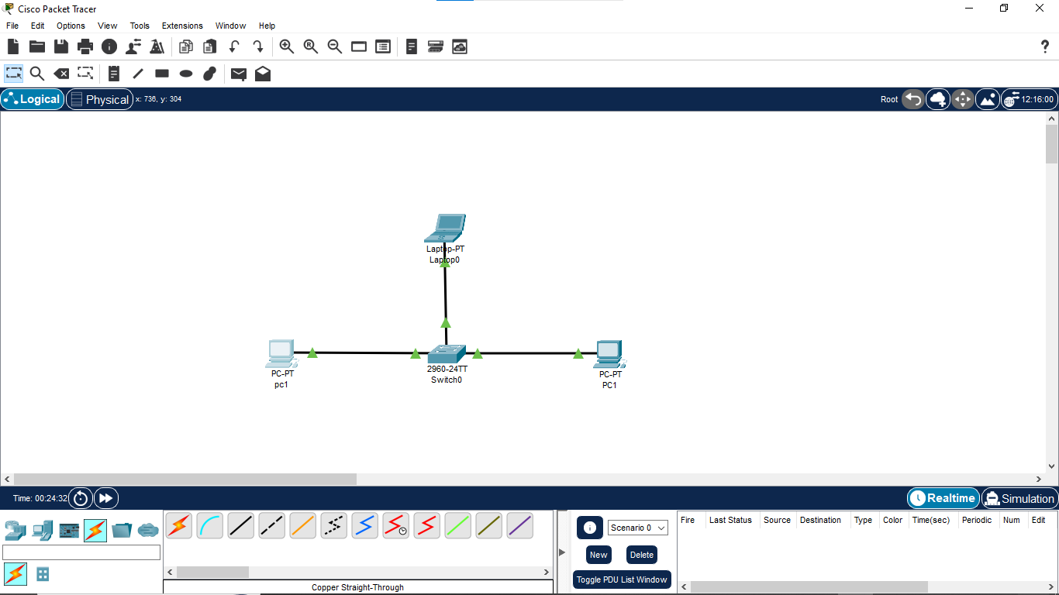
IP Configuration Matrix:
PC0- 192.168.1.1
laptop0 - 192.168.1.2
PC1 - 192.168.1.3
Ping Test Results — Cisco Packet Tracer After all IP addresses were configured, connectivity was tested using the ping command from each device. Each device pinged the other two devices on the network
. PC0 — IP: 192.168.1.1 | Pinging Laptop0 (192.168.1.2) and PC1 (192.168.1.3):
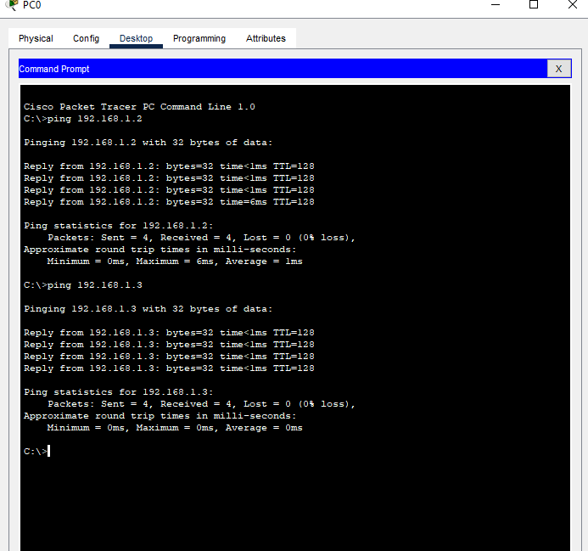
Laptop0 — IP: 192.168.1.2 | Pinging PC0 (192.168.1.1) and PC1 (192.168.1.3):
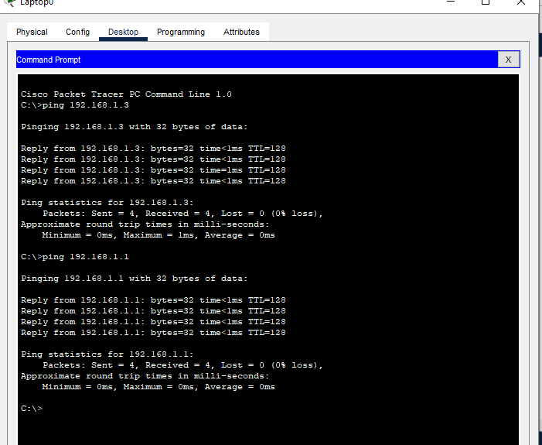
PC1 — IP: 192.168.1.3 | Pinging PC0 (192.168.1.1) and Laptop0 (192.168.1.2): 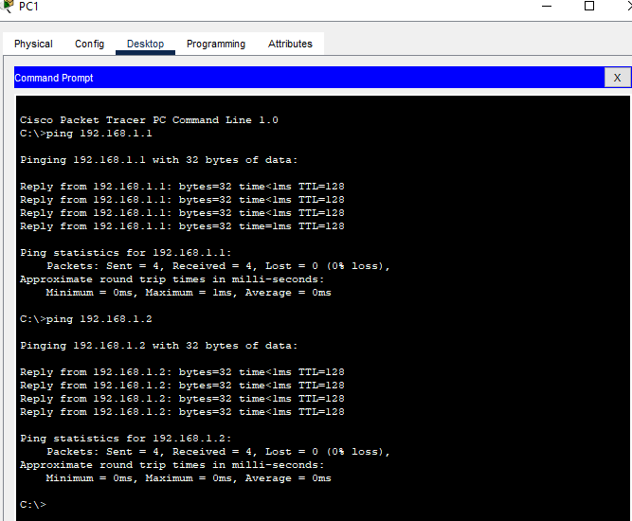
Result: All ping tests in Cisco Packet Tracer returned 4/4 replies with 0% packet loss. The LAN was working correctly.

3. GNS3 Implementation
The same network infrastructure was replicated in GNS3 using VPCS nodes and an Ethernet switch.
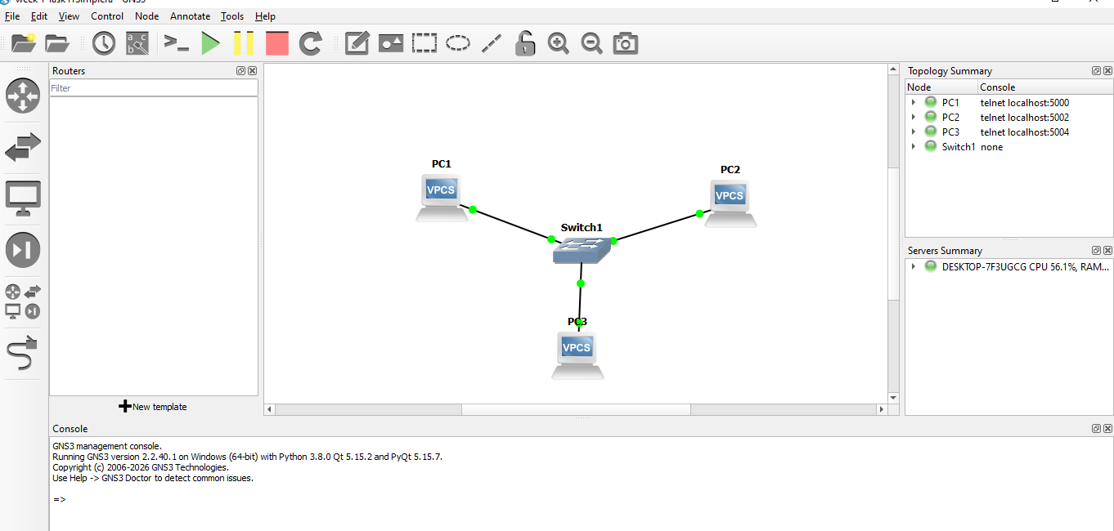
Figure 2: LAN Topology in GNS3 — Switch1 with PC1 (192.168.1.1), PC2 (192.168.1.2), PC3 (192.168.1.3)
Ping Test Results — GNS3 After configuring all three VPCS nodes, ping tests were run from each device to verify connectivity across the LAN. Each device pinged the other two nodes on the network.
PC1 — IP: 192.168.1.1 | Pinging PC2 (192.168.1.2) and PC3 (192.168.1.3):
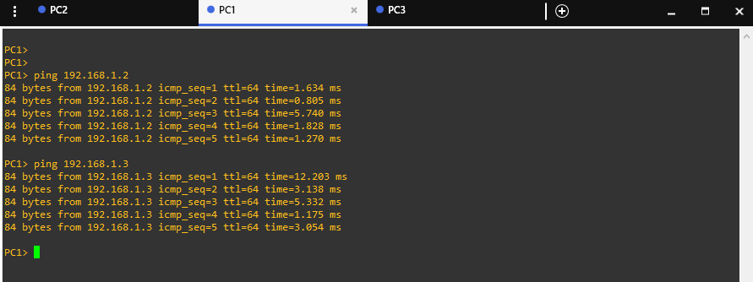
PC2 — IP: 192.168.1.2 | Pinging PC1 (192.168.1.1) and PC3 (192.168.1.3):
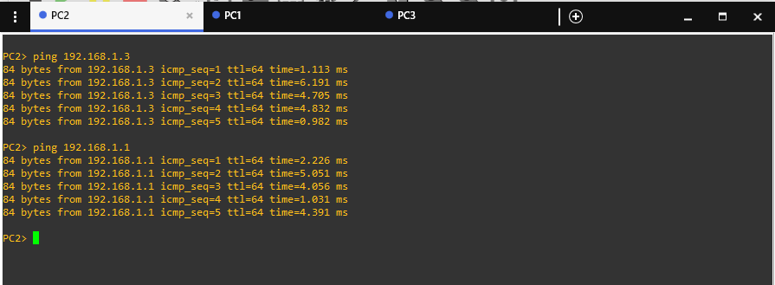

PC3 — IP: 192.168.1.3 | Pinging PC1 (192.168.1.1) and PC2 (192.168.1.2):
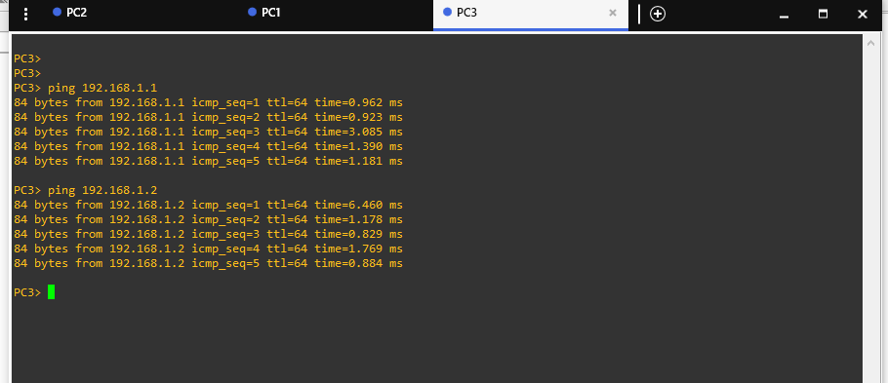
Result: All GNS3 ping tests returned 5/5 replies with 0% packet loss. Full connectivity was confirmed across all VPCS nodes.

4. Challenges Faced & Troubleshooting
• GNS3 Local Server Timeout.
• Missing Npcap Dependency.
• Syntax Adaptations in VPCS terminals.

5. Conclusion
Week 1 successfully established practical expertise in basic network configuration using Cisco Packet Tracer and GNS3. All topologies were verified operational with 0% packet loss.

