Assignment 3

Cloud Computing

**Milestone 01:**

**Source Code Link:**

<https://drive.google.com/drive/folders/120uEbRFYhDpFq7ylNjkI6_iOjfGseRep?usp=share_link>

**Docker Hub Link:** <https://hub.docker.com/r/talha539/bcsf18a539_pngm>

**Milestone 02:**

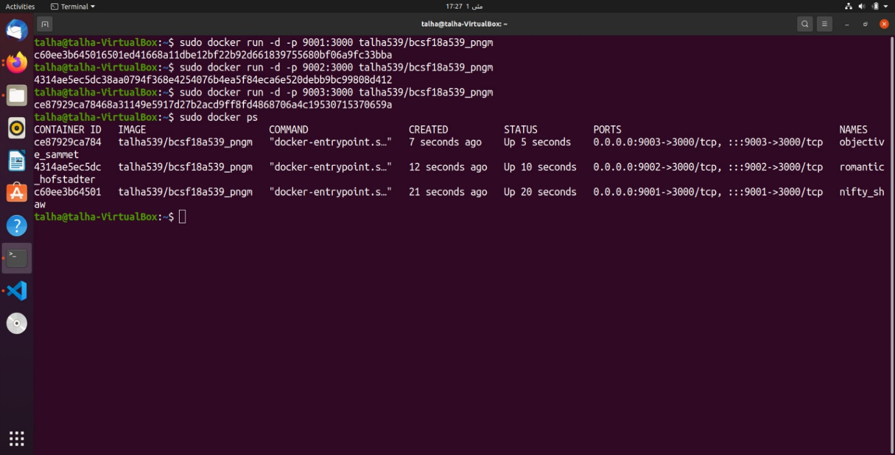

**Milestone 03:**

**Source Code Link:** <https://drive.google.com/drive/folders/1pOu5hZRsnN6MiJYHmUgS4GyjvTPr6-9T?usp=share_link>

**Docker Hub Link:** <https://hub.docker.com/r/talha539/bcsf18a539_masterservice>

**CPU & Memory Usage Graph:**

