Library Management System Project Report

Project Members:
- Ayşe Gül Pekgöz – 22290558
- Selman Bedri Gün – 22290014
- Bayram Kıcalı – 2290226
- Talha Eken – 21290420

1. Project Description and Purpose
The goal of this project is to develop a Library Management System that operates on a relational database structure and streamlines core library processes. The system aims to manage book inventory, member registrations, book borrowing and returning, reservations, and librarian operations. Through automation and a consistent data structure, the system minimizes manual errors, increases efficiency, and enhances user experience for both librarians and library members.

2. Technologies Used
- Database: MySQL
- Programming Language: Python 3 (Libraries: tkinter, datetime, mysql.connector)
- Database Connector: mysql-connector-python
- Development Environment: Visual Studio Code
- Diagram Tool: digital ER diagram (https://app.diagrams.net)

3. Database Design and ER Diagram
The database consists of the following core tables:
- Categories: Stores book genres and categories.
- Books: Stores detailed information about each book.
- Members: Stores information about registered users.
- Librarians: Handles login credentials for administrative users.
- Borrow: Tracks borrowing activity.
- Reservations: Manages reservation records.
Relationships:
- Each book belongs to one category.
- Members can borrow and reserve multiple books.
- Books can be borrowed multiple times but only once at a time.
- Only one active reservation is allowed per book.
- Librarian credentials are used for login authentication only.

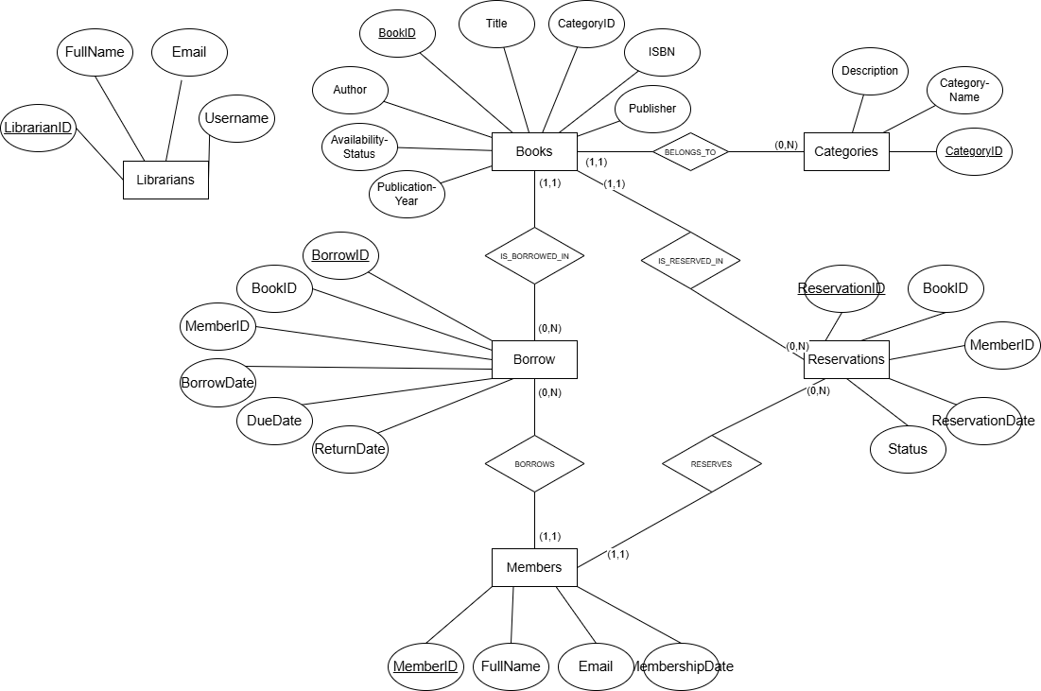

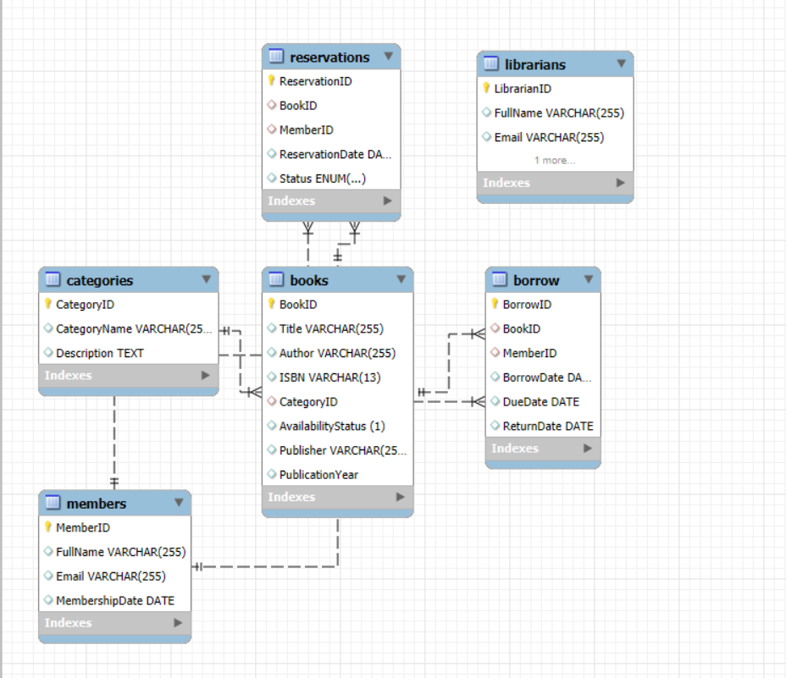

4. Application Features
The terminal-based application developed in Python provides a functional user interface through a command-line menu. A login is required by a valid librarian to access system features. After login, the following functionalities are available:
- Add new books to the library
- List all available books
- Search books by title
- Borrow a book
- Return a book
- Register new members
- Reserve a book
Each action interacts with the MySQL database through structured queries. Data integrity constraints are respected, such as unique ISBNs, one active reservation per book, and automatic update of availability status.

5. Test Scenarios and Sample Screenshots

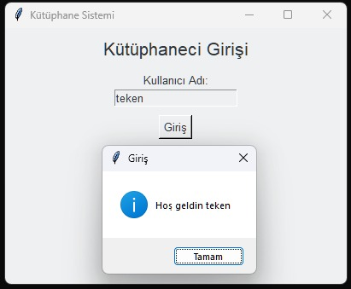
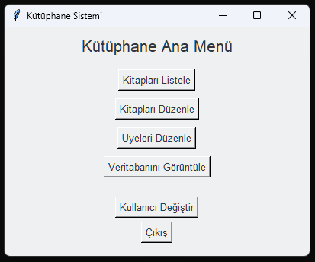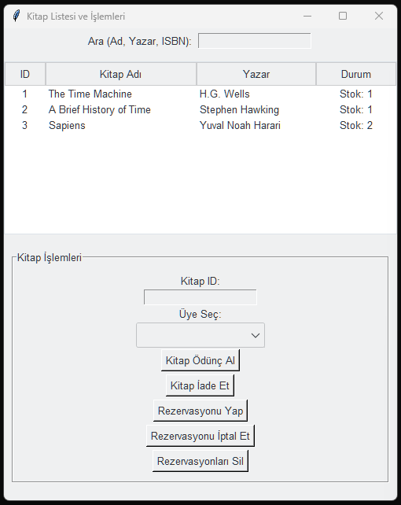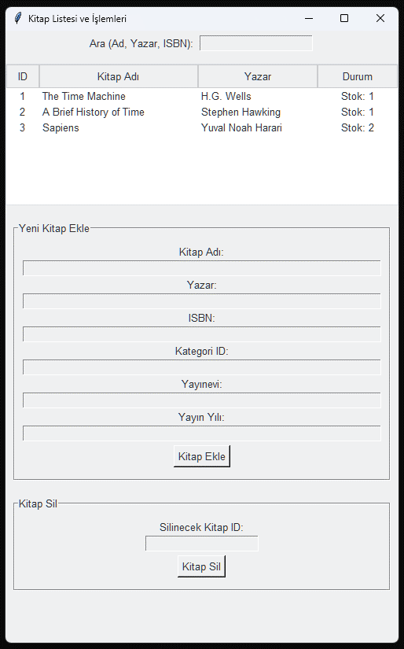

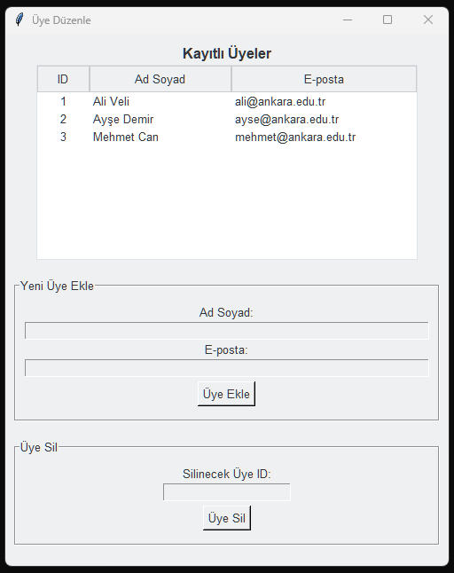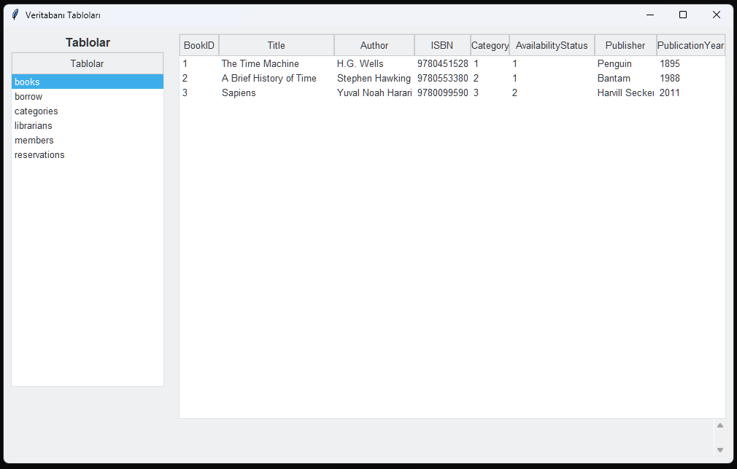

7. Conclusion and Evaluation

The Library Management System project provided a practical implementation of database principles, including ER modeling, normalization, and query operations. By integrating these concepts with Python and developing the graphical interface using Tkinter, we were able to create a fully functional, user-friendly desktop application. The use of MySQL as the backend ensured reliable data storage and integrity. This project gave students valuable hands-on experience in both backend development and GUI design. In the future, the system can be enhanced by adding user authentication layers, reporting modules, or extending it into a web-based application for broader accessibility.

