1:There are many changes on the FX Analyzer Pro page. We can compare the current design with the previous Figma design.
2: Replace the text “Forex Fundamental ” with “Forex Fundamental Trends” acrossEdge the website in multiple places.

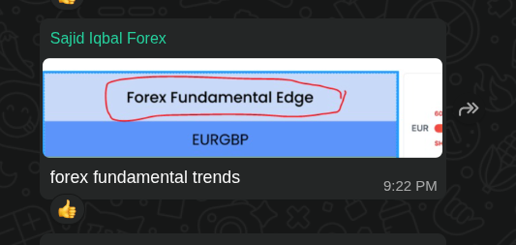

3 (Major work) All tables that include related graphs and gauges should have functionality to change their ranges. This functionality will be managed through a separate Settings page (shown in images 1, 2, and 3).
The Settings pages include:
- 5 gauges on the FX Analyzer Pro page
- 3 gauges on the Edge Tools & Alerts page
- 2 gauges on the Risk Mode page
- 6 charts
This work includes both frontend and backend implementation. The values configured in the Settings pages will be applied across all 10 gauges and 6 charts, involving significant backend logic. Admin users should be able to update these ranges at any time.

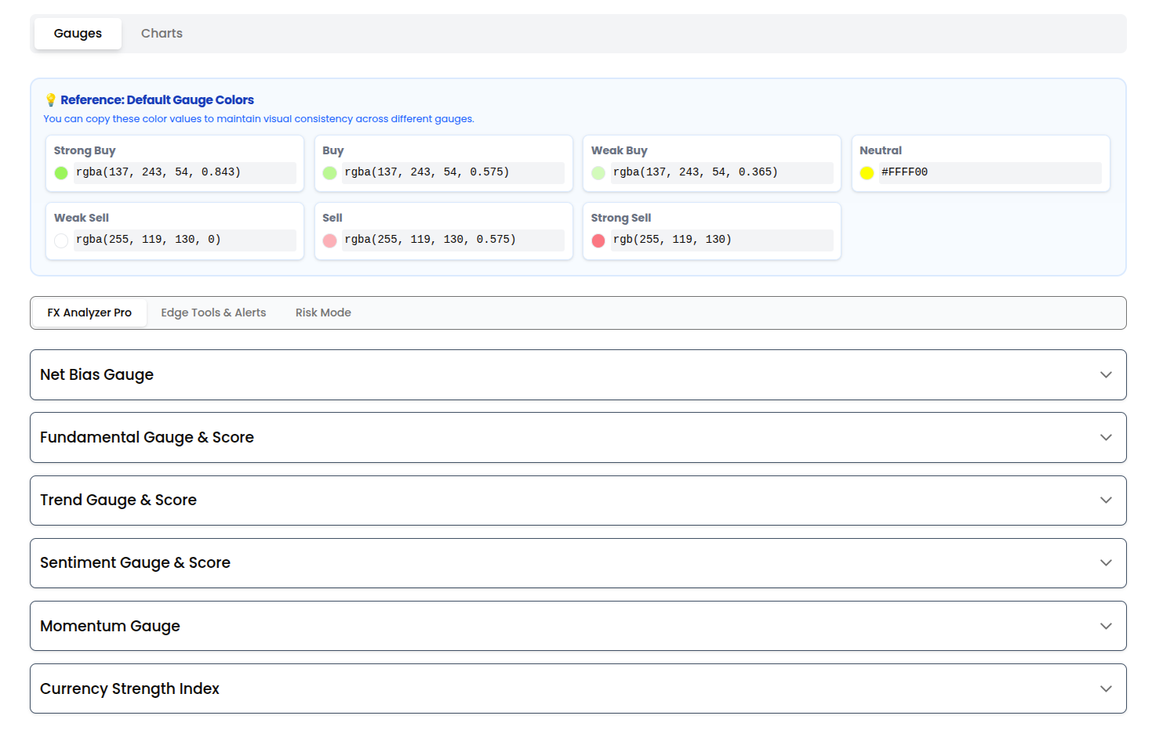

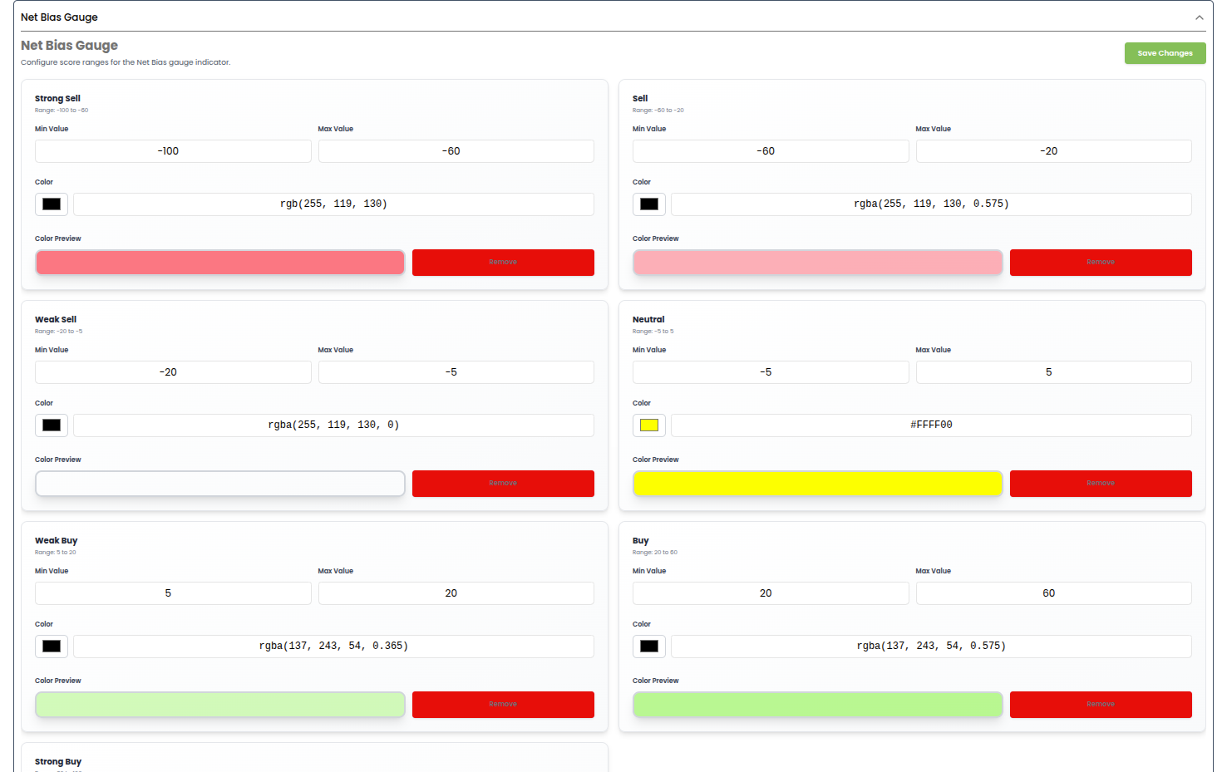
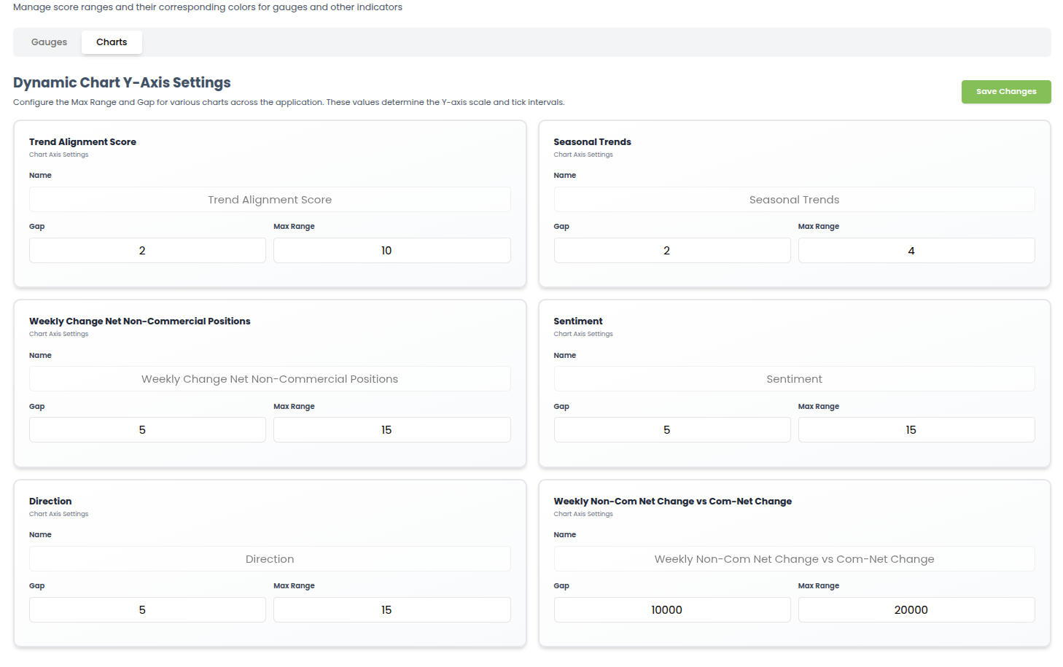
4: Add a calendar and calculators such as a profit calculator, pip calculator, position size calculator, and drawdown calculator.
5:Retail and COT charts should be automatically arranged, with gradients applied based on percentage values.
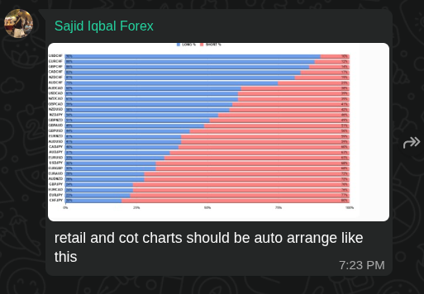
6: (major work) retail sentiment table scraping.
7: (major work) Risk Mode scraping.
8: (minor work) add ticker on website.
9: (major work) heat map scraping.
10: (major work) currency strength index scraping.

