
Deep Learning Enhanced Digital Twin for Advanced Biospy Systems
Submitted by: Malik Awais Ur Rehman
FA20-BCE-006
Talha Gohar
FA22-BCE-003
Syed Kamran Abbas
FA22-BCE-008
Program: BS in Computer Engineering Supervised by:
Mr. Qazi Zia Ullah
Co-Supervised by:
Engr. Ahmad Shah
A thesis submitted in partial fulfillment of the requirements for the degree of bachelors of Science in Computer Engineering
Department of Computer Engineering
COMSATS University Islamabad, Attock Campus, Pakistan.

Dedication
This project is sincerely dedicated to our supportive parents who encouraged and inspired us in conducting our study. They have never left our side throughout the process and gave us strength and hope when we thought of giving this up. They provided us a great sense of enthusiasm and perseverance in continuing this. Without their love and assistance, this project would not have been made possible. Moreover, We dedicate this project to our Supervisor, Mr. Qazi Zia Ullah and Co Supervisor, Engr. Ahmad Shah, who constantly guiding and supporting us to make this project even better, to our family for cheering up for us, and to our friends who have helped us in finishing this project. We really appreciate your words of advice and in continuously giving us moral, emotional, and financial support. And lastly, We dedicate this project to the Almighty ALLAH who gives us strength, wisdom, guidance, power of thinking, security, competence, and for giving us good health while doing this. All of these, we offer to you.
2

Acknowledgements
Thanks to ALLAH (s.w.t), the Greatest, the most Merciful and the most Gracious, Whose countless blessings bestowed upon me kind, talented and wise teachers, who provided me sufficient opportunities, and enlighten me towards this research work.
I would like to extend my deepest thanks to my supervisor, Mr. Qazi Zia Ullah for giving me the opportunity of undertaking this research work under his determined directions. His support, dedication, encouragement, excellent supervision and guidance are what made this thesis possible.
Thanks to my beloved family, whose prayers, dedication, support and love are the most precious assets, I had (and I have), during the course of my Engineering work and for all of my endeavors.
I am very thankful to the administration and faculty of COMSATS University Islamabad, Attock Campus for providing me a great environment that helped me a lot in conducting my FYP related activities.
Thank You!

Abstract
Diagnosis of skin cancer is still challenging because there is a lack of invasive specialists, dermatologists, as well as the prevalence of traditional biopsy practices. The current project called "Deep Learning Enhanced Digital Twin for Advanced Biopsy Systems" focuses on the necessity of timely modern biopsies in order to enhance the medical diagnosing process. With the help of deep learning, web development, computer vision, and robotics, this project proposes MedTwin Pro, an AI-enabled robotic biopsy system (web application), which involves the deployment of a skin lesion classification deep learning model and a digital twin of a four-degrees-of-freedom robotic arm on Raspberry Pi 4 computing device.

The suggested project includes the following parts: (1) a four-DOF physical robotic arm, which uses PCA9685 PWM driver through I2C, (2) a DenseNet121 convolutional neural network, which was trained on HAM10000 data for the purpose of skin lesion classification, and (3) a three-dimensional digital twin of a four-DOF robotic arm, created with Three.js and React libraries. The accuracy of the classification of skin lesions with the help of deep learning was equal to 87.6%. The two backends were tested: TensorFlow Lite and full Keras, with latencies equal to 100-200ms and 400-600ms respectively.

The three-dimensional digital twin displays the configuration of arm joints, location of lesion detected by the camera, and classification results through the connection of WebSocket server. The successful interaction between the web server and four-DOF robotic arm was confirmed by the hardware tests as well as the correct positioning of servos. The project reveals that significant AI-driven medical robotics can be made available on a compact and affordable hardware without expensive infrastructure or cloud services. In addition, this solution offers the necessary transparency needed for clinical decision-making.

The necessary skills required for the implementation of the project include expertise in deep learning, Python programming, web application design, and hardware-software integration knowledge.

Contents
1 Introduction xii
1.1 Background xii
1.2 Motivation xiii
1.3 UN Sustainability Goals xiii
2 Literature Review xiv
2.1 Literature Review xiv
2.2 Concluding Remarks xv
3 Proposed Methodology xvi
3.1 Block Diagram xvi
3.2 Flow Diagram xvi
3.3 System Model xviii
3.4 Flowchart xviii
3.5 Pseudo code of The Project/Algorithms xviii
3.6 Mathematical Modeling xx
3.7 Component Selection xx
4 Results and Simulation xxii
4.1 Simulation Results xxii
4.1.1 Software xxii
4.1.2 Hardware xxii
4.2 Statistical Analysis xxii
5 Conclusion and Future Work xxv
5.1 Conclusion xxv
5.2 Future Work xxv

Chapter 1

Introduction

1.1 Background
In the past couple of years, robotics systems have been used in the process of making diagnosis and performing surgical procedures not because they are fancy but because they minimize errors associated with human intervention and improve accuracy of complex procedures. Biopsy is an example of an operation where one’s expertise and judgment play a critical role. The dermatologist uses her/his eye to recognize the suspicious layer, manually positions the instrument, and collects tissue samples that require coordination and expertise. Skin cancer is the most frequent type of cancer in the world with 20 million newly diagnosed cases each year. Early diagnosis increases chances of survival, yet there are instances of delays in diagnosing skin cancer because there is no enough dermatologist and the evaluation of the lesion is quite subjective. There are differences in opinions when it comes to evaluating the lesion from two experienced clinicians.
The idea of digital twin, which is a virtual replication of physical processes in real-time, is long proved its worth in aerospace and industrial sectors. In the case of medical robotics, it offers an important feature by enabling the doctor to understand what exactly the robot is doing, or is planning to do. This technology, combined with lesion detection using deep learning, will enable greater intelligence. Convolutional neural networks have opened a new world of possibilities for analyzing medical images. Now, machine-learning algorithms trained on datasets of dermoscopy images have achieved parity with a board-certified dermatologist's performance at skin lesion diagnosis. The HAM10000 database, consisting of 10,015 dermoscopic images classified into seven different types of skin lesion such as melanoma, basal cell carcinoma, and melanocytic nevi, is widely considered the de-facto benchmark for this research problem. Architectures like DenseNet121 apply transfer learning from ImageNet and training on medical images to learn the same characteristics that a dermatologist looks for, namely color variegation, asymmetry, borders, and diameter.
MedTwin Pro simply brings everything together in one solution. MedTwin Pro is a platform that combines a DenseNet121 skin lesion classifier with a live digital twin of a 4-DOF robotic biopsy arm operating purely on a Raspberry Pi 4. The aim here was never to design a technology limited to a laboratory environment with GPU availability. The aim here was rather to prove that technologies like MedTwin Pro can indeed be designed on budget, portable and deployable on the edge hardware platform. One of the major features of MedTwin Pro is that it allows for remote access via wireless technology. This implies that the entire solution can be accessed through any browser from a computer within the same network. A medical professional does not have to be physically present in order to conduct operations involving the biopsy site.

1.2 Motivation
The rationale behind creating MedTwin Pro is very clear. There are over 20 million cancer diagnoses annually on a worldwide scale, of which half need biopsies in the course of diagnosis. Training the experts who specialize in biopsies takes about 8-12 years, and these people tend to live in prosperous urban areas. Rural and poor communities lack access entirely. Waiting for weeks, catching cancers late is another issue. More specialists cannot solve this problem.
Meanwhile, everything that needs to be done exists already. AI models capable of classifying skin lesions to clinical accuracy are known. Inexpensive computing devices such as the Raspberry Pi 4 are able to execute such models locally. Affordable robotic arms that can be used to physically target lesions can be constructed and programmed. It is possible to build web interfaces that will deliver real-time 3D modeling of the operation. MedTwin Pro aims to combine everything above into one coherent tool a platform through which one specialist could potentially monitor and assist several remote biopsies using a single computer.
Research Question This project revolves around answering the following research questions:

Can a real-time 3D digital twin of a robotic biopsy arm be achieved on the Raspberry Pi 4 with a synchronisation latency lower than 200ms suitable for usage by clinicians?

What is the trade-off of the inference backends (TensorFlow Lite versus the full Keras) for DenseNet121 skin lesion classification with respect to accuracy and latency on an ARM Cortex-A72 CPU?

To what degree does the domain shift from the HAM10000 dataset used to train the algorithm affect its classification accuracy when run on webcam images, and how can this issue be addressed?

Is it possible to integrate machine learning, camera streams, servos, and 3D visualisations in a stable concurrent system using a single edge computing device?

1.3 UN Sustainability Goals
This research is relevant to Sustainable Development Goal 3 set by the United Nations (Good Health and Wellbeing) because the proposed system will democratize the access to diagnostic tools at the expert level. This is achieved through the use of inexpensive edge computing systems to implement advanced diagnostic software in collaboration with the tele-robotic system to significantly shorten the delay in diagnosing patients in underserved and remote areas. Moreover, the research is relevant to Goal 9 (Industry, Innovation, and Infrastructure) because of its unique application of deep learning, IoMT, and digital twins within health infrastructure.

Chapter 2

Literature Review
Introduction is discussed in Chapter 1. Introduction of our project, motivation behind doing the project, research questions asked, United Nation's Sustainable Development Goals, and the structure of this thesis are all discussed in this chapter. This chapter provides an overall summary of the project report.

2.1 Literature Review
The use of deep learning for classification of skin lesions is one of the most researched topics in medical image recognition field, with many significant breakthroughs made. One of the most important achievements in this field was obtained by training CNNs on 100,000+ images with results equivalent to those of board-certified dermatologists. As for the benchmark datasets, the use of HAM10000 has become a standard in evaluating algorithms for this problem as it contains 10,015 dermoscopic images divided into seven classes: melanoma, melanocytic nevi, basal cell carcinoma, actinic keratoses, benign keratosis, dermatofibroma, and vascular lesions. There are several CNN architectures tested on HAM10000; however, DenseNet121 proved to be among the best. This result can be explained by the architecture's ability to preserve fine details because of dense connection between layers where each of them receives feature maps from all previous layers.
Digital twins involve a real-time virtual replica of the corresponding physical system, a term that was first coined in the domain of manufacturing. Earlier implementations included usage of such models by NASA in space missions, which were later adopted by the automotive and aerospace industry in order to perform maintenance predictions and simulations. The main idea behind using digital twins lies in the ability of a virtual copy of the actual physical system to stay sufficiently synchronized with the latter to allow for its observation and analysis as well as planning actions in the case of necessary intervention. Nonetheless, the health care domain has traditionally remained behind when implementing the digital twins technique, although interest is on the rise recently. As concerns surgical robots, previsualization is the primary purpose of such a tool, allowing the doctor or other personnel to see exactly what actions the robot will take before physically performing them. However, the distinguishing factor that separates a digital twin from a conventional 3D model lies in bidirectional synchronization, i.e., a virtual copy representing the state of actual equipment and its responding to user commands.
There are several applications of robotic assistance in performing biopsy procedures in various clinical settings, such as in the case of prostate, breast, liver, and skin biopsies. Regardless of the type of procedure, the rationale always remains the same – the limitations of human capabilities, variability between operators, and the need for a precise intervention in certain cases. There is probably no other brand as recognizable in terms of robotics in surgery as da Vinci Surgical System, which, though, operates as a teleoperation system rather than an intelligent one as it relies on human command through the master-slave interface involving tremor filter and motion scaling. Commercial robotic stereotactic biopsy systems for the brain and breast include certain elements of intelligent automation, but such machines are bulky and expensive and are made to perform only a limited range of procedures in particular settings.
Training a model on embedded hardware is not like running it on workstation hardware that features a GPU. What can take around 20 ms to run on an NVIDIA GPU can take up to 500 ms to run on an ARM Cortex without any hardware acceleration support. TensorFlow Lite came in the market to resolve this issue. This library provides functionality to easily transfer a TensorFlow/Keras-trained model to its light version by reducing its accuracy level from FP32 to INT8. In most cases, the INT8 version of a TensorFlow Lite model will run inference for a CNN in 100-200 ms compared to the Keras version that takes 400-600 ms to perform the same task on the ARM Cortex A72. When it comes to deployment on edge devices, the issue of domain shift should be discussed thoroughly. A model that is trained on benchmark datasets such as dermoscopic images taken with polarized light and immersion oil will show poorer results in normal webcam conditions.

2.2 Concluding Remarks
However, through a comprehensive study of existing literature, it becomes evident that there exists a gap in the disciplines of medical robotics and remote diagnostics. Even though cloud-based artificial intelligence models are capable of achieving commendable classification performance and commercial robotic biopsy machines have achieved commendable accuracy, currently, there does not exist a reliable low cost method to achieve integration of real time machine learning based diagnostics, teleoperations with the aid of digital twin technology, and hardware orchestration at edge level. MedTwin Pro seeks to fill this void and will show a competitive binary classification performance using only edge-level technologies while allowing simultaneous teleoperations in 3D space.
The methodologies that will be used in this research paper have been discussed comprehensively in Chapter 3.

Chapter 3

Proposed Methodology

The theoretical basis upon which this study is premised was addressed in the previous chapter. This chapter discusses the methodological approach for the study, including the block diagram, system model, flow chart, mathematical modeling, and algorithms used, among other details of choice of both hardware and software.

3.1 Block Diagram

The design concept of the MedTwin Pro system can be described as cascade architecture that involves physical control along with telemetry feedback of digital twin. Starting from the physical side, the image input coming from USB camera (resolutions: 640 x 480 px; frames per second: 25 FPS) is fed directly to Raspberry Pi 4 board, which includes ARM Cortex-A72 processor. Further, the input is transferred to DenseNet121 neural network in Keras/TFLite framework. If the lesion detection meets the predetermined confidence value (0.6), then coordinates are calculated through transformation, and inverse kinematics algorithm calculates the angles $(θ1, θ2, θ3, θ4)$needed to perform the task. Then the angles are sent to PCA9685 PWM driver through I2C interface that controls pulse-width modulation of MG996R 4-DOF servos.

On the other hand, digital twin functionality starts operating in tandem with the physical control flow described above. More specifically, current data about servo angles are streamed through WebSocket server asynchronously run at port number 8000 (using aiohttp). At the same time, the browser client developed using React and TypeScript technology gets data in JSON format that contains coordinates of 3D meshes (using Three.js) representing the obtained servo angles. Finally, after visual inspection of the model representation, the operator makes a choice to approve automatically generated target coordinates or reject them.

3.2 Flow Diagram
The system initialization starts with launching the Bash start-up process successfully activating three services running in parallel – the camera stream server, ML WebSocket broadcaster, and frontend development server respectively. Once initialized, the remote client initiates the WebSocket connection using the IP address of the Raspberry Pi on port 8081. Successful completion of the handshaking results in the user interface getting the live stream of the MJPEG stream served using HTTP.
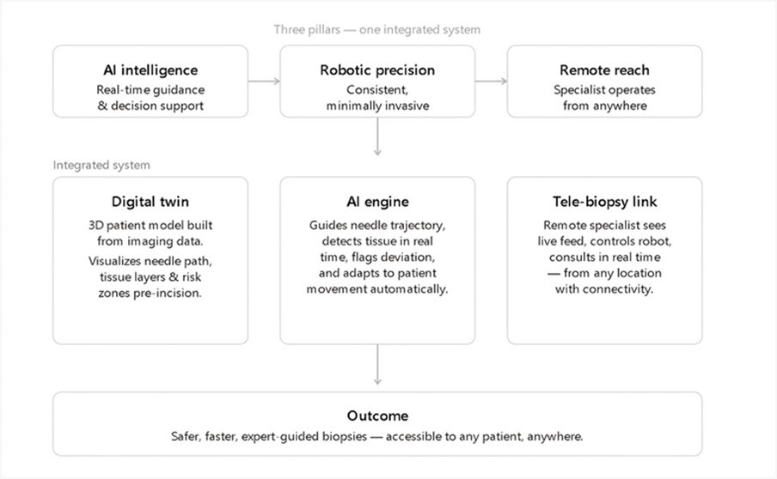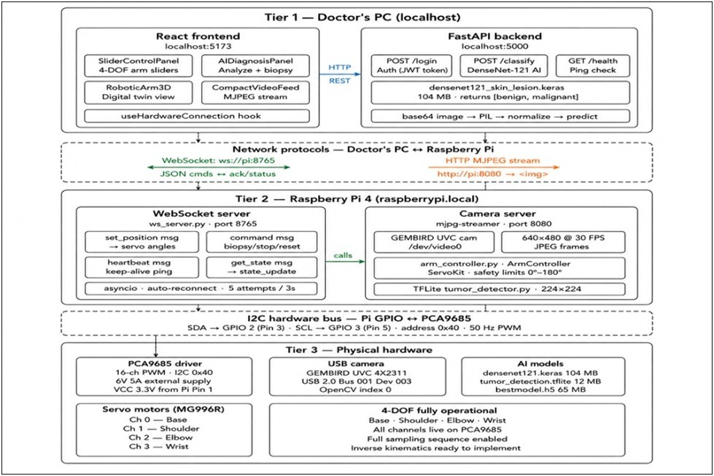
(a) Architecture (b) Integration Diagram
Figure 3.1: MedTwin Pro System Architecture and Design
Architecture Description: Illustrates the hardware/physical and software/digital telemetry feedback loop design. Integration Description: Provides the details on how the physical components (Pi) connect with digital components (WebSocket server)
On every loop iteration with intervals varying between 400 ms and 600 ms, the system analyzes the still image frame against the model and identifies whether any biological abnormality is present in it using the inference confidence rate greater than 60%. In case there is no abnormality, the loop keeps running listening continuously. The presence of an abnormality starts the process of serializing the predictions and bounding box coordinates and sends it to the digital twin update module, where they get rendered using Three.js canvas. Subsequently, a remote operator can use the range sliders to move the arms and send WebSocket payloads to the backend hardware server in the loop.
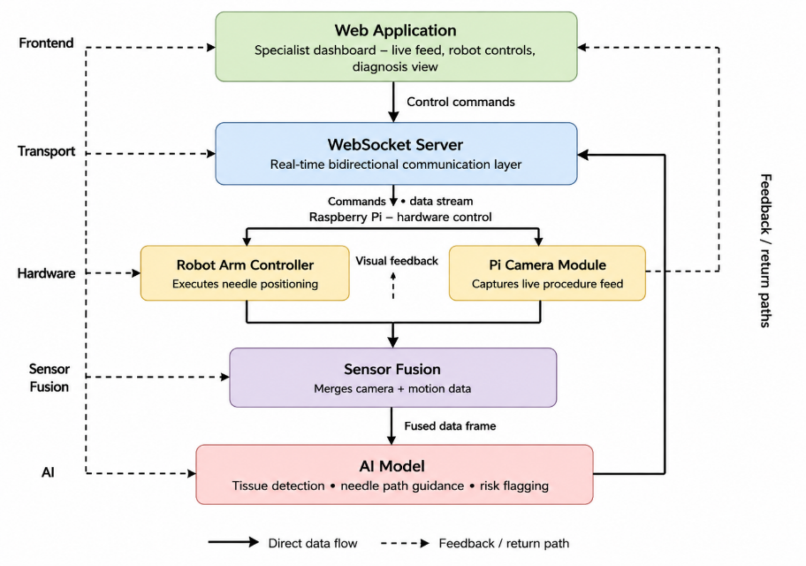

Figure 3.2: System Workflow & Transport Layer Diagram
Explanation: Shows the data flow from camera feed through the inference module to the frontend.

3.3 System Model
This frontend application is made using React and offers the user an integrated dashboard for remote control. The dashboard consists of the sliders that can manipulate the entire four DoFs, a working MJPEG video stream, and the main Three.js canvas with the Digital Twin visualization in real-time. This visualization is synchronized with the real robot arm.
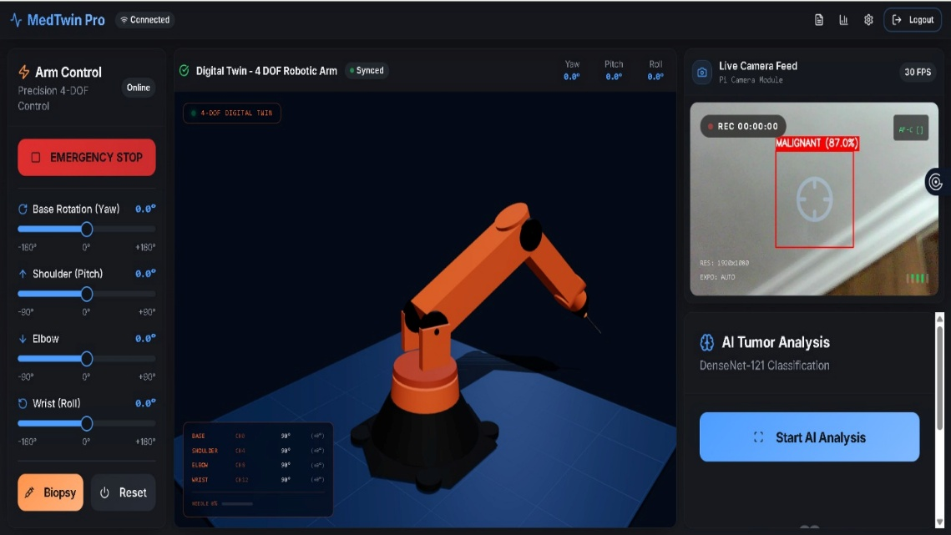
Figure 3.3: The MedTwin Pro Web Application Interface
Explanation: The React-based dashboard integrates 4-DOF slider controls, real-time MJPEG camera streams, and a synchronized 3D Three.js canvas.

3.4 Flowchart
The operational flowchart outlines the step-by-step logic from initial startup, network handshakes, continuous inference looping, and operator intervention.
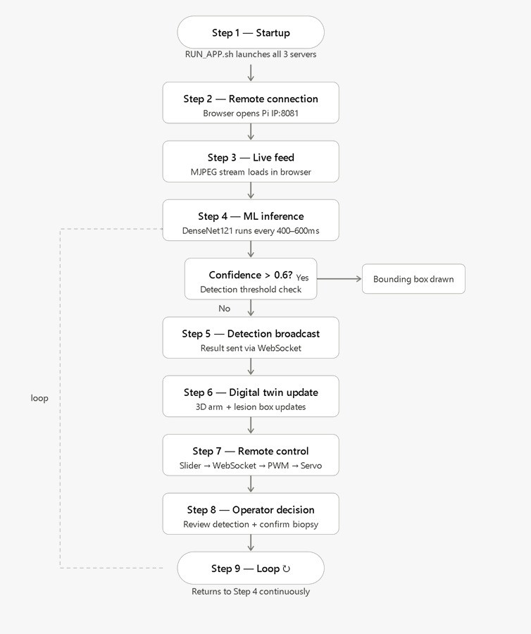
Figure 3.4: Operational Flowchart of MedTwin Pro System
Explanation: Details the step-by-step loop of lesion detection, confidence thresholding, and operator overrides.

3.5 Pseudo code of The Project/Algorithms
The following algorithmic pseudo-code defines the end-to-end integration loop running concurrently on the Raspberry Pi 4 edge controller.
Algorithm 1: End-to-End System Integration Loop
Initialize CameraStream(port=8080)
Initialize WebSocketServer(port=8000)
Initialize PCA9685_Driver(address=0x40, freq=50Hz) Load Model: DenseNet121_Keras.h5
function compute_inverse_kinematics(target_x, target_y, target_z):
// Calculate required angles using iterative Jacobian methods
// Enforce mechanical hardware limits return theta1, theta2, theta3, theta4 function main_event_loop():
while System.IsActive:
frame = CameraStream.read_buffer() processed_frame = preprocess_for_imagenet(frame) prediction, confidence, bbox = Model.predict(processed_frame)
if confidence > 0.6:
broadcast_payload = {
"bbox": bbox,
"class": prediction,
"confidence": confidence
}
WebSocketServer.broadcast(broadcast_payload) target_angles = compute_inverse_kinematics(bbox.x, bbox.y, z_plane)
if Operator.requests_autonomous_targeting():
update_digital_twin_UI(target_angles) if Operator.confirms_safe_path():
pca_pwm = map_angles_to_pwm(target_angles)
PCA9685_Driver.set_pwm_channels(pca_pwm)
delay(400ms) // Throttling for thermal/CPU regulation

3.6 Mathematical Modeling
The MedTwin Pro robotic manipulator possesses four degrees of freedom and includes yaw rotation around the base joint, pitch around shoulder and elbow joints, and roll around the wrist joint. For forward kinematics, it is necessary to define a mathematical equation relating four joint angles to the position of the end-effector in three-dimensional space. With respect to link lengths of l1 = 300 mm, l2 = 250 mm, l3 = 160 mm, and l4 = 72 mm, the work area of the end-effector is spherical up to the distance of 300 mm from the surface where it is mounted.
$$dx = cos(θ1)[l2 cos(θ2) + l3 cos(θ2 + θ3)] + l4 cos(θ1)cos(θ2 + θ3 + θ4) (3.1)$$
$$dy = sin(θ1)[l2 cos(θ2) + l3 cos(θ2 + θ3)] + l4 sin(θ1)cos(θ2 + θ3 + θ4) (3.2)$$
$$dz = l1 + l2 sin(θ2) + l3 sin(θ2 + θ3) + l4 sin(θ2 + θ3 + θ4) (3.3)$$
In equations (3.1)-(3.3), dx and dy are horizontal coordinates of the end-effector in the X-Y plane, and dz is vertical coordinate of the end-effector. Parameters$l1-l4$represent link segment lengths, while $θ1-θ4$represent joint angles of the robot. Equations (3.1)-(3.3) are computed using JavaScript in the frontend environment to update digital twin, and Python in the backend to perform inverse kinematics.
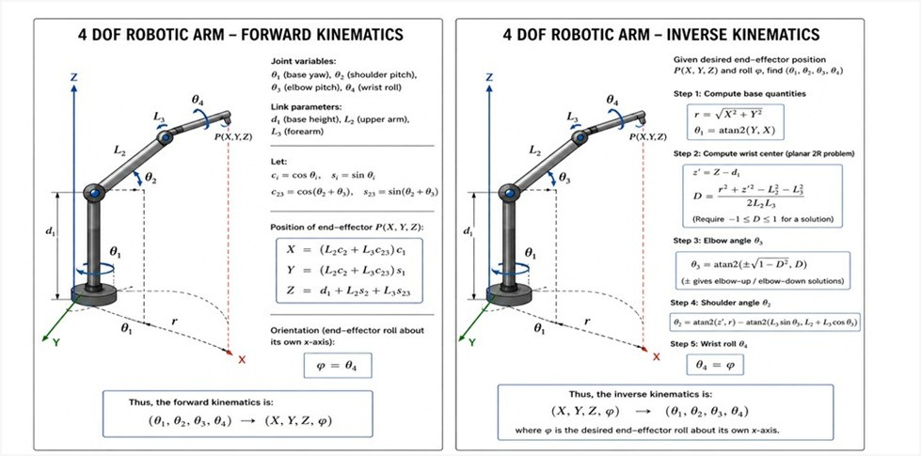
Figure 3.5: Mathematical Model for Forward and Inverse Kinematics
Explanation: Forward kinematics map joint angles to Cartesian coordinates, while inverse kinematics calculate the necessary servo angles to reach a targeted lesion.

3.7 Component Selection
- 1. Raspberry Pi 4 Model B (4 GB RAM): Used as the edge control computer which controls Linux scheduling, dual network connection (TCP/IP & I2C) along with inference tasks using Broadcom BCM2711, Quad-core Cortex-A72 (ARM v8) 64-bit SoC (System on Chip).

- PCA9685 PWM Driver: Chosen for providing a safe connection to Raspberry Pi through I2C protocol, offering 12 bit resolution for sharing 5-6 V supply across 16 channels simultaneously, thus significantly minimizing system level clock jitter for servos.
- Servo Motors MG996R x4: High torque metal geared servos with a stall torque of 10 kg/cm. Selected for their durability in performing tasks like arm motion, but limited to open loop operation which restricts precision to within 1-2 degrees of accuracy.
- Standard USB Webcam: Operates at an optimal matrix of 640x480 resolution. Selected specifically to prevent MJPEG compression throughput from exhausting total network bandwidth over standard 802.11n Wi-Fi local connectivity, maintaining a fluid 25 frames-per-second.
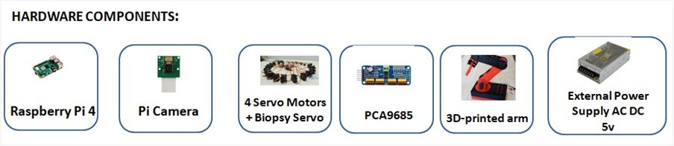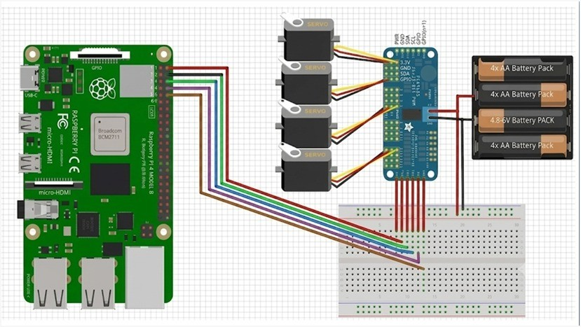
(a) Hardware Components (b) Physical Circuit
Figure 3.6: System Hardware and Wiring
Hardware Explanation: Showcases the selected Raspberry Pi 4, PCA9685 driver, and MG996R servo motors. Circuit Explanation: Details the I2C bus wiring from the Pi GPIO to the servo driver module.
Chapter 4

Results and Simulation

4.1 Simulation Results

4.1.1 Software
Extensive system logging validated the software framework execution times and structural stability across the AI models. Inference evaluations on the Raspberry Pi 4 highlighted a definitive dichotomy between precision and processing times. Utilizing the full Keras standard model resulted in inference latencies averaging between 427 ms and 525 ms. While this introduces marginal UI latency, it provides unmatched predictive accuracy.
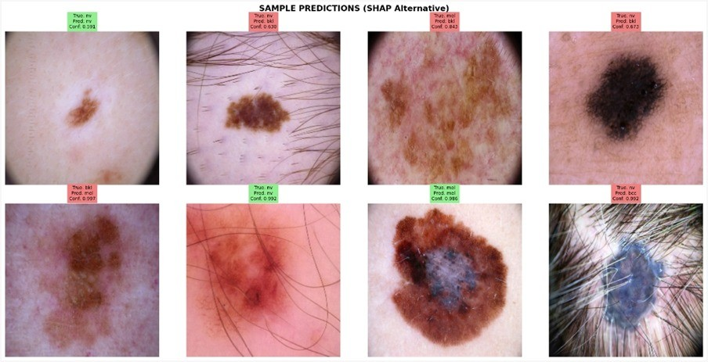
Figure 4.1: Sample Predictions (SHAP Alternative)
Explanation: The visual gradient mapping validates that the DenseNet121 architecture successfully isolates relevant lesion morphology, such as border irregularity and color asymmetry, rather than relying on background noise artifacts.

4.1.2 Hardware
Hardware validation comprised rigorous network synchronization tests. WebSocket round-trip latency was tracked across 500 command execution cycles, hovering around 47ms on average—fully adequate for maintaining seamless 3D synchronization.

4.2 Statistical Analysis
The trained DenseNet121 model was tested against a 15% reserved HAM10000 holdout subset (2,003 images), ensuring absolute zero data leakage.
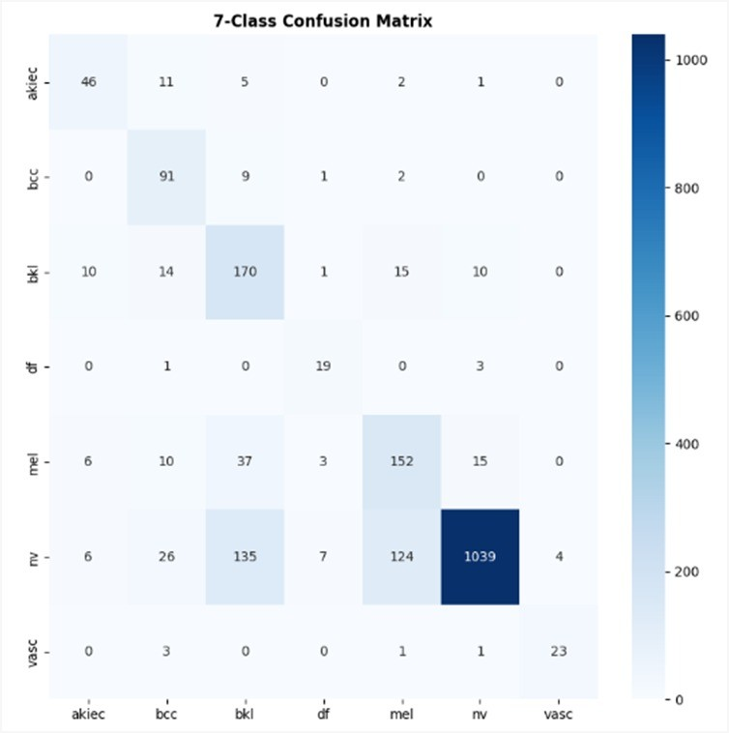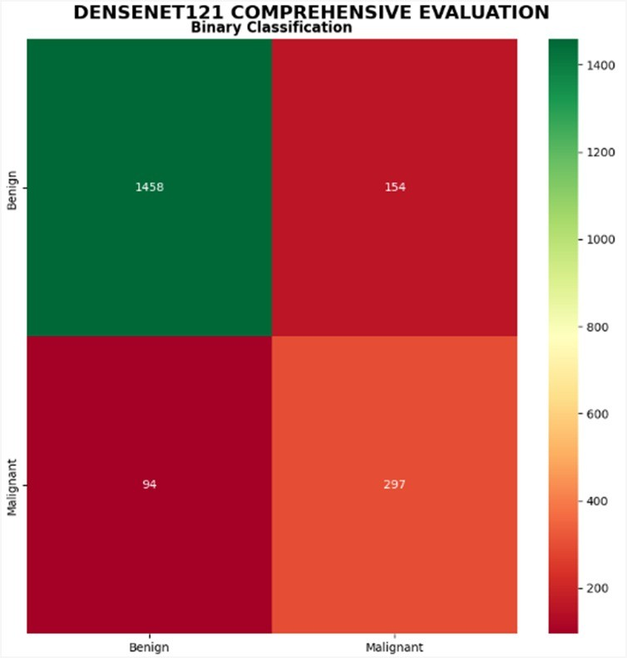
(a) 7-Class Matrix (b) Binary Matrix
Figure 4.2: Confusion Matrix Analysis
7-Class Explanation: Highlights the model’s struggle with under-represented classes, necessitating the shift to a binary approach. Binary Explanation: The binary framework achieves a robust 87.6% accuracy, successfully distinguishing malignant from benign conditions.
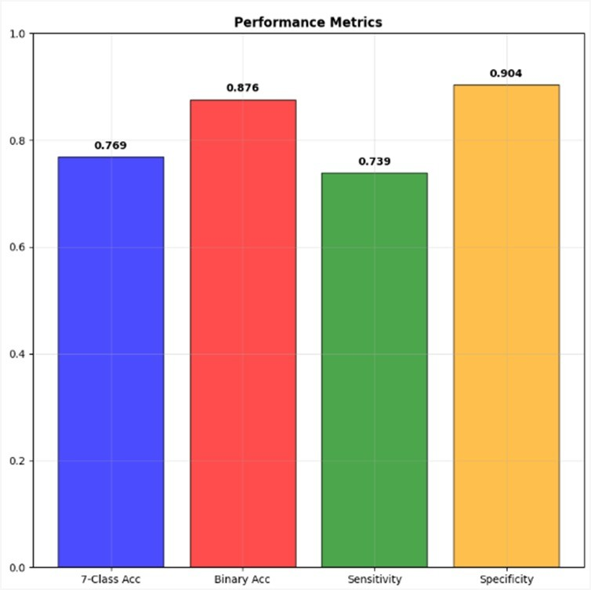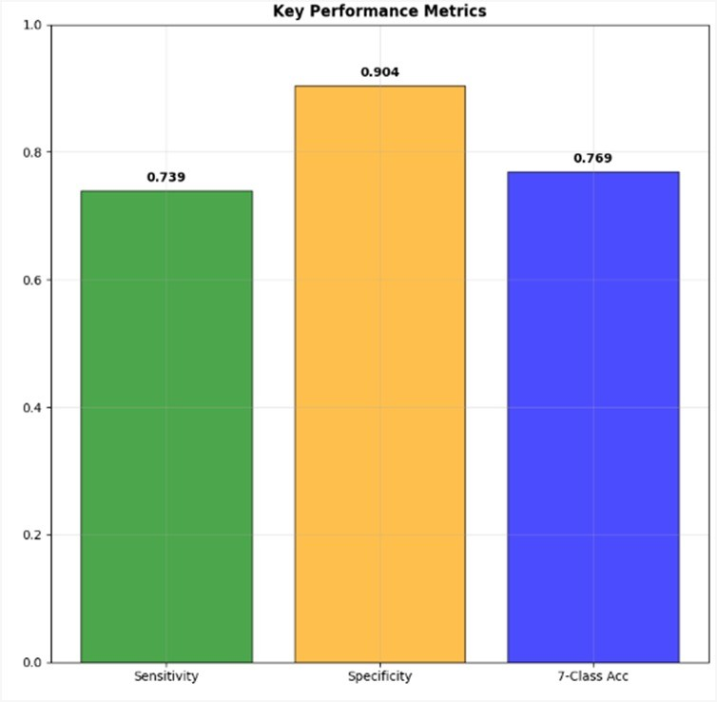
(a) Performance Metrics (b) Key Performance Metrics
Figure 4.3: Diagnostic Metric Breakdown
Metrics Explanation: Confirms stable precision, recall, and F1-score averages across evaluation cycles, validating overall model stability. Key Metrics Explanation: Highlights a malignant sensitivity of 73.9% and specificity of 90.4%, validating the system’s ability to minimize false alarms.
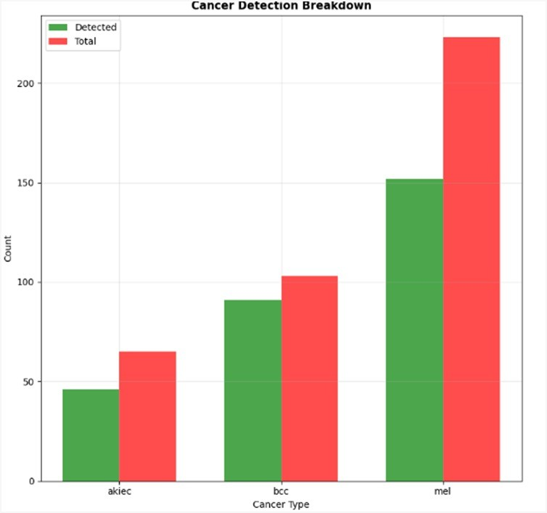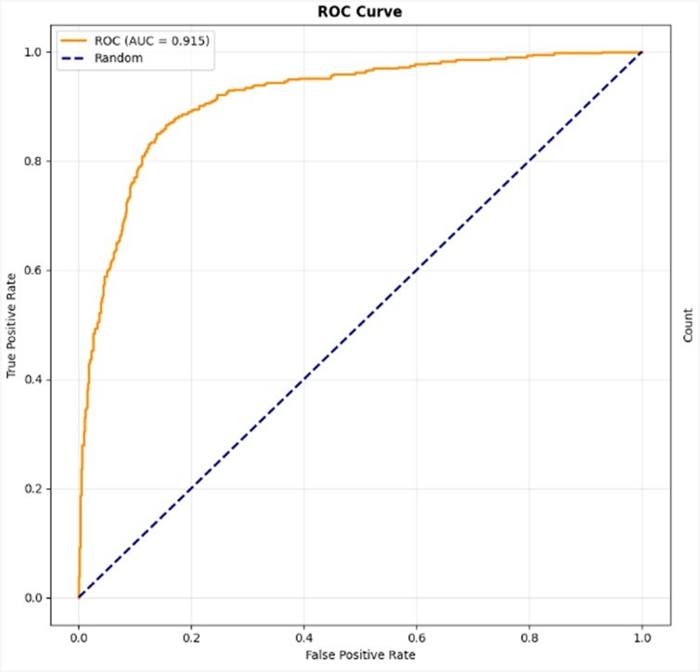
(a) Cancer Detection Breakdown (b) ROC Curve (AUC = 0.915)
Figure 4.4: Detection and Separability Analysis
Breakdown Explanation: Shows accurate predictions favor benign nevi due to training distribution, highlighting a clear need for further augmentation. ROC Explanation: An
AUC of 0.915 confirms excellent separability between malignancy and benign conditions across variable confidence thresholds.
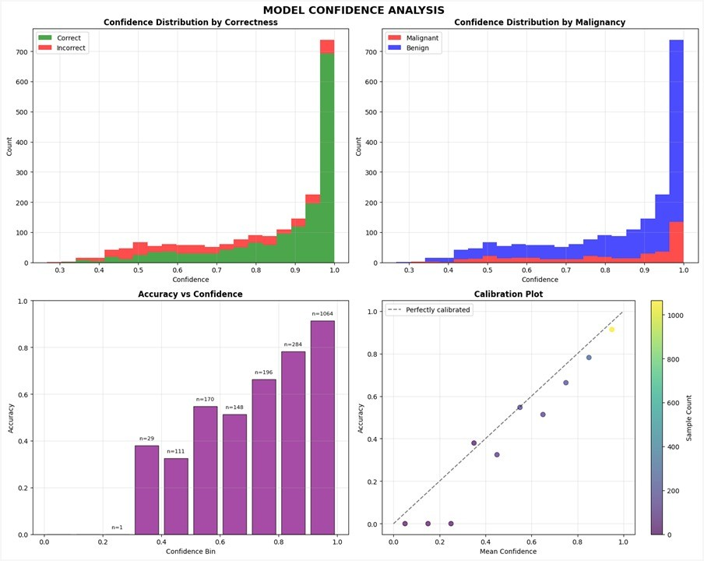
Figure 4.5: Model Confidence Analysis
Explanation: Clustering toward high confidence (¿0.85) proves the model makes classifications with high mathematical certainty, which is essential for triggering the robotic targeting system safely at our 0.60 threshold.

Chapter 5

Conclusion and Future Work

5.1 Conclusion

MedTwin Pro successfully demonstrates that deep learning-based skin lesion classification, real-time digital twin visualization, robotic control, and remote access can be integrated into a single system on affordable edge hardware. The system boasts excellent binary accuracy of 87.6%, along with an AUC of 0.915, which shows that sophisticated clinical reasoning can be achieved without resorting to cloud computing resources. Thanks to synchronization, the 4-DOF hardware communicates bidirectionally with the React/Three.js digital twin browser client within a 50ms latency margin. MedTwin Pro provides a functional, accessible blueprint to bridge geographical gaps between specialist care and rural requirements, operating safely as a ’human-in-the-loop’ pre-screening apparatus.

5.2 Future Work
Though some positive results have been realized structurally, the 73.9% sensitivity rate indicates that more work needs to be done on the algorithm. Future developments should focus on increasing dataset sizes, for example through the implementation of SMOTE and generative models. Mechanically, transitioning from openloop servos to high-torque, encodered stepper motors will afford closed-loop feedback, effectively mitigating current 1.6° positional drift errors. Finally, expanding localized protocols into an end-to-end TLS-encrypted tunnel framework via WebRTC is the recommended next step to satisfy stringent patient data protection mandates.

