Computer Architecture Lab
(EL-2012)
LABORATORY REPORT

Fall 2026

(Lab#2)
Half and Full Adder in Modelsim

Student Name: Talha Hassan khan Roll No: 24i-6012 Section: CE-A

Date performed: _____________, 2026

MARKS AWARDED: ________ / 10

Signature and date of Instructor: _________________
Lab Instructors: Dr. Nasir Ali Shah, Engr. Fasih Ahmad

______________________________________________________________________________________________________________________________________________________

NATIONAL UNIVERSITY OF COMPUTER AND EMERGING SCIENCES, ISLAMABAD
Prepared by: | Fasih Ahmad |  | Version: 1.0
Verified by: | Dr. Nasir Ali Shah |  | Updated: Fall 2026

Task 1:

Description:
In this task, I designed the Half Adder and Full Adder using Verilog HDL. I implemented both circuits using Gate Level and Dataflow Level modeling. I also wrote testbenches to simulate the designs and verify their outputs for different input combinations.

Code:
HALF ADDER

module half_adder_gate(sum, carry, a, b);
input a, b;
output sum, carry;

xor(sum, a, b);
and(carry, a, b);

endmodule

module half_adder_dataflow(sum, carry, a, b);

input a, b;
output sum, carry;

assign sum = a ^ b;
assign carry = a & b;

endmodule

module testbench();

reg a;
reg b;

wire sum_gate;
wire carry_gate;

wire sum_data;
wire carry_data;

half_adder_gate HA1(sum_gate, carry_gate, a, b);

half_adder_dataflow HA2(sum_data, carry_data, a, b);

initial begin

a=0; b=0; #50;
a=0; b=1; #50;
a=1; b=0; #50;
a=1; b=1; #50;

end

endmodule

FULL ADDER

module half_adder(sum, carry, a, b);

input a, b;
output sum, carry;
xor(sum, a, b);
and(carry, a, b);
with dataflow
//assign sum=a^b;
//assign carry=a&b;

endmodule

module full_adder(sum, carry, a, b, cin);

input a, b, cin;
output sum, carry;

wire s1;
wire c1;
wire c2;

half_adder HA1(s1, c1, a, b);
half_adder HA2(sum, c2, s1, cin);
or(carry, c1, c2);
//assign carry=c1|c2;

endmodule

module testbench();
reg a;
reg b;
reg cin;

wire sum;
wire carry;

full_adder FA1(sum, carry, a, b, cin);

initial begin

a=0; b=0; cin=0; #50;
a=0; b=0; cin=1; #50;
a=0; b=1; cin=0; #50;
a=0; b=1; cin=1; #50;
a=1; b=0; cin=0; #50;
a=1; b=0; cin=1; #50;
a=1; b=1; cin=0; #50;
a=1; b=1; cin=1; #50;

end

endmodule

Output:
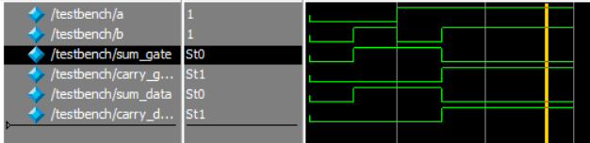
Full ADDER
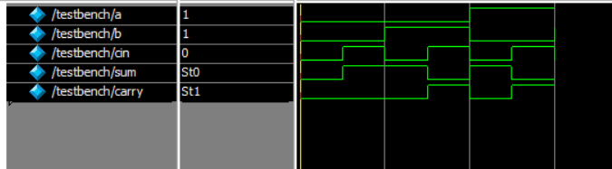
Half ADDER
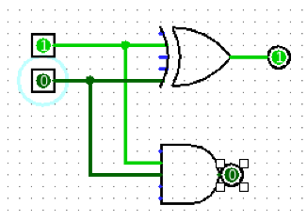
Full Adder
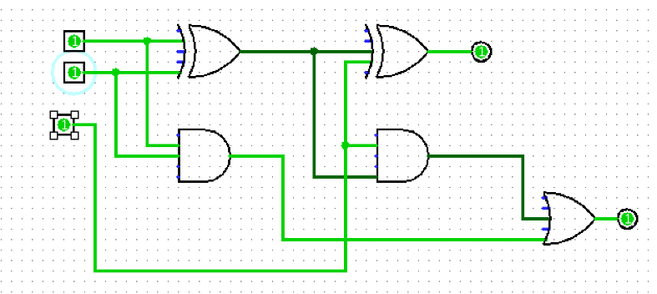

Task 2:

Description:
In this task, I designed a 3×8 Decoder using Verilog HDL. The circuit was implemented using both Gate Level and Dataflow Level modeling. I created a testbench to simulate the decoder and checked the output for different input combinations.

Code:
module decoder_3X8(a,b,c,y0,y1,y2,y3,y4,y5,y6,y7);
input a,b,c;
output y0,y1,y2,y3,y4,y5,y6,y7;

wire na;
wire nb;
wire nc;

not(na,a);
not(nb,b);
not(nc,c);

and(y0,na,nb,nc);
and(y1,na,nb,c);
and(y2,na,b,nc);
and(y3,na,b,c);
and(y4,a,nb,nc);
and(y5,a,nb,nc);
and(y6,a,b,nc);
and(y7,a,b,c);
endmodule

module testbench();
reg a;
reg b;
reg c;

wire y0;
wire y1;
wire y2;
wire y3;
wire y4;
wire y5;
wire y6;
wire y7;

decoder_3X8 uut(a,b,c,y0,y1,y2,y3,y4,y5,y6,y7);

initial begin

a=0; b=0; c=0; #50;
a=0; b=0; c=1; #50;
a=0; b=1; c=0; #50;
a=0; b=1; c=1; #50;
a=1; b=0; c=0; #50;
a=1; b=0; c=1; #50;
a=1; b=1; c=0; #50;
a=1; b=1; c=1; #50;

end

endmodule
WITH DATAFLOW

module decoder_3X8(a,b,c,y0,y1,y2,y3,y4,y5,y6,y7);
input a,b,c;
output y0,y1,y2,y3,y4,y5,y6,y7;

wire na;
wire nb;
wire nc;

assign na=~a;
assign nb=~b;
assign nc=~c;

assign y0=na&nb&nc;
assign y1=na&nb&c;
assign y2=na&b&nc;
assign y3=na&b&c;
assign y4=a&nb&nc;
assign y5=a&nb&c;
assign y6=a&b&nc;
assign y7=a&b&c;

endmodule

module testbench();
reg a;
reg b;
reg c;

wire y0;
wire y1;
wire y2;
wire y3;
wire y4;
wire y5;
wire y6;
wire y7;

decoder_3X8 uut(a,b,c,y0,y1,y2,y3,y4,y5,y6,y7);

initial begin

a=0; b=0; c=0; #50;
a=0; b=0; c=1; #50;
a=0; b=1; c=0; #50;
a=0; b=1; c=1; #50;
a=1; b=0; c=0; #50;
a=1; b=0; c=1; #50;
a=1; b=1; c=0; #50;
a=1; b=1; c=1; #50;

end

endmodule

Output:
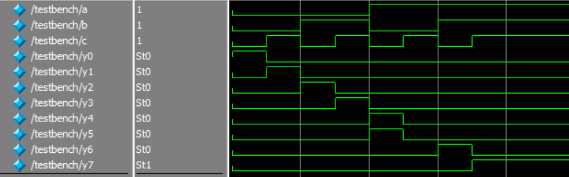
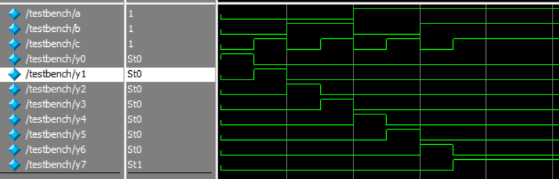

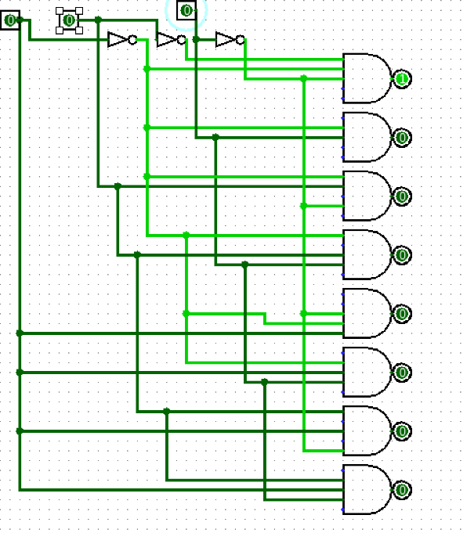

Task 3:

Description:
In this task, I designed an 8×1 Multiplexer using Verilog HDL. I implemented the multiplexer using Gate Level and Dataflow Level modeling. A testbench was written to simulate the circuit and verify that the correct input was selected for different select-line combinations.

Code:
module MUX8x1(i0,i1,i2,i3,i4,i5,i6,i7,s0,s1,s2,y);

input i0,i1,i2,i3,i4,i5,i6,i7;
input s0,s1,s2;
output y;

wire ns0,ns1,ns2;
wire w0,w1,w2,w3,w4,w5,w6,w7;

not(ns0,s0);
not(ns1,s1);
not(ns2,s2);

and(w0,i0,ns2,ns1,ns0);
and(w1,i1,ns2,ns1,s0);
and(w2,i2,ns2,s1,ns0);
and(w3,i3,ns2,s1,s0);
and(w4,i4,s2,ns1,ns0);
and(w5,i5,s2,ns1,s0);
and(w6,i6,s2,s1,ns0);
and(w7,i7,s2,s1,s0);

or(y,w0,w1,w2,w3,w4,w5,w6,w7);

endmodule
module testbench();

reg i0,i1,i2,i3,i4,i5,i6,i7;
reg s0,s1,s2;

wire y;

MUX8x1 uut(i0,i1,i2,i3,i4,i5,i6,i7,s0,s1,s2,y);

initial begin

i0=0; i1=1; i2=0; i3=1;
i4=0; i5=1; i6=0; i7=1;

s2=0; s1=0; s0=0; #50;
s2=0; s1=0; s0=1; #50;
s2=0; s1=1; s0=0; #50;
s2=0; s1=1; s0=1; #50;
s2=1; s1=0; s0=0; #50;
s2=1; s1=0; s0=1; #50;
s2=1; s1=1; s0=0; #50;
s2=1; s1=1; s0=1; #50;

end

endmodule

Dataflow
module MUX8x1(i0,i1,i2,i3,i4,i5,i6,i7,s0,s1,s2,y);

input i0,i1,i2,i3,i4,i5,i6,i7;
input s0,s1,s2;
output y;

wire ns0,ns1,ns2;
wire w0,w1,w2,w3,w4,w5,w6,w7;

assign ns0 = ~s0;
assign ns1 = ~s1;
assign ns2 = ~s2;

assign w0 = i0 & ns2 & ns1 & ns0;
assign w1 = i1 & ns2 & ns1 & s0;
assign w2 = i2 & ns2 & s1 & ns0;
assign w3 = i3 & ns2 & s1 & s0;
assign w4 = i4 & s2 & ns1 & ns0;
assign w5 = i5 & s2 & ns1 & s0;
assign w6 = i6 & s2 & s1 & ns0;
assign w7 = i7 & s2 & s1 & s0;

assign y = w0 | w1 | w2 | w3 | w4 | w5 | w6 | w7;

endmodule

module testbench();

reg i0,i1,i2,i3,i4,i5,i6,i7;
reg s0,s1,s2;

wire y;

MUX8x1 uut(i0,i1,i2,i3,i4,i5,i6,i7,s0,s1,s2,y);

initial begin

i0=0; i1=1; i2=0; i3=1;
i4=0; i5=1; i6=0; i7=1;

s2=0; s1=0; s0=0; #50;
s2=0; s1=0; s0=1; #50;
s2=0; s1=1; s0=0; #50;
s2=0; s1=1; s0=1; #50;
s2=1; s1=0; s0=0; #50;
s2=1; s1=0; s0=1; #50;
s2=1; s1=1; s0=0; #50;
s2=1; s1=1; s0=1; #50;

end

endmodule

Output:
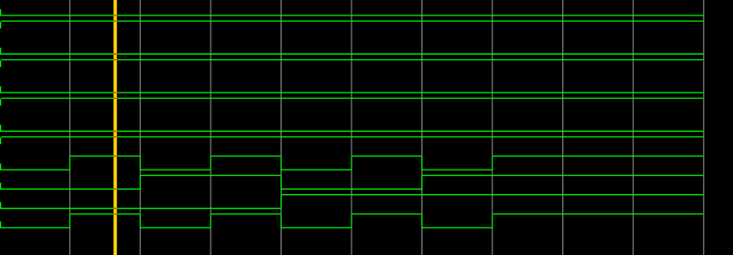
Multiplexer

