

Hollywood strikes force Vue cinema chain into fresh debt restructuring

**Vue International, Europe's largest independent cinema operator, is finalising a fresh debt restructuring after the Hollywood actors' strike halted the release of a string of blockbuster movies.**

Sky News has learnt that UK-based Vue, its shareholders and lenders are in the process of organising the company's second debt-for-equity swap in 18 months in a bid to put the business on a sustainable long-term footing.

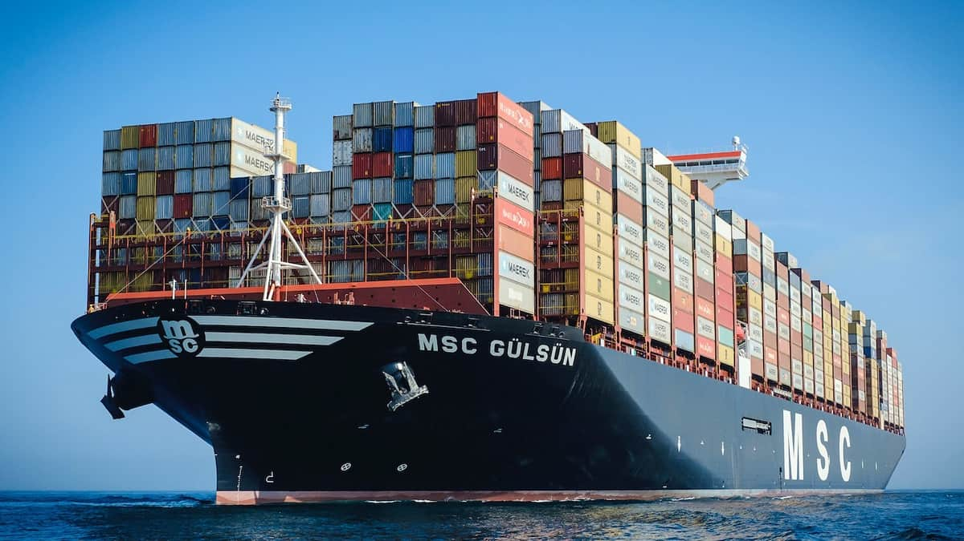

# Shipping costs are more than 300% up as Suez crisis deepens

There are growing fears of the economic implications of the continued disruption to shipping caused by the Houthi attacks on container ships, with Tesla among the latest companies to take a hit.

Shipping costs have risen by more than 300% since November amid the disruption caused to freight in the Red Sea from attacks, according to fresh data.



# Economy grew by 0.3% in November but recession remains a threat

There are early indications that Black Friday sales contributed to a recovery in UK growth in November but the data continues to show a picture of flatlining growth.

The UK economy returned to growth in November, according to official figures that are being closely watched amid fears the prospect of recession remains on a knife edge.

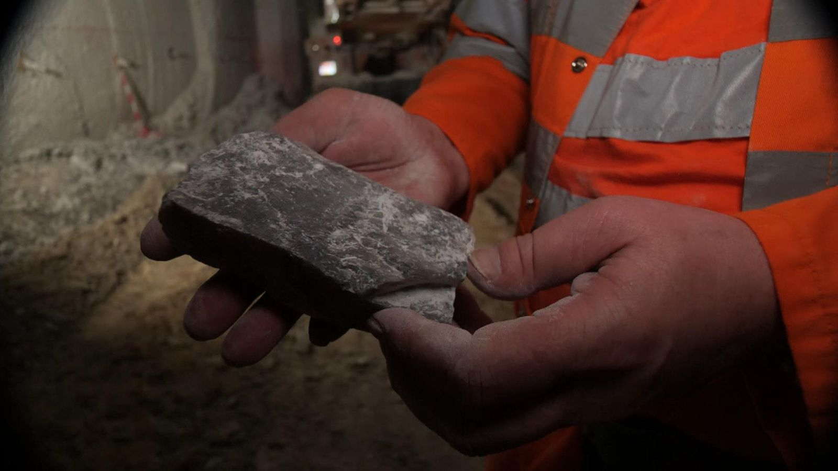

# More than 1km under the North Sea is a climate-friendly mineral that could help feed the world

Polyhalite is like a thick crumbly slate and is made up of potassium, magnesium, calcium and sulphur. These minerals all nourish crops, especially potatoes, vegetables and fruit.

What lies 1,000 metres beneath the North Sea could help the climate of the atmosphere above. And I'm on my way down to see it.

The rattly lift drops at 10 metres per second, the speed of a sprinter, ruffling the air and flapping my shorts as it plunges down. Yes shorts.



# Boeing faces additional safety scrutiny amid 'other manufacturing problems'

Regulators are to check processes at Boeing more widely as the vast majority of 737 MAX 9 aircraft remain grounded due to the panel blowout in a plane above Oregon last week.

US flight safety regulators are to intensify their scrutiny of Boeing in the wake of the mid-air panel blowout a week ago aboard one of the company's planes.

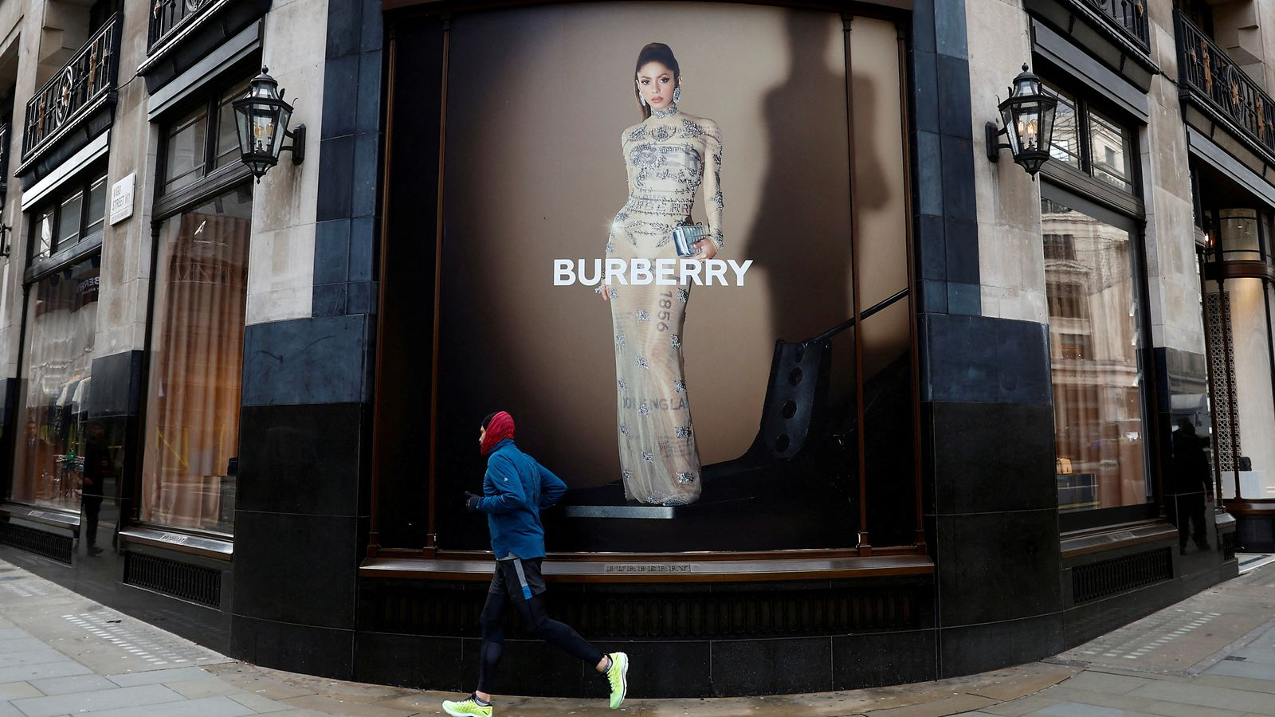

# Burberry issues second profit warning in three months after tough Christmas

Shares suffer their biggest one-day fall since 2012 at one stage as luxury shoppers tighten their belts further, with other headwinds also set to harm profits.

Burberry shares have fallen sharply after the luxury brand said it had failed to see the global pick-up in demand it had hoped for over the crucial Christmas season.

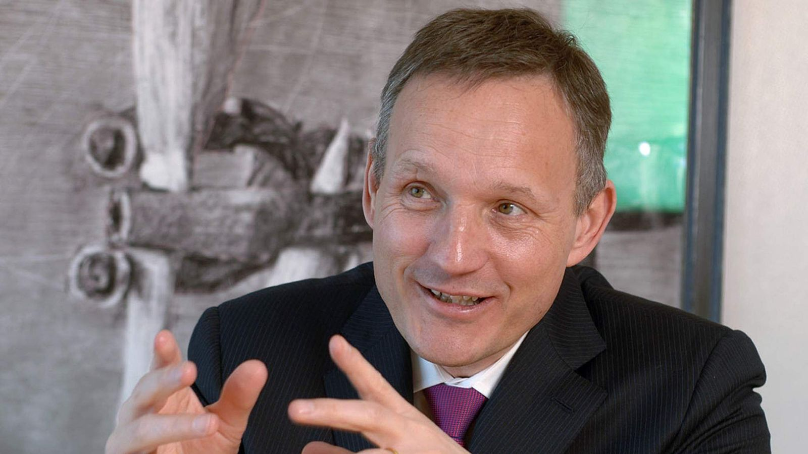

# Former Barclays CEO Jenkins raises $50m for fintech 10X

10X Banking Technology, which was founded by Antony Jenkins in 2016, has raised tens of millions of pounds in a funding round led by existing backers, Sky News learns.

The fintech business founded by Antony Jenkins, the former Barclays chief executive, has secured $50m in a fresh injection of capital from investors.

Sky News has learnt that 10X Banking Technology recently closed its first funding round since 2021 with new money understood to have been provided by existing shareholders in the company.

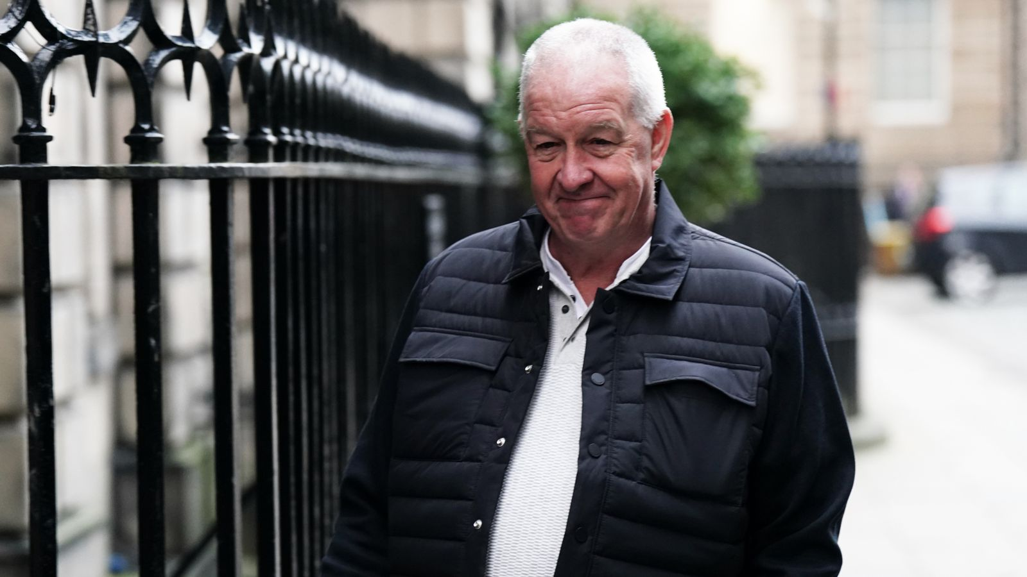

# Post Office scandal: Scottish victims placed in 'intolerable' position, court told

Around 100 Scots were criminalised due to the faulty computer system but only four have so far been successful in overturning their convictions.

A court has been told Scottish sub-postmasters who were given a criminal record as a result of the Post Office scandal have been placed in an "intolerable" position by politicians promising to pardon victims.

Around 100 Scots were criminalised due to the faulty computer system but only four have so far been successful in overturning their convictions.