AI Usage DISCLOSURE FORM

1. Team Details
Team Name: ClawReachAi
Project / Product Name: ClawReach
Organization / Institution (if any): Ramaiah Institute of Technology
Submission Date: 8th May 2026

2. AI Usage Declaration
Did your team use any Artificial Intelligence (AI) in developing this project? Yes / No
Yes

3. Purpose of AI Usage ( Brief Details)
Idea generation / brainstorming : Small initial brainstorming was done using AI
Code generation or assistance: Prototype skill python files were ai generated
UI / UX design : Dashboard frontend coding was coded in with ai, but designed by team members
Content creation: No ai used
Data analysis: No ai used
Testing / debugging: No ai used

4. Feature Origin Classification ( Please add/delete based on the number of the feature)
Feature Name Next.js AI Bouncer (Brief Extraction) 2. Self-Generated/AI-Generated/Both Both 3. Description * AI Tools/Platform Used: Vercel AI SDK, Gemini 2.5 Flash, Next.js.
- Prompt Used: "The LLM is struggling with the single-tool architecture. Refactor app/api/chat/route.ts using the Two-Tool Routing pattern and force toolChoice: 'required' to extract Brand, Target Audience, Creator Profile, Campaign Goal, Target Location."
- Output Summary: A conversational UI that successfully extracts a structured 5-pillar JSON brief (plus min/max subscriber counts) and inserts it into a Supabase database.
- Modification: Transitioned from a single-tool setup (which caused empty tool call errors) to a strict two-tool routing system (askForMissingInfo and finalizeBrief) to completely eliminate hallucination and force data collection.

1. Feature Name Heartbeat Bridge Orchestrator 2. Self-Generated/AI-Generated/Both Both 3. Description * AI Tools/Platform Used: Python, Supabase Client, OpenClaw Framework.
- Prompt Used: "I want it to have a heartbeat, in which it checks campaign table in supabase but the filter can be if the created at is of the same day... and then start executing the skills."
- Output Summary: A lightweight Python listener (heartbeat_bridge.py) that polls the database every 5 seconds for new campaigns, prevents double-execution by immediately locking the status, and triggers the OpenClaw agent.
- Modification: Added a UTC date-time filter (.gte("created_at", today_start)) and a .limit(1) modifier to optimize database querying and ensure the worker only processes fresh, relevant campaigns without overloading memory.

1. Feature Name YouTube Discovery Skill (Lead Generation) 2. Self-Generated/AI-Generated/Both Both 3. Description * AI Tools/Platform Used: Python, YouTube Data API v3.
- Prompt Used: "Update the discover_active_channels.py code to now check for the sub filter too."
- Output Summary: An automated script (discover_active_channels.py) that searches YouTube based on the brief's location and niche, returning a pristine JSON array of 10 channels.
- Modification: Integrated a "Filter Gauntlet" that deduplicates leads against the existing Supabase database, checks for recent upload activity (within 365 days), and drops channels outside the user's requested subscriber range.

1. Feature Name Concurrent AI Description Analysis 2. Self-Generated/AI-Generated/Both Both 3. Description * AI Tools/Platform Used: Python, concurrent.futures, Google Generative AI (Gemma 4 31b).
- Prompt Used: "Make the 2nd skill file, explain what this takes as input and what it does and its output."
- Output Summary: An enrichment script (analyze_descriptions.py) that takes the 10 discovered channels, scrapes their latest video descriptions, and outputs an enriched JSON array containing extracted emails and current brand sponsors.
- Modification: Implemented Python ThreadPoolExecutor to process all 10 channels simultaneously instead of sequentially. Truncated text inputs to the first 1000 characters and used Regex for email extraction to save LLM context window limits and execution time.

1. Feature Name Real-time UI Dashboard Updates 2. Self-Generated/AI-Generated/Both Both 3. Description * AI Tools/Platform Used: Next.js, Supabase Realtime (WebSockets), Python.
- Prompt Used: "Give the code for the 3rd skill file (save_to_database.py)."
- Output Summary: An end-to-end data pipeline where the Python worker upserts influencer data and writes to the outreach_logs table, which instantly triggers the Next.js frontend to render the creator cards on the user's screen.
- Modification: Separated the Bouncer's "Searching" state from the final result rendering. Designed the Python script to act as the ultimate trigger for the UI by utilizing database insertion events rather than relying on standard HTTP response times.

5. Ethical & Compliance Confirmation
AI usage complies with guidelines and policies. Yes
No proprietary or copyrighted data misused. I Agree

6. Declaration & Sign-Off
Name of Team Representative: Mohamed Talha Natherma
Role: Team Engineer
Signature:
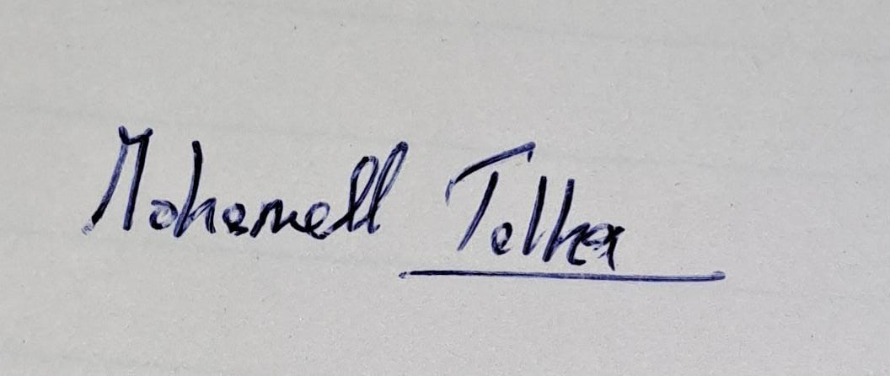
Date: 8/5/2026

