Table of Contents

iScripts eSwap Installation Guide ............................................................2
System Requirements................................................................................3
Install Checklist ........................................................................................4
Installation.................................................................................................5-6
Upgrade................................................................................................….7-8

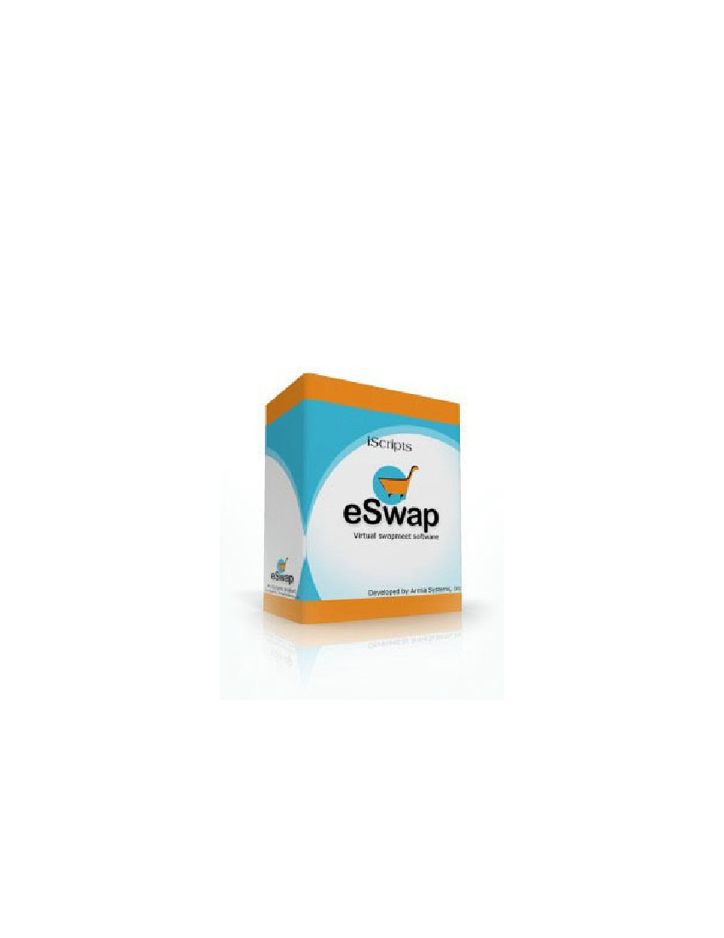

iScripts eSwap Installation Guide

Last Updated 18th November 2020

System Requirements

Linux/Windows
PHP 5.6 or greater
MySQL database server 5.0 or greater
Apache or IIS5/6 Web Server

Other settings

SendMail - (Yes)
PHP safe mode - (OFF)
PHP open_basedir - (OFF)
CURL extension - (Yes)
Port 1129 to be opened (For First Data Payment Gateway)

Install Checklist

1. Create a new MySQL database with new user that has full rights to it.
2. Upload iScripts eSwap files.
3. Run install script.
4. Delete install directory.
5. Customize as desired.
6. Test.
7. Go Live!

Installation

Create Database

Create a new MySQL database and new user with full rights to the database.
Check with your server's control panel documentation for details on how to create databases on your system.

Upload files

Unzip the iScripts eSwap full install zip file with paths in your computer. Upload all files maintaining the directory structure.
OR
Upload the iScripts eSwap full install zip file and unzip on your server. If you do this, be sure your files are owned by the user who owns the site.

Run the install script

Open a new browser window. Surf to http://[your_ iScripts eSwap_domain]/install/install.php (Substitute your domain name for [your_iScripts eSwap_domain])

Step 1:

The first screen contains 4 sections

1. License Key Section
2. Database Details section
3. Site Details section
4. Display & Image Settings section
5. Administration Details section

License Key Section

Enter the same license key you received at the time of purchase

Database Details section

This section displays the following fields to fill

a. Database Server Hostname – enter the hostname of your database server.
b. Database Name – name of your database.
c. Database User Name – database username.
d. Database Password – database password.
e. Database Prefix – specify a name as table prefix.

Site Details section

Enter the name of the site corresponding to the field ' Site Name '

Display & Image Settings section

Browse the site logo

Administration Details section

Site administration details are recorded in this section. It displays the following fields

a. Admin Login Name – administrator login name
b. Admin Password – administrator password
c. Confirm Admin Password – confirm the administrator password by reentering here
d. Admin Email – email address of the administrator

Click on the “continue” button to go to step2

Step 2:

If the installation is successful you will get the following message

“Congratulations! The Installation Process is completed successfully! ”

iScripts eSwap installation is complete!
Remove or rename and relocate the install directory. This is a security measure, you don't want anyone surfing to it.

Upgrade

From version 1.0 to version 2.1

Run the upgrade script

Open a new browser window. Surf to http://[your_ iScripts eSwap_domain]/upgrade/index.php (Substitute your domain name for [your_ iScripts eSwap_domain])

Step 1:

Click the continue button after giving the correct permissions to folders and files

Step 2:

If the upgradation is successful you will get the following message

“Congratulations! The Upgradation Process is completed successfully!”

iScripts eSwap upgradation is complete!

Remove or rename and relocate the upgrade directory. This is a security measure, you don't want anyone surfing to it.

From version 2.0 to version 2.1

Run the upgrade script

Open a new browser window. Surf to http://[your_ iScripts eSwap_domain]/upgrade2.0/index.php (Substitute your domain name for [your_ iScripts eSwap_domain])

Step 1:

Click the continue button after giving the correct permissions to folders and files

Step 2:

If the upgradation is successful you will get the following message

“Congratulations! The Upgradation Process is completed successfully!”

iScripts eSwap upgradation is complete!

Remove or rename and relocate the upgrade2.0 directory. This is a security measure, you don't want anyone surfing to it.

From version 2.1 to version 2.2

Run the upgrade script

Backup your site and database. Copy all the files of the pack 2.2 (except pics folder, banners folder, pem folder, logo image [in image folder], config.php file [in includes folder]) to the site location. Open a new browser window. Surf to http://[your_ iScripts eSwap_domain]/upgrade2.2/index.php (Substitute your domain name for [your_ iScripts eSwap_domain])

Step 1:

Click the continue button after giving the correct permissions to folders and files

Step 2:

If the upgradation is successful you will get the following message

“Congratulations! The Upgradation Process is completed successfully!”

iScripts eSwap upgradation is complete!

Remove or rename and relocate the upgrade2.2 directory. This is a security measure, you don't want anyone surfing to it.

From version 2.2 to version 2.3

Run the upgrade script

Backup your site and database. Copy all the files of the pack 2.3 (except pics folder, banners folder, pem folder, logo image [in image folder], config.php file [in includes folder]) to the site location. Open a new browser window. Surf to http://[your_ iScripts eSwap_domain]/upgrade2.3/index.php (Substitute your domain name for [your_ iScripts eSwap_domain])

Step 1:

Click the continue button after giving the correct permissions to folders and files

Step 2:

If the upgradation is successful you will get the following message

“Congratulations! The Upgradation Process is completed successfully!”

iScripts eSwap upgradation is complete!

Remove or rename and relocate the upgrade2.3 directory. This is a security measure, you don't want anyone surfing to it.

