BUIlding integration services

3.1 Overview

In this exercise, we experience creating integrations to use in BAW processes. Thanks to the simplicity of the development approach of IBM Business Automation Workflow, in the second lab we were able to develop the process without worrying about integrating it with back-end systems or external services. One could imagine, though, that our integration team has been working on toolkits that allow us to connect to back-end services. Additionally, we may also want to expose our own automation services, allowing external systems a simple way to connect to our BAW applications via a simple REST call.
Let’s get started!

Environment setup

Your environment should be up and running before you continue with this lab. Your instructor probably did this setup ahead of time. If you are unsure, please ask your instructor.
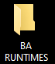
- In addition to the BAW runtime, we will also need the Operational Decision Manager environment up and running. From your Desktop open BA RUNTIMES, and then double-click on the ODM Server START icon:
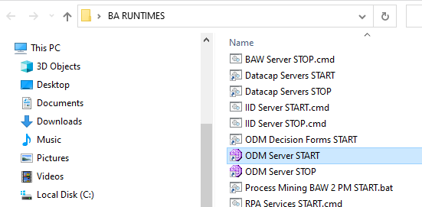
- Wait for the ODM Server to be ready:
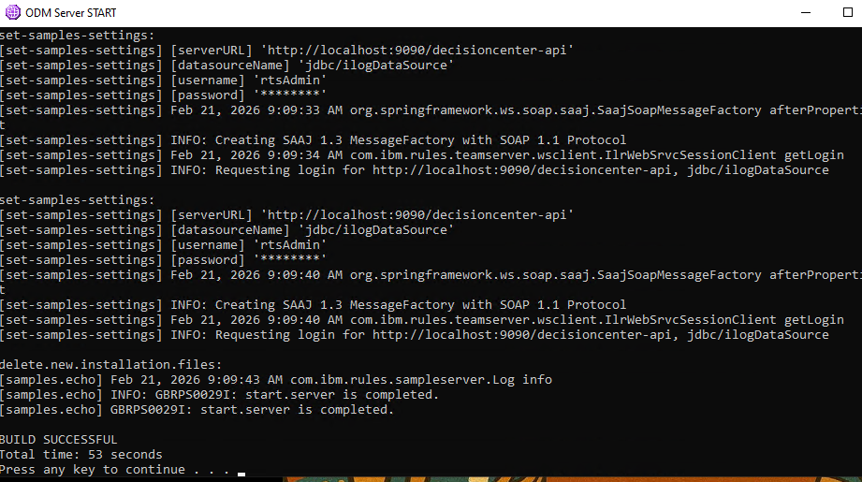
- Open Chrome web browser, and log in to the Workflow Center from bookmarks toolbar BAW Workflow Center - Solutions (https://ibmbaw:9443/WorkflowCenter).
- As in previous lab, navigate to the Toolkits page by clicking on HamburgerProcess appsToolkits
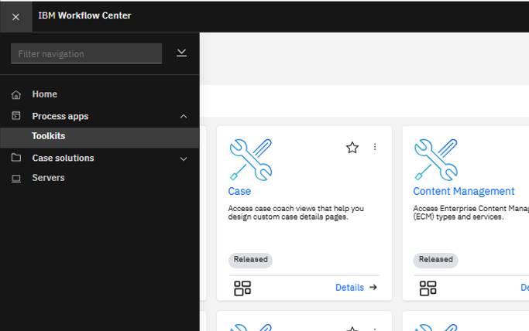

Create an Integration Toolkit with integration services

Toolkits are used to share libraries of reusable assets across multiple process applications. Integration services are often contained in these toolkits. We will now create a new toolkit that will contain our integration to a downstream service.

Create a toolkit

- On the Toolkit page, click Create:
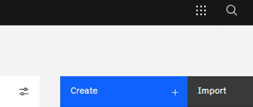

- Provide the toolkit name as “ODM Integrations”. Click Create while keeping Open in Designer selected.
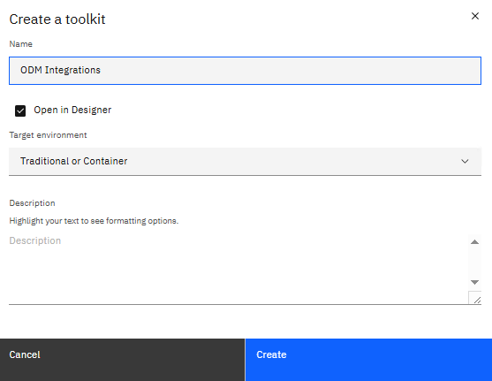
- Once created, the toolkit opens in the designer.
- We now want to connect to an external service an import it into our Toolkit. Hover over the Services menu item in the toolkit, and click on the :.
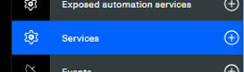

- Select the External service menu option:
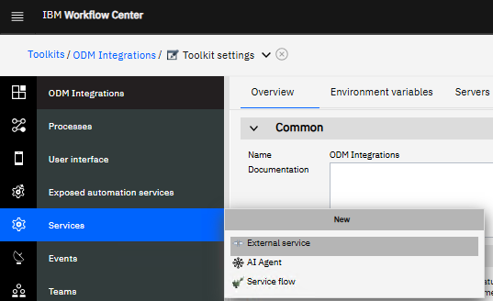

- Select the Jave, REST or web service option:
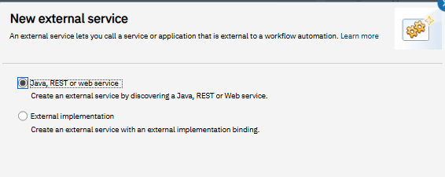

Create the credit score web service

- You can import REST, SOAP, or Java Services. Java services are loaded from a jar file you add to the toolkit via the Files section. In this example, we will be connecting to a REST service exposed from the ODM Server.
- Select REST service from URL in the selection list, and then click Next:
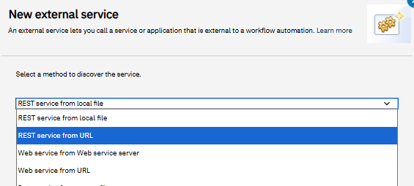

- Enter the following tURL:
http://localhost:9090/DecisionService/rest/v1/my_deployment/my_operation/OPENAPI?format=JSON&security=basic
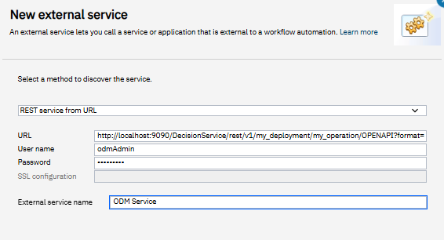
- This is the URL of a deployed Decision Service on the ODM Server. Complete the fields using odmAdmin as the username and password, and ODM Service as your service name:

- Click Next. You should see the following:
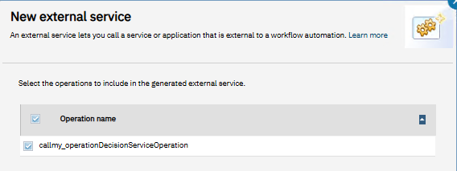

- Click Next again. You should see the following:
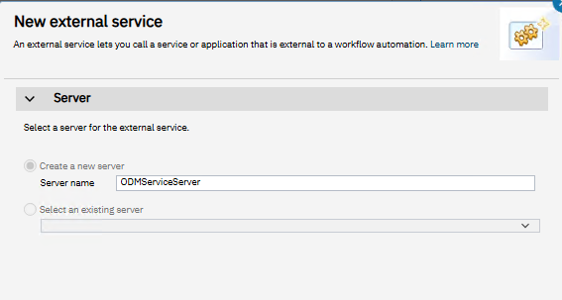
- Click Finish and the service should be created:
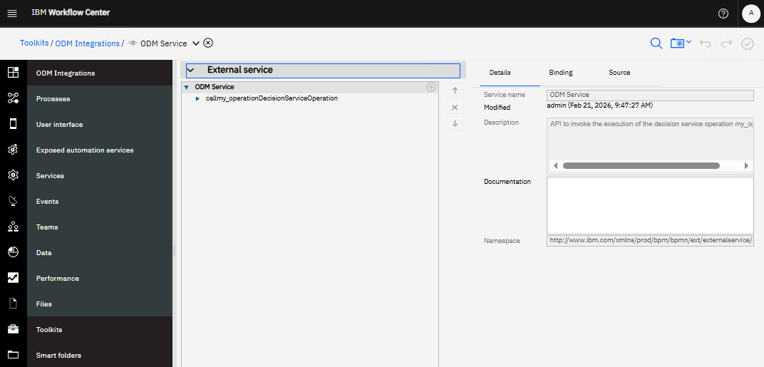

- Open the Toolkit settings page by clicking on the down arrow next to your service name and selecting Toolkit settings:
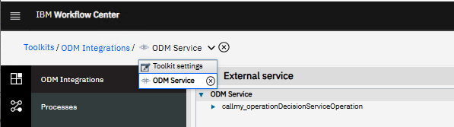

- Now click on the Servers tab:
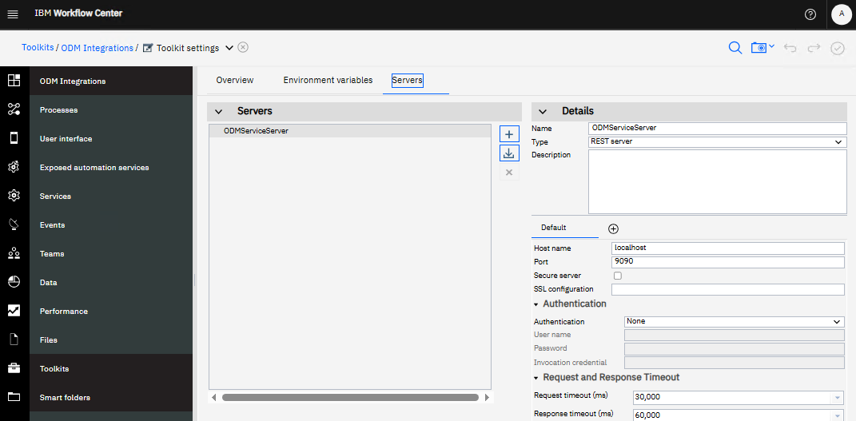
- Choose HTTP Authentication as the authentication mechanism and provide username odmAdmin and password odmAdmin. Save your work.
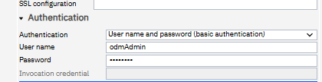

- Create a new service flow by selecting the Service flow option from the Services menu:
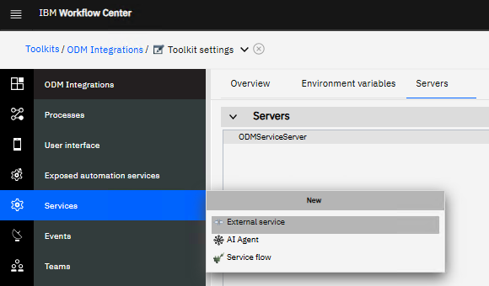
- Provide name (Miniloan) and click Finish:
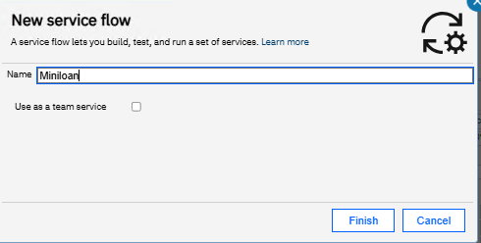
- You will now see the canvas for the service.
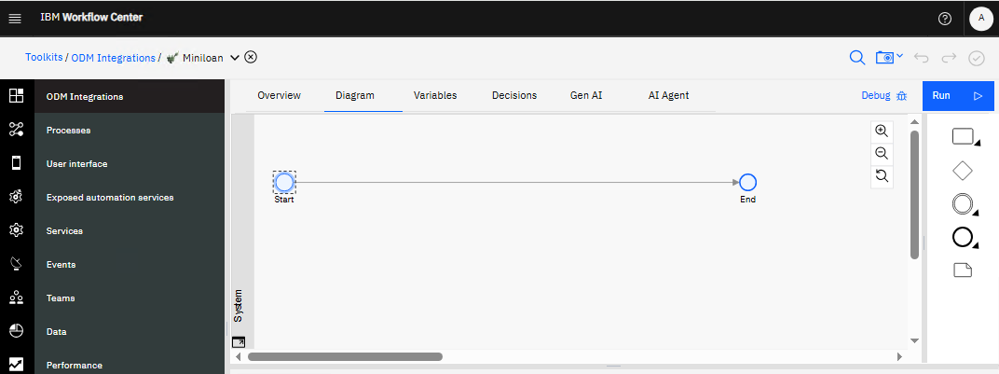
- Open the rectangle icon from the palette and drag the gear into the flow:
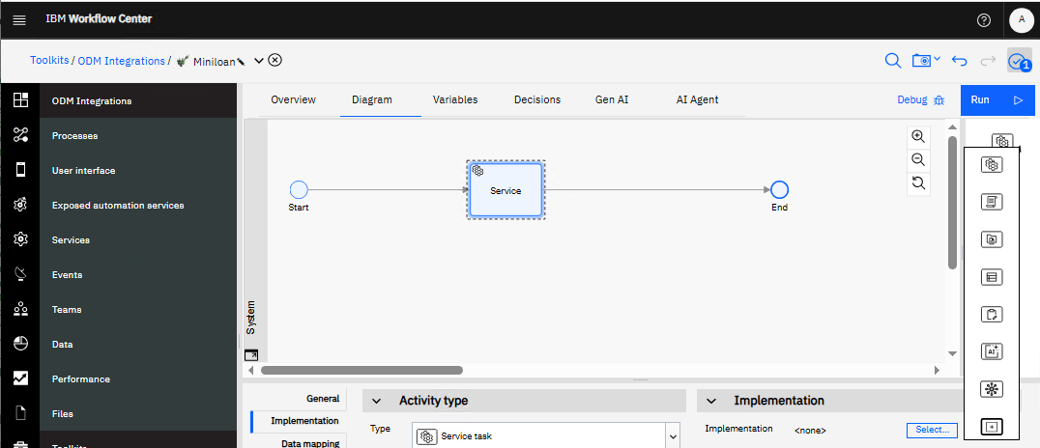
- Press the Select button next to Implementation and click on ODM Service:
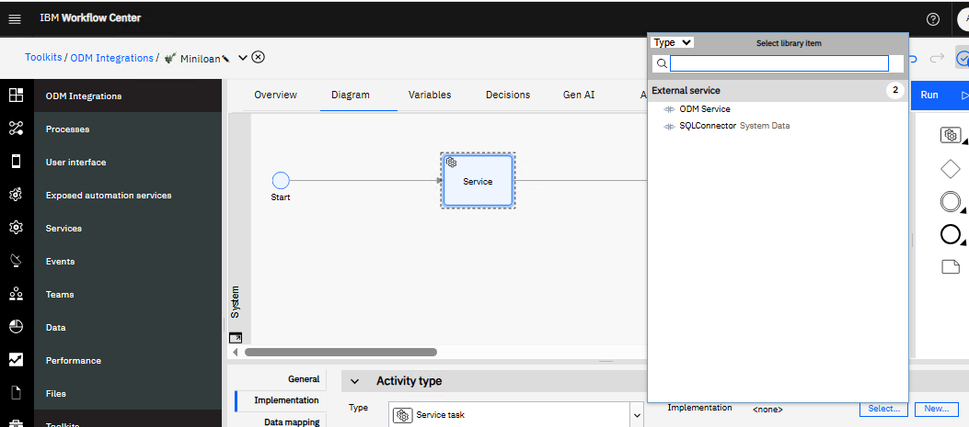
- Choose the operation (requestCreditScore).
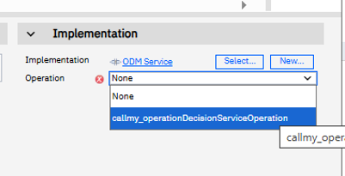

- Have a look at the Data Mapping tab:
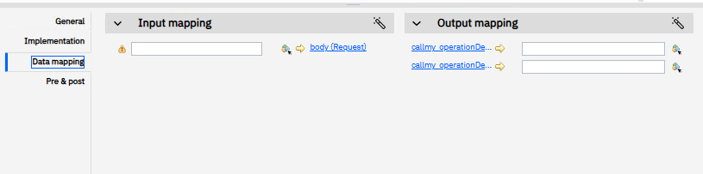
- We need to create variables to map these fields to. Click on t he Data tab and you will see the BAW Business Objects that were created when you imported the service:
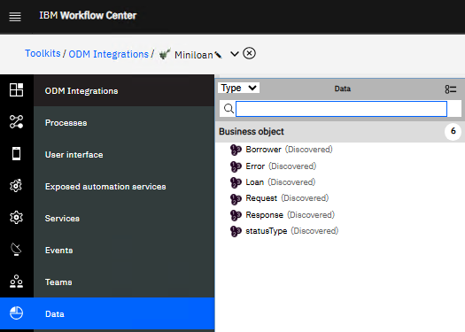
- Click on the Variables tab:
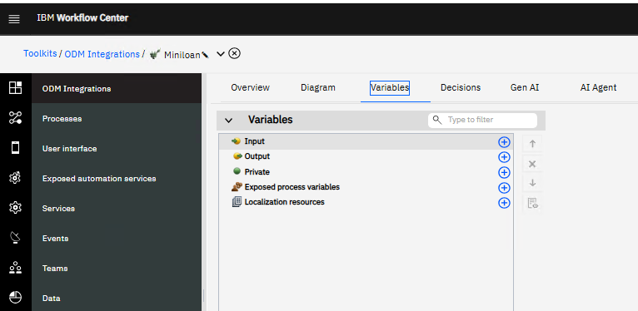
- In the Private section, create 3 variables called odmRequest, odmResponse, and odmError, with Variable type Request, Response, and Error, respectively:
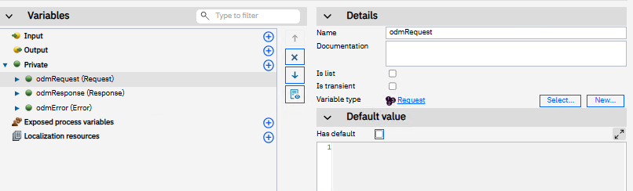
- In the Input section, create 2 variables called borrower and loan, with Variable type Borrower and Loan, respectively. In the Output section duplicate the loan variable with Variable type Loan:
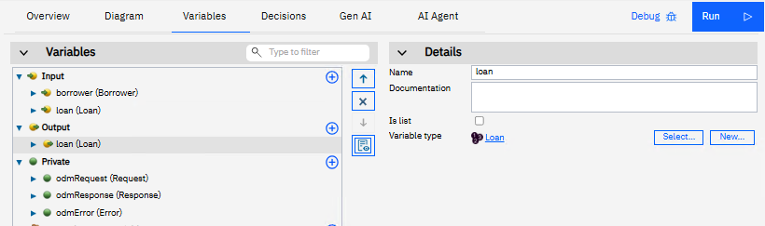
- For testing, we can populate default values for our input fields. For the borrower variable, click the Has default check box and update with the following values:
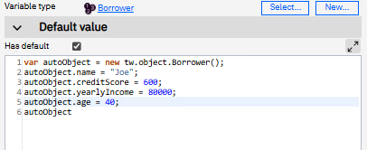
- Do the same with the loan variable:
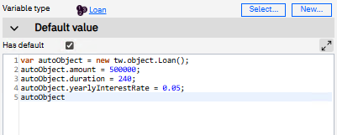
- NOTE: When you click the Has default checkbox for the loan, it will also create some of the return fields that will come back from the ODM Server. You can trim those to just the input fields as shown above.
- DOUBLE NOTE: Make sure that autoObject is that last line in each of the default values area.
- Save your work.
- Before we map the variables, we need to package them up. Click on the Diagram tab, and drag a Script node to the left of the Service node:
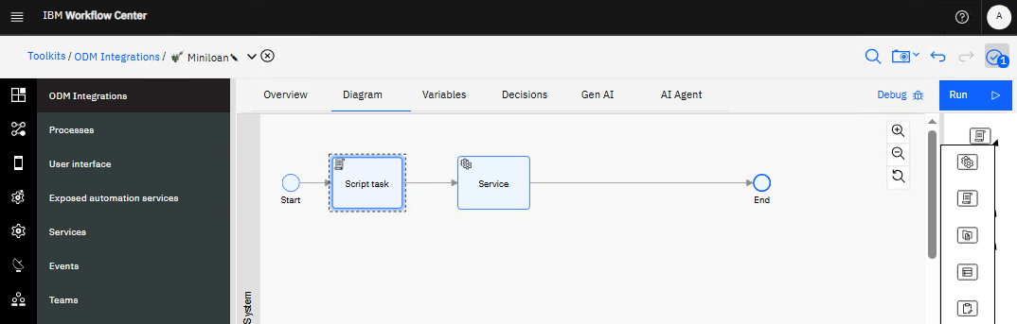
- Click on the new Script task, and put the following code into the Script section:
tw.local.odmRequest = new tw.object.Request();
tw.local.odmRequest.borrower=tw.local.borrower;
tw.local.odmRequest.loan=tw.local.loan;

- This will package up the request:
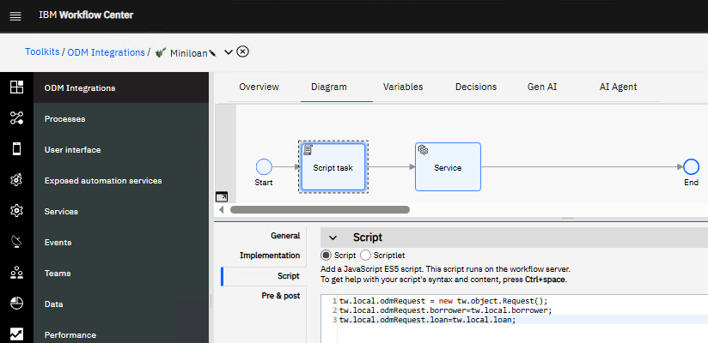
- We also need to unpack the response. Drag another script task and drop it to the right of the Service:
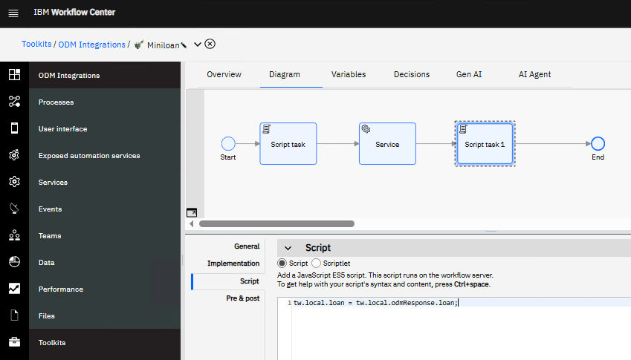
- Populate the Script area with the following code:
tw.local.loan = tw.local.odmResponse.loan;
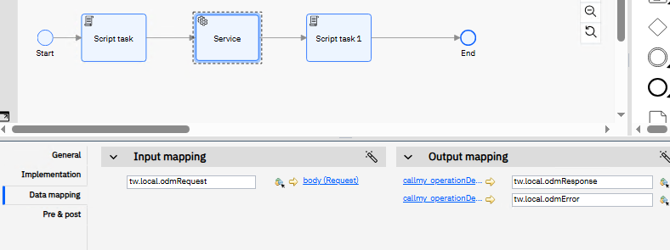
- We are now ready to map the service. Click on the Service task, and in the Data mapping section, map the fields as below:

- Lastly, rename each task to something more meaningful:
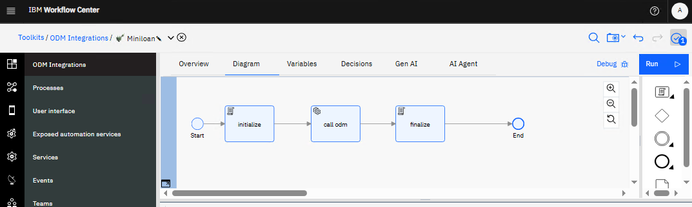

- Save your work.

Test the Service

We are now ready to test the service. Since we supplied default values to each of the input variables, we can simply press the Debug button and see what happens!
- Press the Debug button:
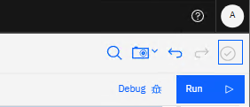

- Notice the Debug icon above that appears over the initialize task:
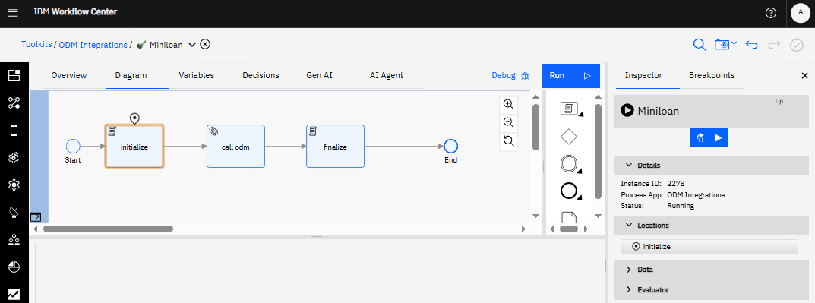

- Open the Data twisty on the right to view how your data changes as you step through the service:
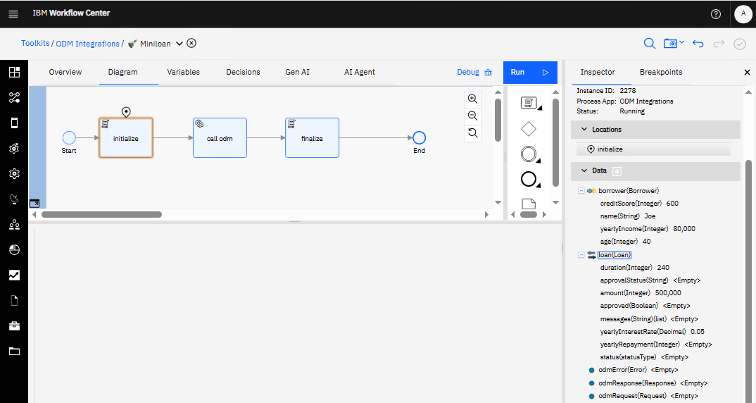
- You can see the populated fields of the borrower and the loan. Now click on the Step over icon:
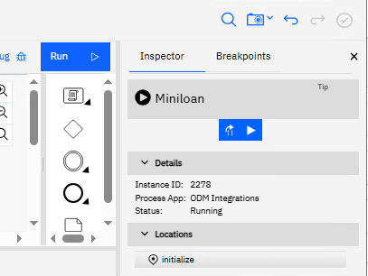

- The Debug token has now moved to hover over the call odm service. You should also be able to see the odmRequest variable populated.
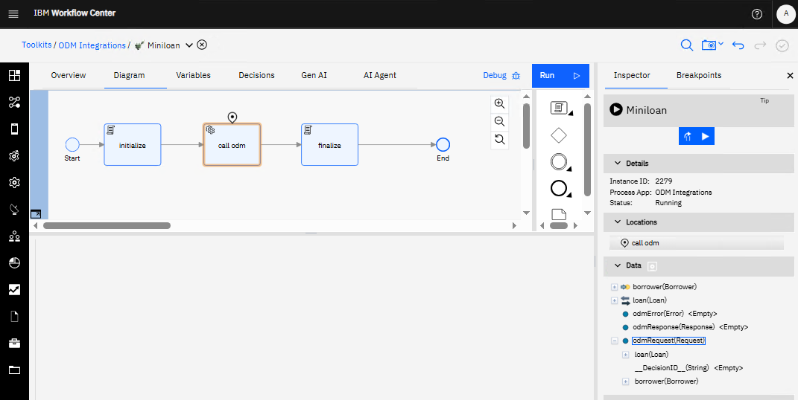

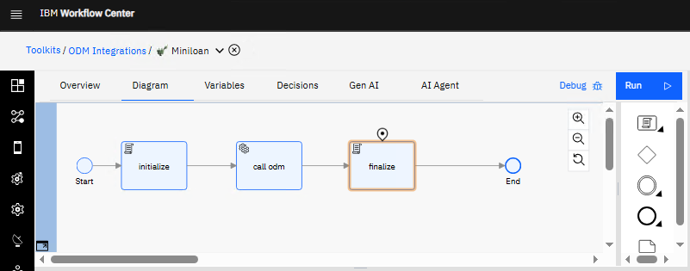
- Click on the Step over icon again, and wait for the debug token to move to the last task:

- Click on the Step over icon one more time:
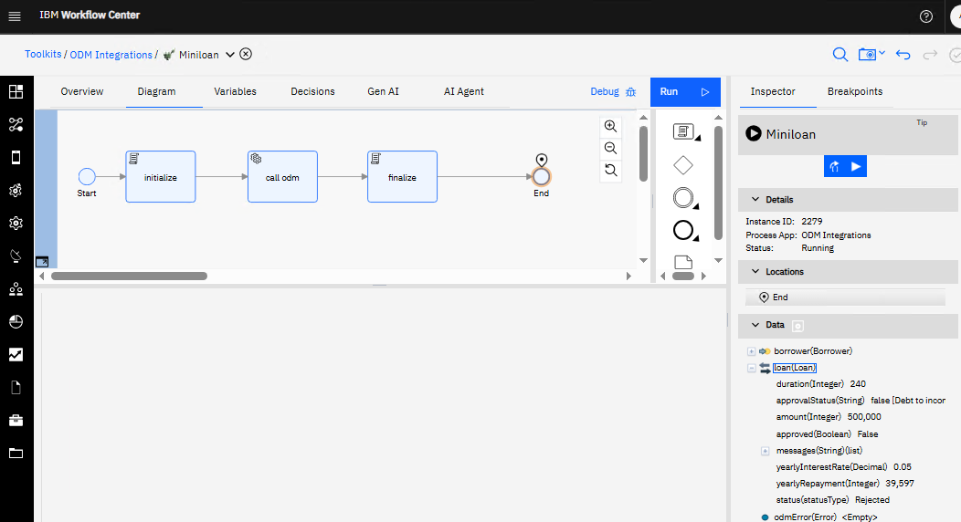
- Looking at the loan variable, we can see it is now populated with more fields, including that the loan has not been approved. Go back to the Variables tab, change the borrower’s yearly income to 150000, and run the debug again:
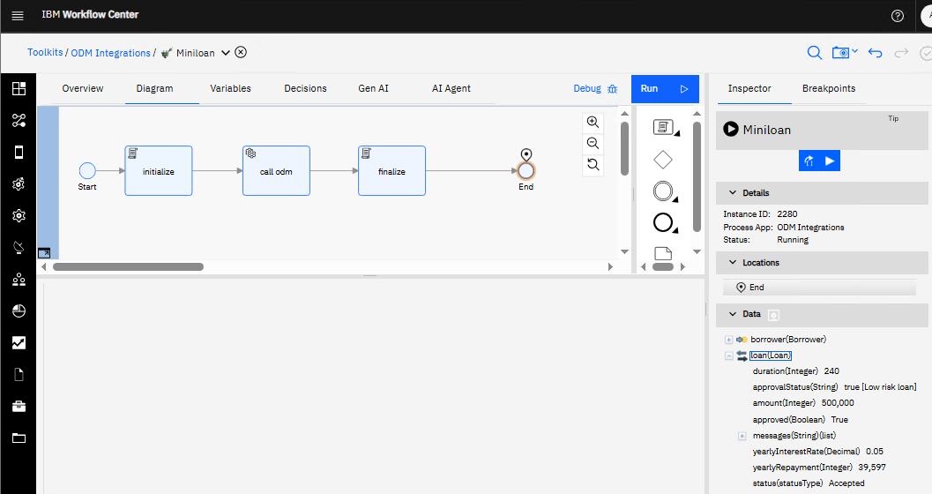
- This time the loan has been approved. The integration works!

ADD THE TOOLKIT TO A PROCESS APPLICATION

- Now is a good time to take a snapshot. Press the Snapshot button and select the option to Create a snapshot:
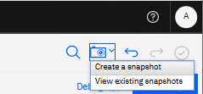
- Enter V1.0.0 for the snapshot name and click Create Snapshot:
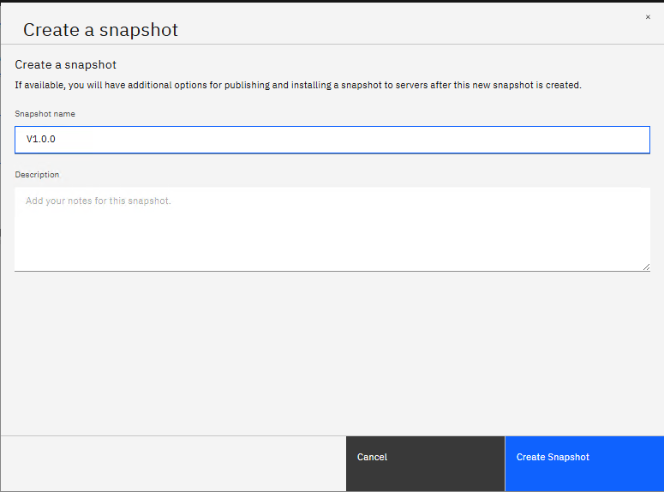
- Click the Done button to complete:
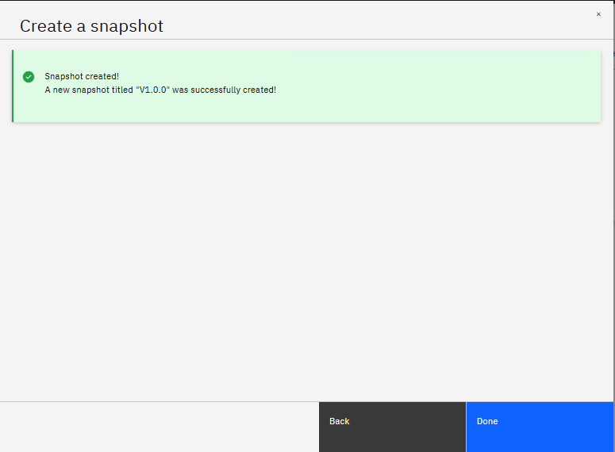

- Click on the IBM Workflow Center icon to get you back to the main page:
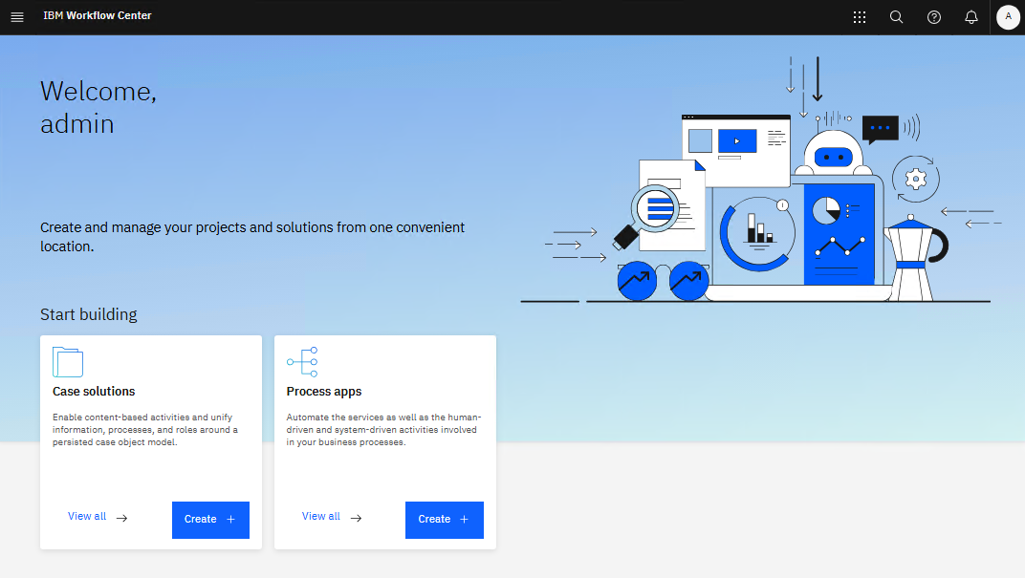
- In the Process apps box, click on the Create button:
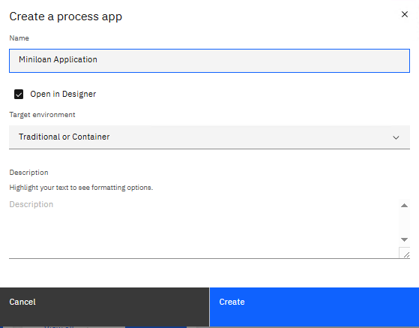

- Call the process application Miniloan Application, and click the Create button:

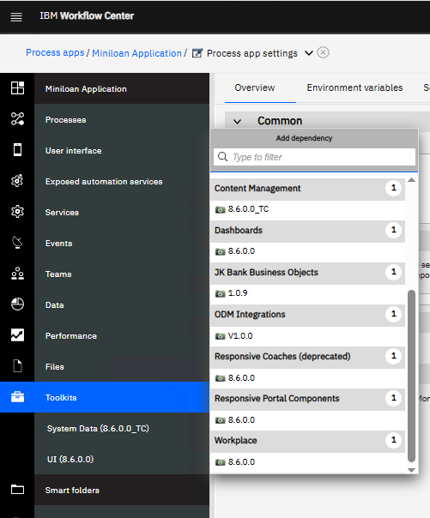
- This will open up into a new process application project. Similar to the previous lab, now add the ODM Integrations toolkit to your project:

- You should now see it in your list of toolkits:
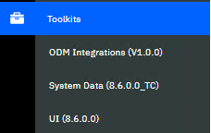

Creating an exposed automation service

We are now going to have some fun exposing REST services from our BAW project. BAW has had a global REST API for quite some time, and now it is possible to provide REST services on a project-by-project basis as well.
- Hover over the Exposed automation services menu item and click its sign on the right:
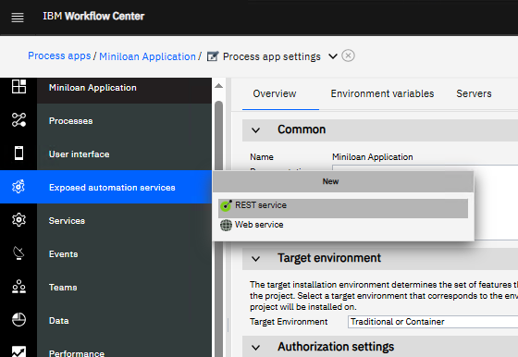
- Select the REST service option, and name it odm proxy:
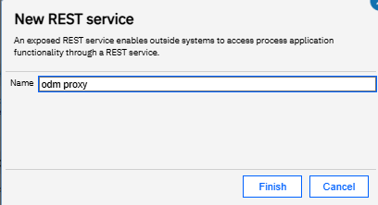
- Click the Finish button, which will take you to the Operations page:
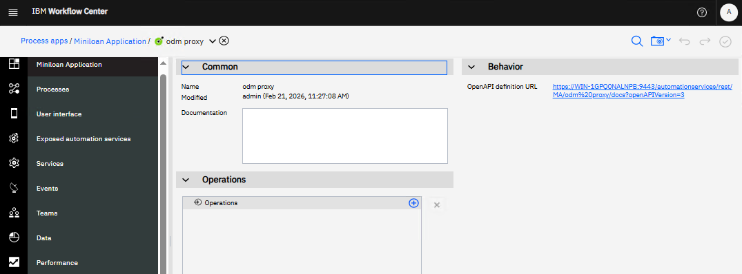
- Click on the icon in the Operations section, and add an operation name miniloan:
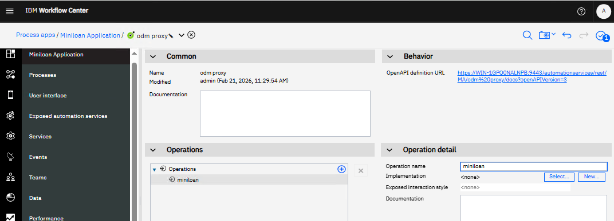
- Press the New… button next to Implementation, and name the new service miniloan microservice. Then click Finish:
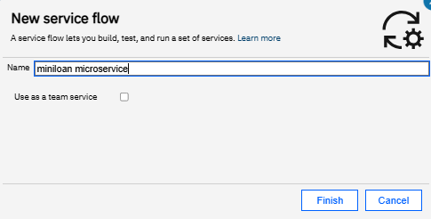
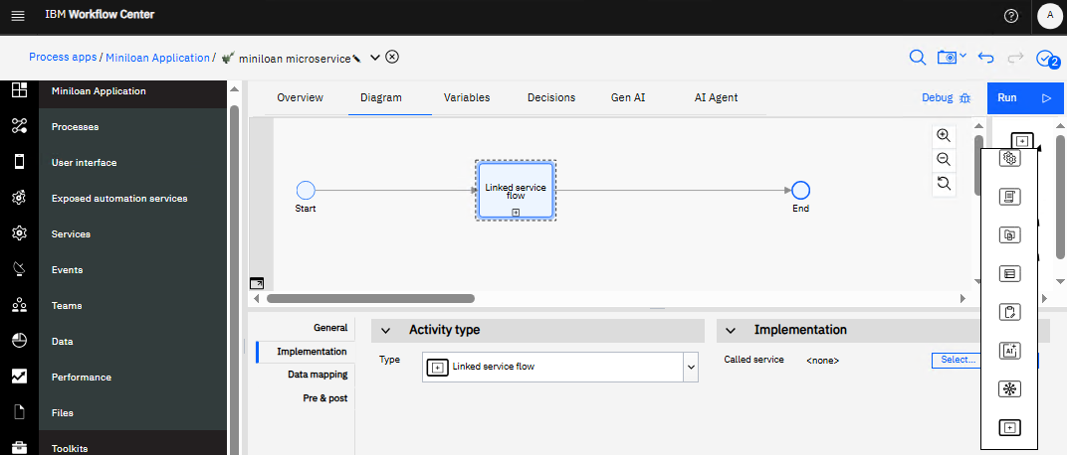
- Drag a Linked Service Flow icon into the service flow:

- In the Implementation section, click the Select… button and pick the Miniloan service from our ODM Integrations toolkit:
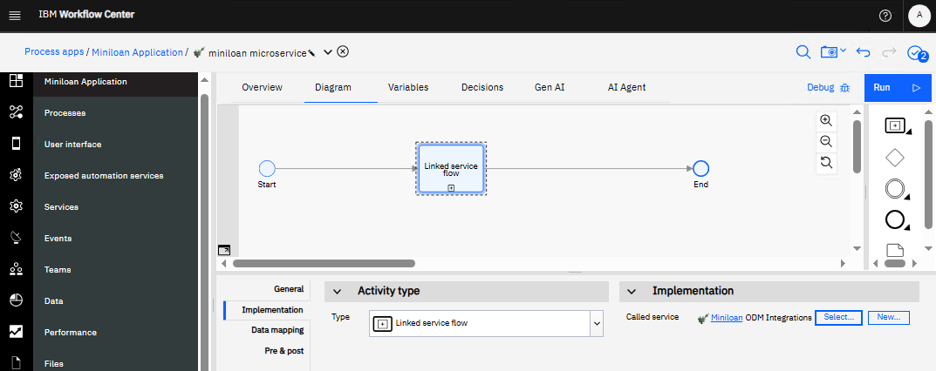

- Rename the service to miniloan and click on the Data mapping tab:
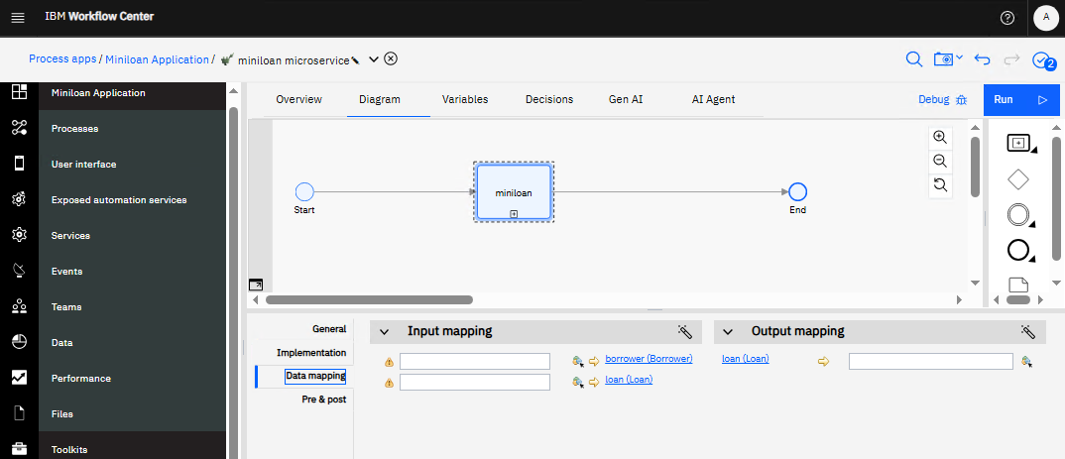
- Here we see we need to provide a borrower and load again, just a before. This time, however, we don’t need to provide the ODM wrapper variables, because they are used in the service call. Click on the variables tab, and as before create a borrower and a loan, and provide some default values:
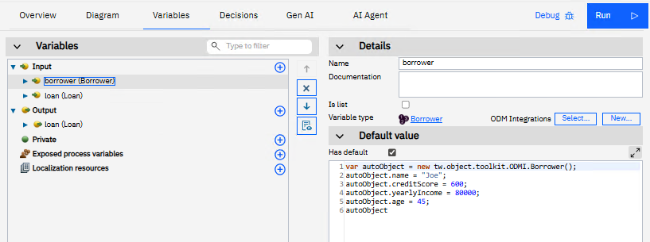

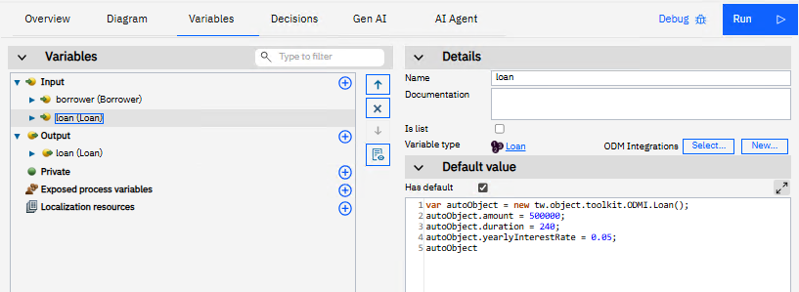
Again, ensure that autoObject is the last line of each default value section.

- Map the fields to the service:
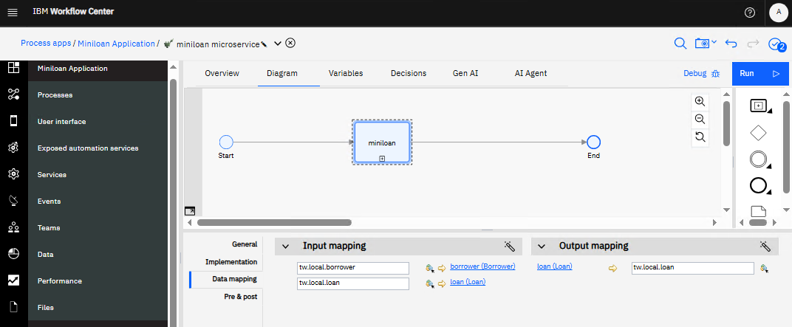
- Save your work, and then test the service call by running it through a Debug again:
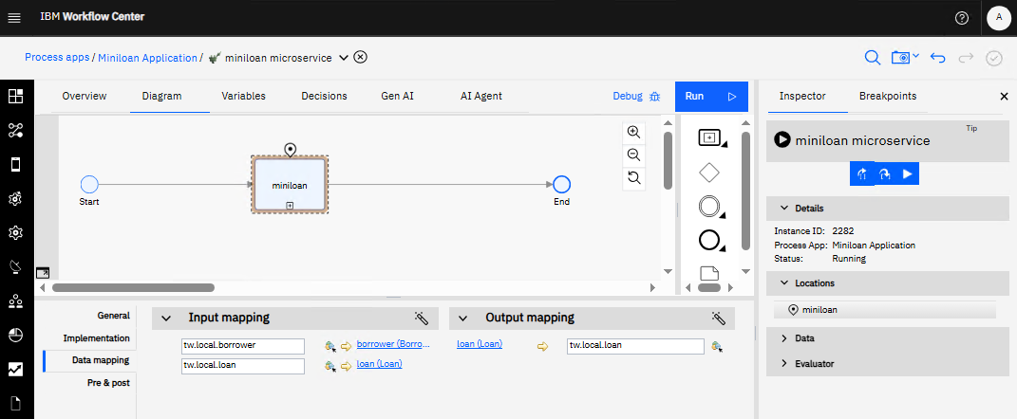
- Note in the debugger you can now Step into the service! For now, just Step over again and check the results:
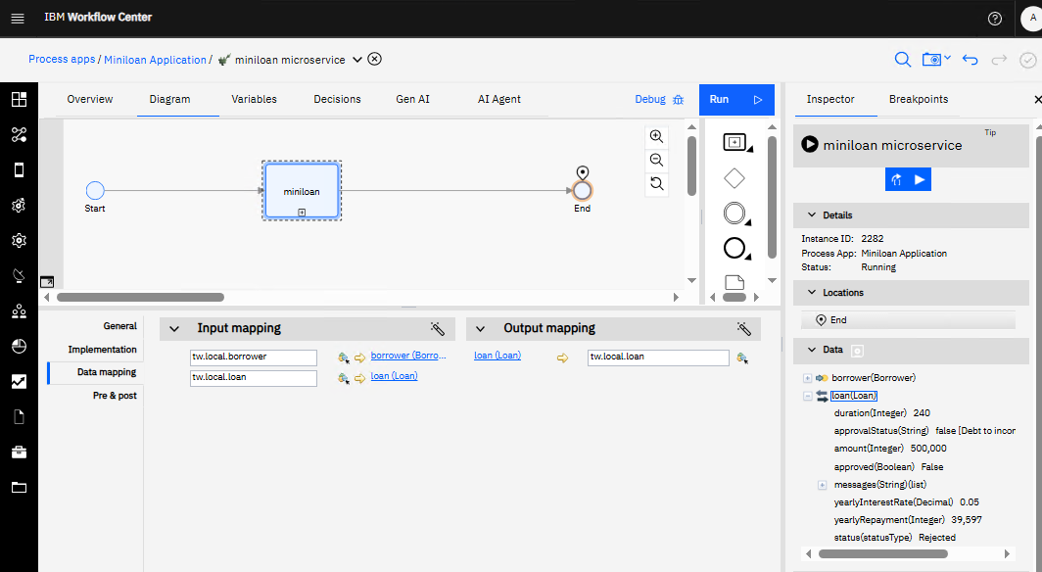
- Create a snapshot of your project, call it V1.0.0. click Next¸ and then click Done:
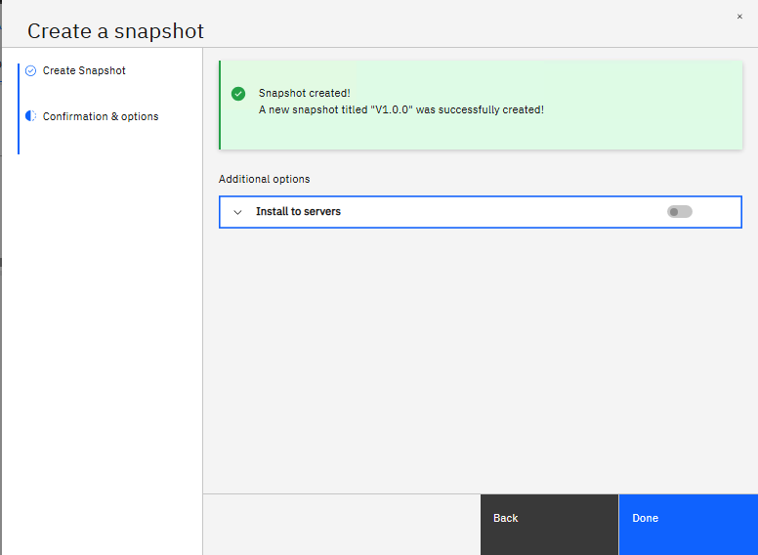
- Close the service by clicking on the next to the service name:
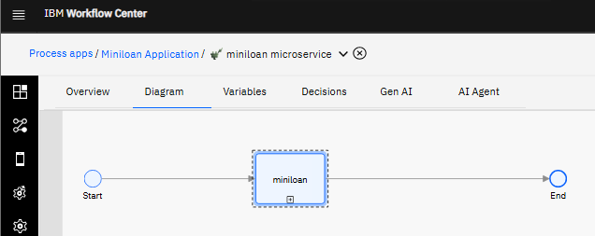
- This will bring us back to the REST service definition page. Click on the OpenAPI definition URL link and take a look:
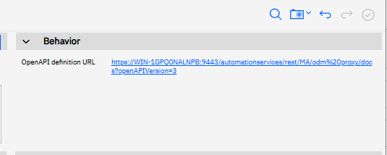
- Here you will see a full OpenAPI (Swagger) file that you can use to import into other applications:
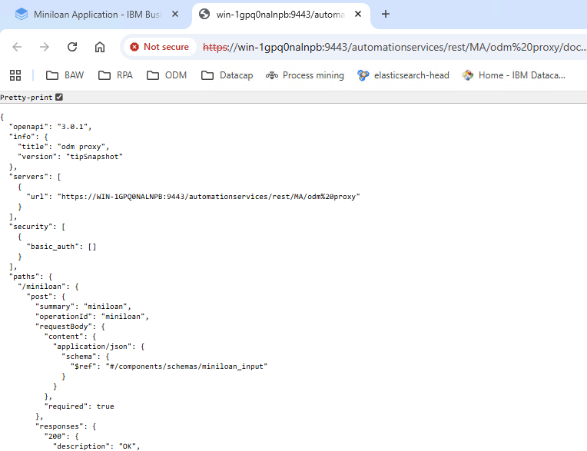
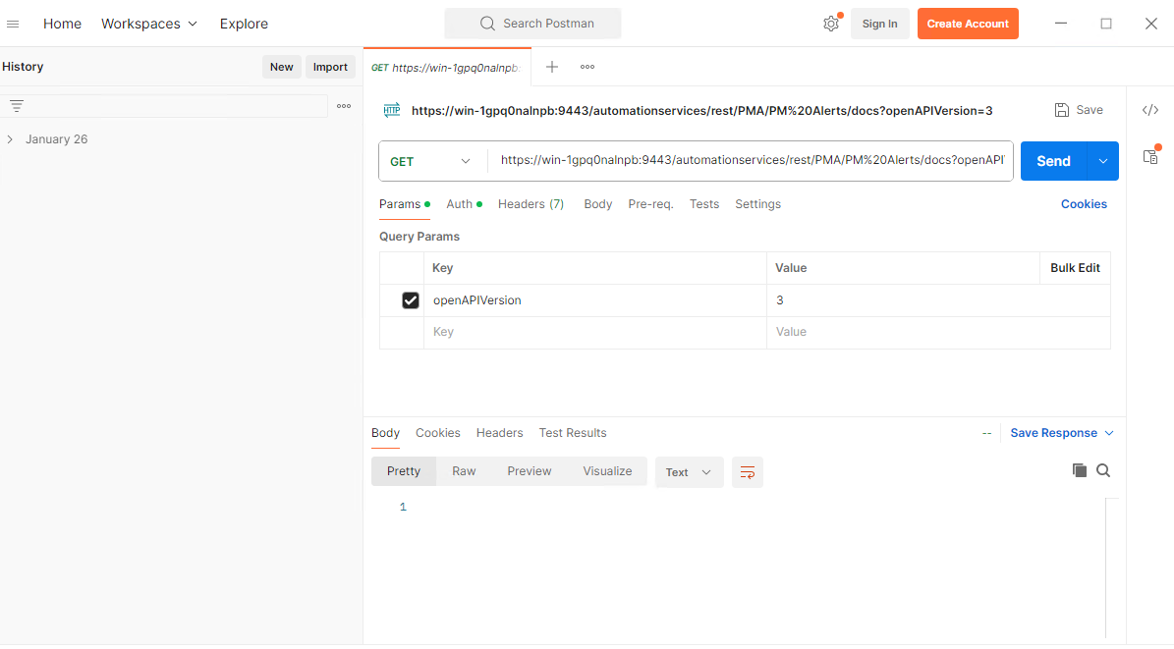
- Let’s try the service in Postman. Launch the Postman application on your machine:

- Click NewHTTPPOST, and paste the following into the URL section:
https://WIN-1GPQ0NALNPB:9443/automationservices/rest/MA/odm%20proxy/miniloan

- It should look like this:
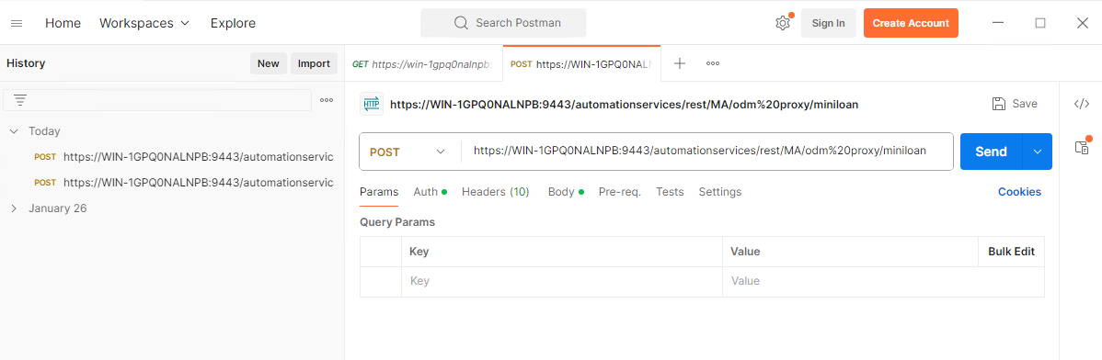

- Click on the Auth tab, select Basic Auth, and provide admin as the user name and password:
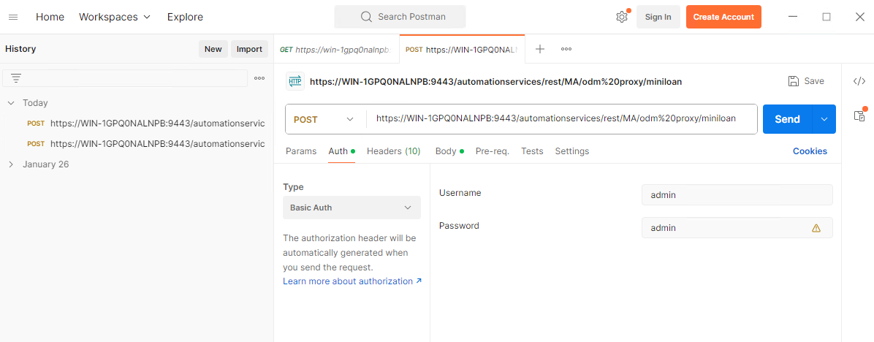
- Now click on Body, select rawJSON and paste the following:
{
"borrower": {
"name": "Joe",
"creditScore": 600,
"yearlyIncome": 80000,
"age": 45
},
"loan": {
"amount": 500000,
"duration":240,
"yearlyInterestRate": 0.05

}
}

- It should look like this:
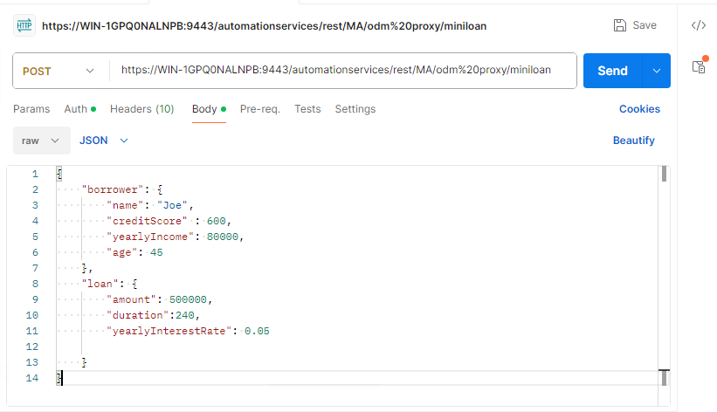
- Press the Send button, you should see the following:
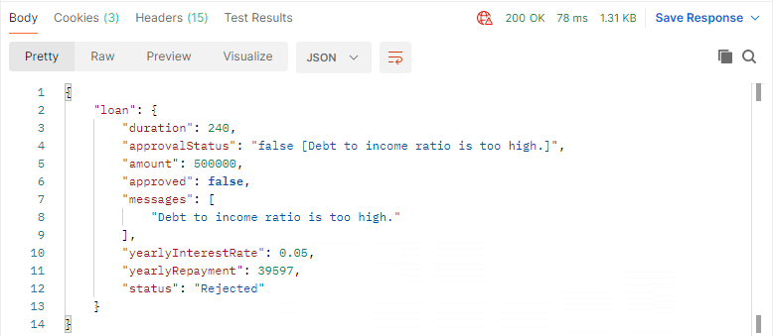
- It worked! Change Joe’s yearly income to 150000 and try again:
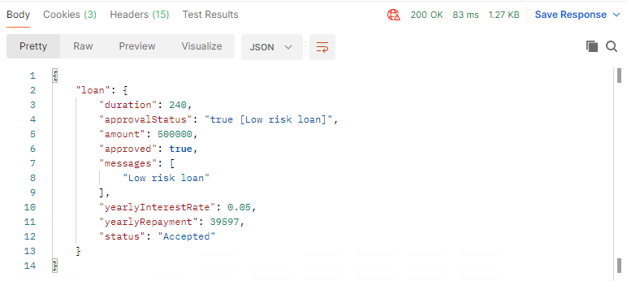
- It worked again!

What did we just do?

Traditionally, BAW process applications have tended to be “closed systems” where processes are launched by users, and tasks are moved between different users, all the while interacting with a system lane to perform automated work. The exposed automation service creates the ability for BAW to become much more event- driven.
In this example, we created a proxy service to the ODM service. This proxy service runs outside of a normal BAW business process and acts like a stateless microservice. However, we can also build exposed automation services that can start processes as well as update them, making BAW a stateful context engine for event-driven scenarios. That’s pretty cool.

Summary

Congratulations! You have completed the steps to create a simple integration service that retrieve information via a REST service. You have also learned how to expose your own BAW services to the outside world.
You created a toolkit to contain these reusable items and built these integrations from scratch. You then implemented these new integration services into your own Process Application. As you can see, simple integrations can be built and implemented very quickly!

Appendix

Start Workflow Center

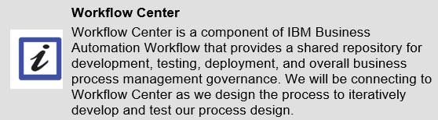

- Locate the RUNTIMES shortcut folder on your desktop.
- Double-click the RUNTIMES shortcut folder to open it.
- Double-click BAW Server START.cmd as shown.
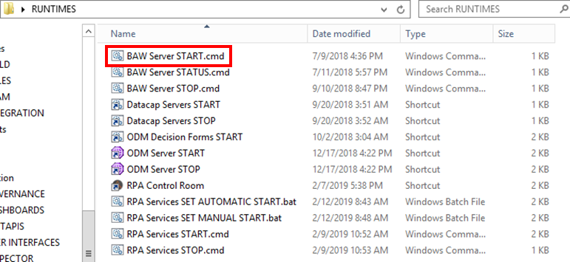
The server will take several minutes to start. Please wait for the server to start completely. (NOTE: When the command window disappears it will still take some time to Workflow Center to start.)

