MARKETING CAMPAIGN
PERFORMANCE REPORT

2,000 campaigns across five companies, six channels, and twelve months of 2021

Prepared September 2026

Executive Summary
This report covers 2,000 campaigns run in 2021 by five companies (Alpha Innovations, DataTech Solutions, Innovate Industries, NexGen Systems, and TechCorp) across six channels and five campaign types. Total ad spend across the set was $24.8 million, with an average ROI of 5.06x and just over half of campaigns (52.3%) closing in profit.
The headline finding is that performance is fairly evenly spread. No single company, channel, or audience dramatically outperforms the rest, and the standard drivers you'd expect to move ROI, like engagement score, conversion rate, or time on page, show almost no statistical relationship to it in this dataset. That's a useful finding in itself: it suggests ROI here is closer to a fixed campaign attribute than something the team can reliably lever by adjusting these inputs, and it's worth flagging that possibility before using this data to guide budget decisions.
Where real, if modest, differences do show up: Facebook and YouTube post the strongest average ROI among channels, Men 18-24 is the strongest-performing audience segment, and organic traffic outperforms paid and social. These gaps are in the 5-10% range rather than dramatic, so we'd treat them as directional rather than definitive.

Key Metrics
2,000  Total Campaigns | $24.8M  Total Ad Spend | 5.06x  Average ROI | 52.3%  Profit Rate

Performance by Company
All five companies land within a narrow band, roughly 4.8x to 5.2x average ROI. TechCorp and Alpha Innovations edge out the group on both ROI and profit rate, while DataTech Solutions trails slightly on both measures despite spending a comparable amount.
Company | Campaigns | Spend | Avg. ROI | Profit Rate | Avg. CAC
TechCorp | 420 | $5.26M | 5.18x | 55.2% | $578
Alpha Innovations | 376 | $4.65M | 5.20x | 55.1% | $687
Innovate Industries | 424 | $5.23M | 5.11x | 52.8% | $610
NexGen Systems | 403 | $5.00M | 5.01x | 50.6% | $611
DataTech Solutions | 377 | $4.65M | 4.81x | 47.2% | $600
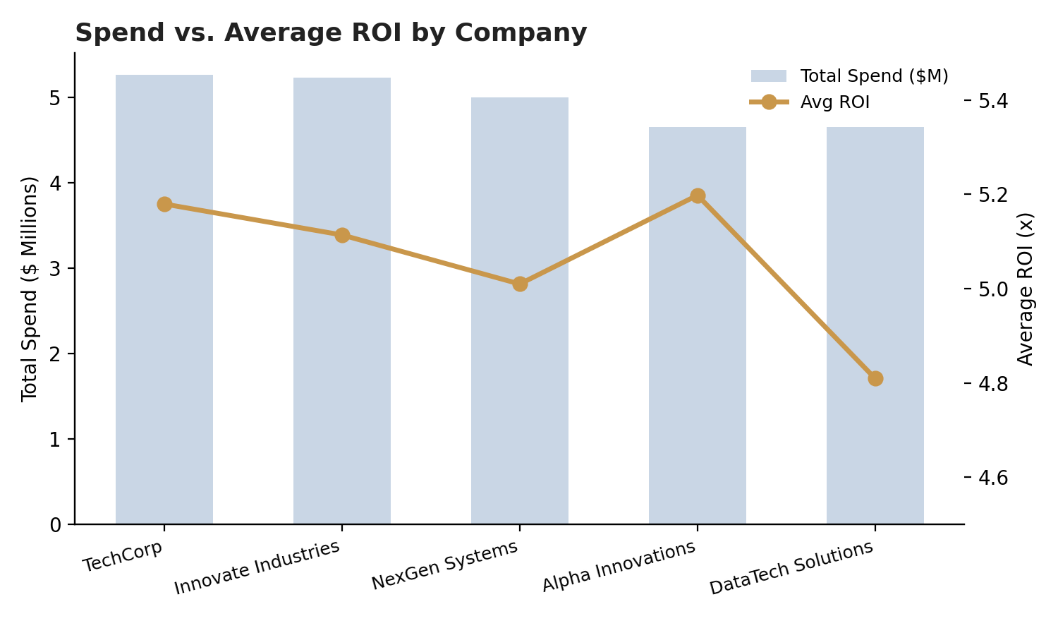
Figure 1. Total ad spend and average ROI by company.

Performance by Channel
Facebook (5.22x) and YouTube (5.13x) lead on average ROI, and Facebook also has the highest profit rate of any channel at 57.1%. Website and Email sit at the bottom of the range, around 4.9x-4.97x. YouTube stands out for a different reason: it carries the highest customer acquisition cost of any channel at $705, meaning its ROI edge doesn't necessarily translate into the cheapest conversions.
Channel | Campaigns | Spend | Avg. ROI | Profit Rate | Avg. CAC
Facebook | 312 | $3.86M | 5.22x | 57.1% | $616
YouTube | 346 | $4.25M | 5.13x | 54.0% | $705
Google Ads | 307 | $3.83M | 5.12x | 52.4% | $560
Instagram | 370 | $4.61M | 5.02x | 50.8% | $646
Website | 295 | $3.69M | 4.95x | 50.8% | $602
Email | 370 | $4.56M | 4.97x | 48.9% | $562
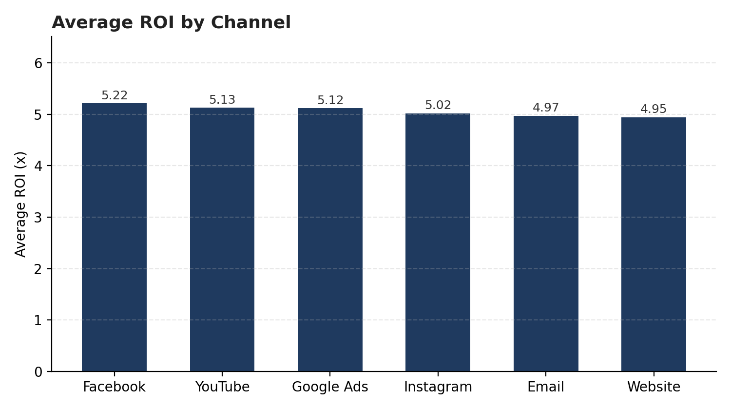
Figure 2. Average ROI by channel, ranked highest to lowest.

Performance by Campaign Type and Audience

Campaign type
Social Media (5.16x avg. ROI, 53.9% profit rate) and Influencer (5.11x, 54.8%) campaigns outperform Search, Display, and Email, though the gap between the best and worst campaign type is under 3.5%, small enough that it likely doesn't justify a major reallocation on its own.
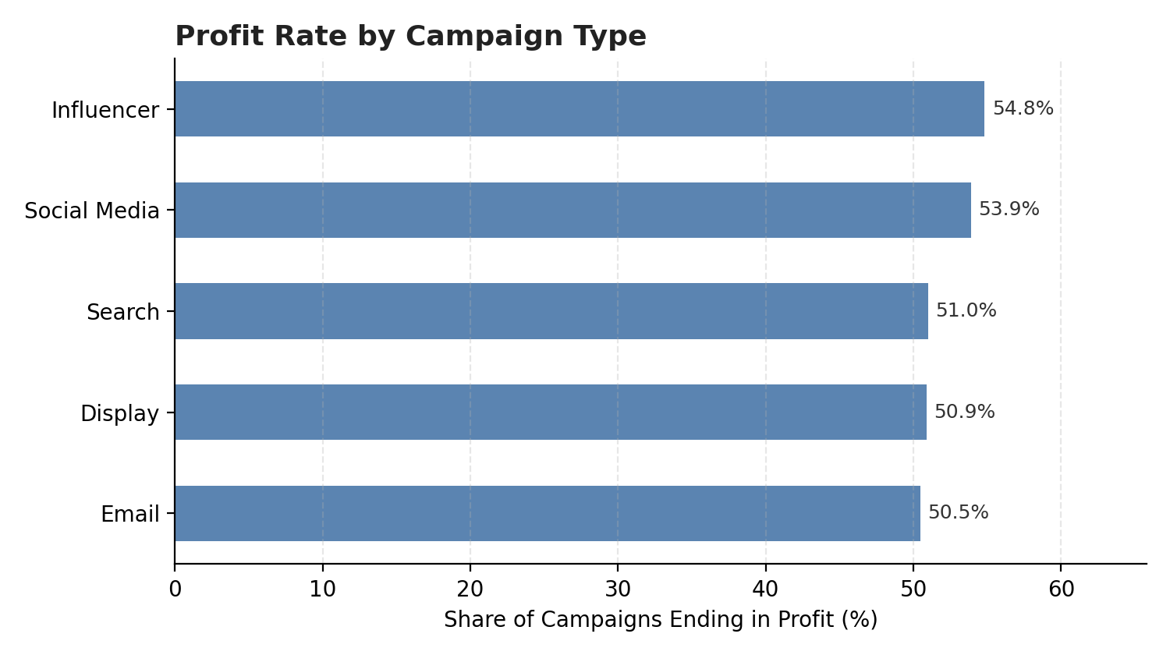
Figure 3. Share of campaigns ending in profit, by campaign type.

Target audience
Men 18-24 is the standout audience segment, with the highest average ROI (5.23x) and the highest profit rate at 57.7%, about 10 points above the lowest-performing segment, Women 25-34 (47.8%). Women 35-44 is a close second on both measures. Men 25-34 and Women 25-34 trail the field.

Customer segment and traffic source
Across the five customer segments (Health & Wellness, Fashionistas, Outdoor Adventurers, Foodies, Tech Enthusiasts), differences are minor, all cluster within half a point of ROI. Tech Enthusiasts is the one segment worth watching, since it combines average spend with the lowest profit rate of the group (48.6%). By traffic source, organic and referral traffic both outperform paid and social traffic on ROI and profit rate, suggesting paid acquisition isn't buying better outcomes in this dataset, just more volume.

ROI Trend Over 2021
Average ROI held steady across the year, moving in a tight band between about 4.97x and 5.22x with no clear seasonal pattern. October and December were the strongest months; January and September the softest. Given the narrow range, this looks like normal variation rather than a meaningful trend.
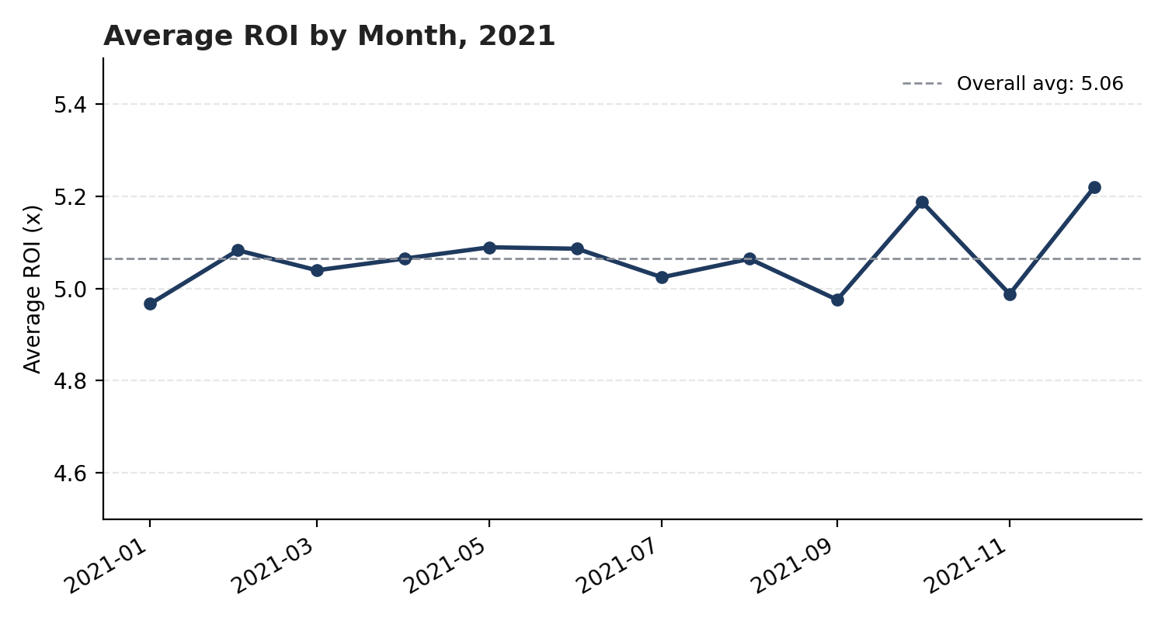
Figure 4. Average ROI by month, with the full-year average shown as a reference line.

What's Not Driving ROI
It's worth being direct about what the data does not show. We checked ROI against every numeric field available, page views, session duration, bounce rate, time on page, previous visits, conversion rate, clicks, impressions, engagement score, and acquisition cost, and none of them correlate with ROI in any meaningful way (all correlation coefficients fell between -0.02 and 0.04). In practical terms, campaigns with high engagement or strong on-page behavior weren't more likely to deliver a strong ROI than campaigns without it.
This matters for how the rest of the report should be read. The company, channel, and audience differences above are real but modest, and the absence of any stronger internal driver suggests ROI in this dataset may be influenced by factors outside what was captured here (creative quality, timing, competitive dynamics) or, if this data was generated for practice/demo purposes, by design. Either way, we'd recommend validating these patterns against a live, production dataset before using them to guide actual budget decisions.

Recommendations
- Shift incremental budget toward Facebook and YouTube, and toward Social Media and Influencer campaign types, where ROI and profit rate are consistently a few points ahead of the rest.
- Prioritize the Men 18-24 audience where feasible. It's the strongest-performing segment by a real margin, particularly on profit rate.
- Investigate YouTube's acquisition cost. Its ROI is strong but its CAC ($705) is the highest of any channel, so the margin on each conversion is worth checking against the other top channels.
- Treat paid and social traffic sourcing as a volume play, not an efficiency play. Organic and referral traffic outperformed them on both ROI and profit rate here.
- Before acting on the company or segment rankings, confirm this dataset reflects live production data rather than a synthetic or sample set. The near-zero correlation between engagement and ROI is unusual enough to warrant a second look at data provenance.

Data Notes
This analysis merges two source tables on Campaign_ID: web-behavior data (page views, session duration, bounce rate, time on page) and campaign data (company, channel, spend, ROI, audience). A few data quality items are worth flagging for anyone extending this analysis:
- The CSV contains two differently-scaled 'conversion rate' columns. The one from the web-behavior table is essentially constant (over 88% of rows equal 1.0) and was not used for the channel/audience conversion figures in this report; those use the campaign-level Conversion_Rate field instead.
- Acquisition cost was originally stored as a formatted string (e.g., "$16,174.00") and was converted to numeric for all calculations.
- CAC (customer acquisition cost) was derived as Acquisition_Cost divided by estimated conversions (Clicks x Conversion_Rate); it was not a field in the source data.
- No missing values or duplicate rows were found across the 2,000 merged records.

