Project Log Book

Group Members:
Entry Date | Work Done
March 9th, 2022 | Discussed the basic plan to build the prototype for PSM in class, noting down all constraints to be taken care of. Furthermore, we decided our next group meeting would be on March 09th, 2022 (Wednesday) at 5:30, meeting place: Baker’s Cafe.
March 9th, 2022 | Meeting at Baker’s Cafe: We discussed about the project objective. Using the Software Management Plan template printed from the web site, we stepped through each section and discussed what was required and what resources were available to us. We also discussed how this prototype should be flexible for other countries. There was constant reference to the "Context Management System" and other related articles.
March 9th, 2022 | Finished a rough draft prototype and set it up on the online account.
March 9th, 2022 | Hassan Khan checked the document of the Software Project Management Plan, and he made some correction marking the corrections in red.
March 11th, 2022 | The mistakes were corrected on the web site, and email was sent to Hassan Khan to check the document for any more mistakes
March 11th, 2022 | The document was checked by Hassan Khan and few more mistakes were found. These mistakes were corrected and put on the web.
March 11th, 2022 | Meeting at Baker’s Cafe: We discussed the Context Management System in more detail and added more information to the SPMP document.
March 13th, 2022 | Hassan Khan checked the document of the Software Project Management Plan, and he made some corrections.
March 13th, 2022 | The mistakes were corrected on the web site, and email was sent to Hassan Khan to check the document for any more mistakes.
March 14th, 2022 | Meeting at Baker’s Cafe: We discussed parts 4 and 5 of the Software Project Management Plan in more detail and decided to update some information in the SPMP document. The different parts of the document were divided between the team for updates.
March 14th, 2022 | Finished updating the rough draft prototype and set it up on the online account. Sent all team members email with link to latest copy of the document.
March 15th, 2022 | Hassan Khan checked the document of the Software Project Management Plan. The mistakes were corrected on the web site. The latest version of the document is available online.

Last Updated on March 15th, 2022
Software Requirements Specification
for
Context Management System
Talha Patni 64085
Hyder Ali 64068
M. Hashir 64093
Humayun Khalid 64085
Hassan Khan 64089
March 15, 2022
Version | Changes Made | Date
1.0 | First Pass for Review | 03/09/2022
1.2 | Second Pass for Review | 03/11/2022
1.3 | Third Pass for Review | 03/13/2022
1.4 | PSM Review Version | 03/15/2022

Table of Contents
1. Introduction
2. The General Description
3. Specific Requirements
4. Supporting Information
1. Introduction

1.1 Purpose

This document describes the software requirements for the Context Management System built for the Pakistan Social Media (PSM).

1.2 Scope In
The CRM is requesting proposals to build a prototype of an Automated Railroad Reservation System (ARRS) for their current system. This new ARRS needs to be scalable enough so that it can accommodate the increase in reservations caused by new railroad building in China.

The system is limited obvious in the way that modern social media applications are not limited to. While building the project, we wanted to build something along the lines of the MVP, (Minimal viable product).

The main functionality of our project is that:

- To provide existing clerks with a new environment in which to make reservations for railroad travel.
- To provide an avenue for customers to get their tickets in a more convenient way.
- To regain control of the railway ticket sales to avoid scalping and overselling of tickets.
- To implement a prototype of a scaled down version of the final system to test the solution and further develop requirements.
- To collect statistics in a more efficient manner for future railroad development and construction.
- To increase efficiency of railroads.

1.3 Scope Out

The following features will not be the part of this Project:

1.3 Definitions, Acronyms, and Abbreviations.

CMS –Context Management System
CASE – Computer Aided Software Engineering
PSM – Pakistan Social Media
PP - Project Plan
SDD - Software Design Description
SRS - Software Requirement Specification
SDS – Software Design Specification
SPMP - Software Project Management Plan
GUI – Graphical User Interface
QAM – Quality Assurance Manager
PDM – Project Development Manager
PMP – Project Management Professional
TBD – To be determined
UML – Unified Modeling Language

1.4 References

• Situation Update – Context Management System
https://github.com › topics › social...social-media · GitHub Topics · GitHub
• https://emplifi.io/resources/blog/social-media-management-guide
• http://socialmediatoday.com/news/how-to-create-a-social-media-management

1.5 Overview

Chapter 2 of the SRS is a brief description of the characteristics of the software to be built, its functions, its users, its constraints and its dependencies.

Chapter 3 is about specific requirements, such as functional requirements, external interface requirements, performance requirements, and also design constraints and quality characteristics.

Finally, chapter 4 includes all the supporting information, such as the Table of Contents, the Appendices, and the Index.

2. The General Description

This section describes the general factors that affect the product and its requirements. This section consists of five subsections that follow. This section does not state specific requirements. Each of the subsections makes those requirements easier to understand, it does not specify design or express specific requirements. Such detail is provided in section 3.

2.1 Product Perspective
The Context Management System diagram showing the overview of the system’s modules and the relationship of the system to external interfaces is presented in Figure 2.1.

Figure 2.1 Overview/Architecture Diagram of the CMS

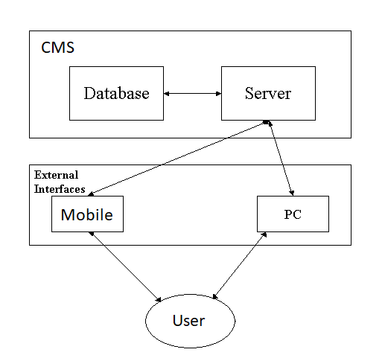

Functions of System Components:

Database:
• Stores data
• Creates reports
• Provides access to data
• Updates information

Server:
• Provides access to the database
• Authenticates users
• Processes reservations
• Performs backups
• Produces reports

External Interfaces:

Personal Computers
• Users (passengers, travel agents, and railroad administration) may use personal computers to obtain a remote access to the server and the reservation database via the Internet.

Cell Phones
• Serve as a medium of accessing the server and the reservation database.
• Passengers may use cell phones and the latest telecommunication technologies to access the server and the reservation database via Internet, or they may use cell phones to call travel agents to inquire about railroad and ticket information.

Computer Hardware and Peripheral Equipment to be used:
• 30 workstations, which include CPUs, monitors, keyboards, and mice
• Printers
• Network
• Cell phones to test connection to the server via remote access

2.2 Product Functions
This section provides a summary of the functions that the software will perform.
2.2.1 Function Relationships
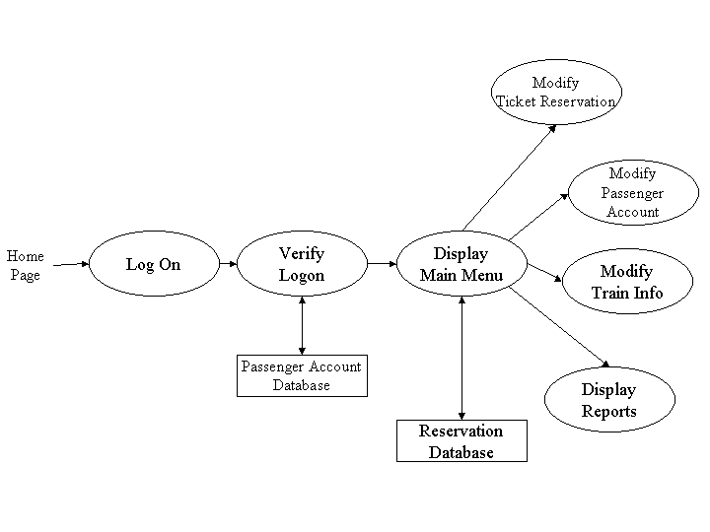
Figure 2.2 to 2.6 depict the relationships among the functions to be implemented by the system.
Figure 2.2 CMS General Function Relationship/Higher Level Use case Diagram

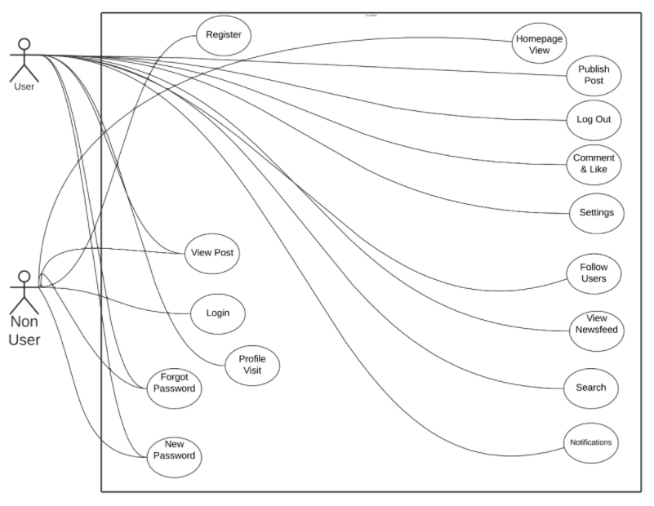
2.2.2 Function Descriptions (Functional Requirement Listings)

2.2.2.1 Log In Function

Description: This function ensures that only authorized users gain access to the Friends, Posting, Comments and Sharing on the app. An authorized user is a user who has an account on the system. Users include students, old generation, and PSM. The user must type a valid username and password to gain access.

2.2.2 Module 1: Friend Request (Talha Patni)

Description: This function allows the user to Create, Read, Update
and Delete friend requests.

2.2.3 Module 2: Friends Management (Hassan Khan)

Description: This function allows the user to Create, Read, Update
and Delete friends.

2.2.4 Module 3: Post (Humayun Khalid)

Description: This function allows the user to Create, Read, Update
and Delete posts.

2.2.5 Module 4: Comment (Hyder Ali)

Description: This function allows the user to Create, Read, Update
and Delete comments.

2.2.6 Module 5: Share (M. Hashir)

Description: This function allows the user to Create, Read, Update
and Delete share posts.

2.3 User Characteristics
The main users of the system will be the students, Businessman, and the PSM administration that access the reports generated by the system. The users are not required to have knowledge in the computer field. The graphical interface provides an easy way of using the CMS system with minimum of training.

2.4 General Constraints
The constraints for the project are:
- The functional prototype should be available after 30 days upon the arrival of the management team to Pakistan. This may prove to be a serious time constraint on the development of a successful prototype.
- Communication with the Pakistani’s team members may prove to be difficult since some Pakistani’s developers do not speak English and the management team does not speak Pakistani’s. Even with the presence of a translator, communication may be difficult. Absence of the translator may severely affect project development.
- Team members are restricted from bringing their own equipment, and insufficient equipment supply may hinder project development.
- Team members are restricted to bringing only the analysts of the team to Pakistan. This might affect the project development if more people are needed or the required skills are not available.
- The majority of the Pakistani’s population does not have or have a limited access to the Internet.

2.5 Assumptions and Dependencies or Business Logic
The assumptions for the project are:
Over the past decade, social media stages have entered profoundly into the mechanics of
standard of, living influencing people's casual intuitive, as well as organization structures
and proficient schedules. Distant from being unbiased stages for everybody, social media
have changed the conditions and rules of social interaction. In this article, we look at the
perplexing energetic between social media stages, mass media, clients, and social teach
by calling consideration to social media logic—the standards, methodologies,
components, and economies—underpinning its flow. This rationale will be considered in
light of what has been recognized as mass media rationale, which has made a difference
spread the media's effective talk exterior its organization boundaries. Theorizing social
media rationale, we distinguish four establishing principles—programmability, ubiquity,
network, and datafication—and contend that these standards ended up increasingly
snared with mass media rationale. The rationale of social media.

<ADD OOAD REPORT DIAGRAMS HERE>

3. Specific Requirements

This section of the SRS contains design requirements for the Context Management System.

3.1 Functional Requirements

3.1.1 Log In Function

- Description: This function ensures that only authorized users gain access to the Friends, Posting, Comments and Sharing on the app. An authorized user is a user who has an account on the system. Users include students, old generation, and PSM. The user must type a valid username and password to gain access.

- Usage Scenario/ Use case Description/ Specification:

Description | Allows access to online CMS
Inputs | Username, password
Source | - User inputs username and password  - Press Login Button

Alternate case
Outputs | Successful login; unsuccessful login
Destination | None
Precondition | Authorized User
Post Condition | No change to Passenger Accounts Database
Side Effects | Failures and successful logins are sent to Management Database

- Detailed Use case Diagram for Login: optional

- Use case Realization for Login: optional

- Flow of Event or Data Flow Diagram for Login: optional

- Sequence Diagram for Login: optional

- Collaboration Diagram for Login: optional

- Activity Diagram for Login: optional

- Class Diagram for Login: optional

- State Chart Diagram for Login: optional
    - Module 1 complete CRUD Friend Request

- Description: This function allows the user to Create, Read, Update
and Delete friend requests.

- Usage Scenario/ Use case Description/ Specification:

Description | [ make | drop | view | update] to a friend list
Inputs | Add other users to see newsfeed.
Source | - Press Button for add friends and communicates

Alternate Case
Outputs | Added | Deleted | Viewed |Updated Friend Request
Destination | Computer screen
Precondition | User should have to be registered.
Post Condition | None
Side Effects | None

- Use case Diagram:
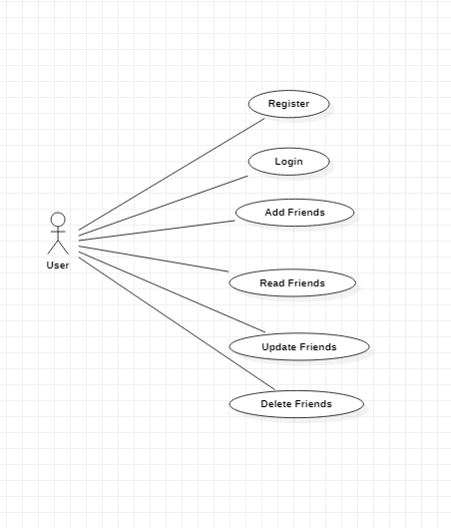
- Use case Realization:
- Flow of Event or Data Flow Diagram:

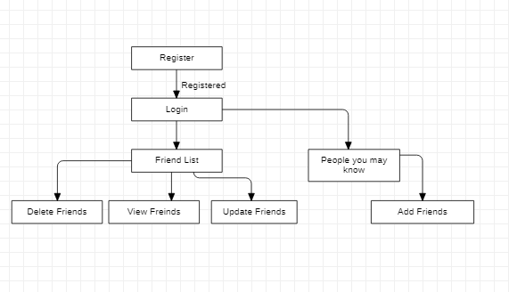

- Sequence Diagram:
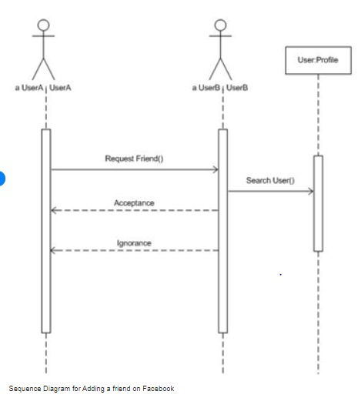

- Collaboration Diagram:

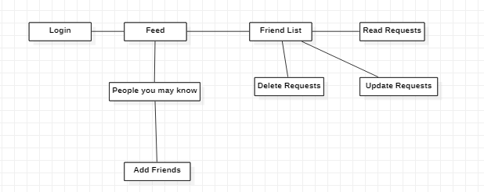

- Activity Diagram:

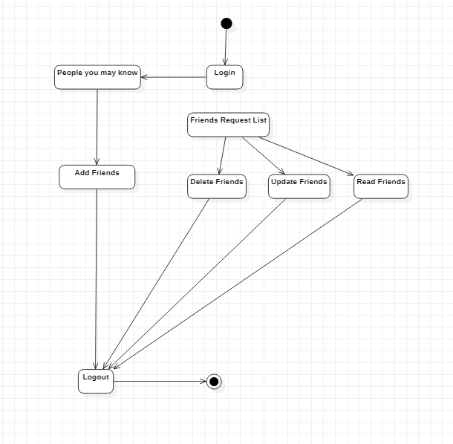

- Class Diagram:
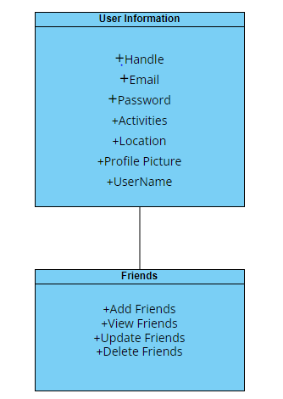
- State Chart Diagram:

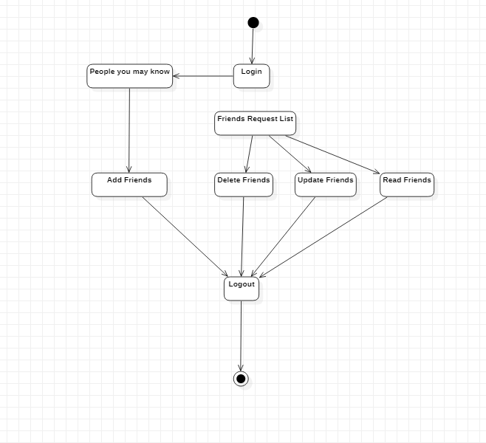

    - Module 3 complete CRUD Friends Management

- Description: This function allows the user to Create, Read, Update and Delete Friends.

- Usage Scenario/ Use case Description/ Specification:

Description | Allows users to add other users and see their post on Newsfeed
Inputs | News feeds, user should be registered.
Source | User should be registered.

Alternate Case
Outputs | Added | Deleted | Viewed | Updated friends list.
Destination | Computer screen
Precondition | The user is logged in.
Post Condition | None
Side Effects | None

- Use case Diagram:

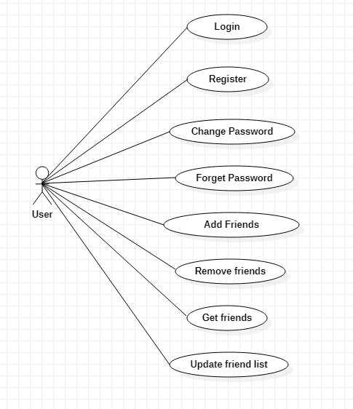

- Use case Realization:

- Flow of Event or Data Flow Diagram:

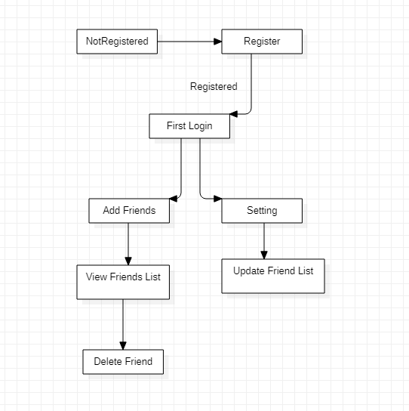

- Sequence Diagram:

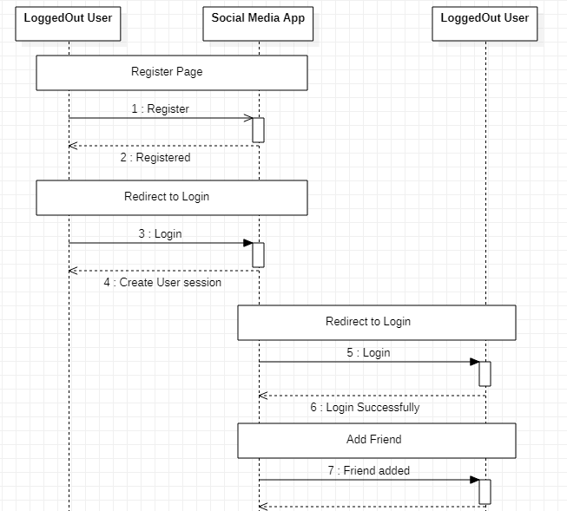
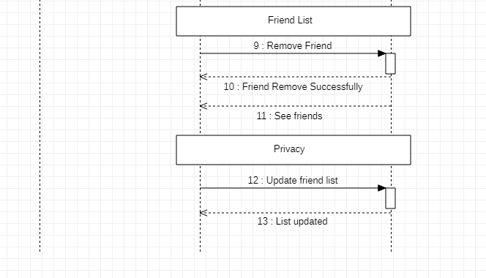

- Collaboration Diagram:

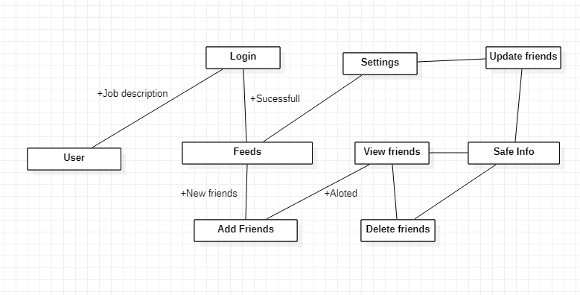

- Activity Diagram:

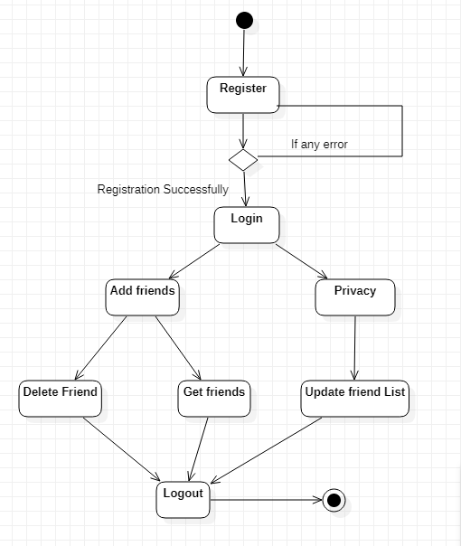

- Class Diagram:

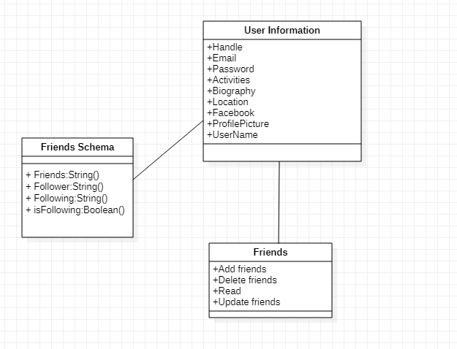

- State Chart Diagram:

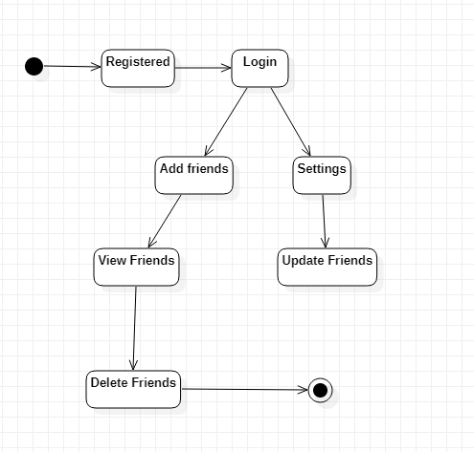
    - Module 4 complete CRUD Post
- Description: This function allows the user to Create, Read, Update
and Delete a Post.

- Usage Scenario/ Use case Description/ Specification:

Description | Allow user to create and share the post form newsfeed or by their self.
Inputs | User should be registered
Source | User input for text document  Press Button to share from newsfeed…

Alternate Case
Outputs | Added | Deleted | Viewed | Updated Posts
Destination | Computer screen
Precondition | The User have to be logged in
Post Condition | None
Side Effects | None

- Use case Diagram:
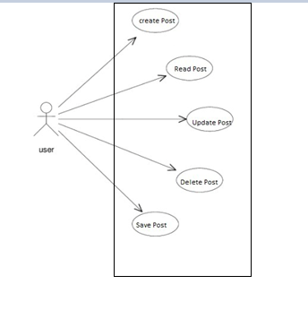

- Use case Realization:

- Flow of Event or Data Flow Diagram:
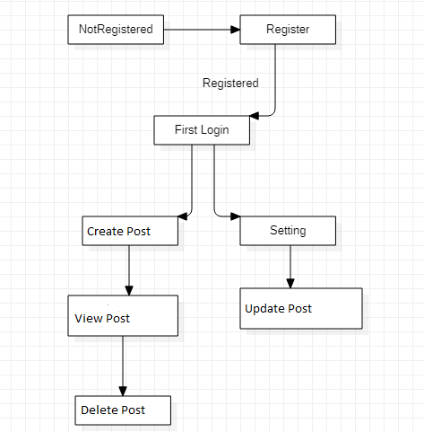

- Sequence Diagram:

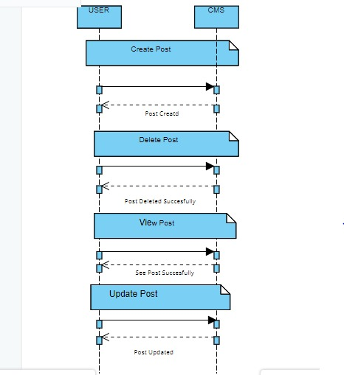

- Collaboration Diagram:

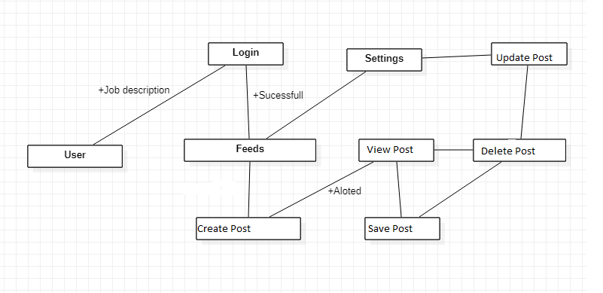

- Activity Diagram:

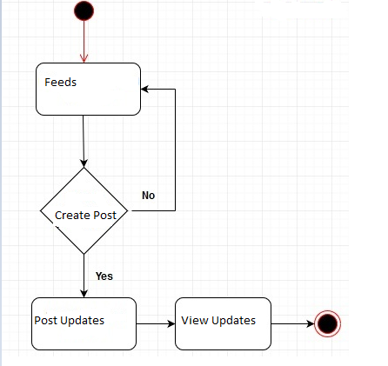

- Class Diagram:

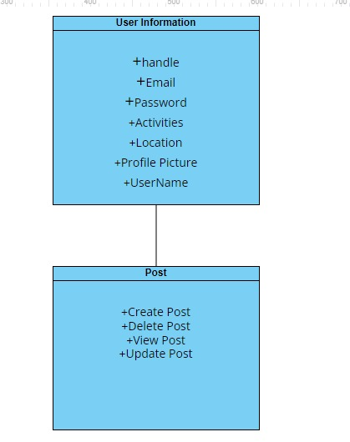
- State Chart Diagram:

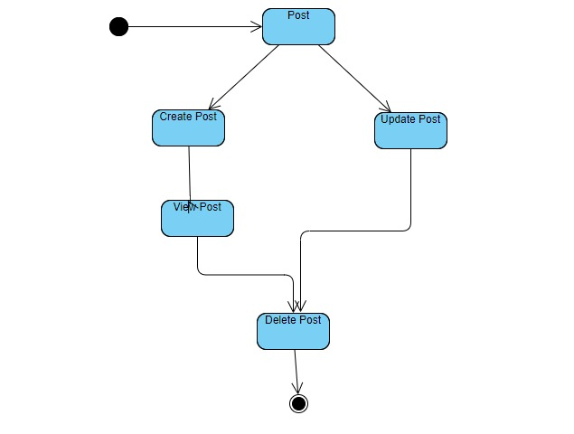

    - Module 5 complete CRUD Comment

- Description: This function allows the user to Create, Read, Update and Delete Comments.

- Usage Scenario/ Use case Description/ Specification:

Description | Allow user comment on any post
Inputs | User should have posts
Source | - User can able to comment their views  - Press Button to add comment …

Alternate Case
Outputs | Added | Deleted | Viewed | Updated Comments
Destination | Computer screen
Precondition | User should be registered and have posts
Post Condition | None
Side Effects | None

- Use case Diagram:

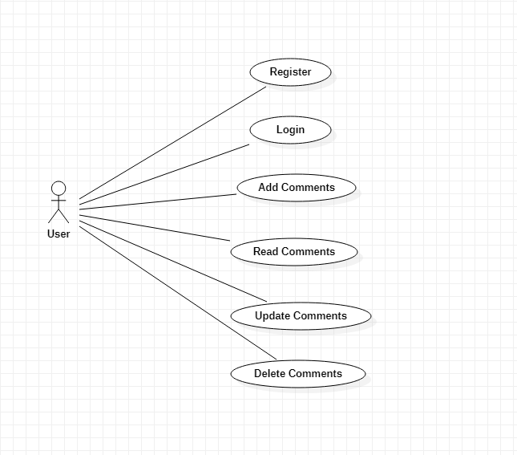

- Use case Realization:

- Flow of Event or Data Flow Diagram:

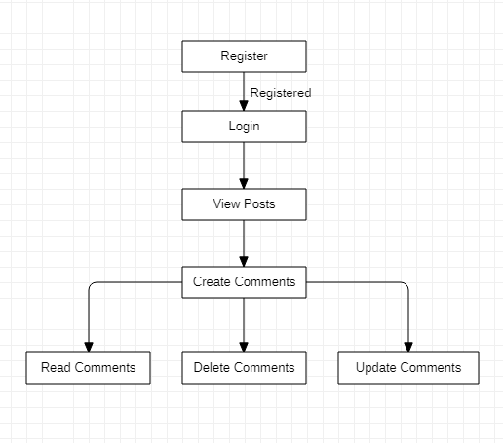

- Sequence Diagram:

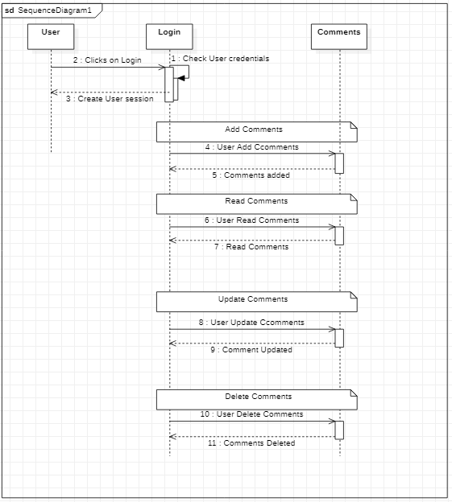

- Collaboration Diagram:

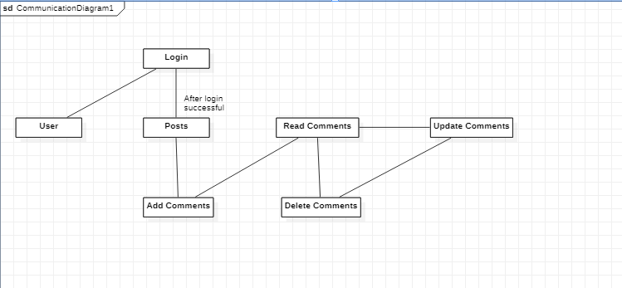

- Activity Diagram:

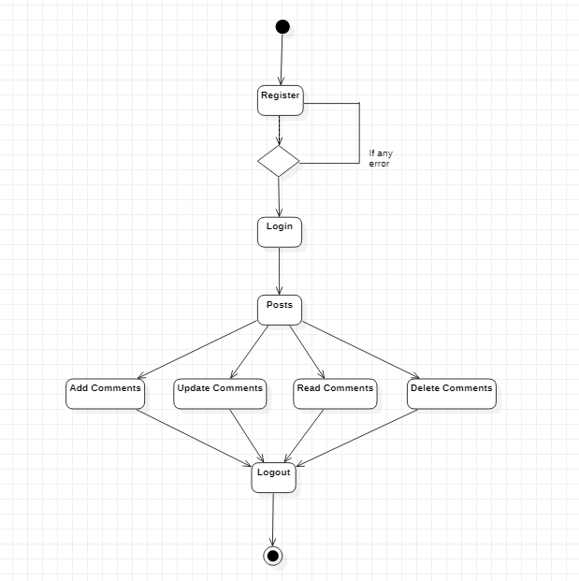
- Class Diagram:
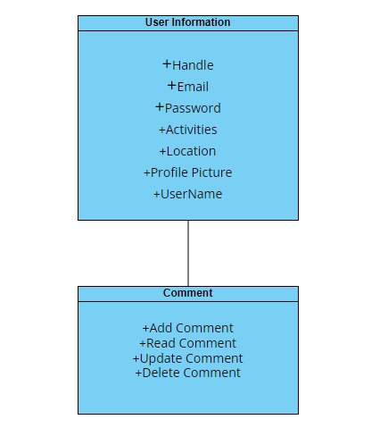

- State Chart Diagram:

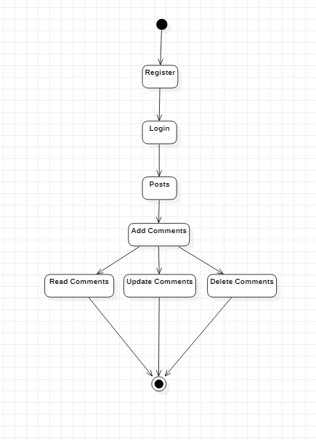
    - Module 6 complete CRUD Share

- Description: This function allows the user to Create, Read, Update and Delete Share Posts.

- Usage Scenario/ Use case Description/ Specification:

Description | [ make | delete | view | update] a share post.
Inputs | User should be registered and have any post to share.
Source | - User can able to share a post.  - Press Button to share a post.

Alternate Case
Outputs | Added | Deleted | Viewed | Updated shared posts.
Destination | Computer screen.
Precondition | The user has to be logged in and must have any post to share.
Post Condition | None
Side Effects | None

- Use case Diagram:

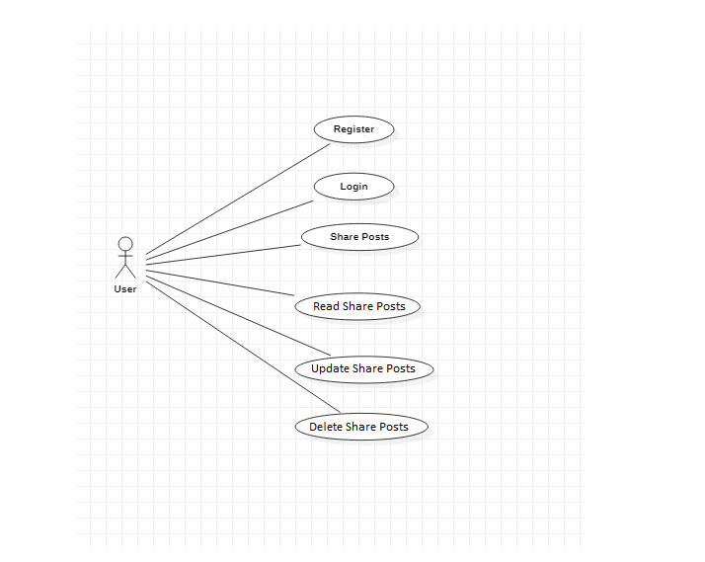

- Use case Realization:

- Flow of Event or Data Flow Diagram:

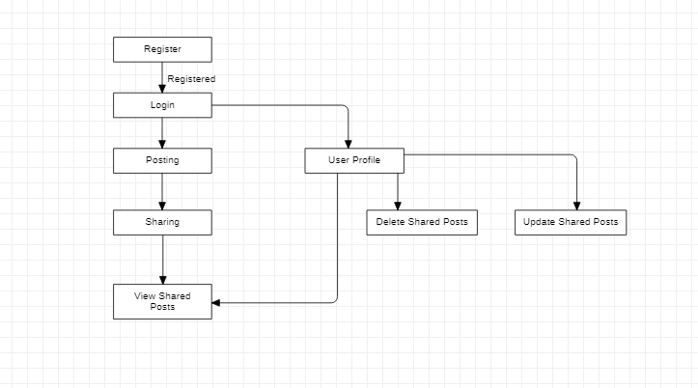

- Sequence Diagram:

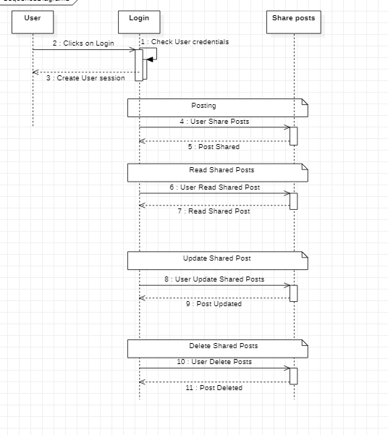

- Collaboration Diagram:

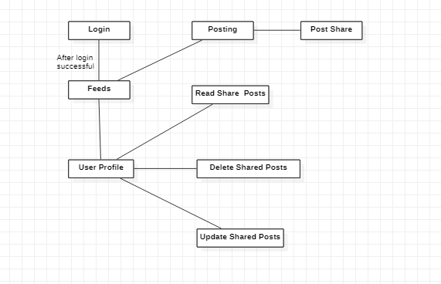

- Activity Diagram:

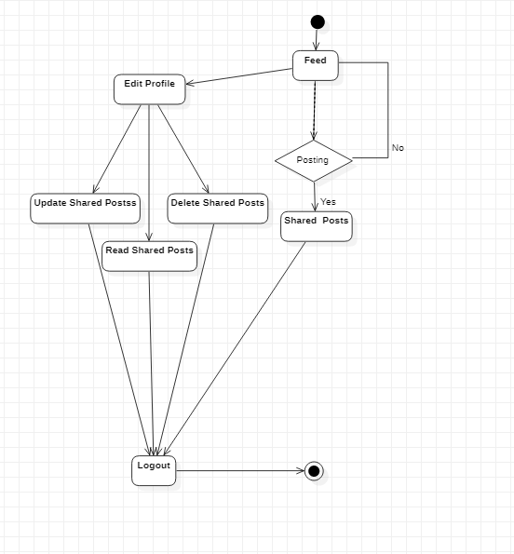
- Class Diagram:
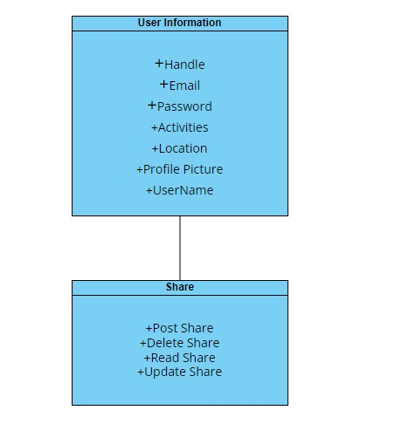

- State Chart Diagram:

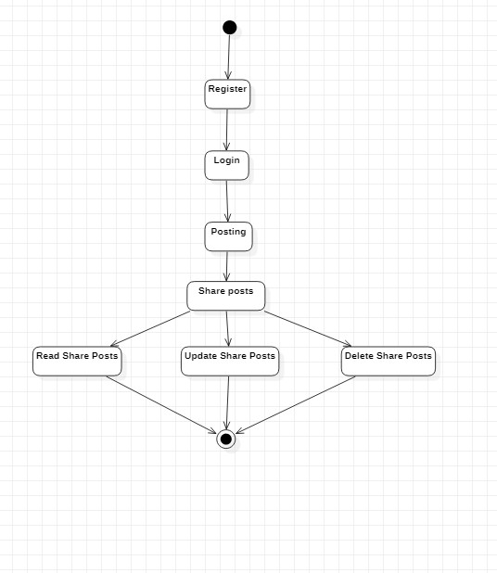

3.2. External Interface Requirements
3.2.1 User Interfaces
The user interfaces are divided into two major components. One part includes the user accessing the system using a cell phone. The other portion involves accessing the system through a remote site or at a particular location specifically designed to access the system. For instance, the clerks and the PSM access the management system from the management or PSM office.
The diagrams and explanations below demonstrate the major transition from one user interface to another. This is a brief description. However, a more detailed demonstration is done in the prototype. The purpose of this interaction is to illustrate the overall view of the CMS.
The diagram below illustrates the four major functionalities or modules. These functionalities will be displayed depending on the user. For instance, the PSM will see all functionalities while the normal user and the clerks will only see the function that we want to see them.

Selecting one of these functions will take the user to a different user interface. For instance, choosing Ticket Reservation will display the following web page. The title of this page is consistent with the function selected, and since the Ticket Reservation was selected, the title displays Ticket Reservation. The purpose of this is to allow the user know what part of the system they are accessing. Furthermore, the user can select any of the four functions.

The user can select any of the four functionalities. For the sake of this demonstration, if the user clicks on the Make Reservation function the diagram below is displayed. Once again the title is the same as the main function and a subtitle indicates the second function selected. In addition, the person can fill up the following information and the date of travel or return if he/she wishes. The three buttons allow the user to navigate through the interfaces. For instance, the back button will take the user to the above page, and the clear button will clear the form of any selection he/she made before. The Display Available displays the available trains, seats and what city they want to travel to. However, before we get to the next page when clicking Display Available the picture below illustrates the Make Reservation function.

The Display Available function displays all the trains traveling from one city to another and the seats available on that train. Furthermore, the last list displays the number of tickets available for the particular train on the selected route. The back button will take the user to the above picture, and the confirm button takes the person to the payment page.

The following page allows the user to pay for the ticket as appropriate. Now, this page is part of the Passenger Account function, and it is used here to make payment for the ticket selected. This makes it easier for the user since they do not have to go back to the main menu and to access their account.

Finally, the submit button displays the appreciation page as shown below with a button to go to the main menu.

The above illustration has shown a brief overview of the user interfaces involved for the normal and clerk users. However, the CRM have specifically requested a number of reports, and they must be able to adjust their train schedule as the trains become unavailable. Therefore, the CRM interface is able to access all four functionalities as shown in the main menu (first diagram). Once the CRM selects the Reports function, a list of five reports is displayed as linked list. This is shown in the diagram below:

The report selected here shows the number of reservation for each departure. This report indicates the major traffic flow, and what trains are needed where during varying time and season. The diagram below shows the report format to be displayed.

As mentioned earlier, the system can also be accessed through the wireless phones. In that case, the overall system will be the same as the above presentation except that the format will be simplified, since the phones do not have graphic support. The phones will have access to the Make Reservation and Passenger Account, however it is difficult to display the reports and trains information on a small screen for the CRM.

3.2.2 Hardware Interfaces
The CMS includes two major hardware components: cellular phones and regular PC's. The cell phones require WAP (wireless application protocol) network protocol, which is already programmed in the latest phones.
The second component involves the regular PC’s, which communicate with the server. The server then communicates with the database. The protocol involved between the PC's and the server is the HTTP protocol, which allows communication between the PC's and the Server. The remote PC's, such as someone accessing the CMS from home using the Internet, are able access the information through the CGI. The requests come in through the HTTP protocol, and using an ODBC the database results are returned and processed using Perl to give a REACT/FLUTTER web page. The format of the output is displayed as web pages.

3.2.3 Software Interfaces
A MONGO DB will be used to manage the database and any changes made to it. Furthermore, the DBMS will make regular backups of the database and generate reports regularly so that they can be accessed by the PSM. The Apache server between the client and the database will handle all communication, and the server will run on a Linux, Windows operating system. Furthermore, the REACT/FLUTTER pages must be implemented such that they can be displayed on two common browsers: Chrome and Internet Explorer.

Information about the products used for the CMS:

(1) Name: Oracle
(2) Mnemonic: Oracle
(3) Version Number: ?
(4) Source: Oracle

(1) Name: Linux
(2) Mnemonic: Linux
(3) Version Number: 6.2
(4) Source: Unix

(1) Name: Internet Explorer
(2) Mnemonic: IE
(3) Version Number: 5.00
(4) Source: Microsoft

(1) Name: Apache
(2) Mnemonic: Apache
(3) Version Number: 1.3.14
(4) Source: Apache Software Foundation

3.3 Performance Requirements
The following sections list the performance requirements for the system.

3.3.1 User Requirements

User Requirements | Description of Requirement For Design Environment
Location(s) and Number(s) of Users | Islamabad, Karachi, Lahore
Expected Growth in Number of Users
After 1 Year | 50%
After 2 Years | TBD
After 3 Years | TBD
User Expectation
Interactivity | User expect that it provides a very easy to use graphical user interface
Reliability | For some applications, reliability must be 100% during the application session
Adaptability | Network must adapt to user additions, deletions and changes
Security | Encryption software would be used for Credit Card transactions
Cost / Funding | Less than $250K

3.3.2 Application Requirements

Since no specified service is indicated, then we have listed the applications as best – efforts. This may change as we learn more about the application.

The communication package is determined to be bursty in nature, with small data sizes and frequent transmissions. We can consider this application to be interactive-burst, while the database transaction-processing application is described by the PSM as transferring large amounts of data (initial estimates are 1 MB/transaction), we have listed this application as interactive-bulk.

Categorizing  Applications | Best-Efforts | Application  Locations
Communication | 100 Kb/s | Islamabad and Karachi
Database Access | 400 Kb/s | All Locations
Database Transaction processing | 1.5 Mb/s | All Locations

3.3.3 Host Requirements

 | Type of Host or  Equipment | Numbers and  Locations
Host A | PC | Islamabad (10), Karachi(7), Lahore(10)
Host B | Database Server | Lahore
Host C | Application Server | Karachi

3.4.1 Standards Compliance
There are no design constraints that can be imposed by other standards limitations.

3.4.2 Software Limitations
• must be able to run Internet Explorer or Chrome web browsers to access the system.
• must have cell-phone web-based capability to access the system from a mobile phone.

3.4.3 Hardware Limitations
• Input/Output: One or two-button mouse, keyboard, cell-phone, or touch screen required.
• Network card required at thin-client terminals to make communication with server possible.

3.5 Quality Characteristics
There are a number of quality characteristics that apply to the CMS software system.

3.5.1 Portability
The CMS system will be developed using REACT/FLUTTER and NODE JS, EXPRESS JS so that it can be accessed from any type of system using just a regular web browser. It will also be available to users that have web access on their cellular phones. The system will be tested on all types of hardware before being released to ensure that is it compliant with this requirement.

3.5.2 Reliability

The CMS system should be capable of processing a given number of reservations within a give time frame with no errors and the system should be available and operational all the time. During the development of the prototype for the 3 cities, the system will be tested in its actual environment to ensure that it can handle the load of reservations that occur during a regular workday.

3.5.3 Usability
The CMS system will be developed so that it is an easy-to-use system that requires the least amount of user input possible. Every input will be validated. The user should only have general computer use knowledge. Error messages will be displayed if the user enters an invalid value or tries to access a function without the required permissions. An easy and well-structured user manual will be provided to the PSM and the system will include descriptive help for all operations allowed.
3.5.4 Correctness
The CMS system will be considered correct when the PSM approves the prototype presented and agrees that all the functions they require are implemented as stated in the Software Requirements Specification.
3.5.5 Flexibility
The CMS system should be developed in such a way that it is easily customizable. If new functions are required by PSM, there will be little effort required to update the system to support new cities or new transactions.
3.5.6 Security

The CMS system should not compromise the customer information at any time. The user information will never be sold to other parties and will be kept secure at all times. Users will be authenticated to ensure that no unauthorized users gain access to private information.

3.5.7 Maintainability
The CMS source code will be kept well structure and documented so that it is easier to maintain and extend the system. All changes to the system shall be documented.

3.6 Other Requirements
Certain requirements may, due to the nature of the software, the user organization, etc., be placed in separate categories such as those below.

3.6.1 Data Base

The Context Management System will have one main databases. The database will be created with MONGO DB. The following are the requirements for these databases that are to be developed as part of the product. They include:

Reservation Database
Types of information | Schedule information for the trains, including date, time, departure city, destination city, ticket cost and ticket availability for a particular train
Frequency of use | Depends on the passenger demand, which may reach 25,000 per day during peak periods
Accessing capabilities | The database should allow access to at least 1,000 people at once; the users will have a general access to the information about the train schedule, and a secure access to the reports (available only to CRM officials) using a username and a password
Data element and file descriptions | To be determined
Relationship of data elements, records and files | To be determined
Static and dynamic organization | To be determined
Retention requirements for data | Train schedule information will be available as long as the train for a particular route is in use and at least one year after the train has been cancelled. The reports information will be available at least for 5 years

Passenger Account Database
Types of information | Passenger account information including their name, address, phone numbers, last reservations, balance owed, credit card number (if they paid by a credit card)
Frequency of use | Depends on the passenger demand, which may reach 25,000 per day during peak periods
Accessing capabilities | The database should allow access to at least 500 people at once; the users will have a secure access to the database using a username and a password
Data element and file descriptions | To be determined
Relationship of data elements, records and files | To be determined
Static and dynamic organization | To be determined
Retention requirements for data | Passenger account will be available for as long as a passenger is using the account, and at least for 6 months since the passenger logged on last time.

3.6.2 Operations
The normal operations required by the user can be viewed as the following:
User-initiated Operations:
These operations include the login operation, which is initiated by the users. Also, the process of becoming a new user is in this category. Building, changing, and viewing posts, comments, news feed, friends as well as sharing posts are all initiated by the users. The user initiates the social media activity.
Interactive Operations and Unattended Operations:
The users initiate all the operations mentioned above, and almost all of them are somehow interactive. Displaying the news feed is non-interactive. The activity display is a non-interactive operation, although selecting the desired activities will require user input.
Data Processing Support Functions:
The user account data is used to create new accounts, as well as to validate user id's during login functions. For new feed, user input, user account data are used and processed. User data along with final results of user interaction are collected.
Backup and Recovery Operations:
The main operation used for the backup and recovery is cloud database. Depending on the customer's needs and budget, additional redundancy can be added using another backup.
3.6.3 Site Adaptation Requirements
There are no site adaptation requirements for this project.

4. Supporting Information.
There is no supporting information required for this project.

