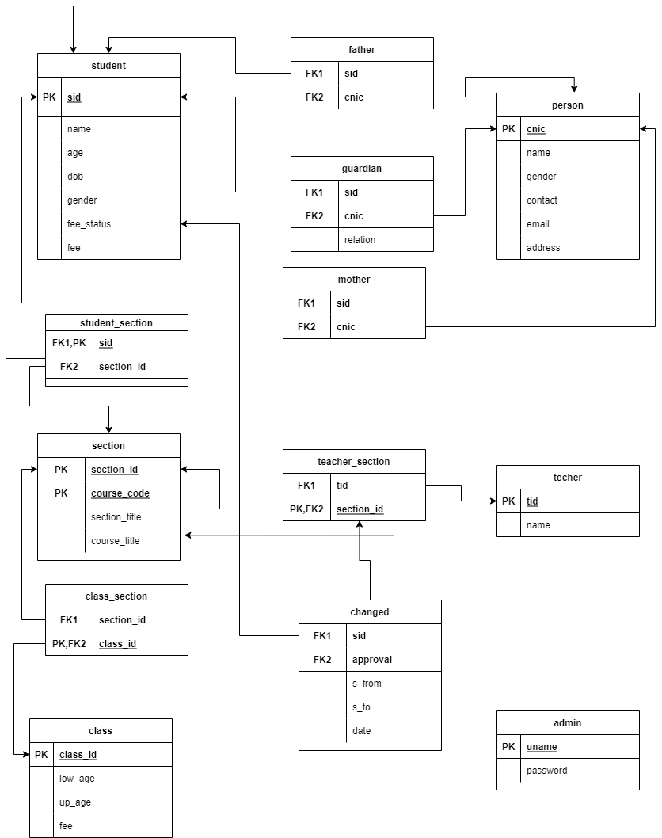

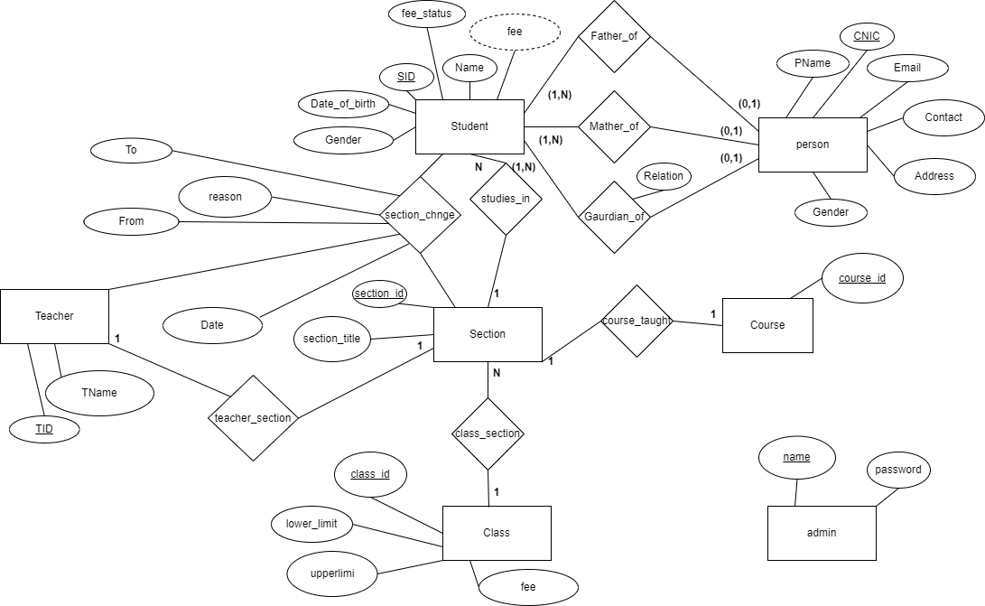

**TABLE NO 1 (student):**

Student table contains basic information of student. It has one primary key SID. It has one derived attribute fee because organization give discount to siblings so fee is not fixed. It can vary. Fee status is attribute to check if a student has paid fee his or not.

**The attributes of the information table are:**

Sid

Name

Age

Date_of_birth

Gender

Fee

Fee_status

**TABLE NO 2 (person):**

This table contains the information of father, mother and guardian, instead of creating three different we decided to make only table. CNIC is primary attribute

**The attributes of the information table are:**

CNIC

Name

Contact

Gender

Email

Address

**TABLE NO 3 (father):**

This table is relation table between student and person. We can use this table to identify a father and its son. Both CNIC and SID are foreign keys in this table.

**The attributes of the information table are:**

SID

CNIC

**TABLE NO 4 (Mother):**

This table is relation table between student and person. We can use this table to identify a mother and its son. Both CNIC and SID are foreign keys in this table.

**The attributes of the information table are:**

SID

CNIC

**TABLE NO 5 (Guardian):**

This table is relation table between student and person. We can use this table to identify the guardian of a student. Both CNIC and SID are foreign keys in this table. It also has its own attribute Relation to identify the relation between student and the guardian.

**The attributes of the information table are:**

SID

CNIC

Relation

**TABLE NO 6 (student_section):**

This table is relation table between student and person. We can use this table to identify the section in which the student is registered. Both Section_ID and SID are foreign keys in this table.

**The attributes of the information table are:**

SID

Section_ID

**TABLE NO 7 (section):**

This table has two primary keys Section_ID and Course_ID. Because there is one to one relation between section and course so we combined section and course table.

**The attributes of the information table are:**

Section_ID

Course_ID

Section_title

Course_title

**TABLE NO 8 (class_section):**

This table is relation table between student and person. We can use this table to identify class and its sections. Both Section_ID and Class_ID are foreign keys in this table.

**The attributes of the information table are:**

Class_ID

Section_ID

**TABLE NO 9 (class):**

This table has one primary key Class_ID. It has three other attributes. Up_age and Low_aghe are used to identify the upper and lower age limit of a specific class.

**The attributes of the information table are:**

Class_ID

Up_age

Low_age

Fee

**TABLE NO 10 (teacher):**

This table has one primary key TID. It has one other attribute name

**The attributes of the information table are:**

TID

Name

**TABLE NO 11 (teacher_section):**

This table is relation table between student and person. We can use this table to identify which teacher teaches which class. Both Section_ID and TID are foreign keys in this table.

**The attributes of the information table are:**

TID

Section_ID

**TABLE NO 12 (changed):**

It’s actually a relationship table. It has two foreign key SID and approval. This table records which student changed from which section to which section and which was the reason and who has approved this.

**The attributes of the information table are:**

SID

Approval

S_from

S_to

Date

**TABLE NO 13 (admin):**

This is used to make sure that admin only admin uses the system. This table is used in login page

It has one primary key username. Other attribute is password

**The attributes of the information table are:**

Username

password