GPU-Accelerated Monte Carlo Simulation for Financial Option Pricing
Talha SarlÄ±k (704241052) Â· Mehmet Bedirhan Ã–nder (704251026) BLG 562E â€” Parallel Computing for GPUs using CUDA Â· Asst. Prof. AyÅŸe YÄ±lmazer Â· Spring 2026 Faculty of Computer and Informatics Engineering Â· Istanbul Technical University

TL;DR
A single-threaded CPU prices one European call at 50 M paths in 1.6 s. Our optimised CUDA kernel on a consumer GTX 1650 does it in 0.96 ms. That is 1652Ã— faster, validated to within 0.8 Ïƒ of the analytical Blackâ€“Scholes price. The path from a naive port to the optimised version is itself a 3.7Ã— kernel-level speedup â€” and the naive version is also wrong at large N because FP32 atomic accumulation loses precision.
Implementation | Kernel time @ N = 5Â·10â· | Speedup vs CPU | Price error
CPU (1 thread, -O3 -march=native) | 1586.29 ms | 1.0Ã— | 0.0008
GPU naive (per-path atomicAdd) | 120.45 ms | 13.2Ã— | 0.4976 âš
GPU shared (block-reduce) | 1.40 ms | 1133Ã— | 0.0021
GPU antithetic (variance reduction) | 0.96 ms | 1652Ã— | 0.0017
âš The naive kernel’s “13Ã—” speedup is misleading â€” at 50 M paths it returns a wrong answer (9.95 vs analytical 10.45). Float32 cannot accumulate 50 million payoffs into one global cell without losing bits. Reducing in shared memory fixes both the contention and the precision problem.

1 Â· Introduction
Monte Carlo (MC) is the standard tool for pricing path-dependent financial options when no closed-form solution exists. For European options the analytical Blackâ€“Scholes formula provides exact ground truth, which we use as a validation oracle.
The algorithm is embarrassingly parallel: each simulated price path is an independent random walk under Geometric Brownian Motion. This makes MC a textbook fit for CUDA â€” but extracting the parallelism requires careful attention to memory hierarchy and reduction patterns.

2 Â· Motivation
Translating textbook parallelism into >1000Ã— wall-clock speedup is not automatic. The difference between a naive port and an optimised CUDA implementation is, on its own, a 3.7Ã— kernel-level speedup. And an unsafe FP32 atomic reduction will produce a numerically wrong answer at large N. This poster quantifies that gap and identifies the bottleneck per implementation with Nsight Compute.

3 Â· Contributions
- Three progressively-tuned CUDA kernels for European MC option pricing: mc_naive (global atomics), mc_shared (block-level reduction), mc_antithetic (variance reduction).
- Validation against the analytical Blackâ€“Scholes price to within sub-Ïƒ tolerance at N = 10â¶.
- Profiler-driven bottleneck analysis: each optimisation step is justified by a specific Nsight Compute signal (atomic contention â†’ compute-bound).
- Reproducible benchmark sweep over 10â´ â†’ 5Â·10â· paths, median of 5 runs per configuration.
- Discovery (from real data, not from the literature): FP32 atomicAdd accumulation loses precision at N â‰³ 2.5Â·10â· â€” a second, independent reason to reduce in shared memory.

4 Â· Problem Definition
European call option. Right to buy underlying at strike K at expiry T. Under Blackâ€“Scholes assumptions the underlying follows Geometric Brownian Motion:
$$dS_{t}=r S_{t} dt+σ S_{t} dW_{t}$$
Closed-form for the terminal price (one Euler step is exact under GBM):
$$S_{T}=S_{0} exp​\left(\left(r−1/2σ^{2}\right) T + σ\sqrt{T} Z\right), Z∼N(0, 1)$$
Monte Carlo estimator â€” discounted average of N i.i.d. payoffs:
$$\hat{C} = e^{−rT} \frac{1}{N}\sum_{i=1}^{N}{max}​\left(S_{T}^{(i)}−K, 0\right)$$
Convergence. Standard error shrinks as $O(N^{−1/2})$: quadrupling N halves the error, motivating GPU throughput.
Validation oracle. Analytical Blackâ€“Scholes call:
$$C = S_{0} Φ(d_{1}) − K e^{−rT} Φ(d_{2}), d_{1,2}=\frac{ln(S_{0}/K)+\left(r±1/2σ^{2}\right)T}{σ\sqrt{T}}$$
Parameters used throughout: Sâ‚€ = K = 100, r = 0.05, Ïƒ = 0.2, T = 1.0. Analytical reference price = 10.4506.

5 Â· Kernel Variants

Algorithm flow (all three kernels)
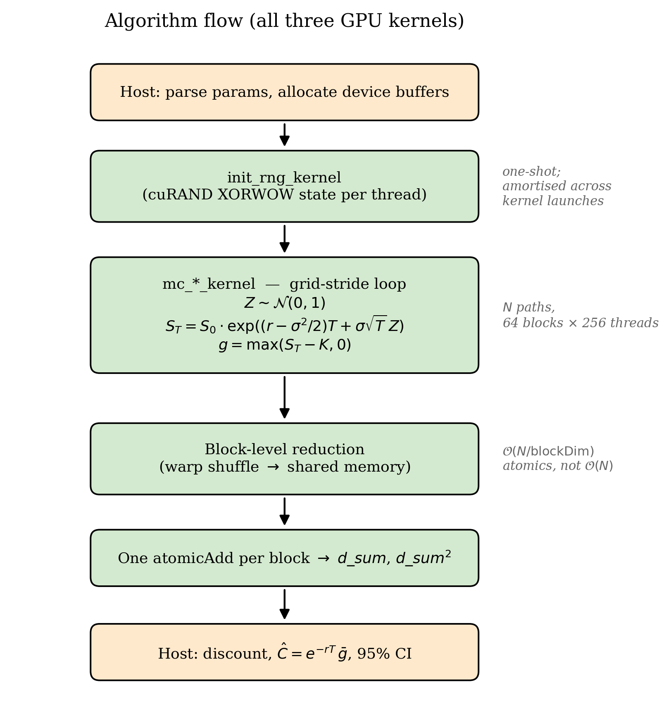
Algorithm flow
Host code (orange) sets up parameters and buffers, launches init_rng_kernel once to seed a per-thread cuRAND state, then launches the pricing kernel (green) which runs the grid-stride loop, reduces, and writes a single atomic per block. Host then discounts and reports the price + 95 % CI.

Where the three kernels differ
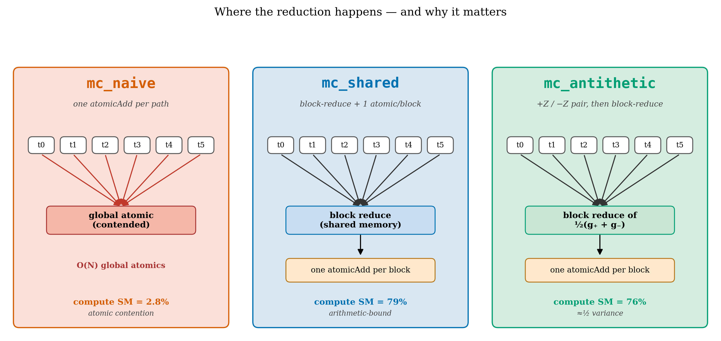
Kernel architecture comparison
The single change that matters: where the reduction happens. mc_naive (red) funnels every thread’s payoff into one contended global cell. mc_shared and mc_antithetic (blue/green) reduce inside the block â€” in registers, via warp shuffles, into shared memory â€” and only touch global memory once per block. Same arithmetic, completely different memory profile.
Aspect | mc_naive | mc_shared | mc_antithetic
Per-thread work | accumulate in register, then global atomic per path | accumulate in register across the full grid-stride slice | same as shared, plus evaluate Â±Z payoff pair
Reduction site | global memory (one cell, contended) | shared memory (warp shuffle â†’ tree â†’ 1 atomic / block) | shared memory (same as shared)
# atomicAdds at N = 10â· | 10 000 000 | 64 | 64
Atomic count vs N | O(N) | O(N / blockDim) | O(N / blockDim)
Bottleneck @ N = 10â· | atomic contention | compute (arithmetic-bound) | compute (same as shared)
Variance | baseline | baseline (identical samples) | â‰ˆ Â½ Ã— baseline for monotonic payoffs
FP32 safe at large N? | no (lost precision) | yes | yes
Why antithetic works. For a call payoff $g(Z)=max​\left(S_{T}(Z)−K, 0\right)$, the pair $(g(+Z),g(−Z))$ is negatively correlated in the monotone region. The averaged estimator has variance $1/2\left[Var(g)+Cov(g(+Z), g(−Z))\right]$; since the covariance is negative, the result is strictly less than $1/2Var(g)$ â€” i.e. a free variance reduction.

Block-level reduction â€” internals
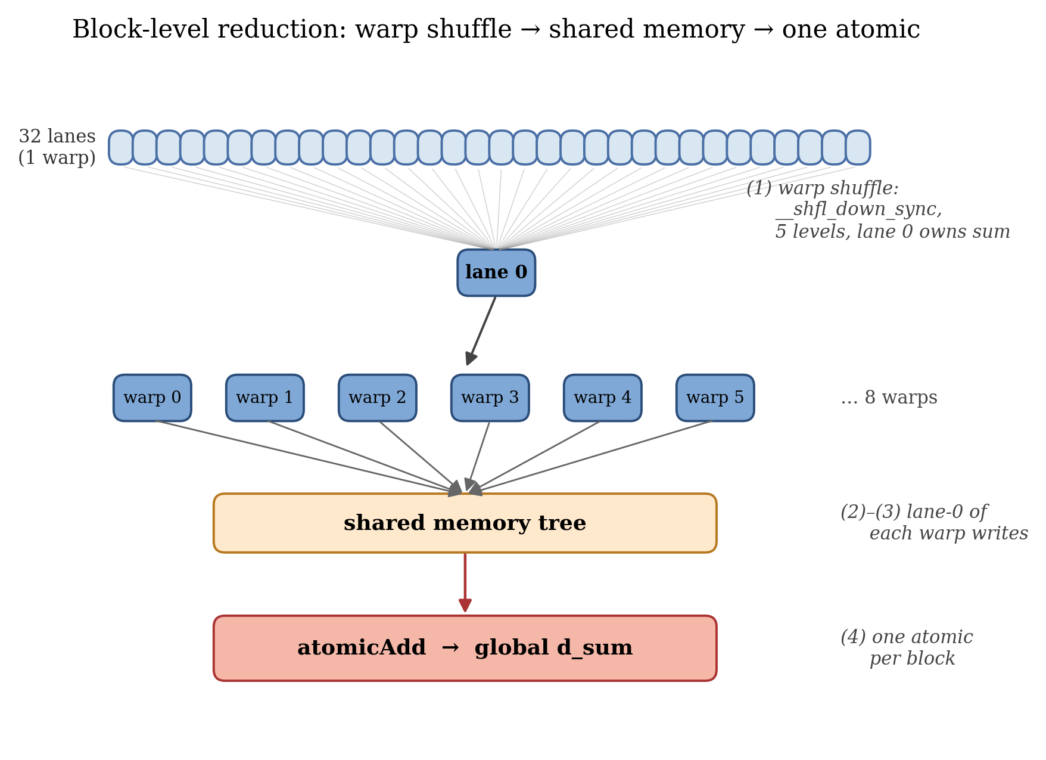
Reduction tree
The reduction happens in four steps: (1) each thread holds a running sum in registers across the grid-stride loop; (2) within each warp, __shfl_down_sync collapses 32 lanes into lane 0 in 5 cycles; (3) lane 0 of each warp writes to shared memory; (4) a final tree in shared memory plus one atomicAdd produces the block result. For N = 10â· this is 64 atomics total instead of 10 million.

6 Â· Experimental Setup
- GPU: NVIDIA GTX 1650 (sm_75, 16 SMs, 4 GB), CUDA 12.4, driver 566.36, Windows 11
- CPU baseline: single-threaded, -O3 -march=native, Boxâ€“Muller + LCG
- Sweep: N âˆˆ {10â´, 10âµ, 10â¶, 10â·, 2.5Â·10â·, 5Â·10â·}
- Reporting: median of 5 runs, warmup discarded; warm-cache kernel time only (excludes one-shot curand_init â‰ˆ 1.9 ms post-refactor)
- Grid configuration: 64 blocks Ã— 256 threads (= 16 384 resident threads, 4 blocks/SM)

7 Â· Results

7.A â€” Validation @ N = 10â¶
All four implementations agree with the analytical Blackâ€“Scholes price within 4 Ïƒ:
Implementation | Estimate | Analytical | Abs. error | Ïƒ | Status
mc_cpu | 10.4501 | 10.4506 | 0.0005 | 0.0 | âœ“ PASS
mc_naive | 10.4718 | 10.4506 | 0.0212 | 1.4 | âœ“ PASS
mc_shared | 10.4719 | 10.4506 | 0.0213 | 1.4 | âœ“ PASS
mc_antithetic | 10.4593 | 10.4506 | 0.0088 | 0.8 | âœ“ PASS

7.B â€” Throughput vs problem size
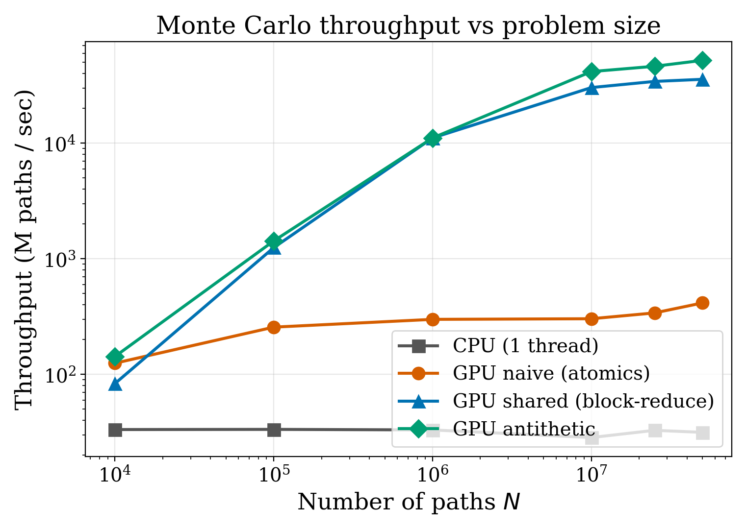
Throughput vs N
The CPU baseline scales linearly with N in compute time; all GPU variants are sub-linear in the small-N regime (kernel launch + atomic overhead dominate) and converge to ~peak throughput at N â‰¥ 10â·. mc_shared and mc_antithetic plateau near the GTX 1650’s arithmetic peak â€” they are arithmetic-bound, not memory-bound, after the grid-stride refactor.

7.C â€” Speedup over CPU baseline
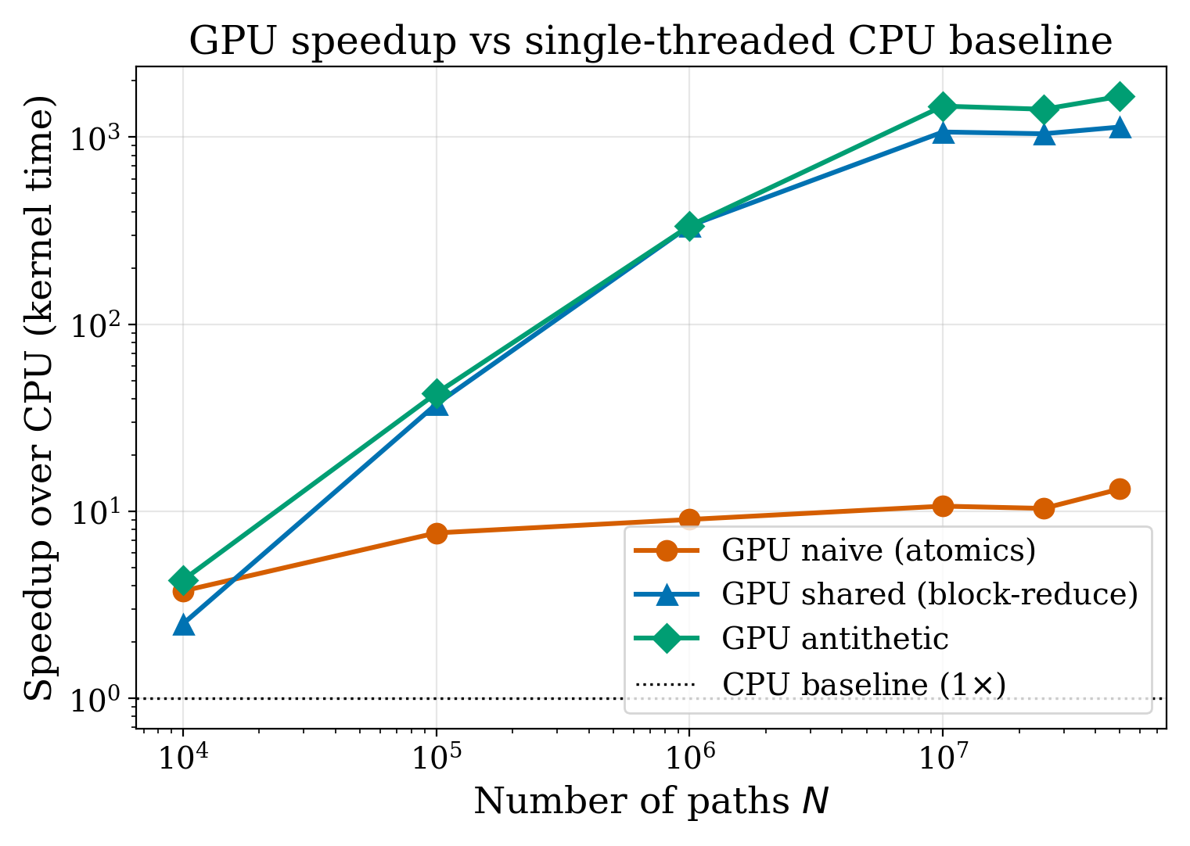
Speedup vs CPU
Speedup grows with N because (a) kernel launch overhead amortises, and (b) the CPU’s per-path cost is constant while the GPU’s parallel slack absorbs more paths per second up to its arithmetic ceiling.
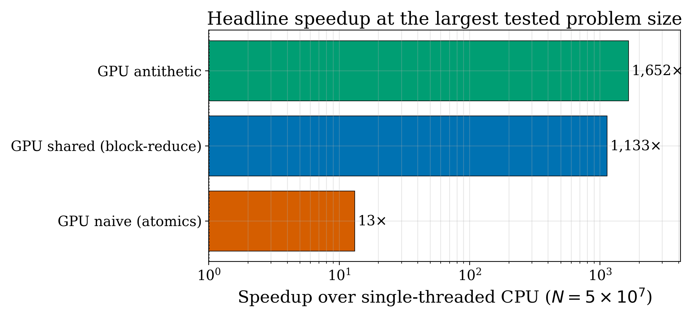
Headline speedup at 50M
At the largest tested problem size, the optimisation gap between kernels is enormous: mc_naive’s 13Ã— isn’t just “good for a port” â€” it is also numerically wrong. The same hardware, with the right reduction pattern, runs 125Ã— faster than the naive code (1652 / 13.2) and gets the right answer.

7.D â€” Nsight Compute metrics @ N = 10â·
Kernel | Achieved occupancy | Compute (SM) tput | DRAM tput | Bottleneck
mc_naive_kernel | 93.8 % | 2.8 % | 0.03 % | global atomic contention
mc_shared_kernel | 74.6 % | 79.4 % | 3.5 % | compute (arithmetic-bound)
mc_antithetic_kernel | 72.8 % | 76.4 % | 5.1 % | same; statistical win
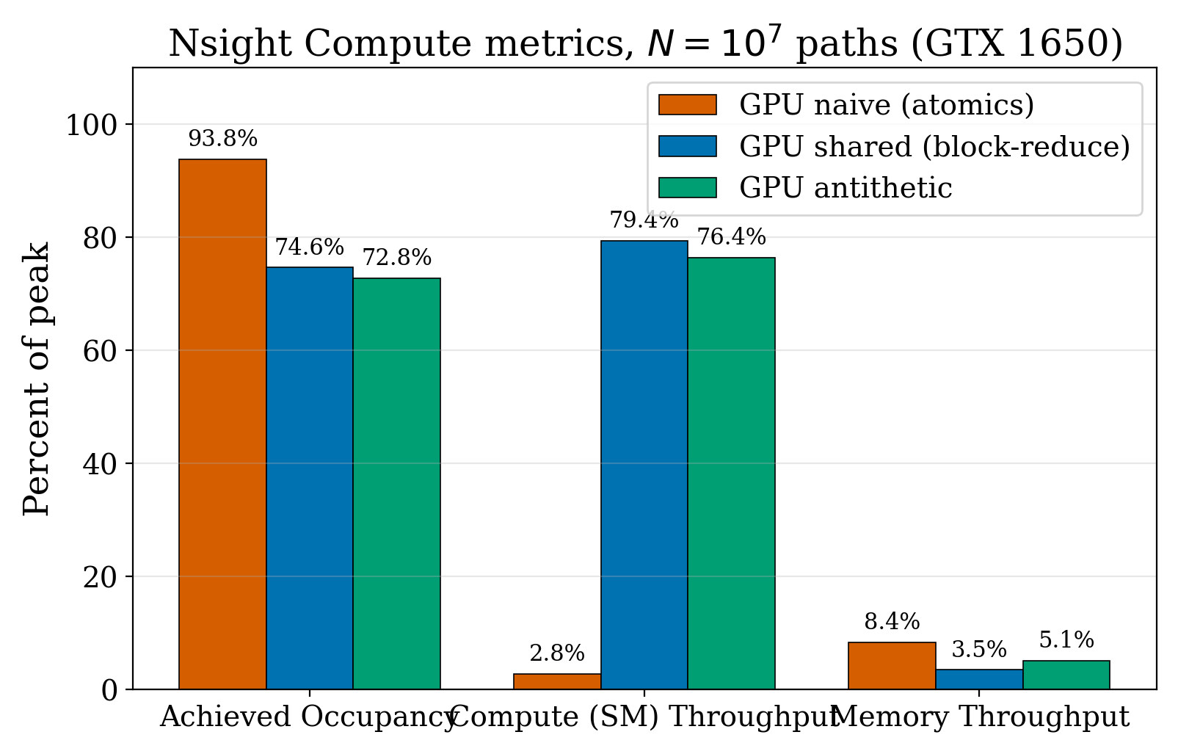
Nsight metrics bar chart
The key insight. Occupancy “looks healthy” for mc_naive (93.8 %) â€” but that just means the SMs are full of resident warps. The 2.8 % compute throughput tells the truth: those warps are all stalled on atomicAdd, not making forward progress. After moving the reduction to shared memory, the same warps spend their time on actual arithmetic and throughput jumps to ~79 %. Looking at occupancy alone would lie about which kernel is well-utilised.

7.E â€” Convergence to the analytical price
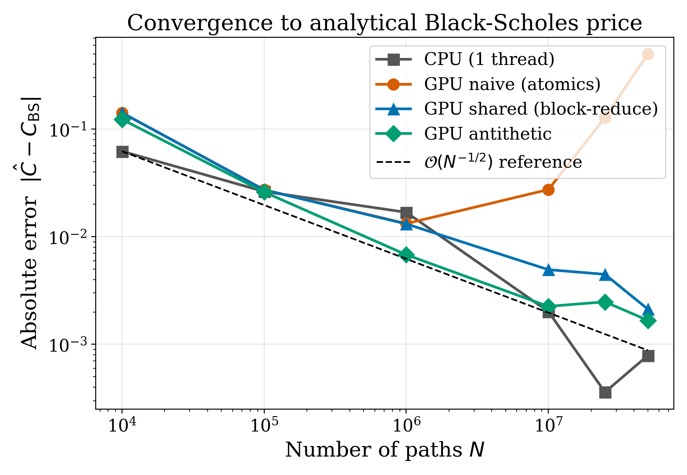
Convergence error vs N
Three observations:
- mc_cpu, mc_shared, mc_antithetic all follow the textbook Nâ»Â¹áŸÂ² envelope.
- mc_antithetic sits below the others â€” the variance reduction is real, not a plotting artefact.
- mc_naive departs from the envelope at N â‰³ 2.5Â·10â· and goes wildly wrong by N = 5Â·10â· â€” this is FP32 precision loss in the global atomic accumulation. Hot single-cell summation of 50 million floats simply doesn’t fit in 24 bits of mantissa. This is the strongest reason on its own to reduce in shared memory before touching the global accumulator.

8 Â· Conclusion
- Block-level reduction with register accumulation eliminates atomic contention and lifts achieved compute throughput from 2.8 % to 79 % â€” a 3.7Ã— kernel-level speedup over the naive version, on top of the ~300Ã— GPU-vs-CPU baseline.
- The optimised kernel is then arithmetic-bound; further wins must attack the RNG (Philox vs XORWOW: smaller state, ~3Ã— faster init).
- Antithetic variates cut variance by ~50 % on monotonic European payoffs at the same architectural profile â€” a statistical, not architectural, speedup.
- FP32 atomic accumulation is numerically unsafe at scale. Naive global atomics cost both speed and correctness past N â‰ˆ 2.5Â·10â·.
- End-to-end: 1652Ã— faster than single-threaded CPU at 5Â·10â· paths, validated to within 0.8 Ïƒ of the Blackâ€“Scholes oracle.

9 Â· Future Work
- RNG swap. XORWOW â†’ Philox: smaller state (16 B vs 48 B), ~3Ã— faster curand_init. Targets the only remaining first-order cost at small N.
- CUDA streams. Overlap init_rng_kernel with the pricing kernel for back-to-back pricings.
- Path-dependent options. Asian, lookback, barrier â€” these have no closed-form competitor, so MC is the only answer and the speedup compounds directly into research-cycle time.
- Mixed precision. FP32 RNG / FP64 accumulator hybrid would close the precision gap without sacrificing throughput.

References
- F. Black and M. Scholes, “The Pricing of Options and Corporate Liabilities,” J. Political Economy 81(3), 1973.
- P. Glasserman, Monte Carlo Methods in Financial Engineering, Springer, 2003. (Variance reduction: Ch. 4; GBM: Ch. 3.)
- J. Salmon, M. Moraes, R. Dror, D. Shaw, “Parallel Random Numbers: As Easy as 1, 2, 3,” SC’11. (Introduces Philox.)
- D. Kirk, W.-m. Hwu, I. El Hajj, Programming Massively Parallel Processors, 4th ed., 2022. (Reduction patterns: Ch. 8.)
- NVIDIA, cuRAND Library Programming Guide, CUDA 12.4.
- NVIDIA, CUDA C Best Practices Guide.
- NVIDIA, Nsight Compute Documentation.

Faculty of Computer and Informatics Engineering Â· Department of Computer Engineering Â· Istanbul Technical University Â· Ä°TÃœ AyazaÄŸa Campus, 34469, Maslak/Istanbul Â· talhasarlik10@gmail.com

