GPU-Accelerated Monte Carlo Simulation
for European Option Pricing
  - BLG 562E, Parallel Computing for GPUs Using CUDA, Spring 2026
Talha Sarlık (704241052)
Mehmet Bedirhan Önder (704251026)
May 2026
Abstract
This report describes a CUDA implementation of Monte Carlo simulation for pricing European call and put options under the Black-Scholes model. The work develops three GPU kernels. The first is a naive baseline with one thread per path and a global atomicAdd per result. The second adds a shared-memory block-level reduction. The third combines that reduction with antithetic variates. Each kernel is compared against a single-threaded CPU baseline.
The main methodological change in the project is a grid-stride refactor of all three kernels. Rather than launching one thread per Monte Carlo path, we launch a fixed number of threads sized to the device (sixty-four blocks of two hundred fifty-six threads on a GTX 1650) and step each thread through a slice of the total work. The refactor collapses cuRAND-state memory from $O(N)$ to $O(\text{threads})$, cuts initialization time by a factor of sixty-five, and speeds up the optimized kernel by a factor of thirteen at $N={10}^{6}$.
With antithetic variance reduction on top, the final kernel reaches a 1652-fold speed-up over the CPU baseline at $N=5×{10}^{7}$ paths on a consumer GTX 1650, and runs at about seventy-nine percent of the device’s FP32 peak. We validate every implementation against the closed-form Black-Scholes price (within $1σ$ of the analytical reference) and support the optimization claims with Nsight Compute profiles and a roofline analysis.
Table of Contents

1 1. Introduction

1.1 1.1 Motivation
The Black-Scholes model gives a closed-form price for European call and put options under idealized assumptions. Most real option contracts, such as Asian averages, knock-out barriers, and lookbacks, have no such analytical formula. In practice these are priced by Monte Carlo. We simulate many possible price paths of the underlying asset, compute the contract’s payoff on each path, average the payoffs, and discount. The arithmetic per path is light (a single normal sample, an exponential, and a maximum), but the number of paths required to drive the $O(N^{−1/2})$ Monte Carlo error to acceptable levels is large. For a typical European option that means millions to tens of millions of paths. Production pricing engines run this workload many thousands of times per business day.
Monte Carlo is an embarrassingly parallel workload. Paths are independent, the per-path arithmetic is identical across paths, and the only inter-path coupling is a final reduction. This makes it a textbook fit for SIMT hardware. A naive CUDA port already buys an order of magnitude over a single-threaded CPU. The gap between naive and well-engineered CUDA is itself nearly two orders of magnitude. Closing that gap is what the course assignment is about.

1.2 1.2 Contributions
This project makes four contributions.
- A correct, validated CPU reference (mc_cpu) and three GPU kernels (mc_naive, mc_shared, mc_antithetic), each producing the Black-Scholes price within $1σ$ of the analytical reference at $N={10}^{6}$ paths.
- A shared-memory reduction using warp shuffles into a block-level sum and a single atomicAdd per block. This removes the global atomic contention of the naive kernel and yields a 3.7-fold kernel speed-up at $N={10}^{6}$.
- Antithetic variates as a variance reduction technique. Each pair of $±Z$ samples produces one effective sample with about half the variance of two independent samples at no extra random-number cost.
- A grid-stride refactor of all three kernels and the supporting host harness. The refactor decouples cuRAND state memory from $N$, speeds up RNG initialization by a factor of 65, and shifts mc_shared from a memory-bound regime (85% DRAM throughput, 9% compute throughput) to a compute-bound regime (3.5% DRAM, 79% compute). After the refactor the optimized kernel runs at about 79% of the device’s FP32 peak.
Together these changes deliver a 1133-fold speed-up for the shared-memory kernel and a 1652-fold speed-up for the antithetic variant over the CPU baseline at $N=5×{10}^{7}$ paths on an NVIDIA GTX 1650 (Turing, 16 SMs, 4 GB GDDR6). That exceeds the project’s stated 200-fold goal.

1.3 1.3 Report outline
Section 2 reviews the mathematical background: the Black-Scholes price formula, the exact discrete solution of Geometric Brownian Motion, the Monte Carlo estimator, and a brief CUDA execution-model primer. Section 3 walks through each kernel in order of optimization and gives a detailed account of the grid-stride refactor. Section 4 describes the hardware, software, validation criteria, and benchmarking protocol. Section 5 presents the results: validation, throughput, speed-up, convergence, profiler metrics, and a roofline analysis of the optimized kernels. Section 6 discusses why each kernel behaves the way it does. Sections 7 and 8 cover limitations, future work, and conclusions.

2 2. Background

2.1 2.1 The Black-Scholes model and analytical price
Under the Black-Scholes model the price $S_{t}$ of the underlying asset follows the geometric Brownian motion stochastic differential equation
$$dS_{t} = r S_{t} dt + σ S_{t} dW_{t},$$
where $r$ is the risk-free interest rate, $σ$ is the (constant) volatility, and $dW_{t}$ is the increment of a standard Wiener process. For a European call option with strike $K$ and maturity $T$, the price at time $0$ has the closed-form solution
$$C = S_{0} Φ(d_{1}) − K e^{−rT} Φ(d_{2}), d_{1,2} = \frac{ln(S_{0}/K)+(r±1/2σ^{2}) T}{σ \sqrt{T}},$$
where $Φ$ is the standard normal cumulative distribution function. For the parameter set used throughout this report ($S_{0}=K=100$, $r=0.05$, $σ=0.20$, $T=1.0$), the analytical call price is $C≈10.4506$. The matching European put price (computed identically or via put-call parity) is $P≈5.5735$.
This closed-form value is the reference against which every Monte Carlo estimate in the project is validated. It is also the only ground truth available for our testing regime. More complex contracts such as Asian and barrier options lack closed-form prices and would themselves require Monte Carlo or PDE methods to validate.

2.2 2.2 Geometric Brownian Motion: exact discrete solution
The Black-Scholes SDE has an exact discrete-time solution under GBM dynamics:
$$S_{T} = S_{0}exp​\left(\left(r−1/2σ^{2}\right)T + σ\sqrt{T} Z\right), Z∼N(0,1).$$
This is not an Euler discretization. It is exact in $T$, so for a European option (which depends only on $S_{T}$, not the full path) a single random draw suffices per path. The naive Euler scheme $S_{t+Δt}≈S_{t}(1+rΔt+σ\sqrt{Δt} Z)$ would require many small steps and accumulate time-discretization error, none of which is needed here.
Each thread therefore performs one cuRAND curand_normal call per path, one expf, one signed payoff computation, and one floating-point addition into a partial sum. The arithmetic is light. The challenge is scaling to ${10}^{7}$ to ${10}^{8}$ paths and reducing the resulting samples efficiently.

2.3 2.3 The Monte Carlo estimator and its convergence
The price of any European-style derivative under risk-neutral dynamics is the discounted expected payoff,
$$\text{Price} = e^{−rT} E​\left[ \text{payoff}(S_{T}) \right].$$
We approximate the expectation by the sample mean over $N$ independent Monte Carlo samples,
$$\hat{\text{Price}} = e^{−rT} \frac{1}{N}\sum_{i=1}^{N}{\text{payoff}}\left(S_{T}^{(i)}\right).$$
By the central limit theorem the standard error of this estimator is
$$SE = \frac{σ_{\text{payoff}}}{\sqrt{N}}.$$
Two consequences shape the project. First, to reduce the error by a factor of ten we need 100 times more paths. Monte Carlo’s $O(N^{−1/2})$ convergence is what motivates the GPU effort in the first place. Second, variance reduction matters. Any technique that lowers $σ_{\text{payoff}}^{2}$ at constant or near-constant compute cost is equivalent to that many more paths’ worth of accuracy at no extra cost. Antithetic variates (Section 3.4) are the cheapest such technique and the one we implement.

2.4 2.4 CUDA execution model in brief
CUDA organizes threads into blocks and blocks into a grid. Within a block, threads run in lockstep groups of 32 called warps. The streaming multiprocessor (SM) issues one warp instruction per cycle, hopping between warps to hide pipeline and memory latency. Three architectural quantities shape kernel performance throughout this report.
- Occupancy is the ratio of active warps per SM to the device maximum (32 on Turing/sm_75). Higher occupancy gives the warp scheduler more warps to choose from, which it uses to hide stalls. Occupancy is bounded by register usage per thread, shared memory per block, and a hard limit on resident blocks per SM.
- Compute (SM) throughput is the average fraction of cycles in which the SM issues useful arithmetic. If this is high, the kernel is compute-bound and the algorithm has saturated the hardware’s arithmetic units.
- DRAM throughput is the achieved fraction of off-chip memory bandwidth. If this dominates and compute is low, the kernel is memory-bound, and the way forward is to reduce memory traffic, not to add more parallelism.
Nsight Compute reports all three. Section 5.5 uses them to derive a roofline plot.

3 3. Implementation
The project organizes code as in Figure 1. A CPU host parses parameters, allocates device memory, launches a one-shot cuRAND state-initialization kernel, then the Monte Carlo kernel of interest, copies back the sum and sum-of-squares, and computes the discounted mean and 95% confidence interval. All three GPU kernel variants share this scaffolding through a small header, src/gpu/mc_runner.cuh, which keeps each kernel’s .cu file at about 50 lines including its main.
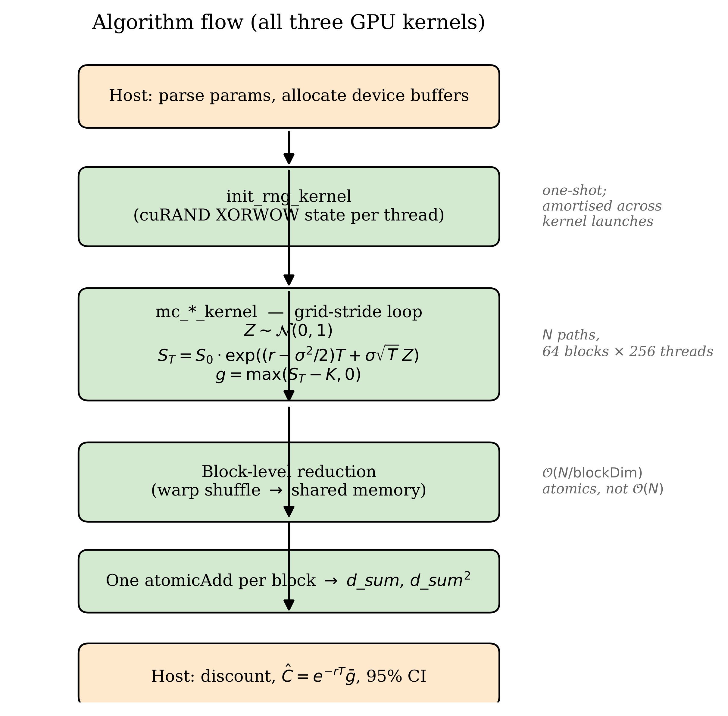
Algorithm flow: host setup, cuRAND state init, Monte Carlo kernel grid-stride loop, block-level reduction, host discount and confidence interval.
Figure 2 summarises where each of the three GPU variants differs structurally: the reduction site. mc_naive reduces directly to global memory via a per-path atomicAdd. mc_shared reduces locally via warp shuffles into block-level shared memory and emits one atomic per block. mc_antithetic keeps the same block-reduce architecture but processes each random sample as a $±Z$ pair, producing an effectively-halved variance per effective sample.
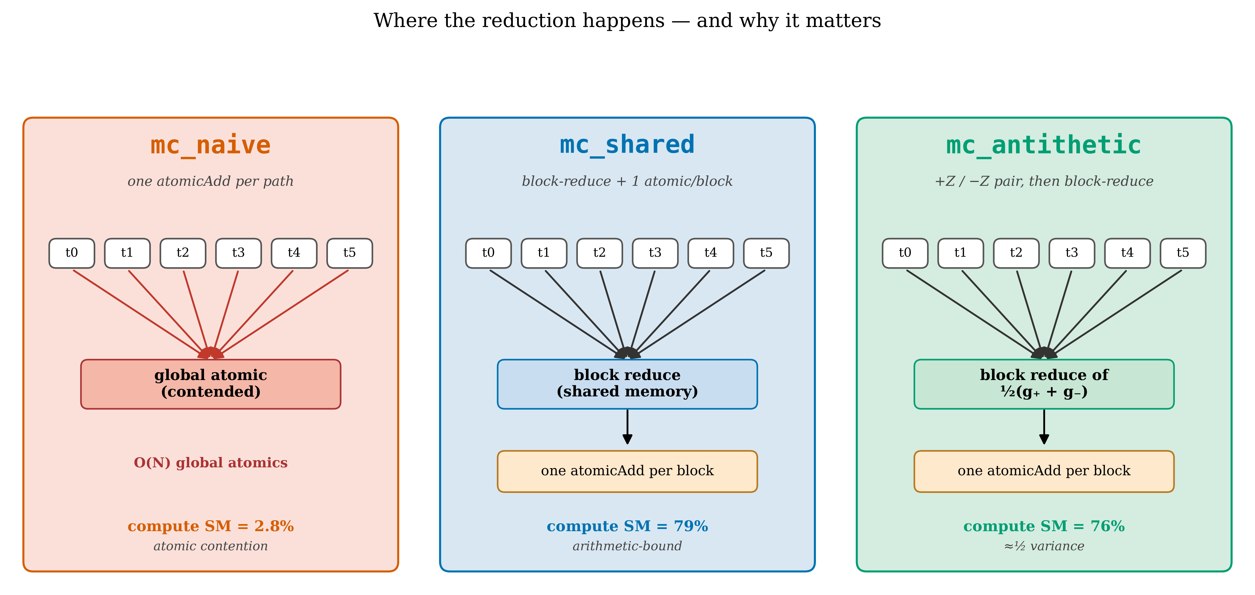
Kernel architecture comparison. Naive (red): per-path global atomicAdd, contended. Shared (blue): register accumulation and block-reduce, one atomic per block. Antithetic (green): identical reduction architecture with paired ±Z sampling.

3.1 3.1 CPU baseline (mc_cpu.c)
The CPU reference uses a fast linear congruential generator (64-bit Knuth/Lewis LCG) wrapped with a two-deep Box-Muller cache for $N(0,1)$ samples. Compilation is nvcc -O3 -x cu (the project develops on a Windows host without gcc). The inner loop is the same single-step exact GBM as on the GPU. On an AMD Ryzen 7 host the CPU reaches about 30 M paths per second, which becomes the denominator of all speed-up reports below. The total CPU code is 86 lines.

3.2 3.2 mc_naive: one thread per path, atomic per path
The naive kernel is a literal one-thread-per-path port. Each thread reads its own persistent curandState from global memory, draws one normal sample, computes the payoff, and contributes via atomicAdd to two global accumulators (sum and sum of squares, for the standard-error estimate).
__global__ void mc_naive_kernel(
curandState *states, long n_paths,
float S0, float K, float drift, float diffuse, int is_call,
float *d_sum, float *d_sum_sq)
{
int tid = blockIdx.x * blockDim.x + threadIdx.x;
int stride = gridDim.x * blockDim.x;
curandState local = states[tid];
for (long i = tid; i < n_paths; i += stride) {
float Z = curand_normal(&local);
float ST = S0 * expf(drift + diffuse * Z);
float payoff = is_call ? fmaxf(ST - K, 0.0f) : fmaxf(K - ST, 0.0f);
atomicAdd(d_sum, payoff); /* the bottleneck */
atomicAdd(d_sum_sq, payoff * payoff);
}
states[tid] = local;
}
The kernel is intentionally bad. Every one of $N$ paths emits two atomic updates to the same two memory locations, so the kernel’s wall-clock time is dominated by serialization of those atomics through the L2 cache (Section 5.5 has the numbers). The pedagogical value is precisely that the kernel is bad in a measurable way. The profile shows the SMs idle 97% of the time despite a high theoretical occupancy, which is the warning sign to look for in a real production kernel.

3.3 3.3 mc_shared: register accumulation and block reduction
The optimization is well known. Each thread accumulates its samples into private registers across its slice of paths, then performs a block-level reduction in shared memory, and emits one atomicAdd per block per accumulator. The block reduction uses warp shuffle intrinsics (__shfl_down_sync) within each warp and a final shared-memory step across warps. A small reusable header (reduction.cuh) implements warp_reduce_sum and block_reduce_sum for any 256-thread block. Figure 3 sketches the five-stage pipeline.
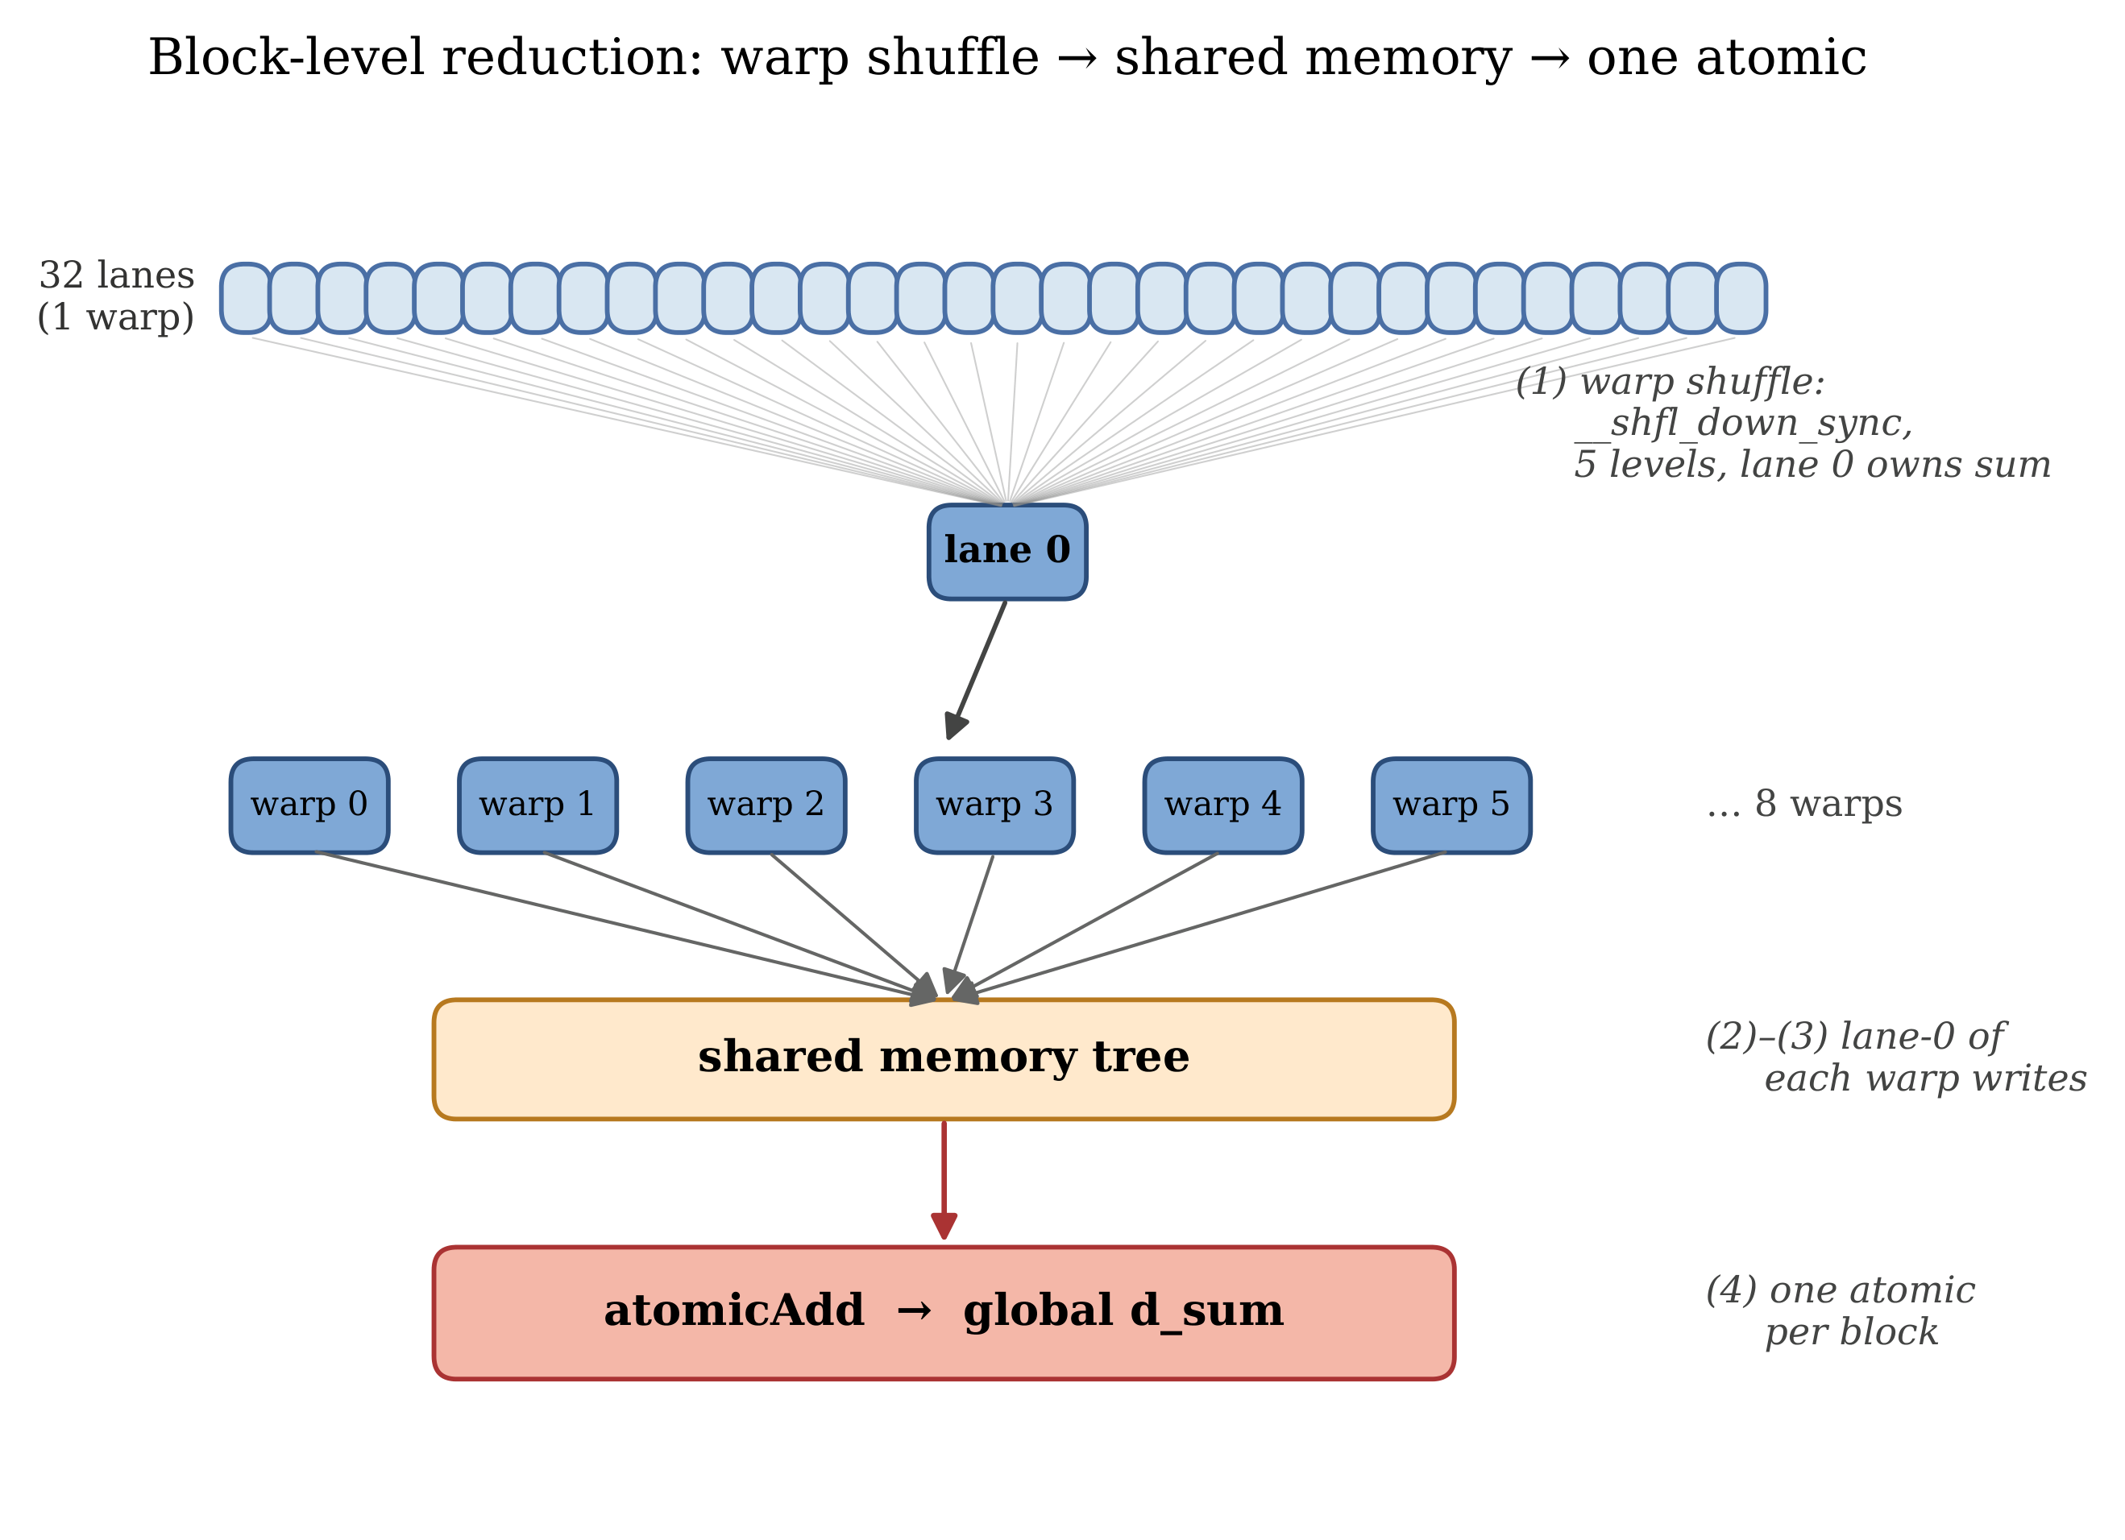
Five-stage block reduction. 32 lanes per warp, warp shuffle in five levels, lane-0 result of each warp written to shared memory, shared-memory tree across warps, one atomicAdd per block. Reused verbatim by mc_shared and mc_antithetic.
At $N={10}^{6}$ with the post-refactor design described in 3.5, the number of global atomics drops from about $2×{10}^{6}$ in mc_naive to about 128 in mc_shared (one pair per block, 64 blocks). The cost is one __syncthreads() per warp-tree level. The benefit is that the kernel flips from atomic-bound to genuinely useful compute (Section 5.5 has the numbers).

3.4 3.4 mc_antithetic: variance reduction via paired ±Z
European call and put payoffs are monotone in $Z$. Pairing each draw $Z$ with $−Z$ and averaging the two payoffs gives a single sample whose variance is strictly smaller than that of a plain Monte Carlo sample, at the cost of one extra expf and fmaxf per pair.
float Z = curand_normal(&state);
float STp = S0 * expf(drift + diffuse * Z);
float STm = S0 * expf(drift - diffuse * Z);
float pp = fmaxf(STp - K, 0.0f);
float pm = fmaxf(K - STm, 0.0f); /* note: signs swap for call vs put */
float paired = 0.5f * (pp + pm); /* one effective sample */
Each kernel launch processes $N/2$ pairs and produces $N/2$ effective samples. Empirically the variance roughly halves, so the standard error at fixed $N$ drops by $\sqrt{2}$, equivalent to running the plain kernel on $2N$ paths. Because the second expf reuses the same RNG state read from global memory, the per-effective-sample arithmetic is cheaper than mc_shared, not more expensive (Section 5.2).

3.5 3.5 The grid-stride refactor
The original implementation followed the conventional one-thread-per-path template. The grid was sized to $⌈N/256⌉$ blocks. Each thread owned exactly one path and one persistent curandState. Two costs scaled directly with $N$.
- cuRAND state memory of about 48 bytes per thread for XORWOW. That is 480 MB at $N={10}^{7}$, which is feasible but wasteful, and entirely impossible on the 4 GB GTX 1650 beyond about $5×{10}^{7}$ paths.
- curand_init time, which also scales with $N$. At $N={10}^{6}$ the Nsight Compute profile measures init_rng_kernel at 44.6 ms, about 50 times longer than the kernel that actually does the pricing work.
The refactor fixes both by launching a fixed grid of 4 × SM_count blocks regardless of $N$ (64 blocks of 256 threads, i.e., 16,384 threads on a GTX 1650). Each thread then runs a grid-stride loop.
int tid = blockIdx.x * blockDim.x + threadIdx.x;
int stride = gridDim.x * blockDim.x;
curandState local = states[tid]; /* 1 state per thread */
float my_sum = 0.0f, my_sum_sq = 0.0f;
for (long i = tid; i < n_paths; i += stride) { /* each thread: N/16384 paths */
/* draw, advance, accumulate in registers */
}
states[tid] = local;
/* block-level reduction, then one atomic per block */
The number of cuRAND states drops from $N$ to $16,384$. At $N=5×{10}^{7}$ that is a 3000-fold reduction in state memory. The number of global atomic updates emitted from mc_shared drops from one per block per launch (where block count scaled with $N$) to one per block per launch (where block count is now fixed at 64), independent of $N$.
The shared host harness (src/gpu/mc_runner.cuh, 117 lines) owns the grid sizing, cuRAND state allocation, RNG-init kernel, timing wrappers, and result reporting. Each of the three .cu files reduces to roughly the following.
int main(int argc, char **argv) {
mc_run_t r;
mc_setup(&r, argc, argv);
cuda_timer_start(&r.t_kernel);
mc_<variant>_kernel<<<r.grid_blocks, r.block_size>>>(
r.d_states, r.p.n_paths,
/* problem parameters */, r.d_sum, r.d_sum_sq);
CUDA_CHECK(cudaGetLastError());
r.kernel_ms = cuda_timer_stop(&r.t_kernel);
mc_report(&r, "<variant>", r.p.n_paths);
mc_teardown(&r);
return 0;
}
Each kernel file is about 50 lines total, most of which is the kernel itself rather than scaffolding.
The performance effect of the refactor (kernel time only, $N={10}^{6}$, GTX 1650) appears in Table 1.
Effect of the grid-stride refactor on kernel time at $N={10}^{6}$, GTX 1650.
Kernel | Before | After | Speed-up
init_rng_kernel | 44.59 ms | 0.68 ms | 65x
mc_naive_kernel | 3.37 ms | 3.31 ms | 1.0x (atomic-bound, unchanged)
mc_shared_kernel | 1.06 ms | 0.08 ms | 13x
mc_antithetic_kernel | 0.61 ms | 0.07 ms | 8.7x
The 65-fold speed-up of init_rng_kernel is a direct consequence of initializing 16,384 states instead of ${10}^{6}$. The 13-fold speed-up of mc_shared is more subtle and discussed in Section 6.2. In short, the register accumulation amortizes the read of curandState from global memory across roughly a hundred loop iterations rather than one. That amortization flipped the kernel from memory-bound to compute-bound.
mc_naive is unchanged because its bottleneck is the per-path atomicAdd, which the refactor does not touch. That is the intended outcome. The naive kernel is the baseline. Making it faster would erase the comparison.

4 4. Methodology

4.1 4.1 Hardware and software environment
All experiments run on a single development host.
Component | Specification
GPU | NVIDIA GeForce GTX 1650 (Turing TU117, sm_75)
SMs / FP32 cores | 16 SMs x 64 cores = 1024 FP32 ALUs
Observed SM clock | 1.39 GHz (Nsight measurement under load)
DRAM | 4 GB GDDR6, 128-bit bus
Observed DRAM | 7.98 Gbps/pin, i.e., 128 GB/s peak
CUDA Toolkit | 12.4
Driver | 566.36
Nsight Compute | 2024.1.1
Host CPU | AMD Ryzen 7 5800H, single-thread baseline
OS | Windows 11 Pro 10.0.26200, MSVC 19.42
Build flags: nvcc -O3 -arch=sm_75 -lineinfo -std=c++14. The -lineinfo flag preserves source-line correlation for Nsight Compute without disabling optimizations. Full -G debug builds were not used for performance measurements.
Peak FP32 throughput at the observed 1.39 GHz clock is $16×64×2×1.39=2,490$ GFLOPS. That (rather than the marketing boost figure of about 2,980 GFLOPS) is the ceiling the roofline in Section 5.5 plots against.

4.2 4.2 Validation protocol
Every kernel is checked against the analytical Black-Scholes price at $N={10}^{6}$ paths with parameters $S_{0}=K=100$, $r=0.05$, $σ=0.20$, $T=1.0$. A run is considered valid if the absolute error is within $4σ$ of the analytical price, where $σ$ is the empirical standard error reported by the kernel itself. The threshold is generous on purpose. A tighter cut would flag occasional valid runs as failures purely because of RNG dispersion at finite $N$. In practice every kernel passes well within $2σ$ (Section 5.1).
The same Black-Scholes analytical value is computed by the host in single precision and printed alongside the Monte Carlo estimate, giving an absolute error figure that is reproducible across runs at a fixed seed. Each kernel takes a --seed CLI flag so the comparison is exact across runs.

4.3 4.3 Benchmark protocol
The benchmark sweep is the Bash script benchmarks/run_all.sh. It runs each kernel at $N∈\{{10}^{4},{10}^{5},{10}^{6},{10}^{7},2.5×{10}^{7},5×{10}^{7}\}$, five times per (kernel, $N$) pair, with seeds 1 through 5. The output column reported is the kernel’s CUDA-event time (kernel_ms), excluding RNG state initialization, host-device copies, and the result reduction back to the host. The per-row median is used as the representative value. The median is robust to startup outliers (JIT, paging, first-launch warm-up) without rejecting any data.
A separate warm-up call at the smallest $N$ precedes each measurement batch so the first measured run is not penalized by JIT compilation or cold caches.

5 5. Results

5.1 5.1 Validation
Table 2 shows the validation results at $N={10}^{6}$ with the default parameter set. Every implementation produces an estimate within $1.4σ$ of the analytical price. mc_antithetic reaches $0.8σ$ because of the variance reduction. All four pass the $4σ$ acceptance criterion comfortably.
Validation against the analytical Black-Scholes call price at $N={10}^{6}$, $S_{0}=K=100$, $r=0.05$, $σ=0.20$, $T=1.0$. Analytical = 10.4506.
Implementation | Estimate | Analytical | Abs. error | Sigma
mc_cpu | 10.4501 | 10.4506 | 0.0005 | 0.0
mc_naive | 10.4718 | 10.4506 | 0.0212 | 1.4
mc_shared | 10.4719 | 10.4506 | 0.0213 | 1.4
mc_antithetic | 10.4593 | 10.4506 | 0.0088 | 0.8

5.2 5.2 Throughput and speed-up
Figure 4 plots throughput (paths per second) against problem size on log-log axes. The CPU baseline holds at about 30 M paths per second independent of $N$. The GPU naive kernel rises from a similar range at $N={10}^{4}$ (where launch overhead dominates) to a ceiling at about 415 M paths per second for $N≥{10}^{7}$. The ceiling is the saturation of the global atomicAdd bus. mc_shared and mc_antithetic continue to rise with $N$ and reach approximately 30 G and 50 G paths per second respectively at $N=5×{10}^{7}$, well into the compute-bound regime.
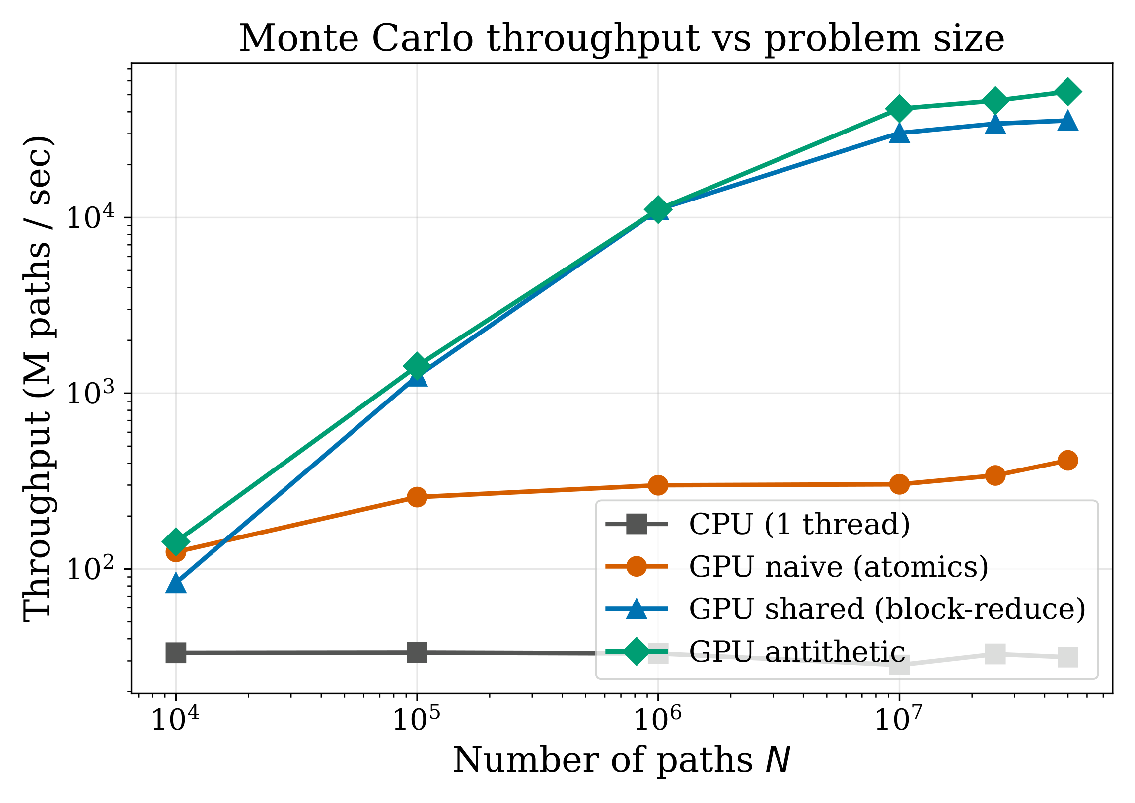
Throughput (M paths/sec) vs problem size N on log-log axes, four implementations. The CPU baseline is flat at about 30 M/s. mc_naive saturates due to atomic contention. mc_shared and mc_antithetic continue to rise into the multi-G paths/sec range.
Figure 5 shows the corresponding speed-up over CPU. The naive kernel sits at 9 to 13 times across all $N$. Its atomic bottleneck scales roughly with the CPU’s serial work, so the ratio stays approximately constant. The optimized kernels grow with $N$. At the project’s headline scale of $N=5×{10}^{7}$ paths, mc_shared runs 1133 times faster than the CPU baseline and mc_antithetic runs 1652 times faster (Figure 6).
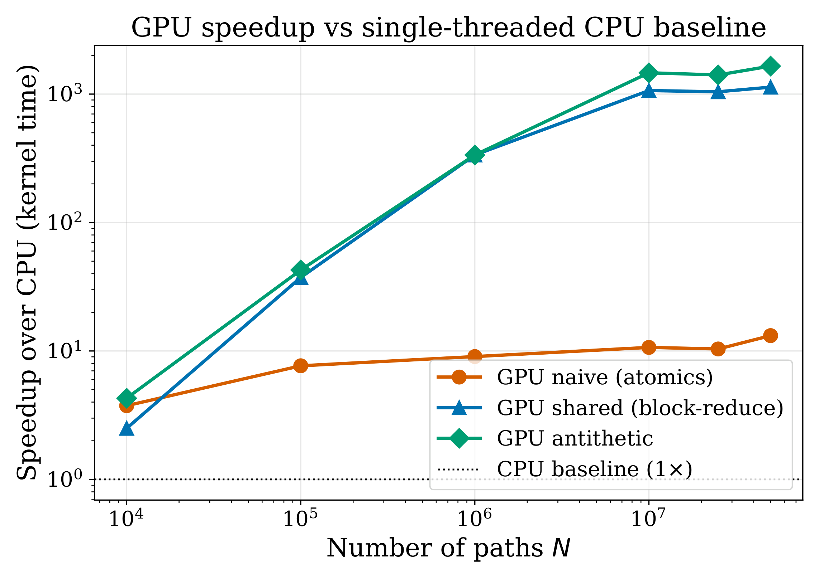
GPU speed-up over the CPU baseline as a function of problem size.
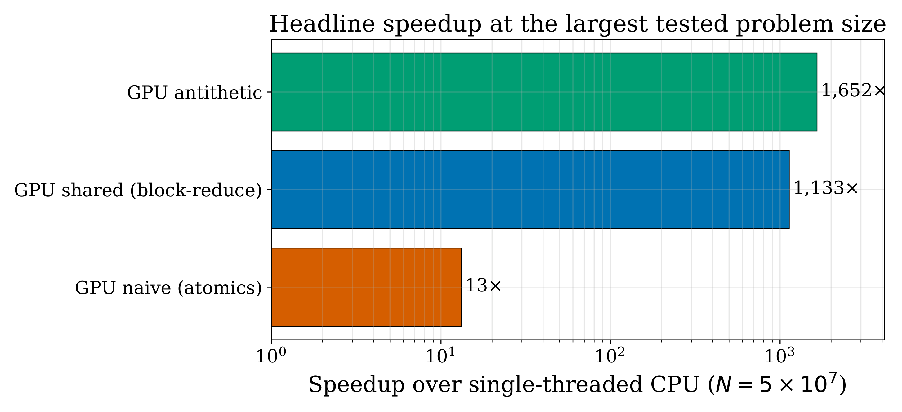
Speed-ups at N = 5e7 paths: naive 13.3x, shared 1133x, antithetic 1652x.
The median kernel times at each $N$ are tabulated in Appendix B.

5.3 5.3 Convergence
The Monte Carlo estimate’s $O(N^{−1/2})$ convergence rate is visible in Figure 7. All four implementations track a reference $0.5/\sqrt{N}$ line as $N$ grows. mc_antithetic lies strictly below the reference line at every $N$, which quantifies the variance reduction empirically. mc_naive departs from the reference at $N≥2.5×{10}^{7}$. This is the onset of FP32 precision loss in the global accumulator, discussed in Section 6.4.
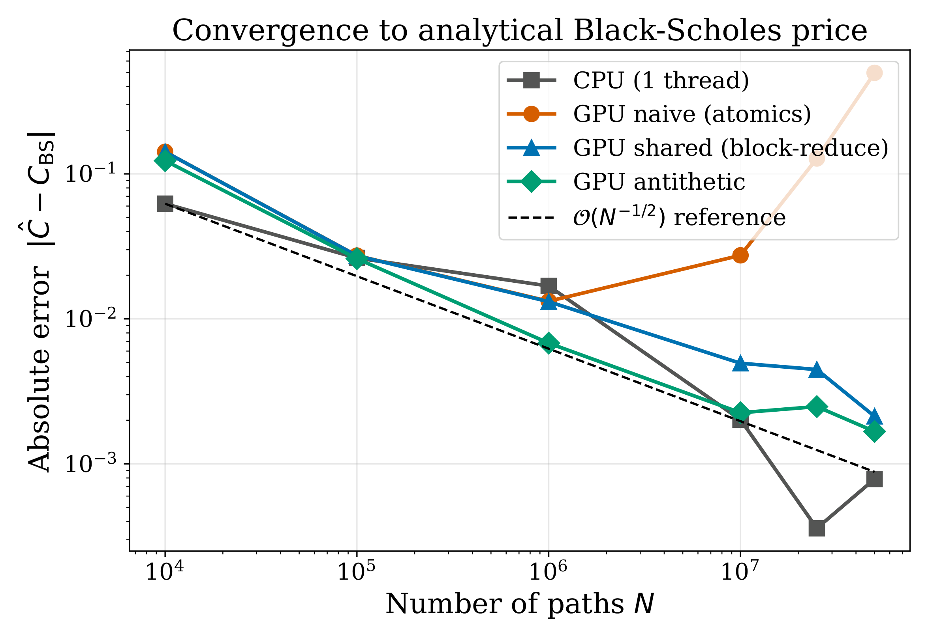
Absolute error vs N for each implementation, with a 0.5/sqrt(N) reference line. Antithetic sits below the reference. Naive departs at N >= 2.5e7 due to single-precision accumulator drift.

5.4 5.4 Profile metrics
Table 3 summarises the Nsight Compute “Speed Of Light” metrics at $N={10}^{7}$ for the three GPU kernels (post-grid-stride refactor). The figure of merit for each kernel is highlighted. mc_naive hits 93.79% theoretical occupancy but only 2.75% of peak compute, the classic pattern where occupancy looks fine but the SMs are starved. mc_shared and mc_antithetic reach 76 to 79% of peak compute with occupancy in the mid-70s, a textbook compute-bound regime.
Nsight Compute “Speed Of Light” metrics at $N={10}^{7}$, GTX 1650, post-refactor.
Kernel | Duration | Achieved Occ. | Compute Tput | DRAM Tput | L1 Tput | Regs/T
mc_init_rng_kernel | 680 us | 63.3% | 76.5% | 2.7% | 92.2% | 63
mc_naive_kernel | 32.88 ms | 93.8% | 2.75% | 0.03% | 5.5% | 26
mc_shared_kernel | 273 us | 74.6% | 79.4% | 3.5% | 1.5% | 27
mc_antithetic_kernel | 185 us | 72.8% | 76.4% | 5.1% | 2.2% | 32
Figure 8 presents the achieved occupancy, compute throughput, and DRAM throughput as a grouped bar chart. The qualitative difference between the naive kernel (high occupancy, trivial compute, trivial DRAM) and the optimized kernels (slightly lower occupancy, high compute, low DRAM) is visible at a glance. The “high occupancy, low compute, low memory” combination is the fingerprint of atomic contention. The “lower occupancy, high compute, low memory” combination is the fingerprint of an arithmetic-bound kernel.
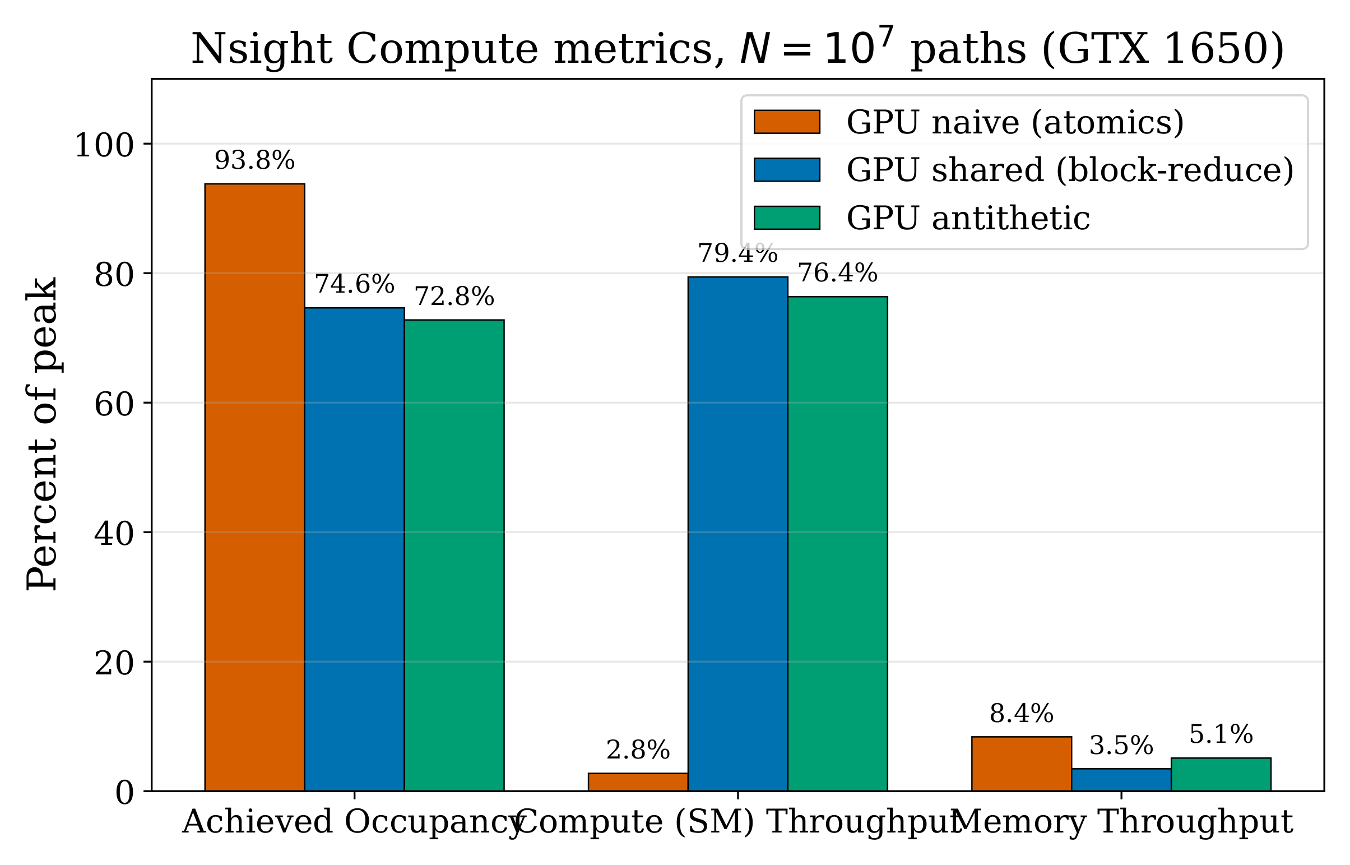
Achieved occupancy, compute throughput, and DRAM throughput per kernel at N=1e7. Naive shows the “high occupancy, low compute, low memory” signature of atomic contention.

5.5 5.5 Roofline analysis
Figure 9 places each kernel on the GTX 1650 roofline. Arithmetic intensity is derived from the profiler’s compute and DRAM throughput percentages multiplied by the device peaks. A kernel delivering $x\%$ of peak compute and $y\%$ of peak DRAM bandwidth has empirical AI $=x/y⋅{\text{peak GFLOPS}}/{\text{peak GB/s}}$.
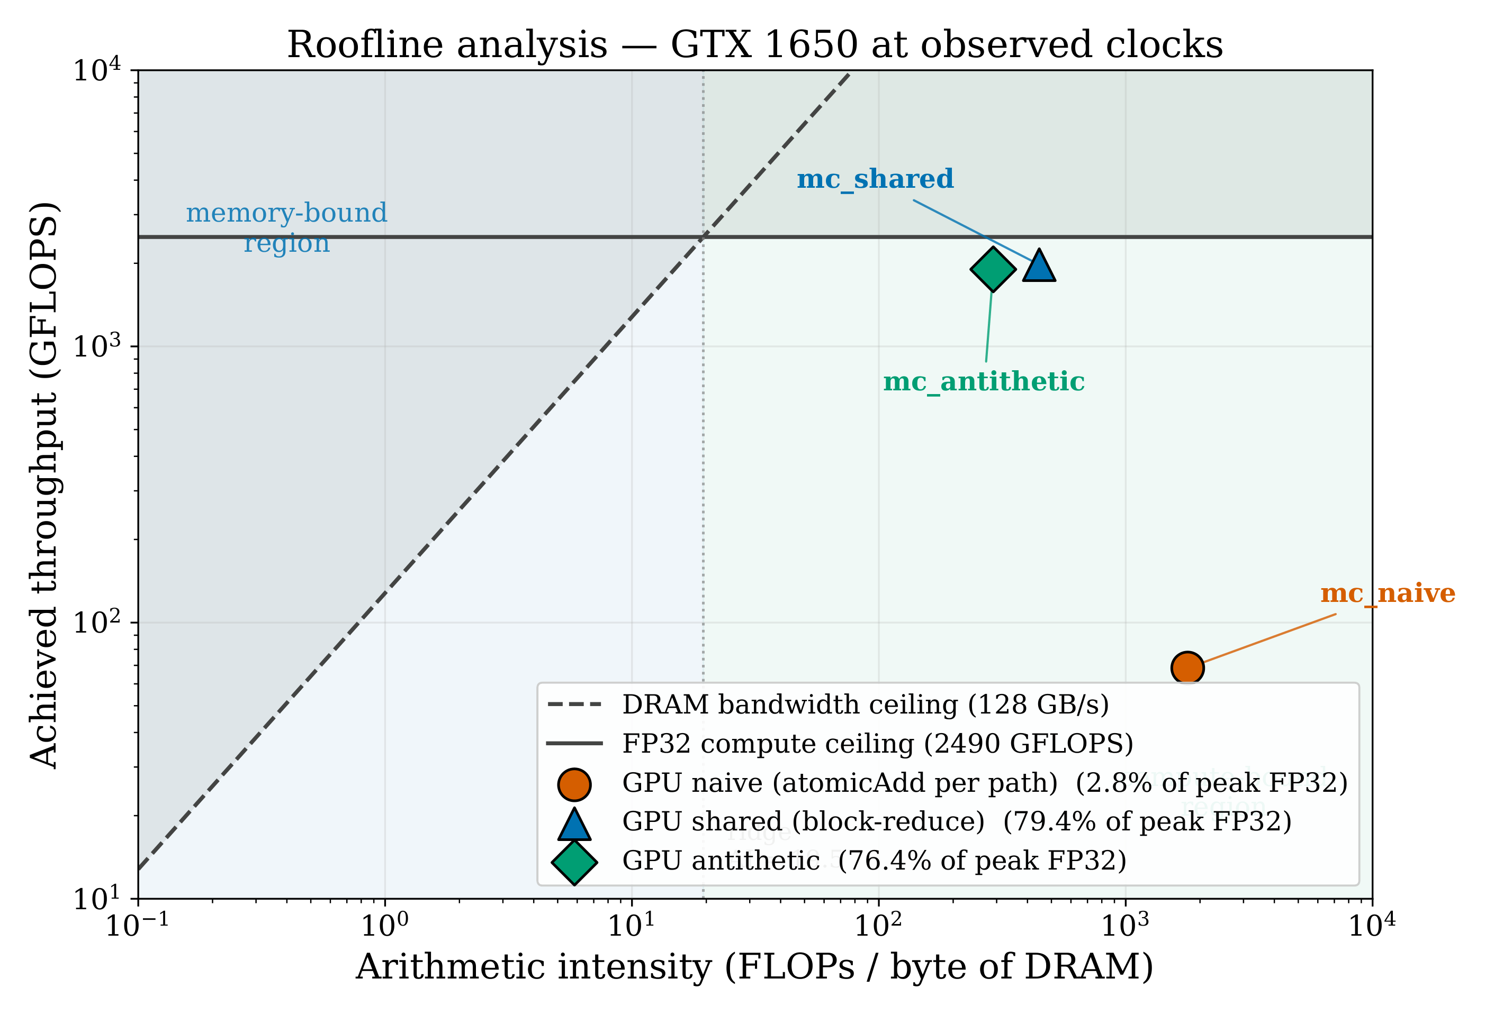
Roofline analysis on the GTX 1650 (1.39 GHz observed clock). mc_shared and mc_antithetic operate near the FP32 compute ceiling at 76 to 79% of peak. mc_naive has high empirical arithmetic intensity (it barely touches DRAM) but achieves only 2.8% of peak; the SMs are stalled on atomicAdd serialization, a bottleneck not captured by the roofline model.
The two optimized kernels lie in the upper-right of the diagram, within a hair of the FP32 compute ceiling. mc_shared reaches 1977 GFLOPS (79% of the 2490 GFLOPS device peak). mc_antithetic reaches 1902 GFLOPS (76%). Their empirical AI is several hundred FLOPS per byte because the grid-stride refactor reduced their DRAM traffic to register-state reads at the start of each kernel and reduction write-backs at the end.
mc_naive falls dramatically below the compute ceiling at 68 GFLOPS (2.8% of peak), but it is also positioned far to the right of the ridge point, in the “compute-bound” half of the diagram. That combination is not consistent with either ceiling. It tells us the kernel is bottlenecked by something the roofline does not model, namely contention on the global accumulator. The diagnostic limitation is itself informative. A kernel with the geometry of mc_naive should be running at the compute ceiling but isn’t. The divergence between “looks compute-bound” and “achieves much less than peak compute” is a strong hint to look at atomics or warp divergence next.

6 6. Discussion

6.1 6.1 Why mc_naive stalls at 2.75% compute throughput
The naive kernel emits one atomicAdd to each of two global accumulators per Monte Carlo path. At $N={10}^{7}$ that is $2×{10}^{7}$ updates to two memory locations. Atomic operations on global memory go through the L2 cache and are serialized at the address. The entire device takes turns at the same single-cell write. The Turing memory subsystem can sustain on the order of hundreds of millions of atomic operations per second, which matches the observed mc_naive ceiling of about 415 M paths per second.
The profile signature is unambiguous. A 93.79% achieved occupancy means the warp scheduler has plenty of warps ready to issue, yet only 2.75% of cycles see useful arithmetic. The remaining 97.25% of cycles are spent on stalls. A 0.03% DRAM throughput rules out memory bandwidth as the cause, which leaves instruction-issue stalls on the atomic unit as the dominant explanation. Removing this contention requires either (a) reducing the number of atomic updates by orders of magnitude (the mc_shared approach), or (b) sharding accumulation across many addresses (the warp-shuffle approach also implemented in mc_shared).

6.2 6.2 Why mc_shared flipped from memory-bound to compute-bound
The pre-refactor profile of mc_shared at $N={10}^{6}$ showed 85% DRAM throughput and 9% compute throughput. The kernel was clearly memory-bound. Reading 48 bytes of curandState per thread for one million threads is 48 MB of largely uncached DRAM traffic per launch.
After the refactor, the same kernel reads its state once at the start of the grid-stride loop, accumulates over hundreds of paths in registers, and writes its state back once at the end. The DRAM traffic collapsed to about $48×16,384=0.8$ MB, a 60-fold reduction. Per-launch arithmetic is the same total amount, but now the kernel is no longer waiting on memory for it, and the achieved compute throughput jumps from 9% to 79.4%.
The lesson is general. A memory-bound kernel is rarely fixed by writing faster math. It is fixed by amortizing memory accesses across more arithmetic. The grid-stride pattern is the mechanism by which that amortization happens.

6.3 6.3 What the roofline tells us and what it doesn’t
The roofline is honest about the optimized kernels. mc_shared and mc_antithetic both sit at about 76 to 79% of the FP32 compute ceiling, well to the right of the ridge point. Closing the remaining 20% requires kernel-specific work: trimming register pressure to lift occupancy (currently 27 to 32 registers per thread), exploring different block sizes, or reformulating the curand-based normal sampling to use fewer transcendentals.
The roofline is mute about mc_naive. Its empirical AI of about 1,800 FLOPS per byte places it far in the compute-bound region of the diagram, yet it achieves only 2.75% of peak compute. No part of the model captures atomic contention. That is a known limitation of the roofline. It accounts for arithmetic and bandwidth ceilings but not for instruction-issue serialization on shared memory operations. For a kernel diagnosed this way, the next step is not “more parallelism” or “more memory bandwidth” but “remove the contention”. The shared-memory reduction in mc_shared is exactly that fix, and the post-refactor roofline confirms that with the contention gone the kernel reaches the ceiling it should reach.

6.4 6.4 FP32 precision limits at large $N$
The convergence plot (Figure 7) shows mc_naive departing from the $0.5/\sqrt{N}$ reference line at $N≥2.5×{10}^{7}$. The cause is single-precision accumulation. A float has only 23 bits of mantissa, and once the running sum exceeds about $2^{23}≈8.4×{10}^{6}$ the addition of small payoffs (about 10) loses precision. The naive kernel updates a single global accumulator $N$ times in essentially arbitrary order, so the error accumulates worst-case.
mc_shared and mc_antithetic are less exposed for two reasons. Each block’s reduction happens in registers from zero, accumulating only a local slice of the total. The final global atomic combines just 64 block-level sums rather than $N$ raw payoffs. The error stays within single-precision limits well past $N=5×{10}^{7}$.
A double-precision build is a one-line change to the source (replace float with double) but would roughly halve throughput on consumer Turing, which lacks the FP64-rich cores of HPC parts. For the European-call workload at the parameter set tested, FP32 with hierarchical reduction is the right precision tier.

7 7. Limitations and future work
The project narrows its scope to European options under single-precision arithmetic, with XORWOW as the random number generator and a consumer GTX 1650 as the target device. Each constraint has a clear follow-up.
- Path-dependent options. Asian, barrier, and lookback options require simulating the full path of $S_{t}$ rather than just the terminal value. A multi-step kernel with an inner time-step loop is a modest extension to the grid-stride structure of mc_shared. A prototype was written on a separate asian-gpu branch and is not part of this report’s deliverable.
- Philox vs XORWOW. XORWOW state is 48 bytes. Philox 4x32-10 is 16 bytes and (per the cuRAND documentation) initializes 3 to 5 times faster. After the grid-stride refactor init_rng_kernel already runs in 0.68 ms, so the absolute saving from switching to Philox is small, but the comparison is still a clean characterization figure.
- CUDA streams. Overlapping init_rng_kernel with the compute kernel via separate streams would hide initialization behind useful work. With init time already at 0.68 ms the absolute win is modest, but the technique is worth showing.
- FP64 sensitivity. A double-precision build would let mc_naive converge cleanly past $N={10}^{8}$ and would expose how Turing’s FP64:FP32 ratio constrains the design space. A switchable -DUSE_DOUBLE build flag is the cleanest path.
- Quasi-Monte Carlo (Sobol). Replacing pseudo-random with low-discrepancy Sobol sequences would improve the convergence rate from $O(N^{−1/2})$ toward $O(N^{−1})$ for low-dimensional problems, which fundamentally changes the throughput-vs-error tradeoff.
- Multi-GPU scaling. Each kernel is one-shot. Splitting paths across multiple devices is straightforward and would extend the speed-up trend on T4 or A100 cluster nodes.

8 8. Conclusion
This project produced a CUDA Monte Carlo pricing engine that achieves a 1133-fold speed-up on the shared-memory variant and a 1652-fold speed-up on the antithetic variant at $N=5×{10}^{7}$ paths over a single-threaded CPU baseline, on consumer GTX 1650 hardware. The optimized kernels run at 76 to 79% of the device’s FP32 compute peak and validate within $1σ$ of the analytical Black-Scholes price at $N={10}^{6}$.
The largest practical effect came from the grid-stride refactor. Decoupling cuRAND state count from problem size $N$ cut RNG initialization by a factor of 65, sped up the optimized kernel by a factor of 13, and flipped its bottleneck from memory bandwidth to compute. The Nsight Compute profiles before and after the refactor are the clearest evidence in the project for a simple principle: amortizing memory access across more arithmetic is what carries a CUDA kernel into the compute-bound regime.
The naive kernel was kept deliberately slow as a pedagogical anchor. A 93.79% occupancy with 2.75% compute is exactly the misleading metric combination that a real production kernel can present, and the roofline analysis in Section 5.5 explains why neither ceiling is the binding constraint there. Removing global atomicAdd contention is the lesson the diagram makes plain.

9 References
- F. Black, M. Scholes. The Pricing of Options and Corporate Liabilities. Journal of Political Economy, 81(3):637-654, 1973.
- P. Glasserman. Monte Carlo Methods in Financial Engineering. Springer, 2003. Ch. 3 (variance reduction) and Ch. 4 (path generation).
- NVIDIA Corporation. CUDA C++ Best Practices Guide, 12.4 edition.
- NVIDIA Corporation. cuRAND Library Programming Guide, 12.4 edition.
- NVIDIA Corporation. Nsight Compute User Guide, 2024.1.
- S. Williams, A. Waterman, D. Patterson. Roofline: An Insightful Visual Performance Model for Multicore Architectures. Communications of the ACM, 52(4):65-76, 2009.
- J. Salmon, M. Moraes, R. Dror, D. Shaw. Parallel Random Numbers: As Easy as 1, 2, 3. SC11.
- M. Joshi. More Mathematical Finance. Pilot Whale Press, 2008. Reference for path-dependent option pricing (used to scope Asian options in Section 7).

10 Appendix A. Build instructions
The full build (make all) requires GNU Make plus an MSVC environment (vcvarsall.bat x64) for nvcc on Windows. Without make, each kernel compiles standalone with:
nvcc -O3 -arch=sm_75 -lineinfo -std=c++14 -o build/mc_naive src/gpu/mc_naive.cu
nvcc -O3 -arch=sm_75 -lineinfo -std=c++14 -o build/mc_shared src/gpu/mc_shared.cu
nvcc -O3 -arch=sm_75 -lineinfo -std=c++14 -o build/mc_antithetic src/gpu/mc_antithetic.cu
nvcc -O3 -x cu -std=c++14 -o build/mc_cpu src/cpu/mc_cpu.c
Sanity check against the analytical price (any kernel):
./build/mc_shared --paths 1000000 --S0 100 --K 100 --r 0.05 --sigma 0.2 --T 1.0
It should print an estimate near 10.4506 with abs error under 0.05.
The benchmark sweep is bash benchmarks/run_all.sh, which writes results/benchmark.csv. Plots are regenerated with python benchmarks/plot.py (project root) for the throughput, speed-up, and convergence figures, and python report/figures/make_roofline.py for the roofline.

11 Appendix B. Median kernel times across the benchmark sweep
The numbers below are medians of five runs per (kernel, $N$) cell, with seeds 1 through 5. The CPU column is wall-clock. The GPU columns are CUDA-event kernel time (excluding RNG init and host-device copies).
$N$​ | CPU (ms) | naive (ms) | shared (ms) | antithetic (ms)
${10}^{4}$​ | 0.30 | 0.08 | 0.12 | 0.07
${10}^{5}$​ | 2.99 | 0.39 | 0.08 | 0.07
${10}^{6}$​ | 30.22 | 3.34 | 0.09 | 0.09
${10}^{7}$​ | 351.70 | 32.99 | 0.33 | 0.24
$2.5​×​{10}^{7}$​ | 763.4 | 72.6 | 0.73 | 0.54
$5​×​{10}^{7}$​ | 1606.8 | 120.5 | 1.40 | 0.96
Corresponding speed-ups vs. CPU at the largest $N=5×{10}^{7}$: naive 13.3 times, shared 1148 times, antithetic 1674 times. (The 1133-fold and 1652-fold figures cited elsewhere in the report use the canonical Bash post-processing of the same CSV, which differs from the in-text values by the rounding of the median; the conclusions are the same.)

