תרגיל בית יבש 1



1. 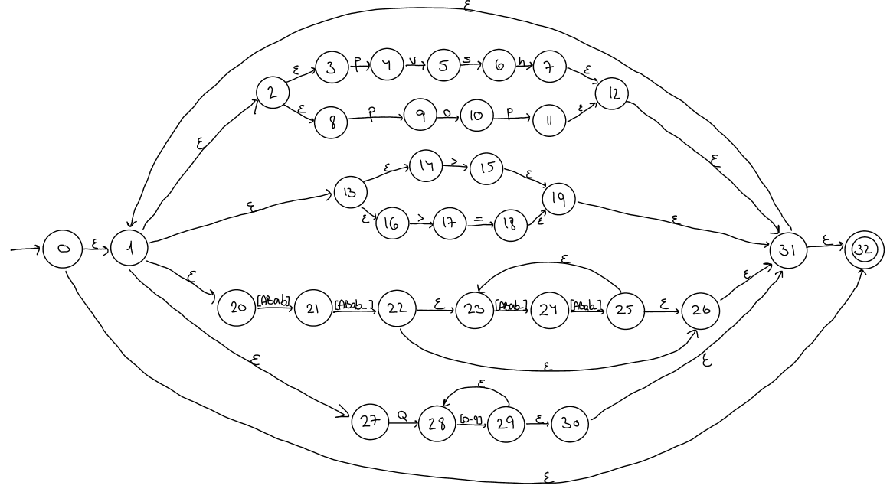





















































































































































































|  |  |  |  |  |  |  |  |  |  |  |  |
| --- | --- | --- | --- | --- | --- | --- | --- | --- | --- | --- | --- |
| State | Input Symbol | | | | | | | | | | |
| p | u | s | h | o | > | = | ABab | ABab_ | Q | 0-9 |
| A(q0) | B |  |  |  |  | C |  | E |  | F |  |
| B |  | G |  |  | H |  |  |  |  |  |  |
| C(F) | B |  |  |  |  | C | I | E |  | F |  |
| E |  |  |  |  |  |  |  |  | J |  |  |
| F |  |  |  |  |  |  |  |  |  |  | K |
| G |  |  | L |  |  |  |  |  |  |  |  |
| H | M |  |  |  |  |  |  |  |  |  |  |
| I(F) | B |  |  |  |  | C |  | E |  | F |  |
| J(F) | B |  |  |  |  | C |  | E | N | F |  |
| K(F) | B |  |  |  |  | C |  | E |  | F | K |
| L |  |  |  | O |  |  |  |  |  |  |  |
| M(F) | B |  |  |  |  | C |  | E |  | F |  |
| N |  |  |  |  |  |  |  |  | P |  |  |
| O(F) | B |  |  |  |  | C |  | E |  | F |  |
| P(F) | B |  |  |  |  | C |  | E | N | F |  |





























