Una LEstrange

[Email address]

Abstract

[Draw your reader in with an engaging abstract. It is typically a short summary of the document.   
When you’re ready to add your content, just click here and start typing.]

**SECOUND PROJECT GROUP REPORT**

**SMART DOOR LOCK**

Table of Contents

1 Names of team members. 2

2 Project Analysis 2

2.1 Background to the area. 2

2.2 Brainstorming Idea 1 2

2.3 Brainstorming Idea 2 2

2.4 Final Project description and feature list. 2

3 Project Design 2

3.1 List of components used and why 2

3.2 Description of software 4

3.3 Limitations of the current design. 5

3.4 Potential future development ideas 5

4 Problems Encountered 5

4.1 Technical issues 5

4.2 Team Issues 5

4.3 Other problems 5

5 The project process 5

5.1 Managing the team 5

5.2 Brainstorming and idea generation 5

5.3 Managing the code using Git 6

5.4 Using Trello to help the process 6

6 Links and reference 6

6.1 Team GitHub page. 6

6.2 Team Trello Page 6

6.3 Web resources used. 6

# Names of team members

|  |  |  |
| --- | --- | --- |
| No. | Names | Student numbers |
| 1 | TALHA TALLAT | S00180011 |
| 2 | PAULIUS BRICKUS | S00176822 |
| 3 | MARCIN MAJCHRZAK | S00180455 |
| 4 | CIAN MARGEY | S00181129 |

# Project Analysis

## Background to the area.

Identify the problem area of your project what real-world problems is your project trying to solve.

## Brainstorming Idea 1

List one of your ideas and describe why you went ahead with it or not.

## Brainstorming Idea 2

List another idea – we are looking for 3 or 4 ideas. (Note use Heading 2 in the styles to make a second level heading)

## Final Project description and feature list.

This should list all of the features of your project. A feature is something like: “when the air reaches a set temperature an LED will light up”.

# Project Design

## List of components used and why

(You may want to include a photo or two here)

The components that are required for building this project are listed below in detail.

* Breadboard – The Breadboard was used for placing components such as a microcontroller, voltage regulator, and some jumper wires.

* Jumper wires – The Jumper wires are used for connecting microcontroller to other components on a breadboard.
* Voltage regulator (Constant Output of 5v) – The voltage regulator was used to supply constant of 5 volts to the microcontroller and servo motor because the voltages coming from the adaptor was extremely high for the microcontroller so that is why the voltage regulator used for regulating the voltages.
* ESP8266 (NodeMCU) module – This Microcontroller with wi-fi chip is a brain of this project and this is used for controlling the output and input.
* Servo motor – The servo motor is used as an output device for closing the mechanism for the door lock which allows us to close the door. This servo motor is programmed to rotate at an only 90-degree angle.
* Reed Switch – The Reed switch is an Input device and used for sending the notification to the phone if the door opens. The Digital pin 1 is connecting to the ground throw the Reed switch and the circuit is closed with a magnet. If the magnet is far from the reed switch the circuit opens and sends a notification to the phone straight away with the help of the Blynk application.
* Adaptor with (7-24 volts) – The Adaptor of 8 volts was available for the team to use but any voltage 7-24 volts can be used for regulating the voltage. The adaptor is used for applying 8 volts to the voltage regulator for getting a constant voltage of 5 volts to supply power to the microcontroller.
* Smartphone with WIFI and (BLYNK application) – In our daily life’s everyone uses a phone which requires internet for interacting with others. In this case, the team used the Blynk application to get a notification on their phone by signing in to the account and connect with a microcontroller.
* Resistor – this is used for limiting the current.
* Magnet – This is used for closing the circuit for Reed switch.

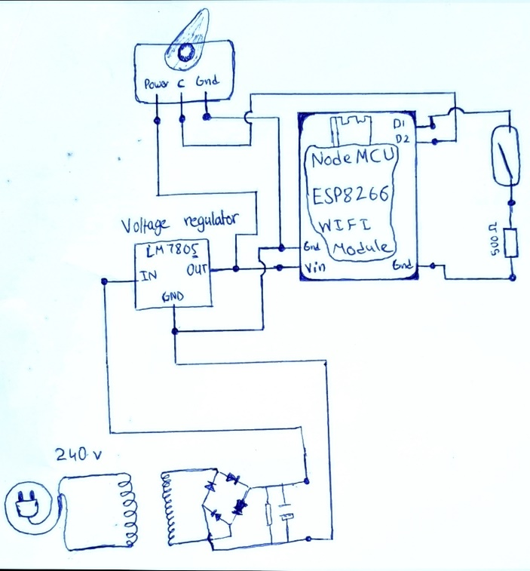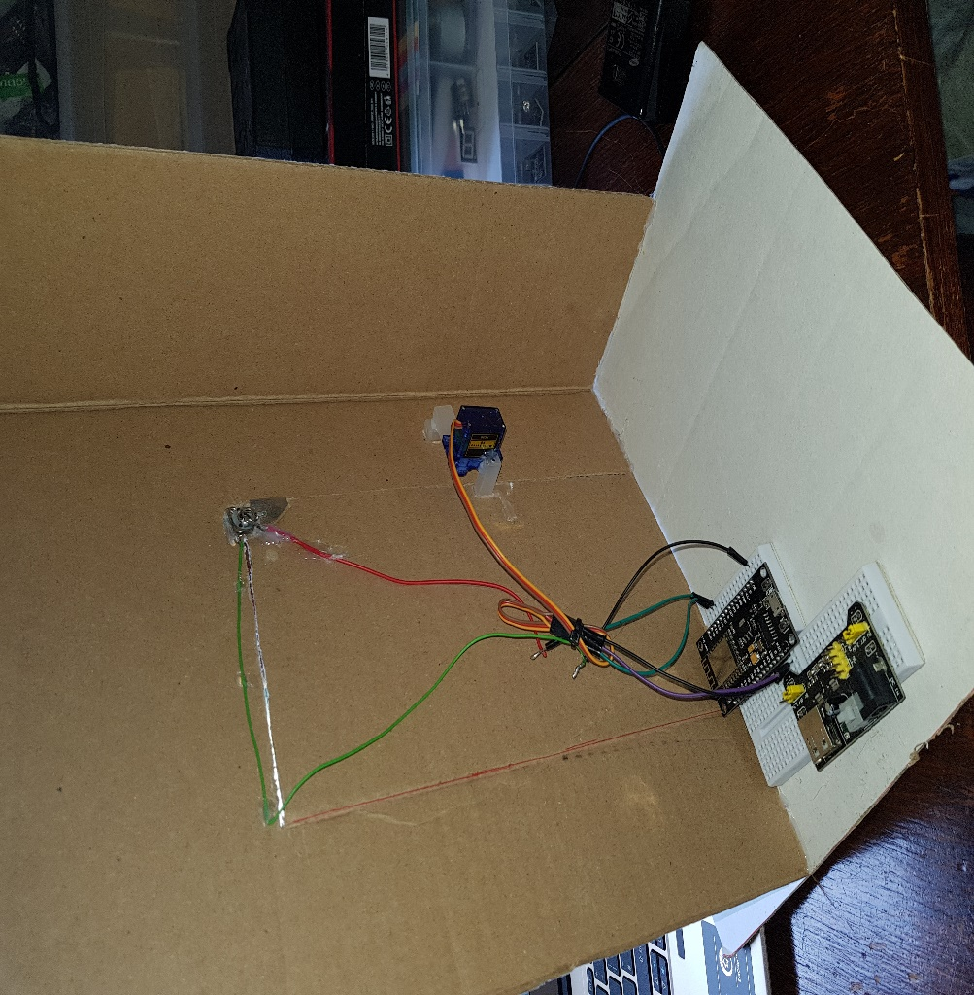The layout of circuit and photo is shown below.

## Description of software

[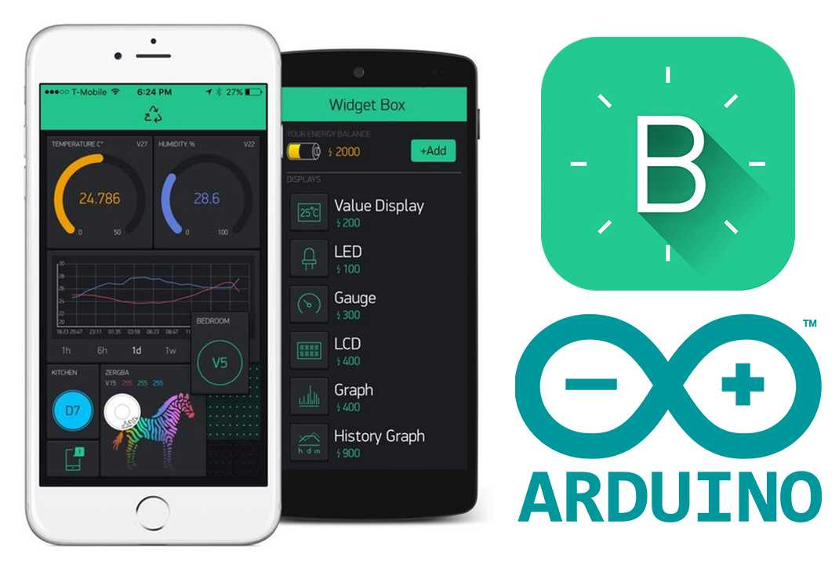](https://www.google.com/url?sa=i&rct=j&q=&esrc=s&source=images&cd=&cad=rja&uact=8&ved=2ahUKEwiRupiQuPbaAhXERhQKHVMNCCcQjRx6BAgBEAU&url=https://www.geekstips.com/arduino-blynk-esp8266-iot-for-non-programmers/&psig=AOvVaw07CPXsUdkH9WUCwslOeAQA&ust=1525879997789849)The software that team used for connecting the wi-fi microcontroller to the phone is called BLYNK application that can be download onto any smartphone. This application was used for connecting to the wi-fi chip that is built on top of the microcontroller by programming the module with “Auth Token” of the BLYNK application that was gotten by signing in to the BLYNK application. Sign in to the application will send an email to give “Auth Token” which is an identity of BLYNK for connecting to the microcontroller. There are some pictures for Blynk Icon and some internal pictures of Blynk application shown below.

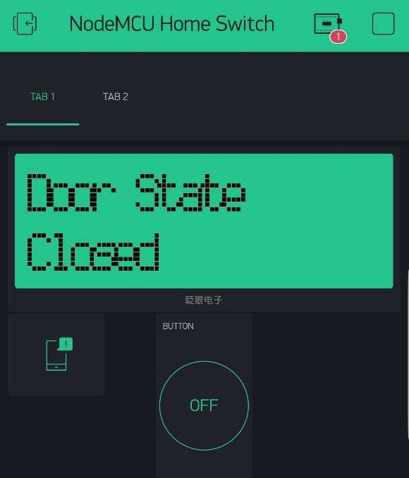

This is the compiler where the program runs to control the outputs which is connected to the NodeMCU module.

* Compiler running the program
* Indication for microcontroller to let us know whether it’s on or off
* LCD for showing states of the door
* Button for Opening the door or for closing
* Notification

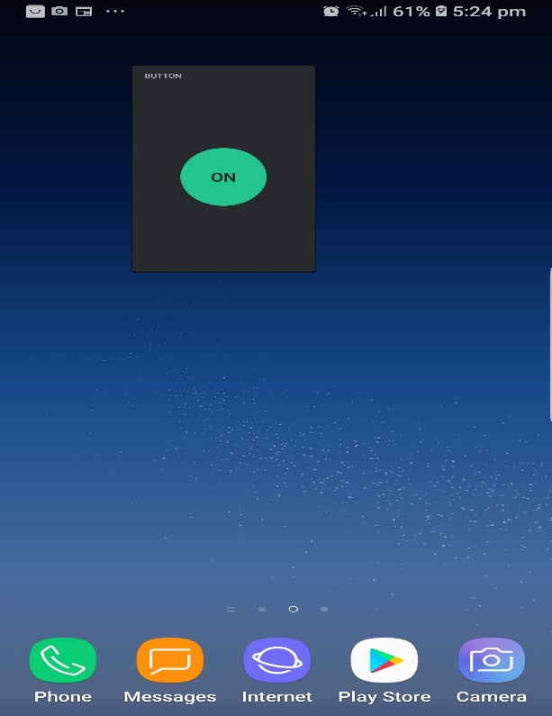This is the home screen of the phone which includes a widgets button.

* Button widget
* Smart Phone home screen

This makes it much easier for user to use a button on their phone quickly and easily without going into the app and opening the door with button. The notification can also be send to your phone at the home screen without having to open the application.

## Limitations of the current design

This project could be better in certain ways which will improve the project and can have more features for the user. The project can be improved by the list which is listed below.

* Camera
* Security features
* Automatic lock
* Fast notifying
* Auto door
* Sensors for detecting

## Potential future development ideas

In the future there are a lot of development ideas that we can improve for door to make it more smart and efficient as possible for user. The ideas for smart door are shown below with details.

* The Camera can be used for detecting stranger’s movement and can be shown on the phone with live cast and if the stranger is relative then the saved photo of that person will match and shows green outline on the phone with notification which will allow user to decide to open the door for him with his phone.
* This security system can be used to give a great head up reminder before someone enters in your property with some sound at house and on your phone.
* Automatic lock can be only used for a user who is willing to use this device because this smart camera feature will detect owners face to open the lock mechanism for him and the owner can open the door easily.
* Fast notifying will help to improve the speed of the notifications and this can be done by using better microcontroller with wi-fi module such as Arduino YUN or Arduino Uno with GSM for massaging.
* Automatic opening the door can also be used for people who are on wheel chairs and have hard times opening the door. This device is also very useful for these purposes. It can easily open with their smart phones.
* Sensors can be used for high technology security on the door for all different kinds of purposes such as PIR motion sensor can be used for high steel locks for if someone tries to break throw the door to enter the house the thick steel plates would not let that happen.

# Problems Encountered

## Technical issues

One of the biggest issue was when the project was tested and one of the parts broke, that part is called reed switch, this is an electrical switch operated by an applied magnetic field, it consist of a pair of contacts on ferromagnetic metal reeds in a hermetically sealed glass envelope which become magnetized and move together or separate when a magnetic field is moved towards the switch. When it broke the team was a bit nervous as it was day before the presentation, but at the end the problem was solved. We used wires and magnet which was working similar as the reed switch. The way it was working is that one of the wire was connected to the negative supply, and magnet that was connected to the USB and another wire that was connected from the magnet that was going also to the negative supply, so all of it was connected as a loop, the negative supply was going into WIFI module. The circuit was closed with a negative supply, so if the doors were opened the circuit will break and that mean a notification would be send to your phone. So that how we fixed our issue.

## Team Issues

One of the team issue was that it took us some time to pick the final project idea because everyone wanted to do something else, when that problem was solved another issue occurred which was time, we didn’t have time to finish the project so we had to come in to college on our free time to finish the project, It was a bit hard to find a day and time that would suit each person that was in the group, but at the end we found a suitable day and time for each member and came to finish the project. Another team issue was that no one knew how to properly use GitHub website as it was a website that was introduced to us this semester, but after some time of using it we got used to it. One issue that we also encountered which was that big of an issue was that the group was a bit late for some of the classes which slowed us a bit with making some progress.

## Other problems

The cardboard wasn’t in good condition for demonstrating but it did the job well.

# The project processes

This chapter is to document how you worked as a team in project 2. Where necessary you should describe how it differs from what you did the first time around. Consider this as a way of documenting what you have learned by going through the process twice.

## Managing the team

At first, it was hard because each of the team members had a different idea about the IOT project 2, so there was a bit of argument and discussions on which idea was the best choice to do. Time was also a problem in our team, there wasn’t enough time to finish the project, so it was hard to pick day and time suitable for each member of the group. During the project, every member completed the task that was given to them.

## Brainstorming and idea generation

The easiest thing for people who are busy and forgets to lock their house door is to lock it using an app phone. The device that must be connected to WIFI and it can be used from anywhere in the world and if the doors will be open notification would be sent to the person straight away. Using a phone to lock the house doors can ease life for people with disabilities, which can be often difficult for them if they are on the first floor of the house.

## Managing the code using Git

GitHub is a Git repository hosting service that adds many of its own features. GitHub can provide a web-based graphical interface, it also provides access control and several collaboration features, such as wikis and basic task management tools for every project.

## Using Trello to help the process

Trello is an app that gives you a visual overview of what is being worked on and who is working on it. Trello was useful for us as a part of team communication, it was easier to communicate on what was needed for the project or if there were any problems that occurred.

# Links and reference

## Team GitHub page.

The URL for your team GitHub page.

## Team Trello Page

The URL for your team Trello page

## Web resources used.

Tutorials you followed.

The sample code you used within your project.