**Design and Report of Players Performance and Review**

**Introduction:**

The data is crack from so FIFA website using Python crawler, the data that comprises every player featured in FIFA 18. It has eighty-nine attributes from player name, flag image, playing position based on actual data of latest FIFA 18. Other attributes including player style statistics including dribbling aggressions GECAS skill etc, also players personal data like photo, age, wage, salary, club.

**Problem Statement:**

The main module of this project is to get the insights and correlations between player values, reach, performance, age and other special attributes. This uninterpreted data further can be further converted to information. By analyzing it we have derived some statistics for teams, clubs and clubs through extensive football experience. The insights provided in results, along with the understanding and contextualized the information enable users to act smartly when player free fall picking a better team for fantasy premier league or increasing their betting odds. Its indeed intuitive to get insight about your player before forming a team.

**Literature Review:**

This data is taken from sofifa website for data analysis. Before FIFA 18 past FIFA data is used for prediction of match winnings probability. In new dataset further attributes added that was gathered in FIFA 18. This data will be helpful in future prediction of wining of teams. Helpful for selection of players for clubs and for fantasy premier leagues.

**Designing Process:**

For designing the data analysis project, I looked for the libraries for data visualizations there are many libararies in python such as matplotlib, pandas visualizations, seaborn, ggplot, and plotly.

For visualization I used matplotlib and seaborn through out the project. Matplotlib is most popular plotting library with matlab interface. It offers freedom from code and have to write very less code Matplotlib is specifically good for creating basic graphs like line charts, bar charts, histograms and many more. I used seaborn along with matplotlib for high-level design of attractive and informatically statistical graphics.

**Evaluation and implementation:**

**Points covered in EDA:**

1. World statistics.
2. Clustering players by nationality.
3. Value and wages of player with age.
4. Value of player with position.
5. Overall and potential with age.
6. Variation of overall and potential by country for top countries.
7. Correlation matrix attribute potential vs overall.
8. Variations in wages for top club.
9. Age vs overall cluster by field position.
10. Make your dream team.
11. Predicting player positions using players statistics.

**Data Visualization**

1. Check the distribution of scores of different skills for this I used the distplot function from seaborn to plot the distribution of these features from this plot we can see the skills such as defending, passing mobility and shooting have scores ranging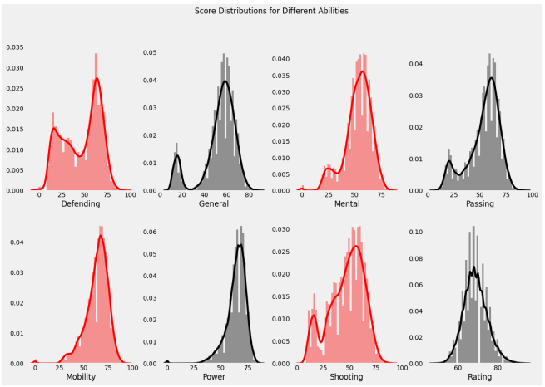
2. Most Preferred Foot of the Players for this we will be using the count plot from the SA dot plot function. The info from the graph that most players prefer to the right foot.

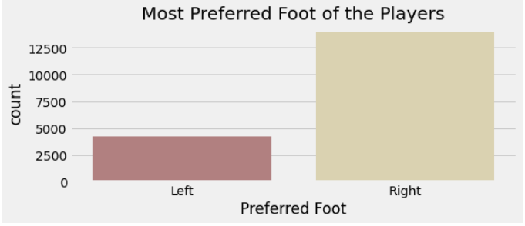

1. International Reputation for the football players for this we will be using pie chart. The info from the pie chart that very few players have five star international reputations

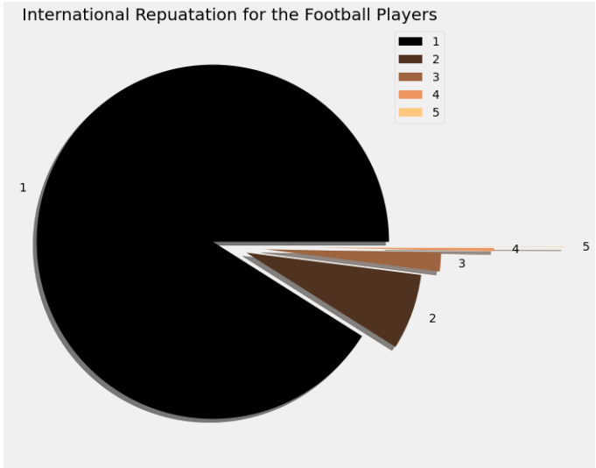

1. Check the player international reputation as 5 I filtered the data to check the players who have five star ratings for international reputations and I’m here selecting only the columns like name, country and overall rating.

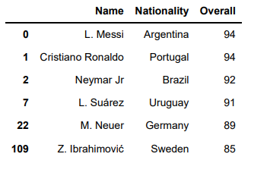

1. Distribution of week foot among the parents for this I am using the pie chart. It shows the most of the players have Wickford with rating of 5 that shows the most of players can shoot well from the other food down their preferred foot.

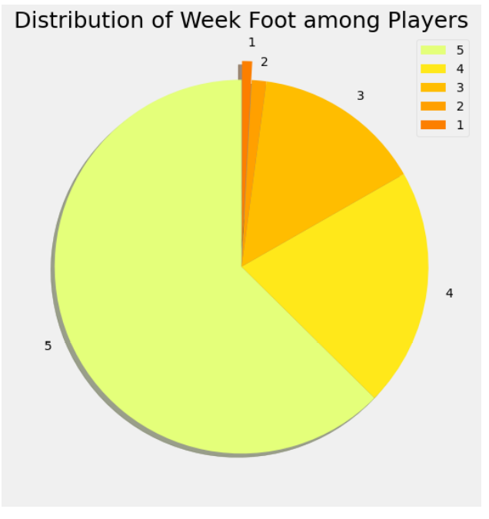

1. Comparison Of Positions and Players it will be present by using the seaborns counterpart for this case. We infer that the most of players play for the strikers and goalkeeper positions.

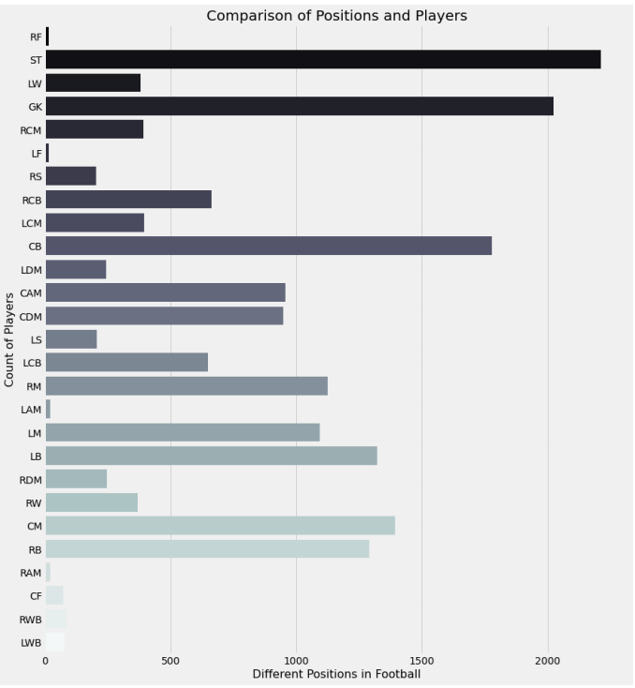

1. Distribution of Players Weight this is get by using seaborn weight function. We infer that most of the players have wait around 150 to 175 pounds.

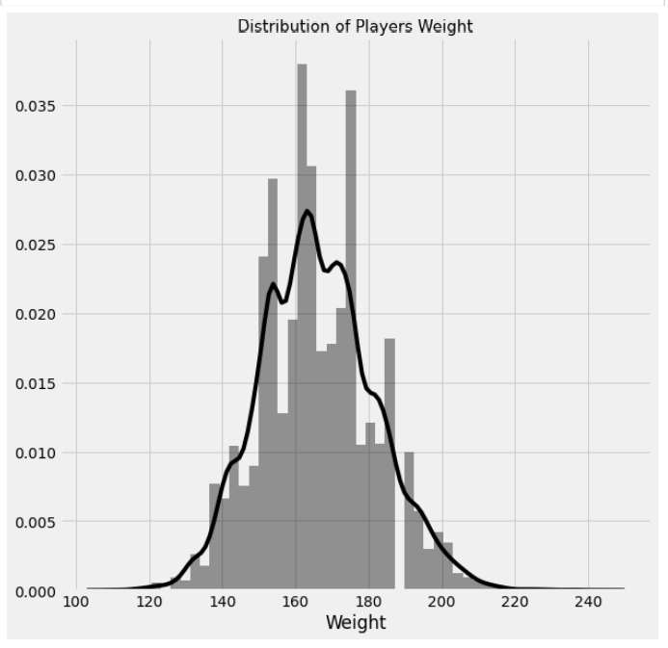

1. Applying the function for value and wage comparison for this we to remove the euro symbols. That graph infer that there are very few players which have high value and similarity only few players are played very high.

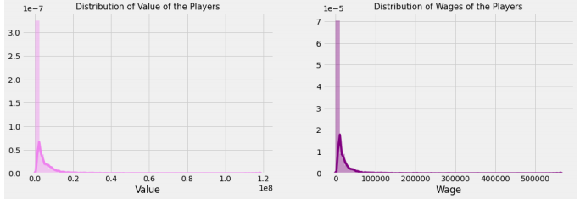

1. Skill Moves of Players. It infer that there are maximum players with the skill moves values.

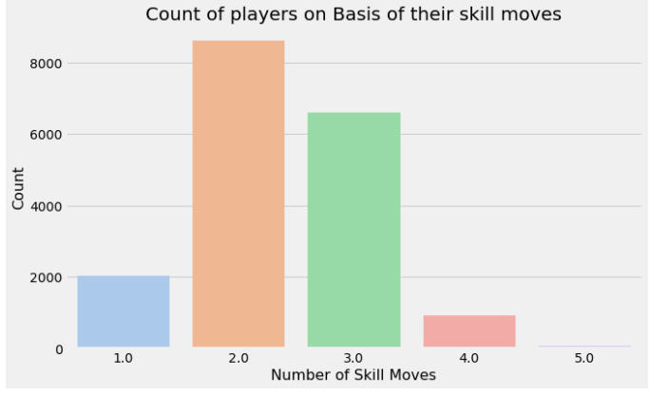

1. Different work rate of the players participating in the FIFA. Form the plot we infer that what great medium for maximum players

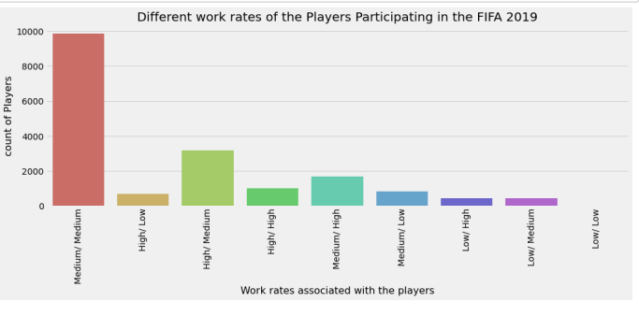

1. Player potential score and Overall Score Histogram. Form the plot it infer the maximum player has a very high potential range from sixty five to seventy five and also the overall score is in the range pf 60 to 70 for most of the players.

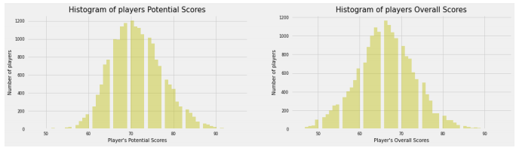

1. Comparison of overall and age with respect to preferred foot that plot infer to overall score is high and distributed from the age 22 to 28 with preferred such right.

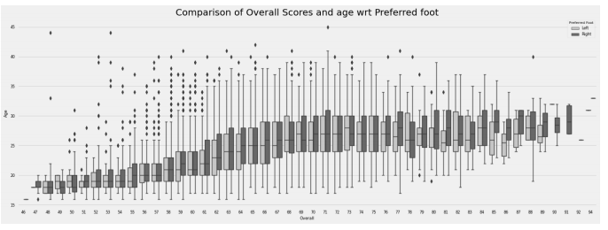

1. Countries having Highest Players from the pie chart we info that Germany and England have a higher number of players compared to other countries.

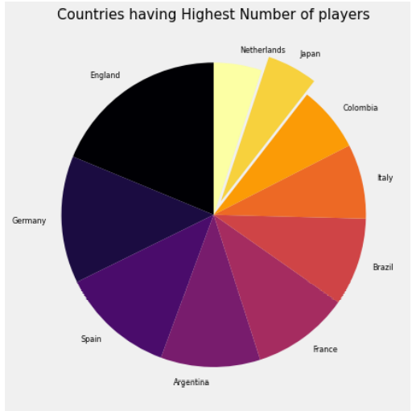

1. Distribution of weight of players from different countries from violent plot we infer that Italy has the maximum range for weight distributions

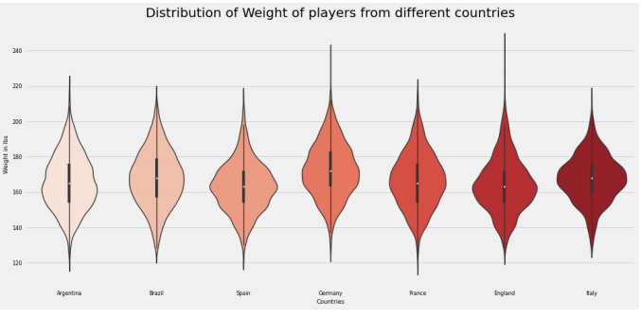

1. Distribution Of overall score of players from different countries from given bar plot we infer that Brazil and Spain have the maximum, highest overall score valued players

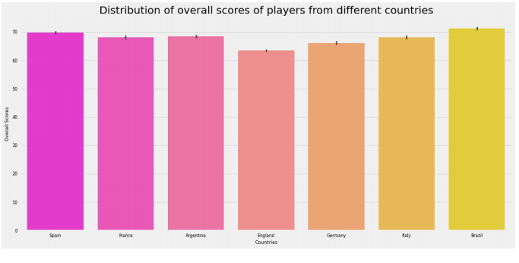

1. Distribution of player wages from different countries for this we are using bar plots again form plot we infer that the players form Brazil and Spain have average higher salaries compared to other popular countries playing FIFA.

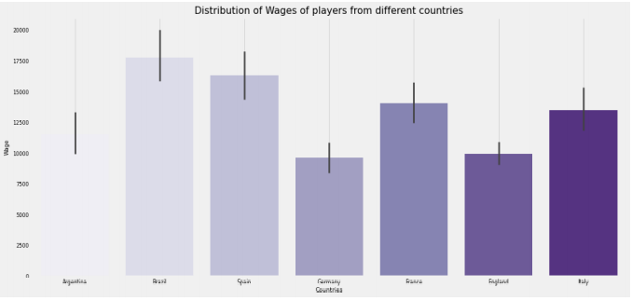

1. Distribution of international reputation of players from countries we use the box plot here from the plot we infer that players from Spain have higher international reputation than any other.

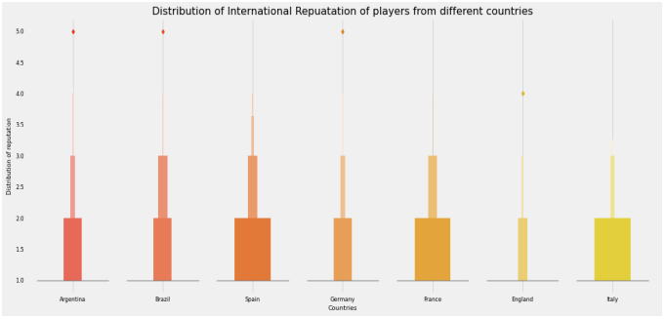

1. Distribution of overall score in Different popular clubs here we are using box plot again from the plot of the info that Chelsea and Real Madrid have the highest overall distribution score and the middle 50 percent of the data is around 75 to 85 which is the best.

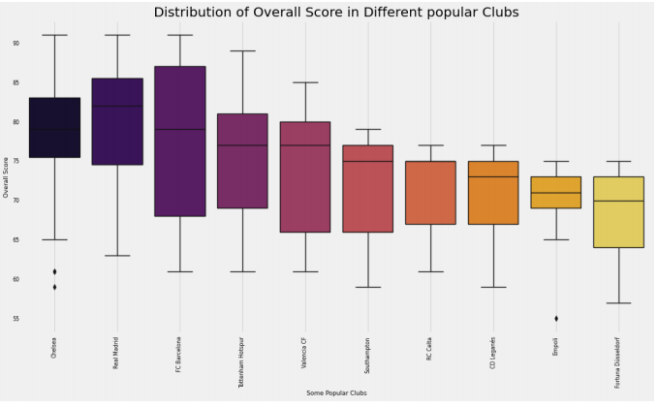

1. Distribution of ages in some popular clubs for this we will be using box plot again info that the Jersey has the maximum age distribution than any ither club.

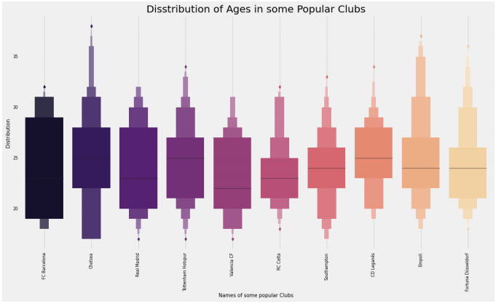

1. Distribution of wages in some popular clubs from the plot we info that Real Madrid FC Barcelona and Chelsea have a higher distribution than any other club.

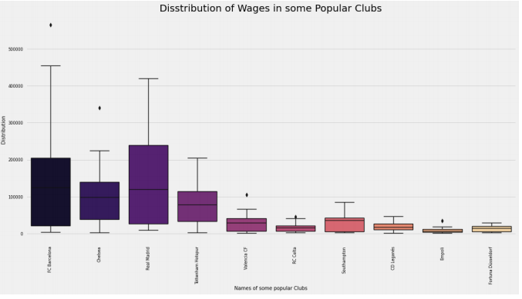

1. Distribution of Wages in some Popular clubs from the plot we info that FC Barcelona has the maximum international reputation than any other popular club.

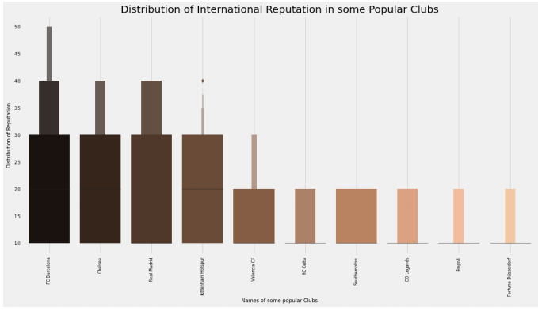

**Knowledge understanding of subject:**

In this project we have learned how EDA can give us a good insight into dataset. It is the crucial part of any data science pipeline before we engage our machine learning models, we learned how data visualizations are the most significant. Learn about missing values imputation query analysis.

**Conclusion**

Further query analysis can perform on this dataset. We can find best players per each position with their age club on their overall score. We can find best players for each skills. We can get the top 15 players from each country. Get the 15 top player of each club. Find the youngest and eldest players in FIFA.

**Needs of The User:**

This project helps the end user to find the best team for the fantasy league. It will show the stats of players that perform well in the league. It shows the characteristics of players that perform well in their carrier. It will help user to understand the salaries of the players according to their performance. The insights provided in results, along with the understanding and contextualized the information enable users to act smartly when player free fall picking a better team for fantasy premier league or increasing their betting odds. Its indeed intuitive to get insight about your player before forming a team.