**Design and Report of Players Performance and Review**

**Table of Contents**

**Introduction:** 2

**Problem Statement:** 2

**User Requirements in EDA:** 2

**Designing Process:** 3

**Evaluation and implementation:** 4

**Data Visualization** 4

**Conclusion** 20

# **Introduction:**

The purpose of this study is to examine some of the problems surrounding the statistical analysis and design of athletic FIFA 18 performance research rather than to provide an official 'cookbook' of techniques. The data used in this project is crack from the FIFA website using Python crawler, which comprises every player featured in FIFA 18.

The primary objective of this research is to get insight into and establish correlations between player values, reach, performance, age, and other unique characteristics. We have generated certain data for teams, clubs, and clubs from our vast football expertise by studying it. Additionally, this uninterpreted data may be transformed into information. The insights given by the outcomes and the interpretation and contextual understanding of the information allow users to respond intelligently when players free fall, whether it's selecting a stronger fantasy premier league club or raising their betting chances. It's indeed intuitive to get an insight into your player before forming a team.

# **User Requirements in EDA:**

1. World statistics.
2. Clustering players by nationality.
3. Value and wages of the player with age.
4. Value of player with the position.
5. Overall and potential with age.
6. Variation of overall and potential by country for top countries.
7. Correlation matrix attribute potential vs. overall.
8. Variations in wages for top club.
9. Age vs. overall cluster by field position.
10. They are predicting player positions using player's statistics.

# **Designing Process:**

The collection of data includes a wealth of data on players' physical features and their wages, positions on the field, and country of origin. This offers up a world of possibilities for studying the relationships between different traits, statistically calculating the averages of the characteristics needed to become a professional player, and so on. I searched for data visualization libraries while developing the data analysis project. Python has many libraries, including matplotlib, panda’s visualizations, seaborn, ggplot, and plotly.

Throughout the project, I utilized matplotlib and seaborn for visualization. Matplotlib is a well-known charting toolkit that comes with a MatLab interface. It provides code independence and requires very little code writing. Matplotlib is particularly well-suited for generating simple graphs such as line charts, bar charts, and histograms. I used seaborn in conjunction with matplotlib to create visually appealing and informative statistical visualizations.

# **Evaluation and implementation:**

## **Data Visualization**

1. Check the distribution of scores of different skills. For this, I used the distplot function from seaborn to plot the distribution of these features. From this plot, we can see the skills such as defending, passing mobility, and shooting have scores ranging.

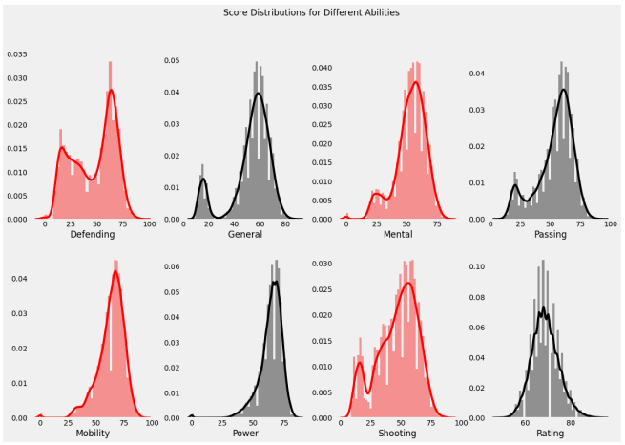

1. Most Preferred Foot of the Players, we will be using the count plot from the SA dot plot function. The info from the graph is that most players prefer the right foot.

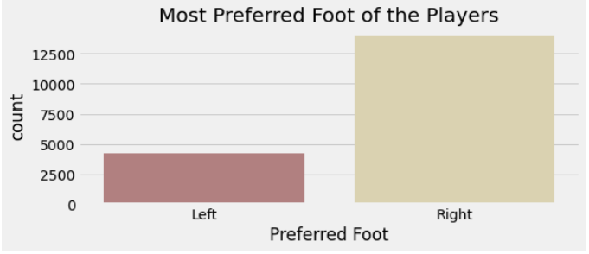

1. International Reputation for the football players for this we will be using a pie chart. The info from the pie chart that very few players have five-star international reputations

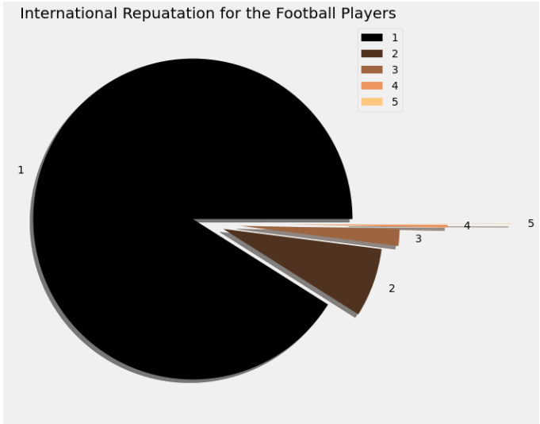

1. Check the player's international reputation as 5. I filtered the data to check the players who have five-star ratings for international reputations, and I’m here selecting only the columns like name, country, and overall rating.

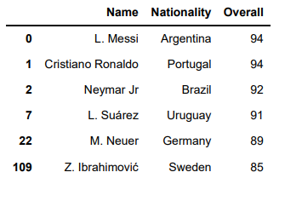

1. Distribution of week foot among the parents for this I am using the pie chart. It shows the most of the players have Wickford with a rating of 5 that shows the most of the players can shoot well from the other food down their preferred foot.

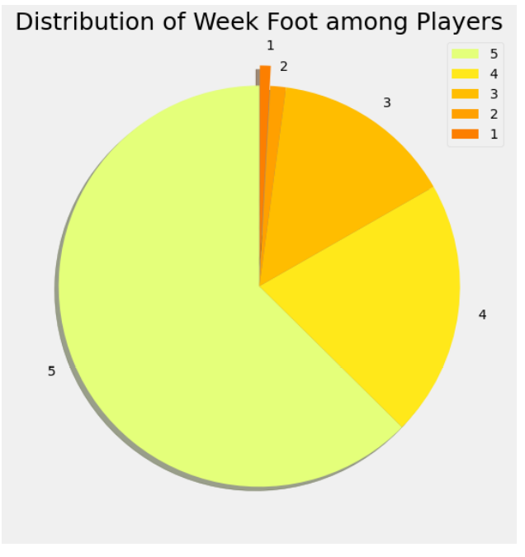

1. Comparison Of Positions and Players it will be present by using the seaborns counterpart for this case. We infer that most of the players play for the strikers and goalkeeper positions.

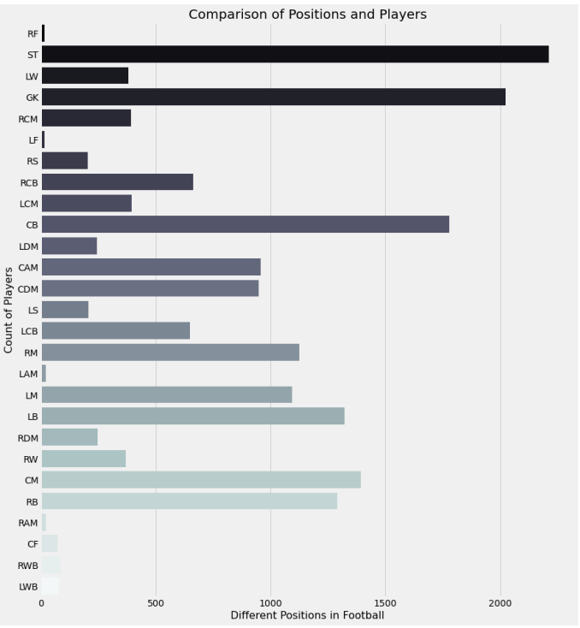

1. Distribution of Players Weight this is obtained by using seaborn weight function. We infer that most of the players have wait for around 150 to 175 pounds.

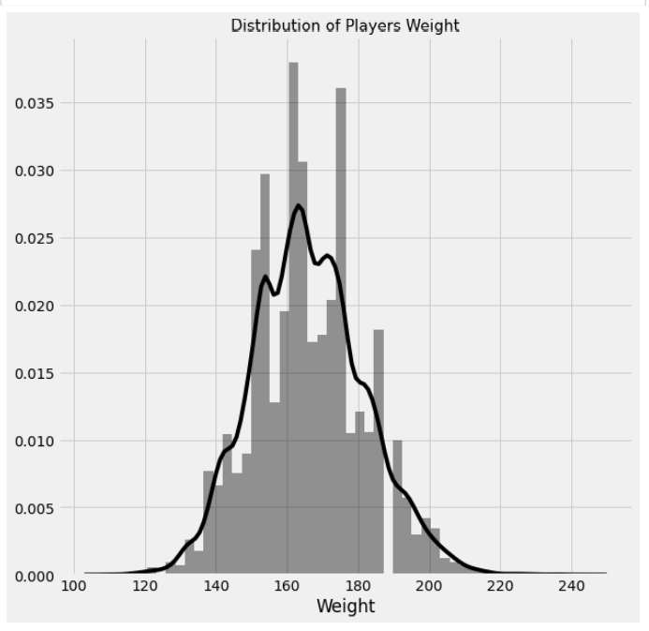

1. Applying the function for value and wage comparison for this, we remove the euro symbols. That graph infers that very few players have high value and similarity. Only a few players are played very high.

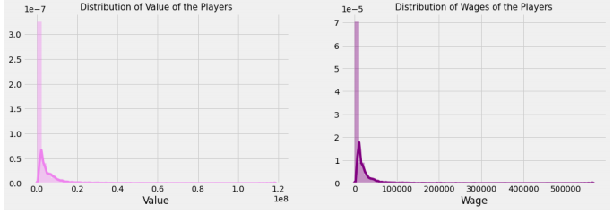

1. Skill Moves of Players. It infers that there are maximum players with the skill moves values.

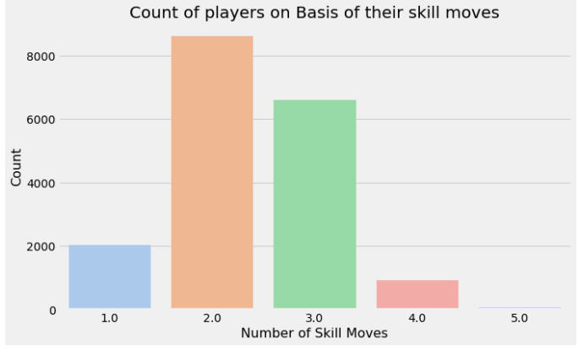

1. The different work rates of the players participating in the FIFA. From the plot we infer that what great medium for maximum players

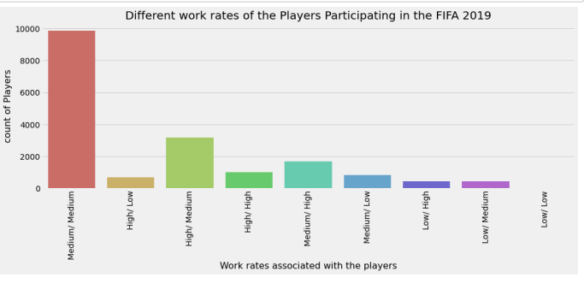

1. Player potential score and Overall Score Histogram. Form the plot, infers the maximum player has a very high potential range from sixty-five to seventy-five, and also the overall score is in the range of 60 to 70 for most of the players.

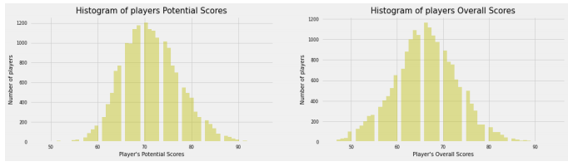

1. Comparison of overall and age concerning preferred foot that plot infers to overall score is high and distributed from the age 22 to 28 with preferred such right.

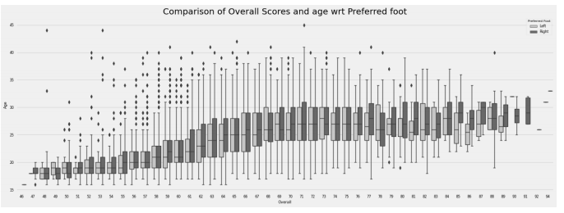

1. Countries with Highest Players from the pie chart we info that Germany and England have a higher number of players than other countries.

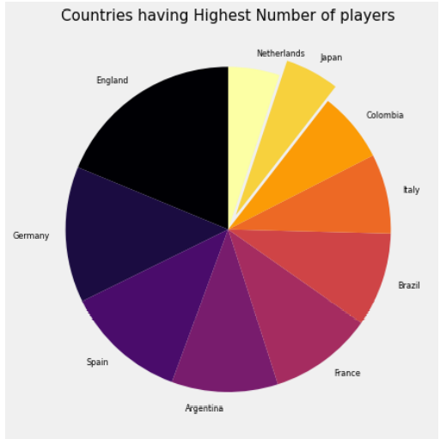

1. Distribution of weight of players from different countries from the violent plot we infer that Italy has the maximum range for weight distributions

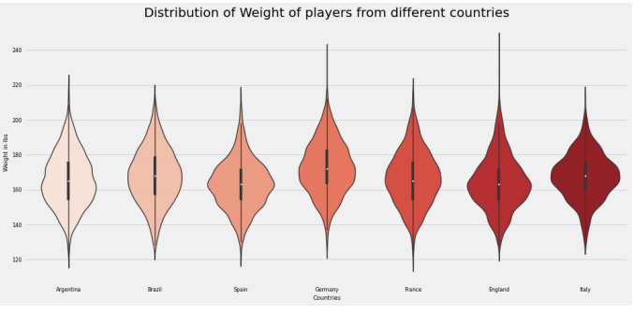

1. Distribution Of overall score of players from different countries from given bar plot we infer that Brazil and Spain have the maximum; highest overall score valued players

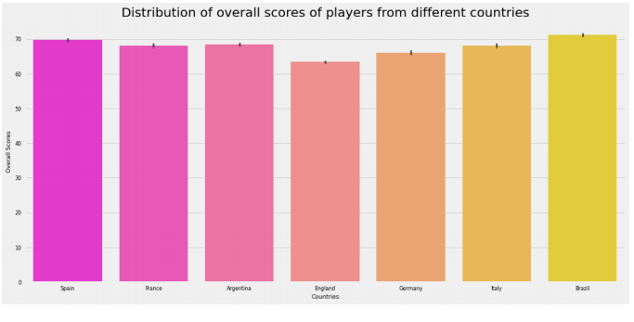

1. Distribution of player wages from different countries for this we are using bar plots again form plot. We infer that the players from Brazil and Spain have average higher salaries than other popular countries playing FIFA.

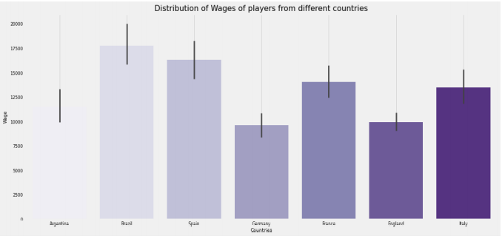

1. Distribution of international reputation of players from countries we use the box plot here from the plot we infer that player from Spain have higher international reputation than any other.

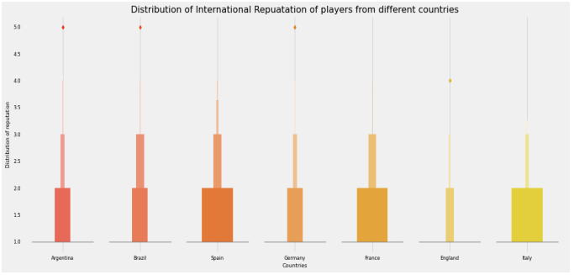

1. Distribution of overall score in Different popular clubs here we are using box plot again from the plot of the info that Chelsea and Real Madrid have the highest overall distribution score and the middle 50 percent of the data is around 75 to 85 which is the best.

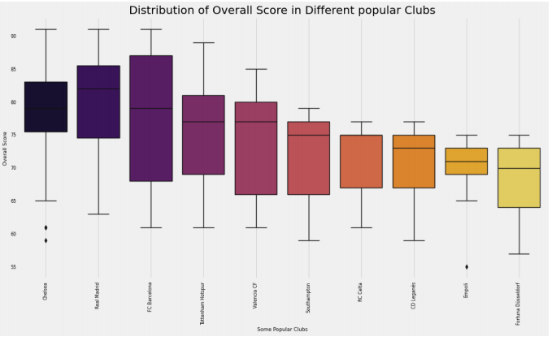

1. Distribution of ages in some popular clubs for this, we will be using box plot again info that Jersey has the maximum age distribution than any other club.

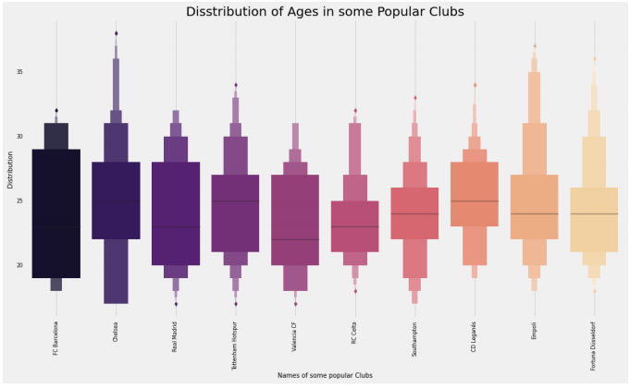

1. Distribution of wages in some popular clubs from the plot we info that Real Madrid FC Barcelona and Chelsea have a higher distribution than any other club.

`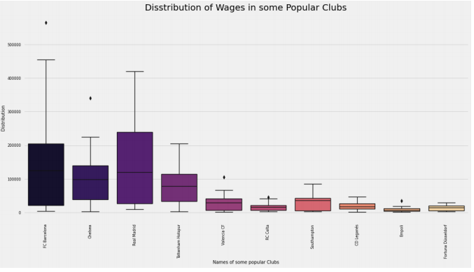

1. Distribution of Wages in some Popular clubs from the plot we info that FC Barcelona has the maximum international reputation than any other popular club.

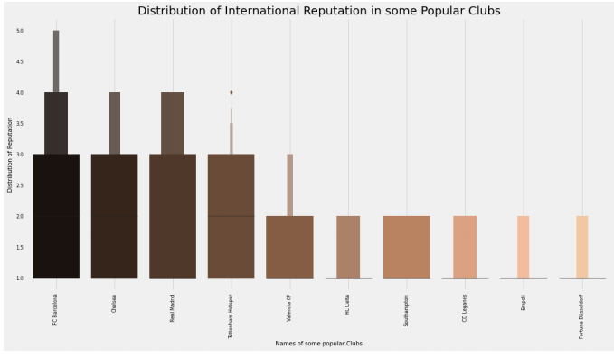

# **Conclusion**

The conclusion of this project is how EDA might provide us with valuable information into the dataset. It is a critical component of any pipeline for data science. Before deploying our machine learning models, we discovered how critical data visualizations are. Learn about query analysis for missing values imputation.

By studying it, we were able to generate certain statistics for teams, clubs, and clubs based on our vast football expertise. The insights given by the outcomes and the comprehension and contextualization of the information allow users to respond intelligently when players free fall, whether by selecting a stronger fantasy premier league club or raising their betting chances. It is, after all, natural to get knowledge about your player prior to establishing a squad.