UDEMY
Instructor Portal:
Account Creation Steps:
Step 1:
Registration:
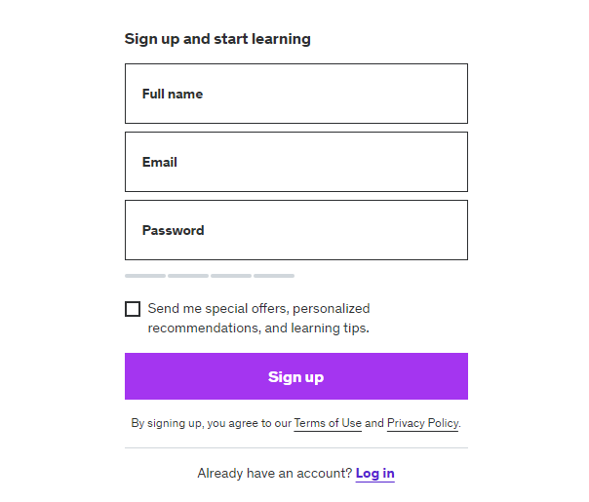
Step 2:
Login:
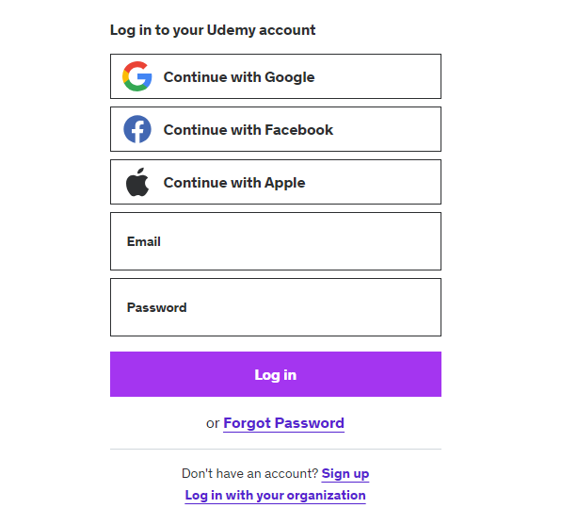
To become an instructor, follow these steps after logging in: update your profile, enter "Instructor" in the Headline field, and then save your changes.
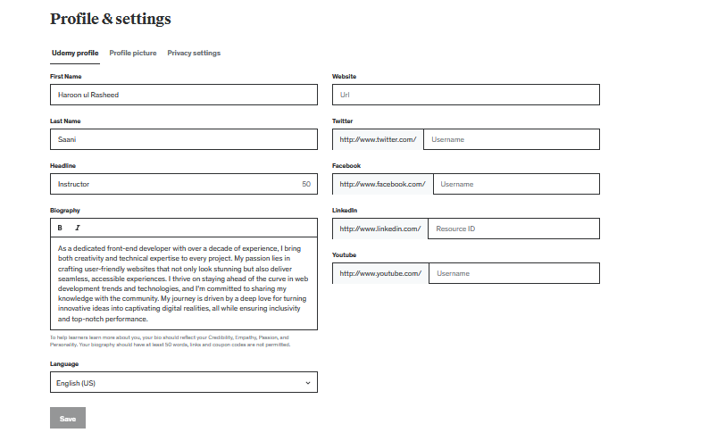
Dashboard:
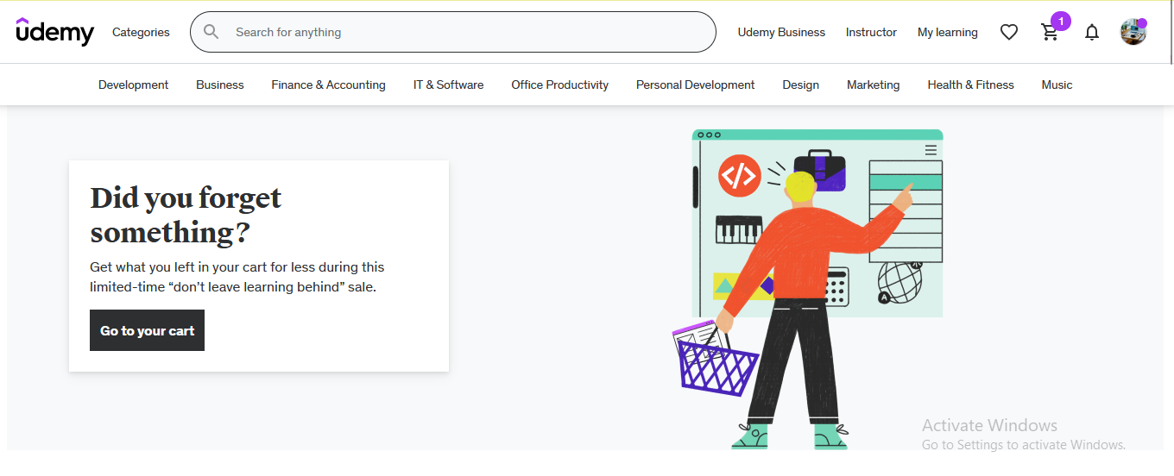
Instructor Dashboard:
Click instructor view
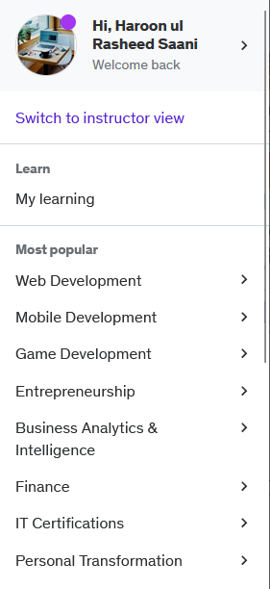
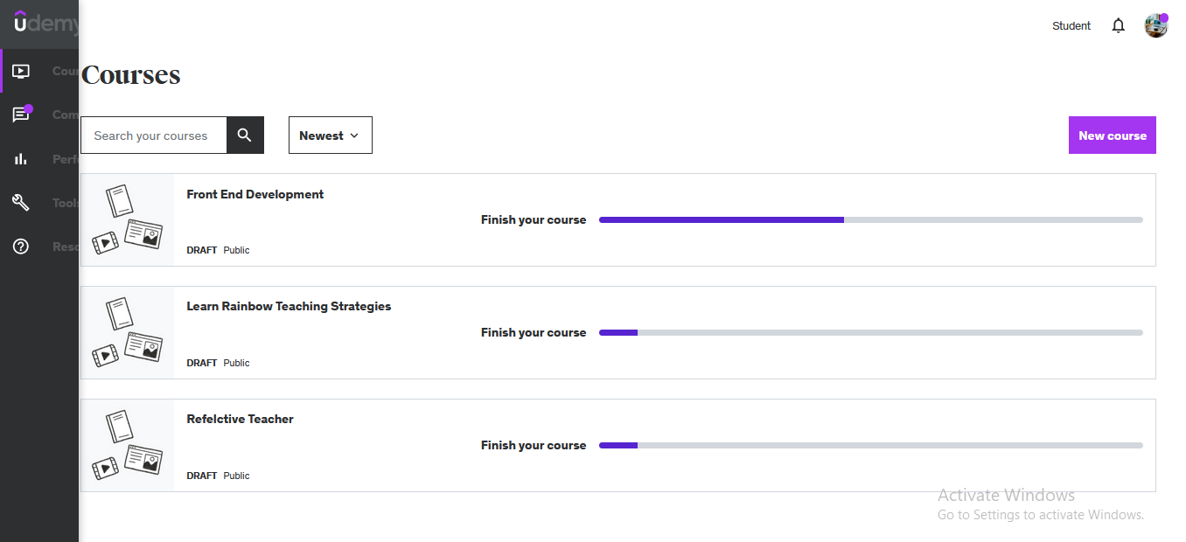
Course Creation Steps:

Step 1:

Prior to course creation, it's important to proactively address frequently asked questions and provide comprehensive responses.

General Questions:

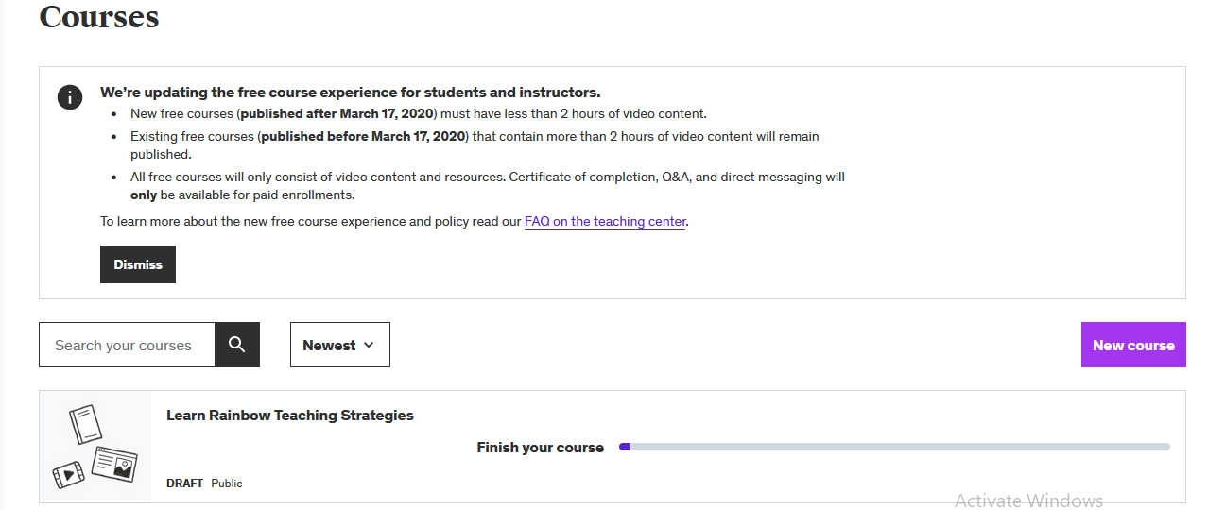

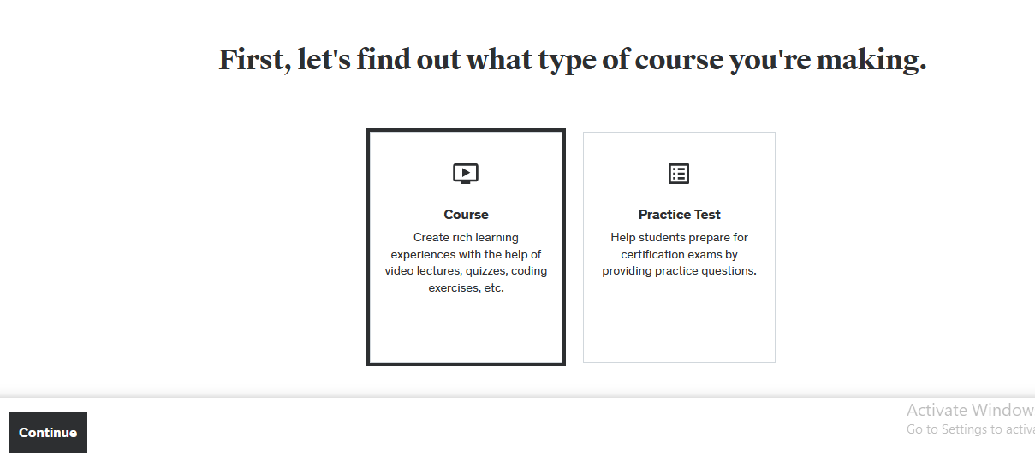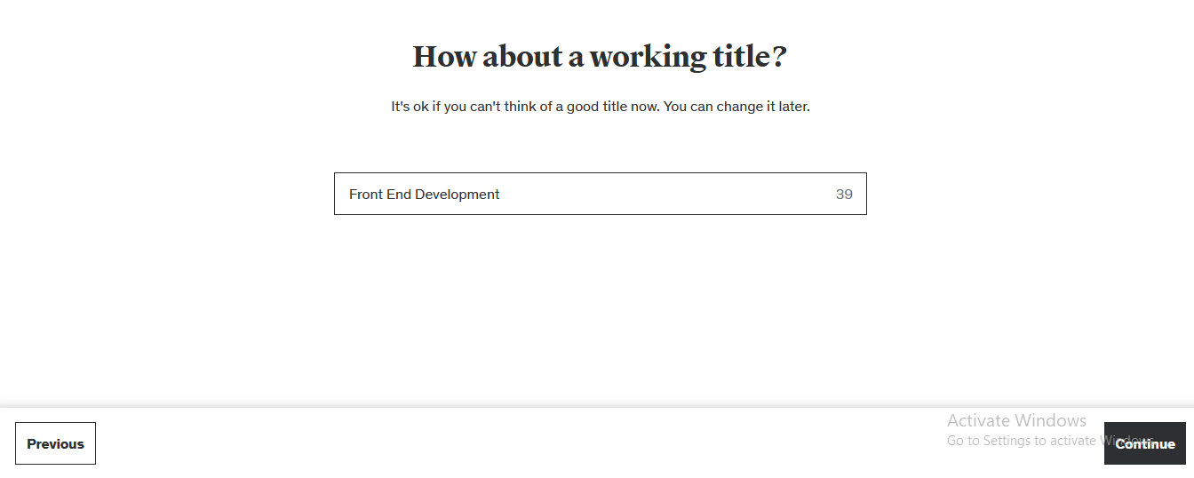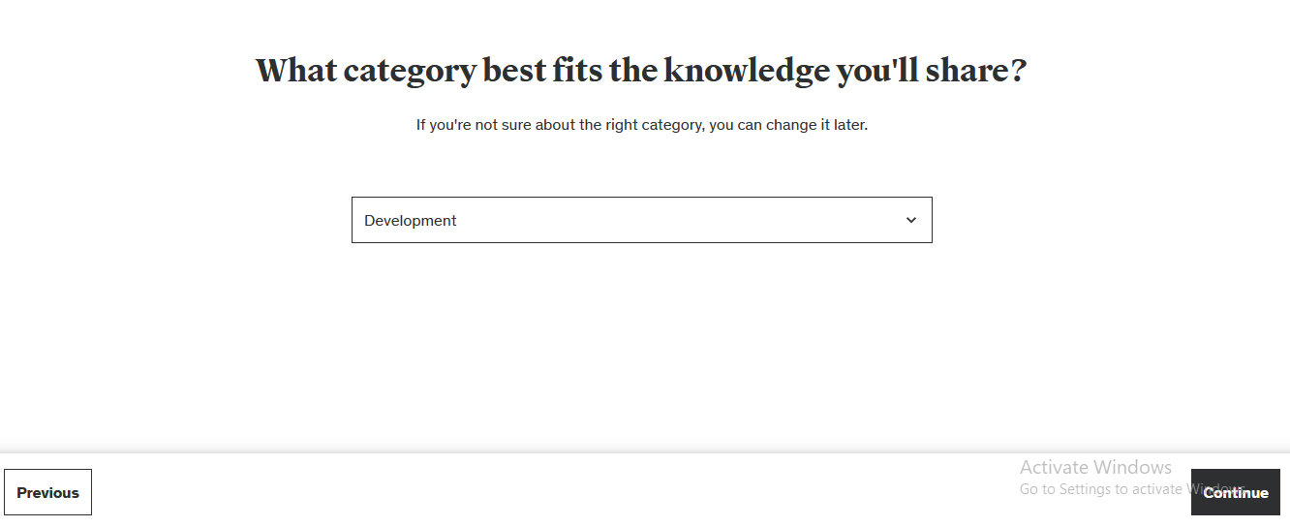

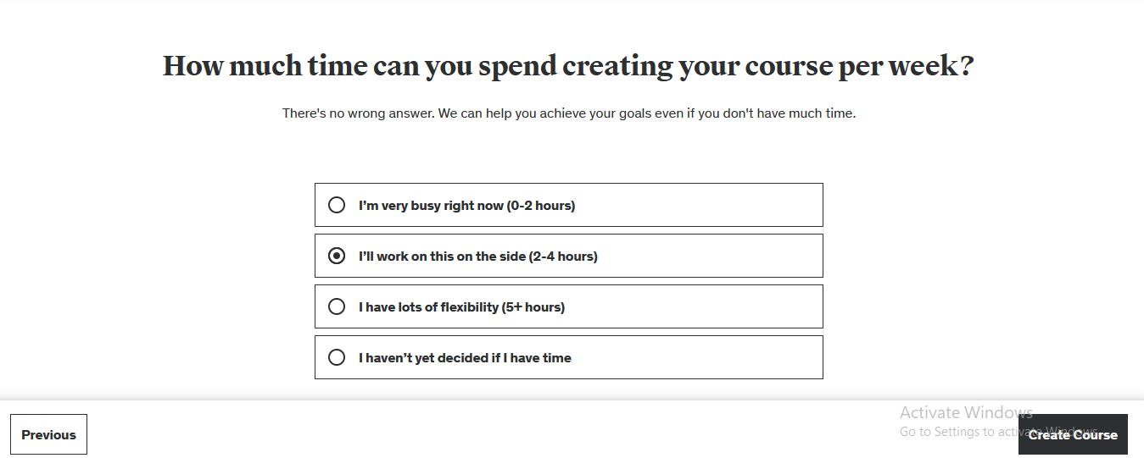

Step 2:

Plan Course:

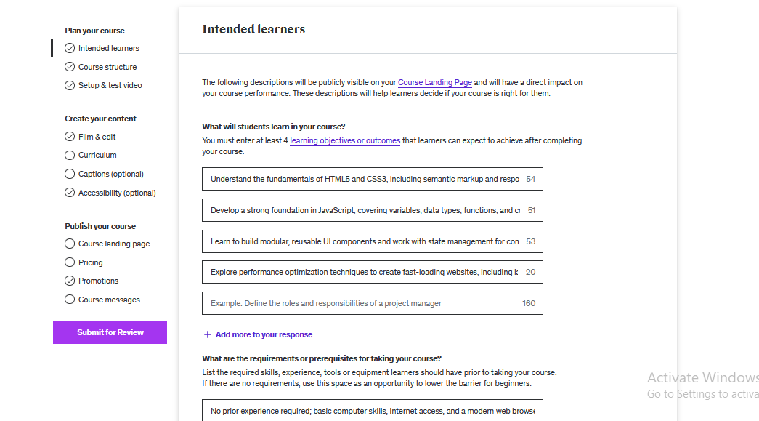

Step 3:

Set Curriculum:
- Each course is organized into multiple sections.
- Within each section, there is a series of lectures.
- A minimum of five lectures is mandatory for each section.
- Each lecture should incorporate related elements, including quizzes, assignments, and video lectures, to enhance the learning experience.

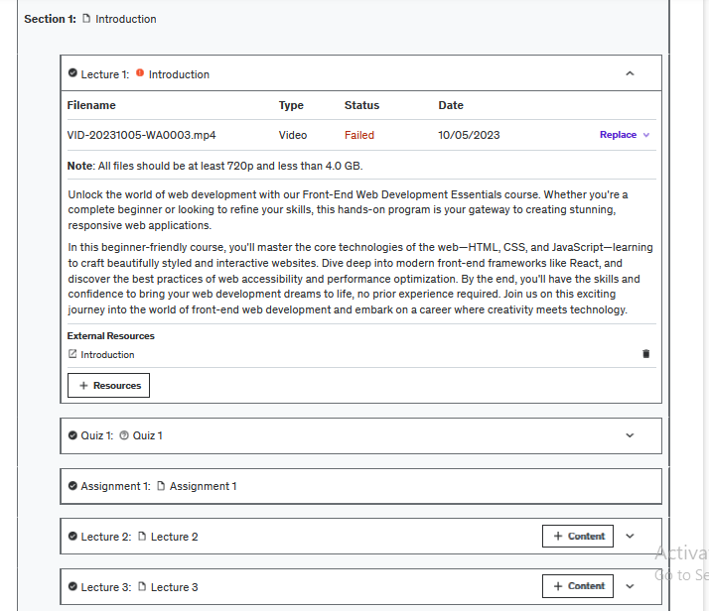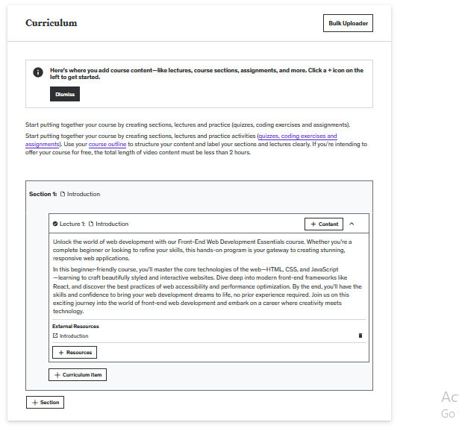
Set Quiz:
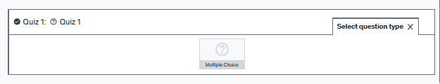
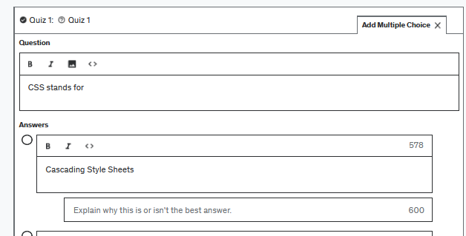
Set Assignment:
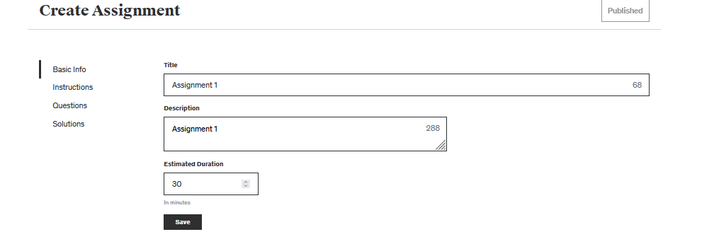

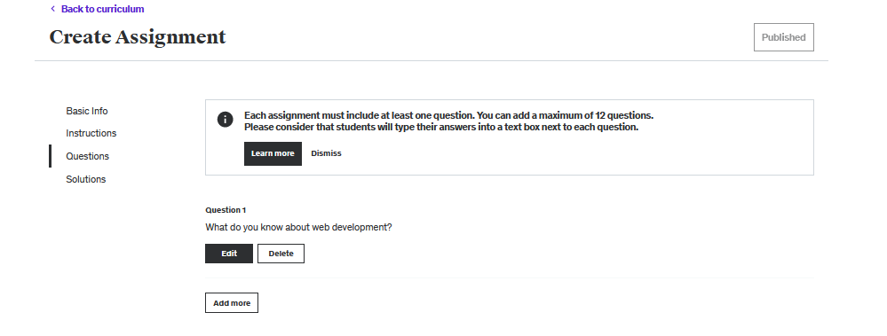
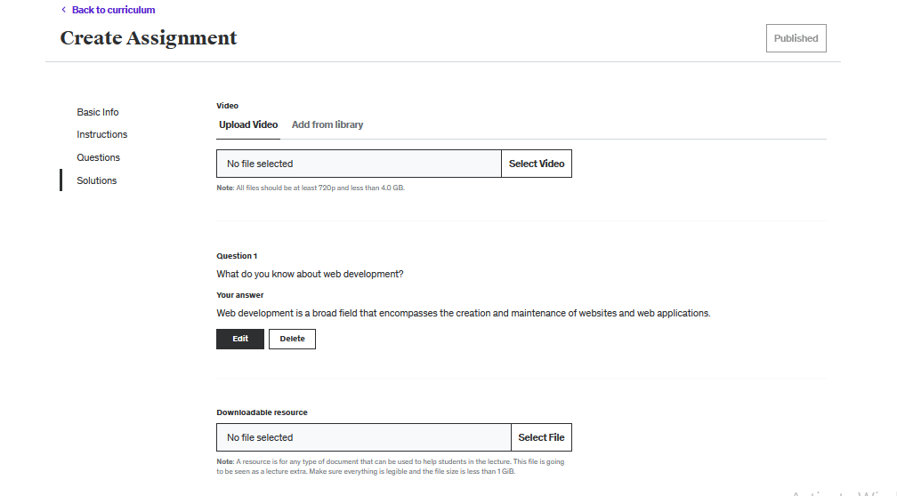

Features:

1. Course Creation
Instructors on the platform have the capability to create various types of courses. Examples of course categories include:
- Cooking
- Programming
- Languages

2. Account Approval
To gain instructor privileges, individuals must pass a test video as part of the account approval process.
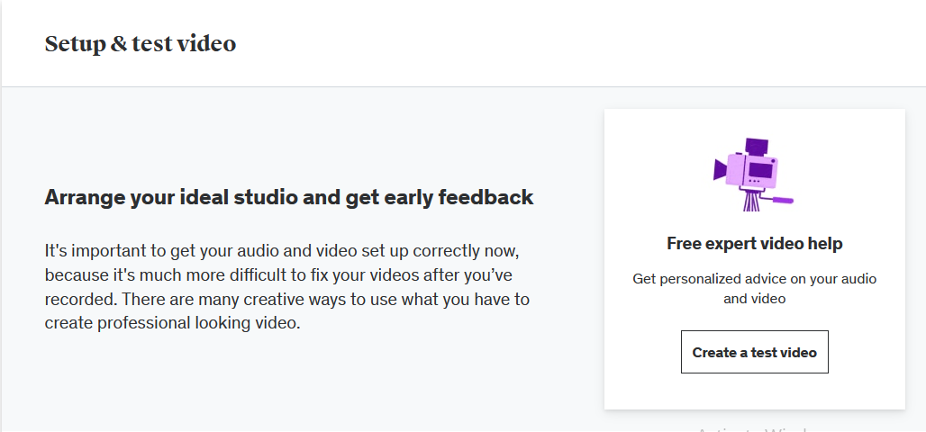

3. Course Approval
Courses created by instructors must undergo an approval process by UDEMY before becoming available to students.
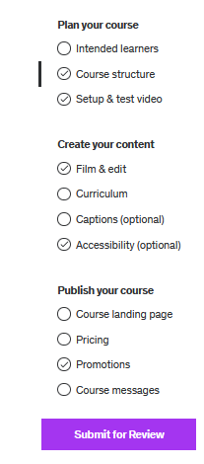

4. Payment Integration
Instructors can integrate payment methods such as Pioneer or PayPal for course revenue collection.

5. Course Thumbnails
Instructors have the ability to upload thumbnail images for their courses to make them visually appealing.
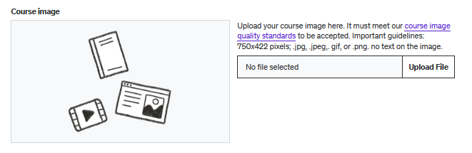

6. Promotional Videos
Instructors can include promotional videos to provide an overview of their courses, attracting potential students.
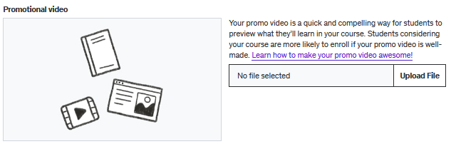

7. Captions
For student convenience, instructors can add captions in different languages (e.g., English) to their course videos.
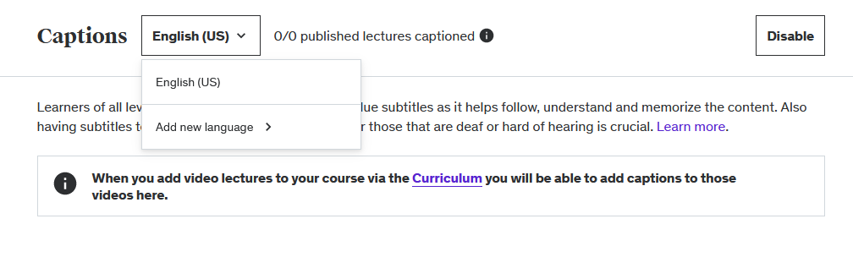

8. Pricing Control
Instructors can set their courses as paid or free, with the flexibility to define the pricing strategy up to a specified limit.
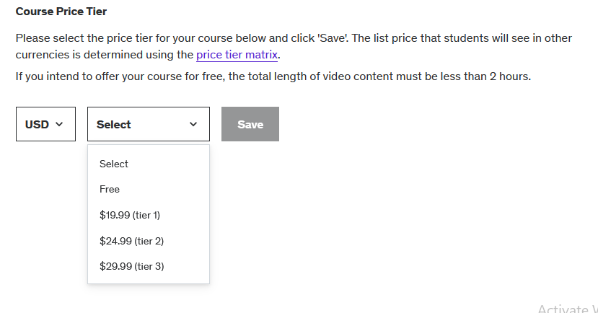

9. Course Sections
Instructors can create structured sections within their courses, including introductory sections and more.
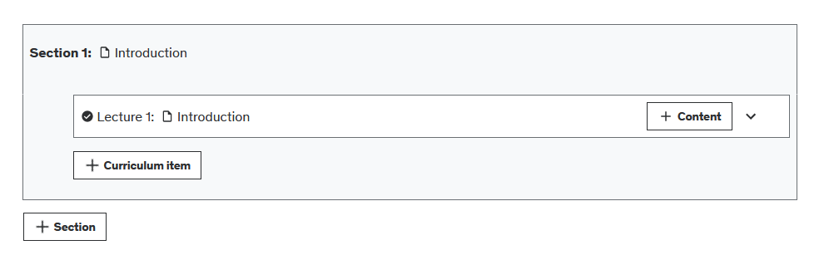

10. Content within Sections
For each section, instructors can add various types of content, such as quizzes, assignments, and videos.
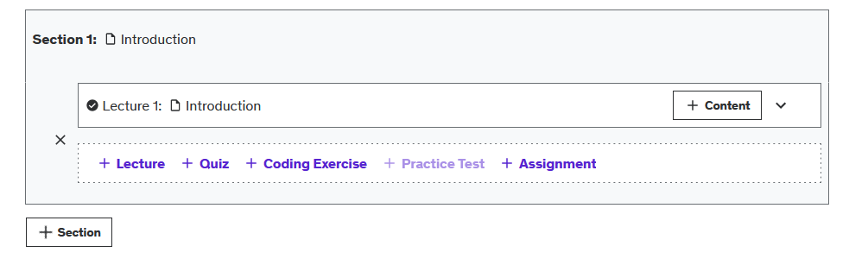

11. Content Management
Instructors have the ability to modify or delete courses and related content as needed.

12. Course Publishing
Instructors can publish their courses, specifying:
- Audience Levels (Beginners, Advanced, Expert, All Levels)
- Categories and Subcategories
- Language
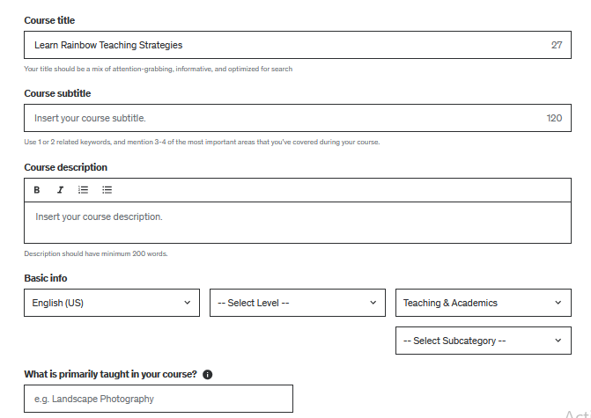

13. Communication
Instructors can communicate with students by adding welcome and completion messages to their courses.
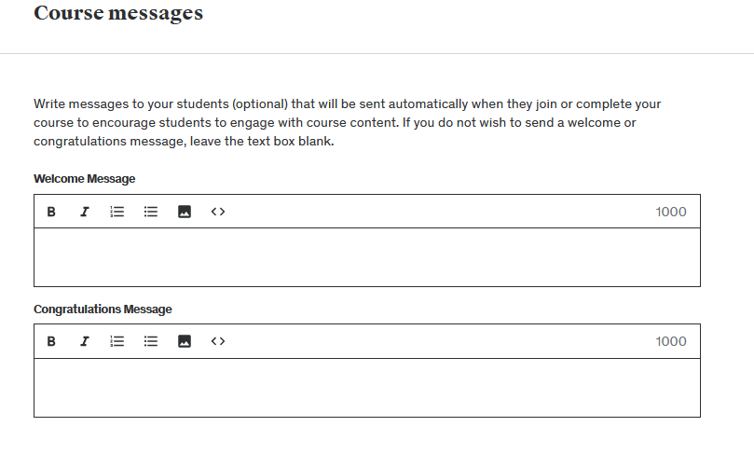

14. Profile Editing
Instructors can edit their profiles, including the option to provide links to their social media profiles (e.g., LinkedIn, Facebook).
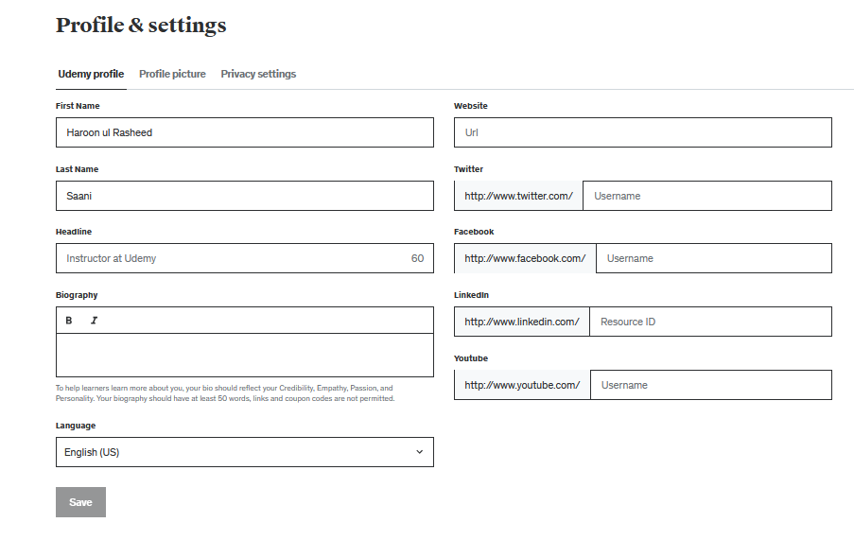

15. Discounts and Coupons
Instructors can offer discounts and coupons to attract more students to their courses.
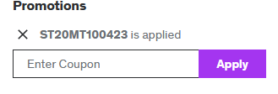

16. Student Interaction
Students can ask questions about courses directly from the instructor's profile.
