Please check and resolve ASAP
Some of our campuses are facing the issue
Entered data of new students/new employee is not showing in any list, on try again entry system shows (Data already exists)
Import students/staff is not working
Discount/Concession is not be deducting from challan / not showing on challan
CNIC/B from is not showing on School Leaving Certificate
Provide an option to add father CNIC as well as students Biform
Change fee challan reports in to as below Screenshot
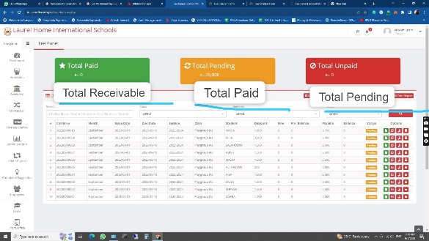

Please Provide a WhatsApp button as Like MUL for Sharing Attendance Reports.
These reports will be sent to class wise WhatsApp group
Change Monthly fee challan AS AGS

