Spelling corection
In Student Admiddin Letter Circule Mentioned Guardian & institiute
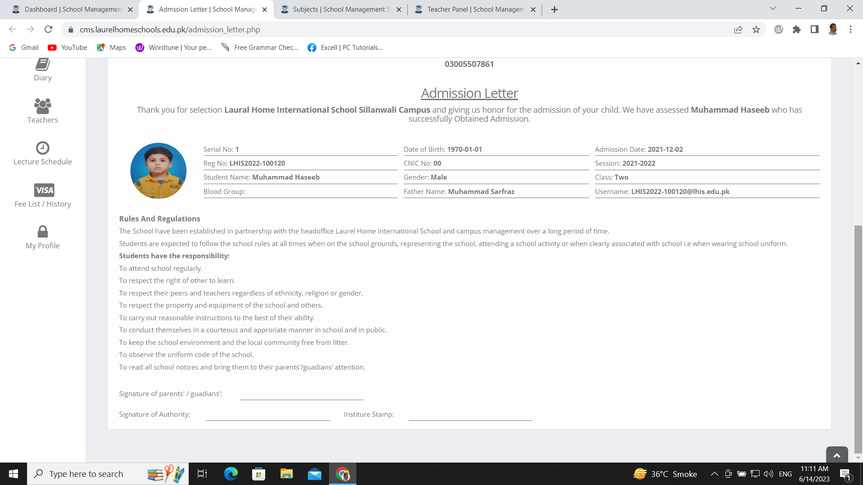
In Teacher Job Letter Circule Mentioned institiute
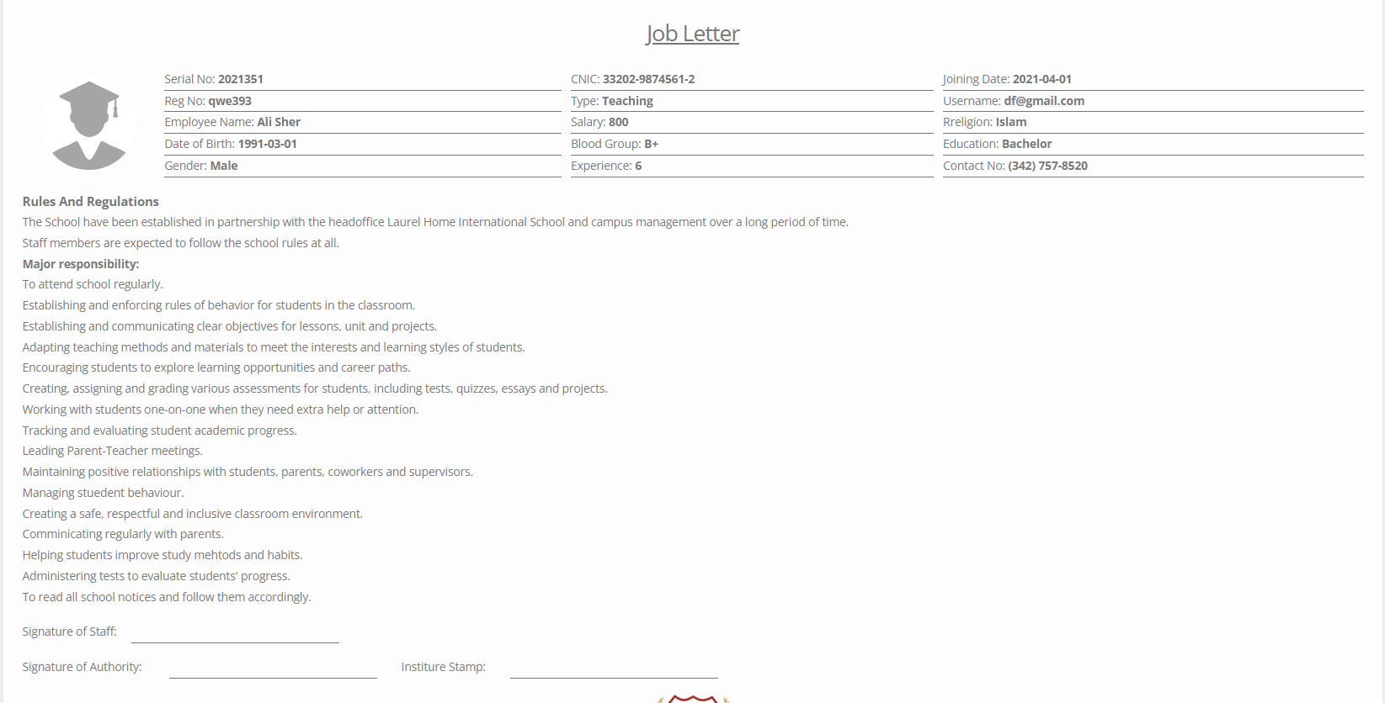

Students Profiles are showing Blank in System and DOB is incorrect please check
