Assignment 1
Exercise 1: Write a C program to find the maximum and minimum of three numbers entered by the user using fork().
Solution:
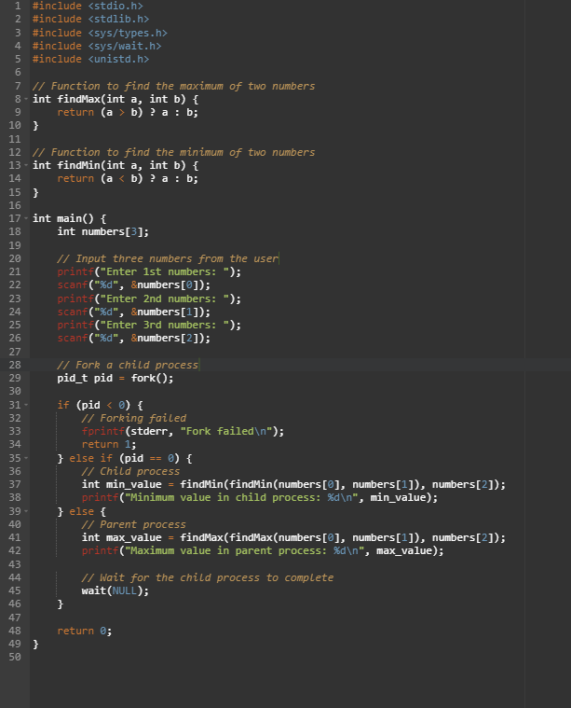
Output:
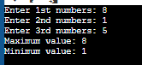
Exercise 2: Create a program that calculates the factorial of a given number using a loop with separate child and parent processes.
Exercise 3: Write a C program to check whether a number entered by the user is prime or not using fork().
Exercise 4: Develop a program that calculates the sum of all even numbers between 1 and 100 using multiple child processes.
Exercise 5: Create a program that reverses a given number and checks if it is a palindrome using fork().
Exercise 6: Write a C program to convert a temperature given in Celsius to Fahrenheit and vice versa using fork(), based on user choice.
Exercise 7: Develop a program that prints the Fibonacci series up to a specified number of terms using multiple child processes.
Exercise 8: Create a program that finds the largest element in an array of integers using fork().
Exercise 9: Write a C program to count the number of vowels and consonants in a given string entered by the user using fork().
Exercise 10: Develop a program that multiplies two matrices entered by the user and prints the result using fork().

