**UDEMY**

**Instructor Portal:**

**Account Creation Steps:**

**Step 1:**

**Registration:**

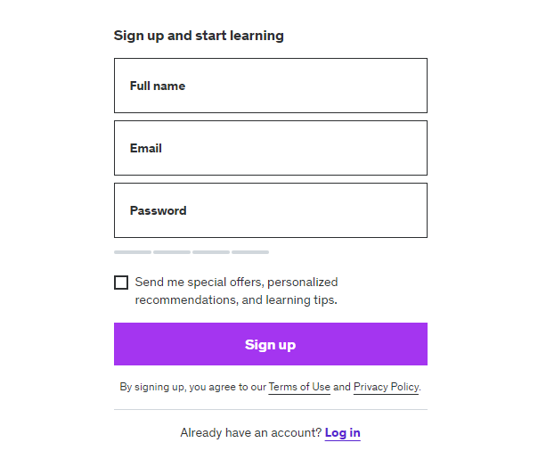

**Step 2:**

**Login:**

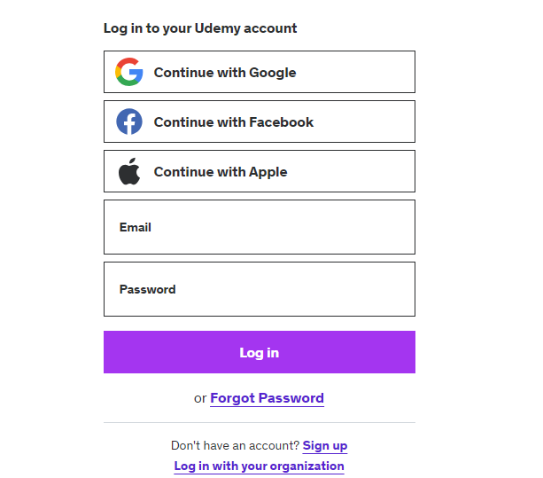

To become an instructor, follow these steps after logging in: update your profile, enter "Instructor" in the Headline field, and then save your changes.

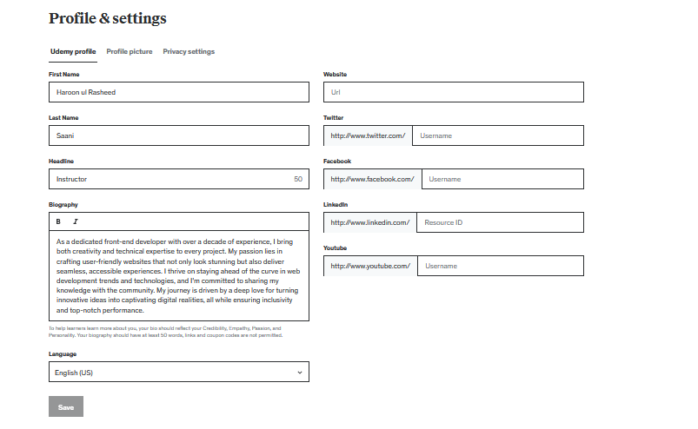

**Dashboard:**

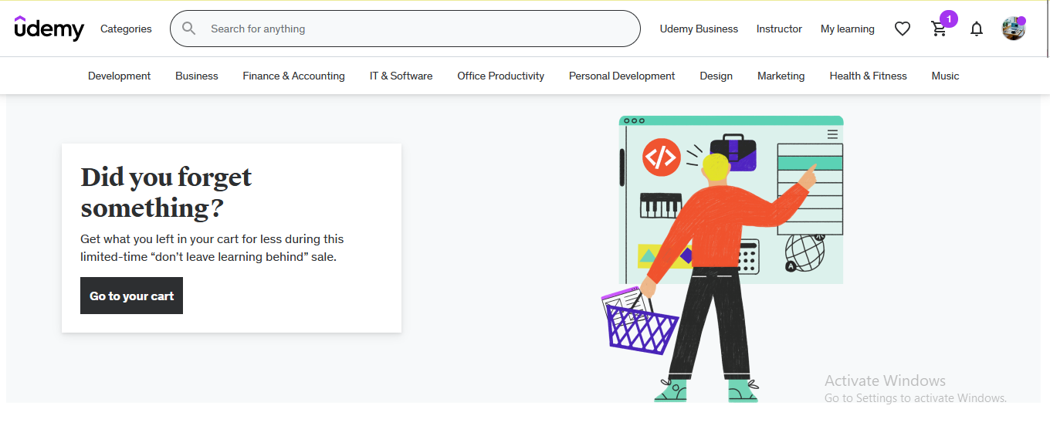

**Instructor Dashboard:**

Click instructor view

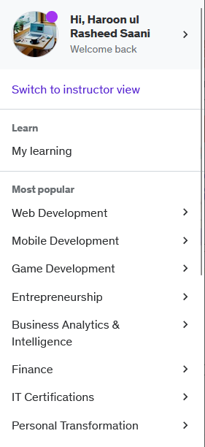

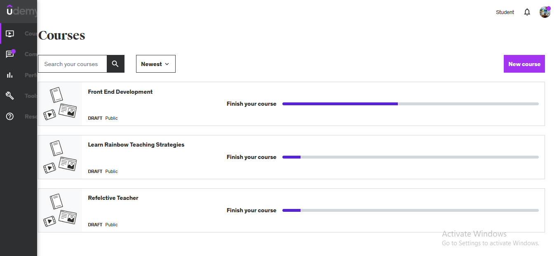

**Course Creation Steps:**

**Step 1:**

Prior to course creation, it's important to proactively address frequently asked questions and provide comprehensive responses.

**General Questions:**

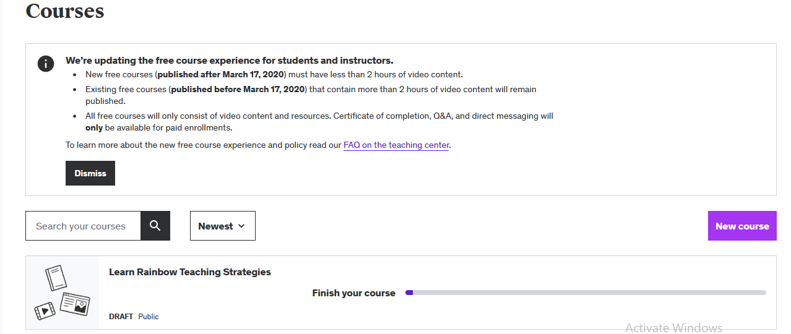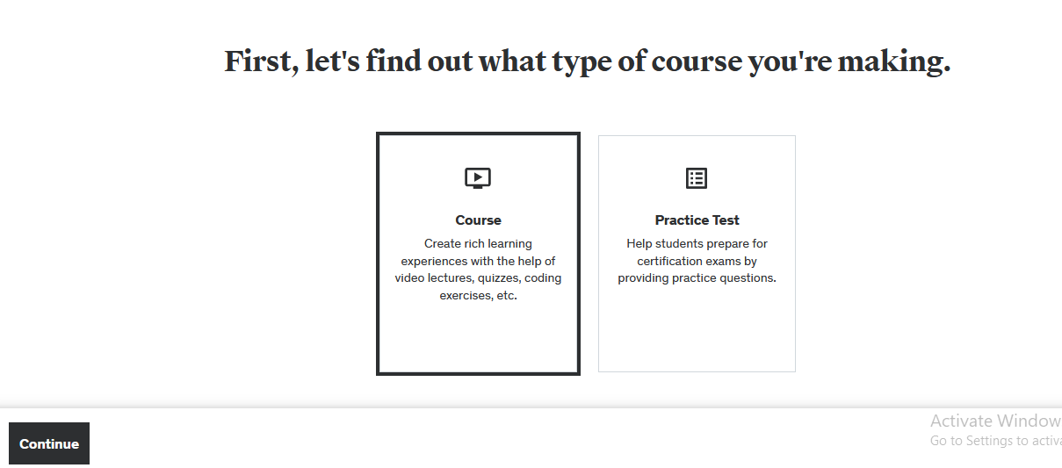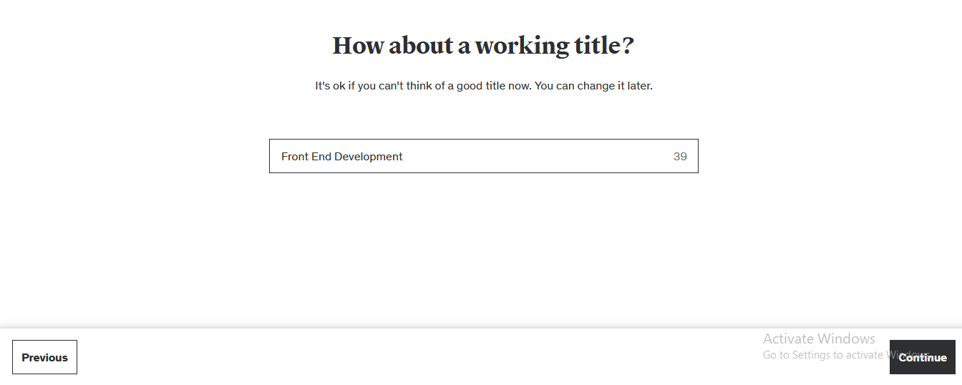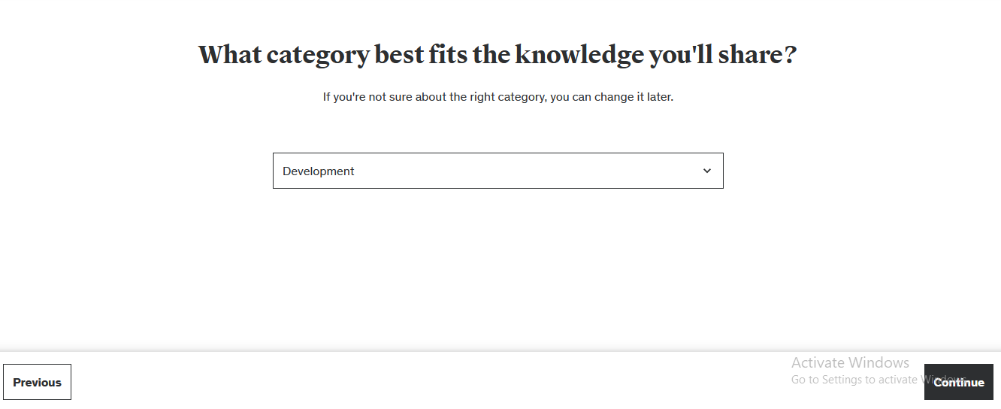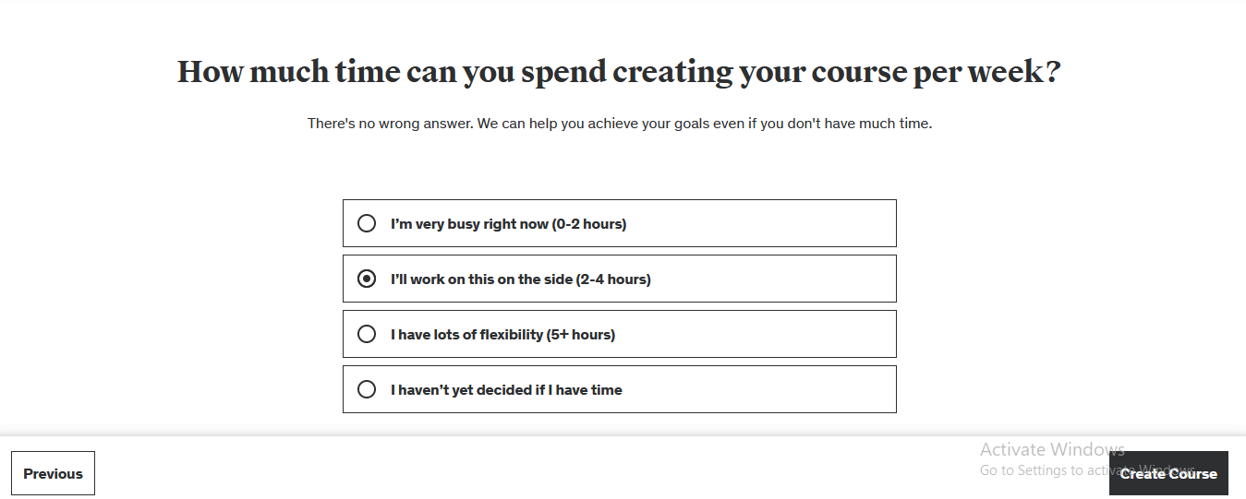

**Step 2:**

**Plan Course:**

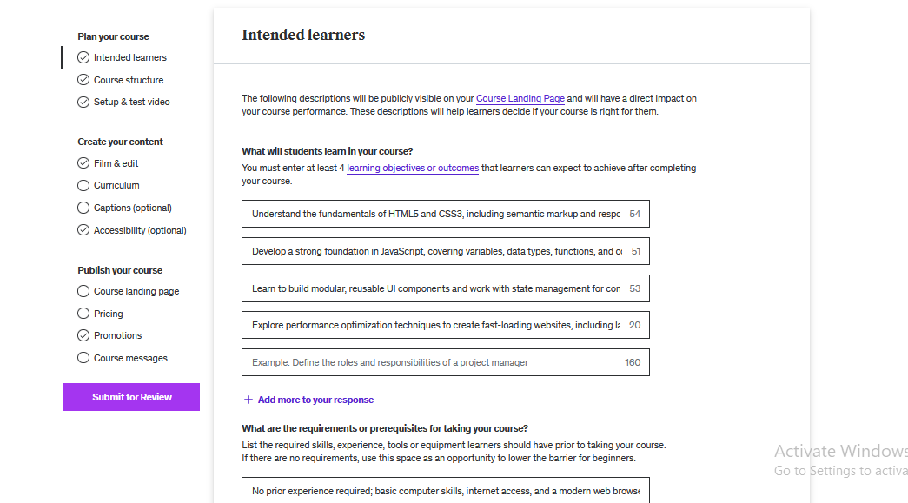

**Step 3:**

**Set Curriculum:**

* Each course is organized into multiple sections.
* Within each section, there is a series of lectures.
* A minimum of five lectures is mandatory for each section.
* Each lecture should incorporate related elements, including quizzes, assignments, and video lectures, to enhance the learning experience.

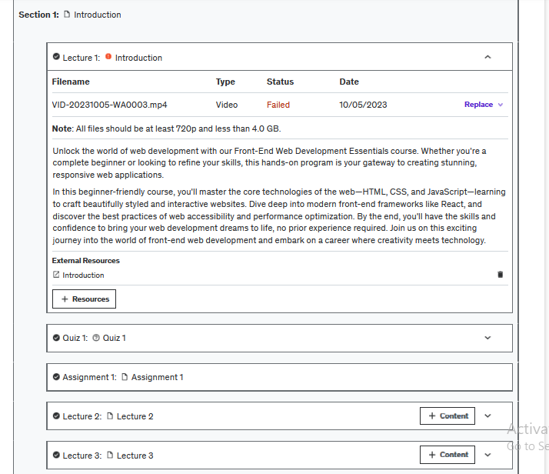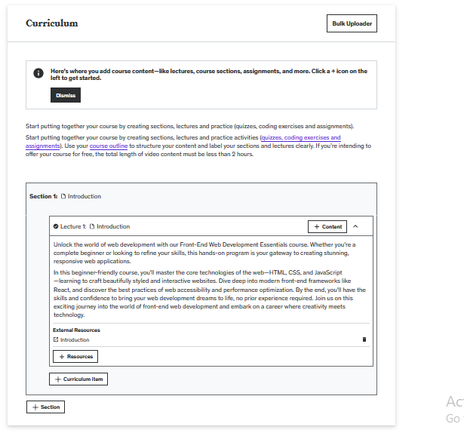

**Set Quiz:**

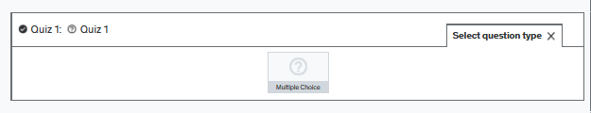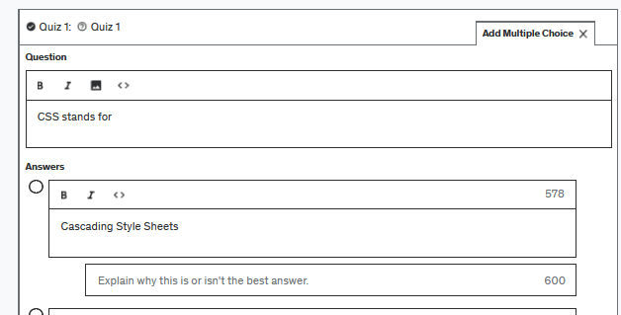

**Set Assignment:**

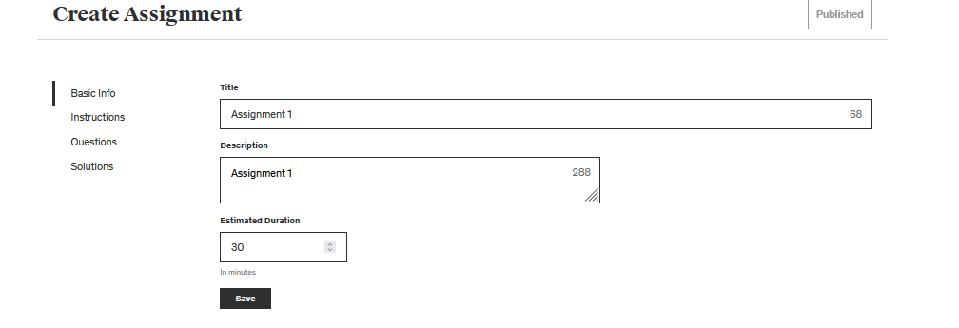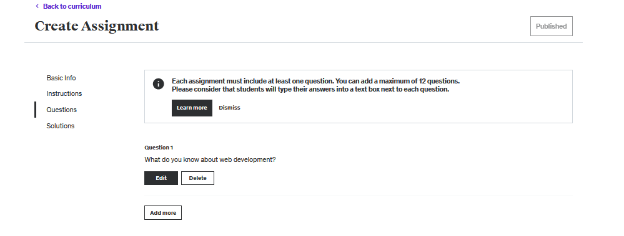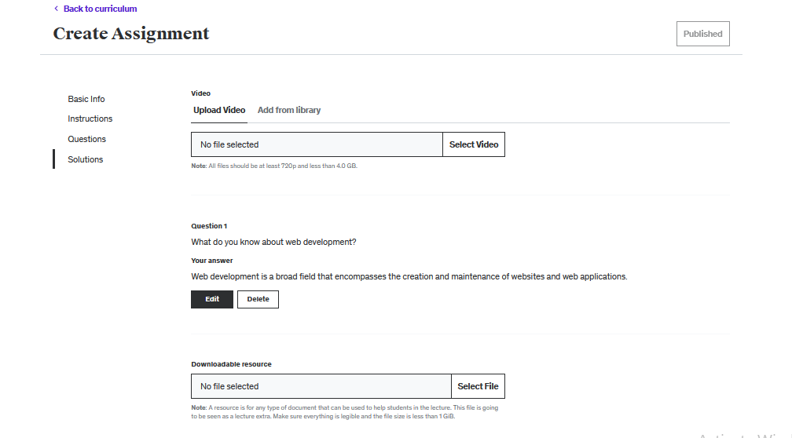

**Features:**

**1. Course Creation**

Instructors on the platform have the capability to create various types of courses. Examples of course categories include:

* Cooking
* Programming
* Languages

**2. Account Approval**

To gain instructor privileges, individuals must pass a test video as part of the account approval process.

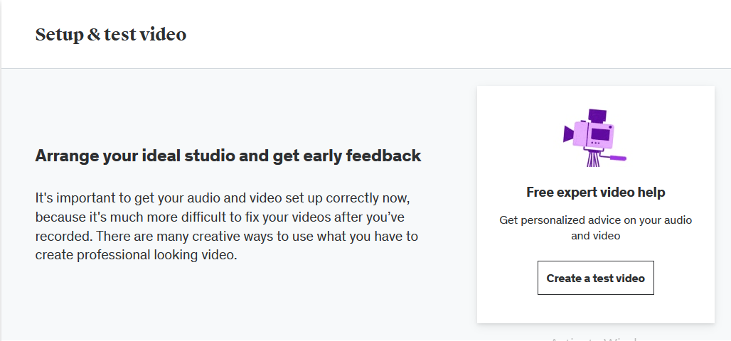

**3. Course Approval**

Courses created by instructors must undergo an approval process by UDEMY before becoming available to students.

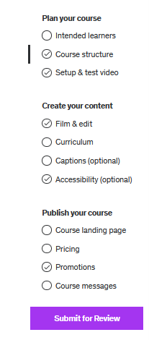

**4. Payment Integration**

Instructors can integrate payment methods such as Pioneer or PayPal for course revenue collection.

**5. Course Thumbnails**

Instructors have the ability to upload thumbnail images for their courses to make them visually appealing.

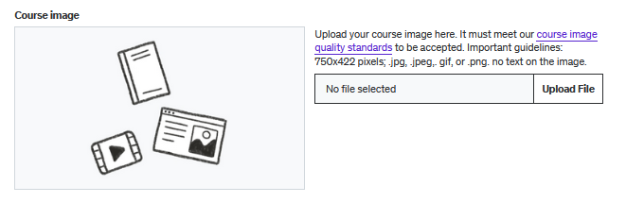

**6. Promotional Videos**

Instructors can include promotional videos to provide an overview of their courses, attracting potential students.

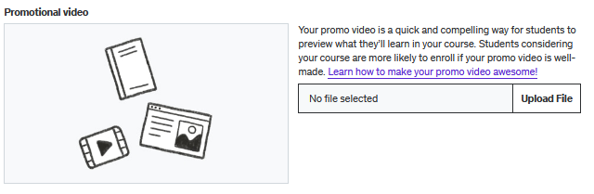

**7. Captions**

For student convenience, instructors can add captions in different languages (e.g., English) to their course videos.

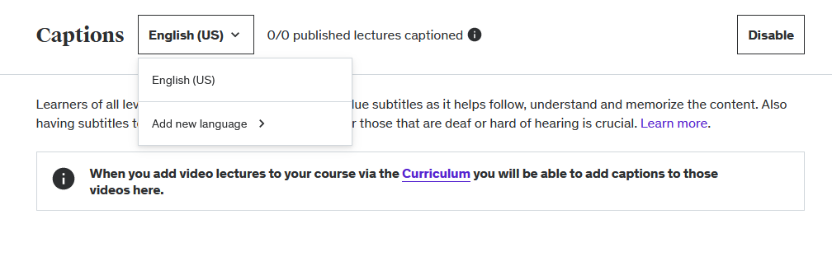

**8. Pricing Control**

Instructors can set their courses as paid or free, with the flexibility to define the pricing strategy up to a specified limit.

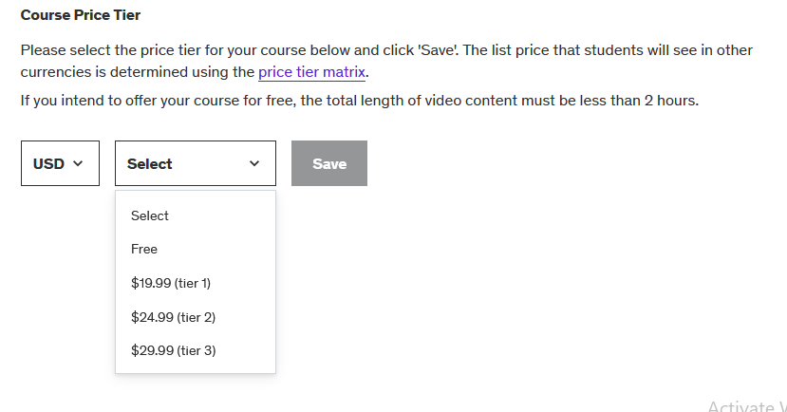

**9. Course Sections**

Instructors can create structured sections within their courses, including introductory sections and more.

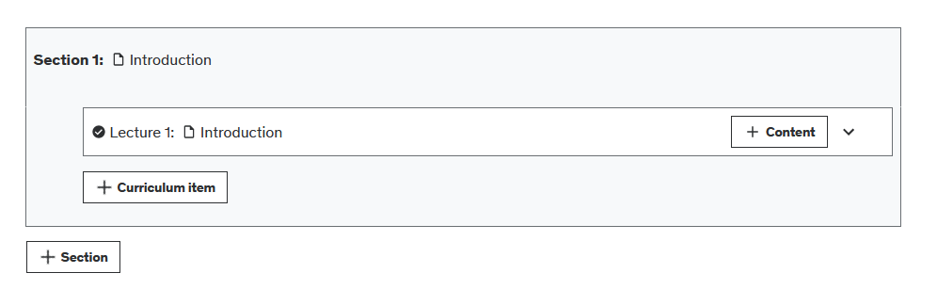

**10. Content within Sections**

For each section, instructors can add various types of content, such as quizzes, assignments, and videos.

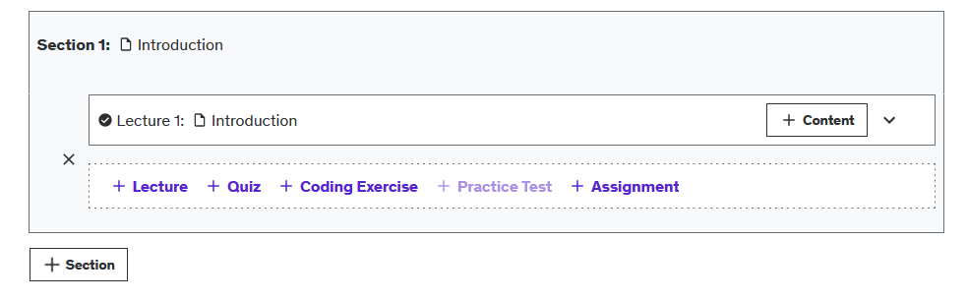

**11. Content Management**

Instructors have the ability to modify or delete courses and related content as needed.

**12. Course Publishing**

Instructors can publish their courses, specifying:

* Audience Levels (Beginners, Advanced, Expert, All Levels)
* Categories and Subcategories
* Language

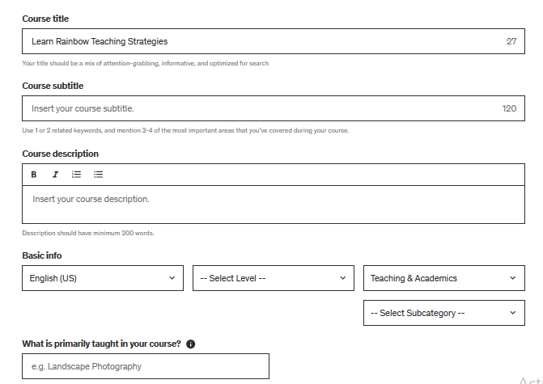

**13. Communication**

Instructors can communicate with students by adding welcome and completion messages to their courses.

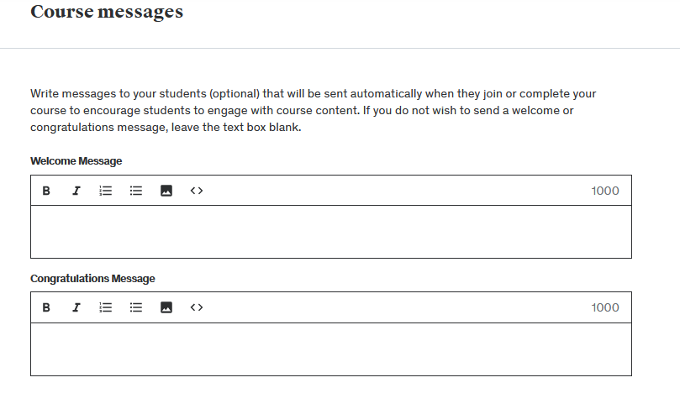

**14. Profile Editing**

Instructors can edit their profiles, including the option to provide links to their social media profiles (e.g., LinkedIn, Facebook).

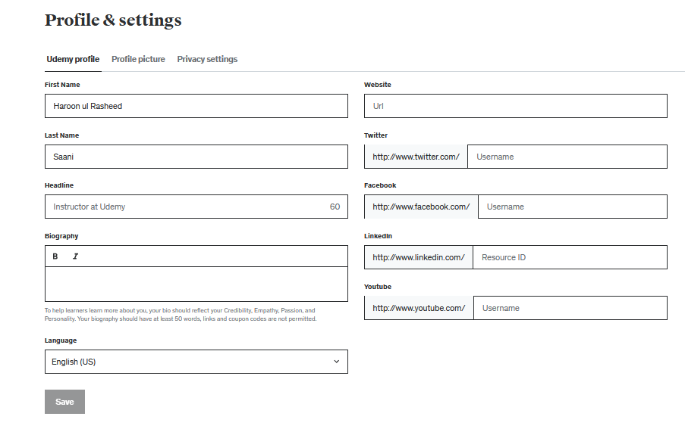

**15. Discounts and Coupons**

Instructors can offer discounts and coupons to attract more students to their courses.

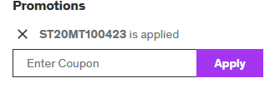

**16. Student Interaction**

Students can ask questions about courses directly from the instructor's profile.

