**Please check and resolve ASAP**

Some of our campuses are facing the issue

Entered data of new students/new employee is not showing in any list, on try again entry system shows (Data already exists)

Import students/staff is not working

Discount/Concession is not be deducting from challan / not showing on challan

CNIC/B from is not showing on School Leaving Certificate

Provide an option to add father CNIC as well as students Biform

Change fee challan reports in to as below Screenshot

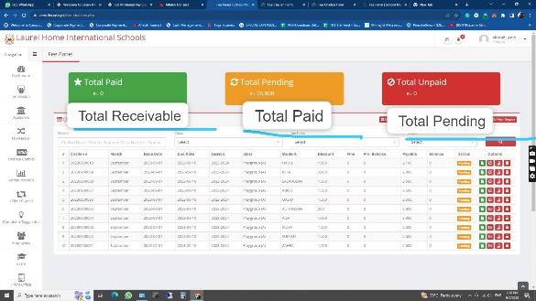

Please Provide a WhatsApp button as Like MUL for Sharing Attendance Reports.

These reports will be sent to class wise WhatsApp group

Change Monthly fee challan AS AGS