Spelling corection

In Student Admiddin Letter Circule Mentioned Guardian & institiute

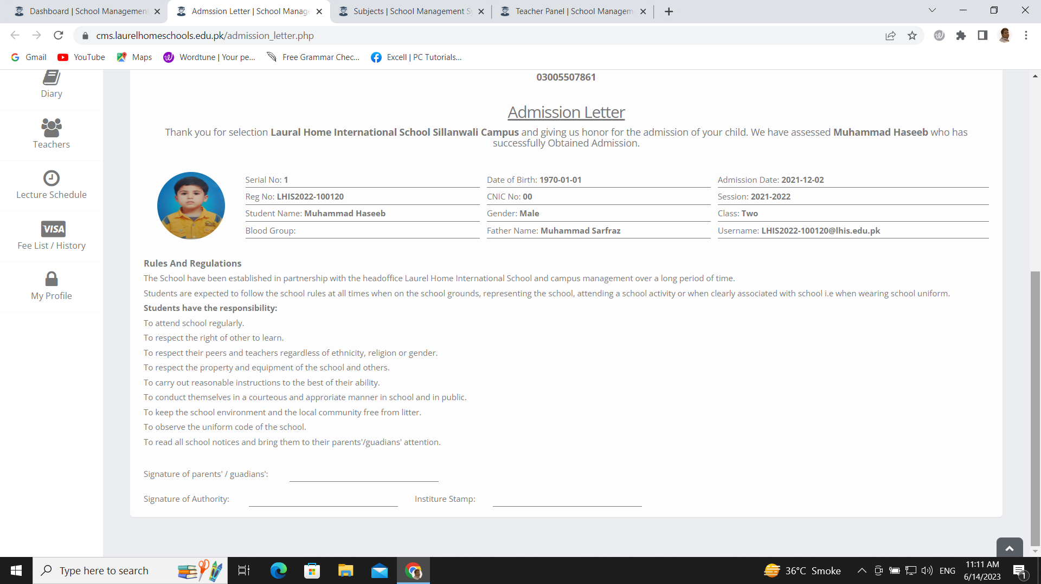

In Teacher Job Letter Circule Mentioned institiute

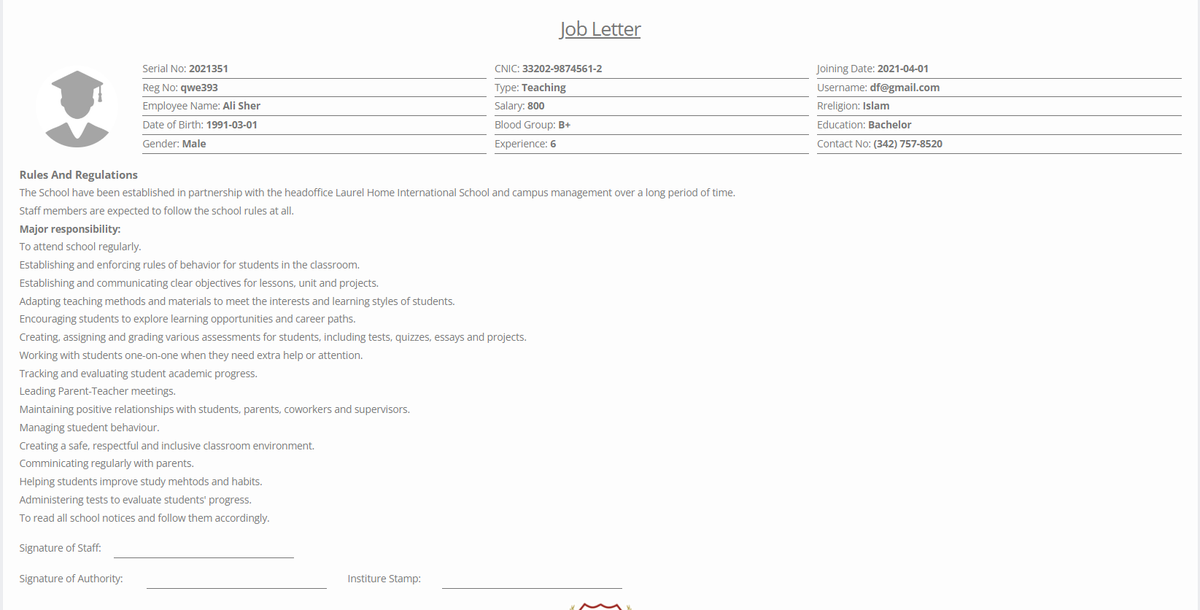

Students Profiles are showing Blank in System and DOB is incorrect please check

