**Assignment 1**

**Exercise 1:** Write a C program to find the maximum and minimum of three numbers entered by the user using **fork()**.

**Solution:**

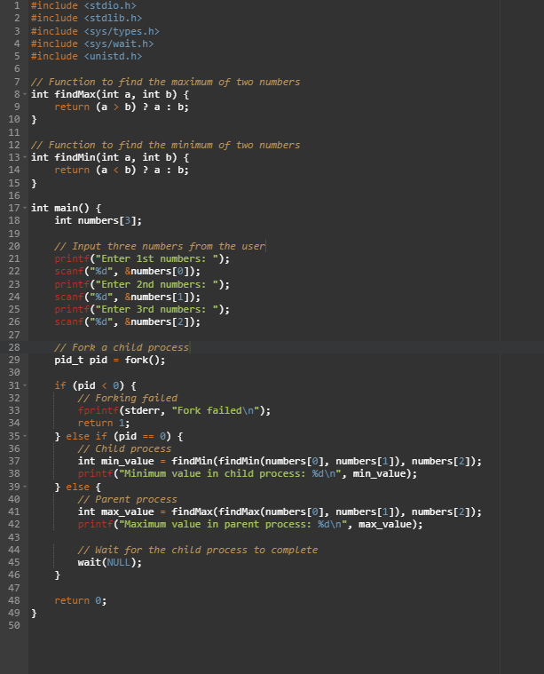

**Output:**

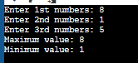

**Exercise 2:** Create a program that calculates the factorial of a given number using a loop with separate child and parent processes.

**Exercise 3:** Write a C program to check whether a number entered by the user is prime or not using **fork()**.

**Exercise 4:** Develop a program that calculates the sum of all even numbers between 1 and 100 using multiple child processes.

**Exercise 5:** Create a program that reverses a given number and checks if it is a palindrome using **fork()**.

**Exercise 6:** Write a C program to convert a temperature given in Celsius to Fahrenheit and vice versa using **fork()**, based on user choice.

**Exercise 7:** Develop a program that prints the Fibonacci series up to a specified number of terms using multiple child processes.

**Exercise 8:** Create a program that finds the largest element in an array of integers using **fork()**.

**Exercise 9:** Write a C program to count the number of vowels and consonants in a given string entered by the user using **fork()**.

**Exercise 10:** Develop a program that multiplies two matrices entered by the user and prints the result using **fork()**.