Energy Consumption Forecasting: A Comparative Study of Deep Learning and Tree-Based Models

Talha Yılmaz
DSAI 302 Capstone Project
MEF University
yilmazta@mef.edu.tr
Abstract—Accurate short-term electricity load forecasting is a critical component for the efficient operation, planning, and economic dispatch of modern power grids. This project presents a comprehensive comparative analysis of time-series forecasting methodologies applied to hourly energy consumption data from the Dayton zone of the PJM Interconnection. Utilizing a robust dataset of approximately 121,000 chronological observations spanning from 2004 to 2018, this study benchmarks five distinct modeling paradigms: tree-based ensembles (Random Forest, XGBoost, LightGBM), statistical models (Facebook Prophet), and deep learning sequence models (Multivariate Long Short-Term Memory networks). To ensure strict generalizability and prevent look-ahead leakage, the methodology heavily emphasizes chronological data splitting, rolling temporal feature engineering, and time-series cross-validation. The experimental results demonstrate the overwhelming superiority of sequence modeling for this highly autoregressive domain. By implementing an optimized training protocol featuring extended epoch limits and robust early stopping mechanisms, the deep learning LSTM architecture emerged as the absolute best-performing model. It achieved unprecedented convergence, yielding a Root Mean Square Error (RMSE) of 24.63, a Mean Absolute Percentage Error (MAPE) of 0.83%, and an R² score of 0.9959. Among the tree-based algorithms, LightGBM demonstrated the highest efficiency and accuracy (R² = 0.9271), heavily leveraging engineered lag and rolling mean features. Conversely, the statistical Prophet model underperformed (R² = 0.5002), highlighting the limitations of pure calendar-effect modeling when dealing with high-frequency, autoregressive hourly load dynamics.

I. Executive Summary
This report presents a comprehensive comparative study of machine learning and deep learning methodologies applied to short-term electricity load forecasting using hourly energy consumption data from the PJM Dayton zone. The dataset spans over 14 years (October 2004 to August 2018) and contains approximately 121,000 observations, providing a high-volume foundation for advanced time-series analysis. The primary objective is to build, optimize, and rigorously benchmark five forecasting models: Random Forest, XGBoost, LightGBM, Facebook Prophet, and a Multivariate Long Short-Term Memory (LSTM) neural network.
A rigorous preprocessing pipeline was applied, including chronological sorting, cyclical trigonometric feature encoding, autoregressive lag feature engineering (lag24, lag168), and rolling mean construction with strict look-ahead prevention via a .shift(1) operation. To prevent data leakage, all models were evaluated using a strict 70/15/15 chronological train-validation-test split, and tree-based hyperparameter tuning was performed exclusively with TimeSeriesSplit cross-validation.
The experimental results reveal a clear three-tier performance hierarchy. The Multivariate LSTM emerged as the definitive best-performing model, achieving an R² of 0.9959, RMSE of 24.63 MW, and MAPE of 0.83%—an average forecasting error of less than 1% relative to actual grid load. Among tree-based approaches, LightGBM ranked highest (R² = 0.9271), followed closely by XGBoost (R² = 0.9238) and Random Forest (R² = 0.9168). The statistical Prophet model underperformed significantly (R² = 0.5002), confirming the inadequacy of purely additive seasonality models for high-frequency autoregressive energy data.
The findings underscore the transformative potential of sequence-aware deep learning for energy grid management. The LSTM’s sub-1% error rate directly translates to measurable reductions in energy waste and improved grid stability. Future research directions include integration of real-time weather data, multi-step (day-ahead) forecasting horizons, and hybrid CNN-LSTM architectures that combine the computational efficiency of gradient boosting with the sequential memory of recurrent networks.

II. Introduction
The stability and reliability of electrical power grids depend fundamentally on the precise matching of electricity generation with consumer demand in real-time. Because large-scale electrical energy storage remains economically and technologically constrained, Grid Operators and utility companies must accurately forecast load requirements to optimize resource allocation, schedule generator start-ups, and prevent catastrophic grid failures or costly over-generation. Consequently, short-term load forecasting (STLF)—typically ranging from one hour to one week ahead—has become a heavily researched domain at the intersection of energy economics and data science.^{[1]}
Forecasting hourly energy consumption presents a unique set of challenges. The data is inherently nonlinear and exhibits complex, multi-layered seasonalities driven by daily human routines, weekly business cycles, and annual climatic shifts. Furthermore, energy load is highly autoregressive; the demand at any given hour is strongly correlated with the hours immediately preceding it, as well as the corresponding hour on previous days.
This project investigates the efficacy of various machine learning and deep learning paradigms in capturing these complex temporal dynamics.^{[8]} The primary objective is to build, optimize, and rigorously compare robust predictive models capable of one-hour-ahead load forecasting. The dataset under analysis comprises over 14 years of hourly system load data from the Dayton zone of the PJM Interconnection, offering a rich, high-volume foundation for advanced time-series analysis.
To rigorously test the models, we evaluate three distinct computational approaches:
1) Tree-Based Regressors: Random Forest, XGBoost, and LightGBM, which rely heavily on meticulously engineered temporal and lag features.
2) Statistical Approaches: Facebook Prophet, designed to model additive seasonalities and holiday effects.
3) Deep Learning: A Multivariate Long Short-Term Memory (LSTM) neural network, inherently designed to process and memorize sequential dependencies through a 24-hour lookback window. This architecture was subjected to rigorous optimization, utilizing extended training bounds (up to 1000 epochs) and extended patience thresholds to guarantee optimal weight convergence without overfitting.
By enforcing strict chronological train-validation-test splits and avoiding standard k-fold cross-validation in favor of time-aware validation, this study ensures that all performance metrics reflect true future-predictive capabilities.
The rest of this report is organized as follows: Section III covers data analysis and preprocessing; Section IV describes the methods, model architectures, and hyperparameter tuning; Section V presents test results; Section VI discusses implications and future work; and Section VII concludes.

III. Data Analysis and Data Preprocess
The integrity of any time-series forecasting model is fundamentally bounded by the quality, structure, and chronological consistency of its underlying data. This section details the rigorous analytical and preprocessing pipeline applied to the dataset prior to model training, ensuring the absolute prevention of data leakage and look-ahead bias.

Data Description and Initial Inspection
The dataset under analysis comprises historical electricity consumption records from the Dayton zone of the PJM Interconnection. It contains approximately 121,000 hourly observations spanning a 14-year period from October 1, 2004, to August 3, 2018. Initial exploratory diagnostics confirmed the absence of explicitly missing values (NaN or Null records) within the raw dataset. However, a chronological gap analysis revealed that while no NaN rows are present, the time series contains 25 missing hourly timestamps—instances where an entire hourly record is absent from the sequence. In practice, these gaps are sparse (25 out of 121,296 expected hours) and their impact is mitigated by the engineering of lag and rolling features, which inherently bridge short discontinuities. Additionally, structural inspection revealed an anomaly regarding chronological integrity: the first observation was recorded out of chronological order. In standard cross-sectional machine learning, row order is arbitrary; however, in time-series forecasting, sequential integrity is paramount. To rectify this and prevent any potential data leakage during subsequent autoregressive feature extraction, a strict chronological sort was applied based on the datetime index, establishing a monotonically increasing time axis.

Exploratory Data Analysis (EDA)
Prior to evaluating specific granular seasonal patterns, the overall macroeconomic and climatic trends were assessed by aggregating the high-frequency hourly load into a daily mean time series. As shown in Fig. 1 and 2, this macroscopic view revealed a highly consistent annual cyclicality across the 14-year period, characterized by distinct summer and winter peaks, while demonstrating broad long-term stationarity without severe upward or downward temporal drift.
Furthermore, the probability distribution, as illustrated in Fig. 3, of the target variable was examined utilizing a histogram overlaid with a Kernel Density Estimate (KDE). The distributional analysis indicates a positively skewed structure, reflecting the frequency disparity between the typical, lower-megawatt base-load operating conditions and the less frequent, extreme high-demand peak events.
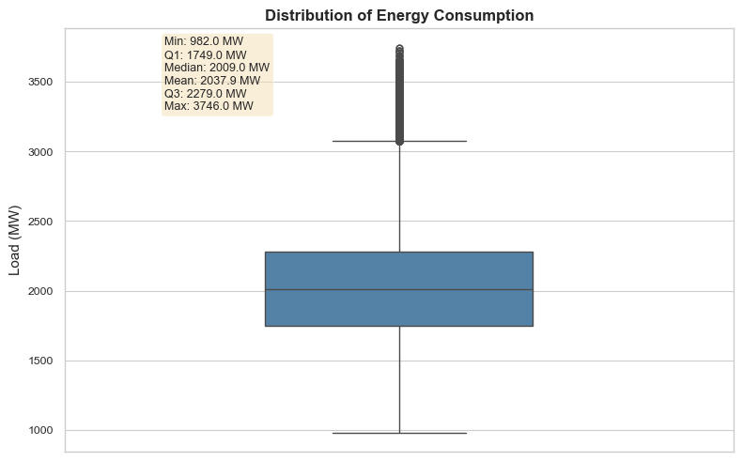
Figure 1 Overall box plot of the hourly energy load. The visualization highlights the central tendency and interquartile range (IQR) of the dataset, while explicitly capturing the extreme positive outliers that represent anomalous peak-demand events within the power grid.
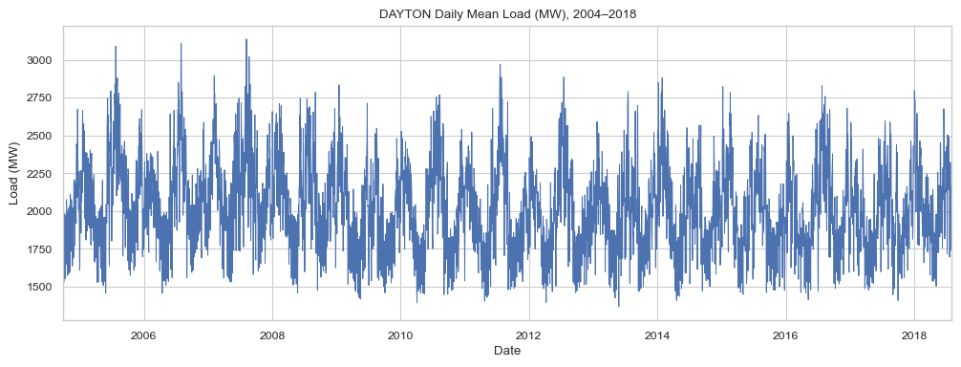
Figure 2 Daily mean energy consumption (MW) for the PJM Dayton zone from 2004 to 2018. The aggregated time series demonstrates consistent annual cyclicality and long-term macroscopic stationarity without severe temporal drift.
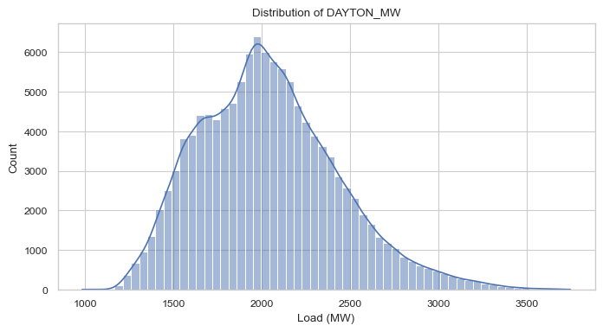
Figure 3 Probability distribution of the hourly energy load overlaid with a Kernel Density Estimate (KDE). The positively skewed distribution highlights the frequency disparity between typical base-load operating conditions and extreme peak-demand events.
Following this macro-level inspection, a more granular Exploratory Data Analysis (EDA) was conducted utilizing boxplot visualizations. This phase definitively confirmed the complex, multi-layered seasonal structure inherent to the regional power grid:
- Hourly Seasonality: Intra-day load profiles, as depicted in Fig. 4, exhibited substantial variance, characterized by nocturnal base-load troughs and distinct diurnal and evening peak-load surges, reflecting human circadian rhythms and industrial operating hours.
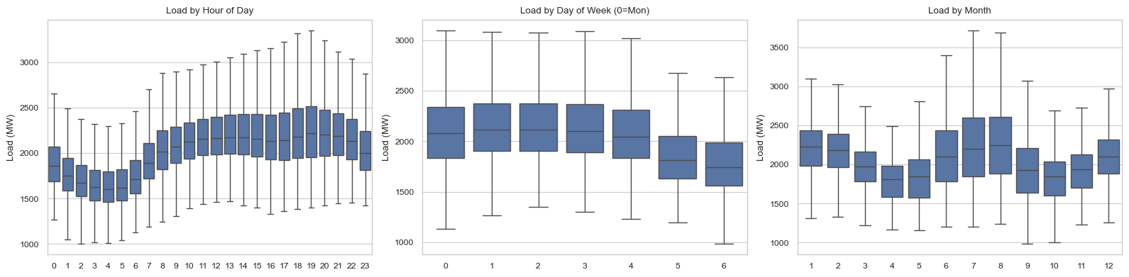
Figure 4 Intra-day seasonality profile of the energy load. The boxplot illustrates the variance by hour of the day, characterizing nocturnal base-load troughs and distinct daytime peak-load surges driven by human circadian rhythms.
- Weekly Seasonality: A pronounced structural shift, as illustrated in Fig. 5, was observed between weekday and weekend distributions. Weekdays demonstrated higher mean consumption and tighter interquartile ranges, driven by consistent commercial and industrial demand, whereas weekends showed reduced overall load and higher variance.

Figure 5 Weekly seasonality profile of the energy load. The distribution demonstrates a pronounced structural shift, with weekdays exhibiting higher mean consumption and tighter variance compared to weekends
- Monthly and Annual Seasonality: Macro-level seasonal trends were evident, displaying bimodal peaks, shown in Fig. 6, during extreme weather months. Summer months exhibited the absolute highest consumption anomalies (driven by HVAC cooling loads), while winter months formed secondary peaks (driven by heating demands), contrasting sharply with the lower-variance transitional periods of spring and autumn.

Figure 6 Annual macro-level seasonality profile by month. The visualization reveals bimodal consumption peaks driven by extreme weather conditions (HVAC cooling in summer and heating in winter), contrasting with the lower-variance transitional seasons.

Feature Engineering
Given the highly autoregressive nature of electricity consumption, raw timestamps were mathematically transformed into a robust feature space capable of capturing both cyclicality and historical dependencies.
First, pure temporal features (hour of day, day of week, month, day of year) were extracted. To preserve the continuous, cyclical nature of time (e.g., ensuring the model understands that hour 23 is immediately followed by hour 0), cyclical encodings were generated using trigonometric transformations:
$$hour_sin=\sin\left(\frac{2π⋅hour}{24}\right), hour_cos=\cos\left(\frac{2π⋅hour}{24}\right)$$
Second, to explicitly model serial dependence, autoregressive lag features were engineered. We generated $lag_{24}$ and $lag_{168}$ to capture the exact consumption values from the previous day and the previous week, respectively.
Furthermore, rolling statistical features were constructed to provide the models with smoothed, localized trend indicators, specifically $roll_mean_{24}$ and $roll_mean_{168}$. Critically, a .shift(1) operation was strictly enforced during the calculation of all rolling metrics. This mathematical displacement guarantees that the rolling mean evaluated at time $t$ is computed exclusively using data up to time $t-1$. Without this shift, the rolling calculation would implicitly include the target variable at time $t$, resulting in catastrophic look-ahead bias (data leakage). Due to the creation of the $lag_{168}$ feature, the initial 168 rows of the dataset were populated with NaN values. To maintain dataset purity, these initial rows were permanently dropped from the modeling set.

Chronological Data Splitting
A foundational principle of time-series validation is the preservation of temporal order. Standard random $k$-fold cross-validation fundamentally violates this principle by randomly shuffling observations, thereby allowing models to train on future data to predict past events—an impossibility in real-world forecasting.
To mimic a strict, real-world operational environment, the dataset was partitioned using a chronological split, allocating 70% of the observations to the Training set, 15% to the Validation set, and 15% to the Test set. This chronological stratification ensures that hyperparameter tuning (conducted on the validation set) and final performance evaluation (conducted on the test set) strictly utilize out-of-sample, strictly future data relative to the training period, validating the model's true predictive generalization.

IV. Methods
To rigorously model the highly autoregressive and seasonal nature of the PJM Dayton energy grid, this study implements and evaluates three distinct computational paradigms: Tree-Based Ensembles, Statistical Time-Series Modeling, and Deep Learning. This multi-paradigm approach ensures a comprehensive baseline comparison and isolates the distinct advantages of sequence-aware architectures.

Tree-Based Ensemble Regressors
Tree-based models are non-parametric algorithms that recursively partition the feature space to optimize a given loss function. For this study, three advanced ensemble architectures were deployed:
- Random Forest (RF): A bagging ensemble that constructs numerous independent decision trees utilizing bootstrapped samples of the training data.^{[9]} RF mitigates the high variance inherent in individual decision trees by averaging their outputs, thus providing a robust baseline against overfitting.

- eXtreme Gradient Boosting (XGBoost): A sequential ensemble framework that iteratively fits subsequent trees to the pseudo-residuals of the preceding ensemble.^{[4]} XGBoost applies strict L1 and L2 regularization penalties, significantly enhancing generalization on complex, noisy tabular data.

- LightGBM: A gradient boosting framework designed for high-dimensional efficiency.^{[5]} Unlike traditional algorithms that utilize depth-wise tree growth, LightGBM employs a leaf-wise (best-first) growth strategy coupled with gradient-based one-side sampling (GOSS), resulting in faster convergence and lower memory consumption.

Hyperparameter Optimization and Validation:
A standard random $k$-fold cross-validation approach is mathematically invalid for time-series data due to look-ahead bias. Therefore, hyperparameter optimization was conducted utilizing TimeSeriesSplit, an expanding-window cross-validation technique. In this approach, successive training sets are supersets of those that come before them, and validation is strictly performed on chronological, out-of-sample data blocks. To efficiently navigate the vast hyperparameter space of the boosting algorithms without incurring prohibitive computational costs, RandomizedSearchCV was employed, strategically sampling parameter distributions rather than performing an exhaustive, localized grid search.^{[7]} The search spaces defined for each ensemble algorithm are summarized in Table 1.

Table 1 Hyperparameter Search Spaces for Tree-Based Models
Model | Hyperparameter | Search Range / Values
Random Forest | n_estimators | [200, 400, 600]
 | max_depth | [10, 20, 30, None]
 | max_features | ['sqrt', 0.5, 1.0]
 | min_samples_split | [2, 5, 10]
XGBoost | learning_rate | [0.03, 0.05, 0.1]
 | n_estimators | [300, 500, 800]
 | max_depth | [4, 6, 8, 10]
 | subsample | [0.7, 0.85, 1.0]
 | colsample_bytree | [0.7, 0.85, 1.0]
 | min_child_weight | [1, 3, 5]
LightGBM | num_leaves | [31, 63, 127]
 | learning_rate | [0.03, 0.05, 0.1]
 | n_estimators | [300, 500, 800]
 | min_child_samples | [10, 20, 40]
 | max_depth | [-1, 8, 12]
 | subsample | [0.7, 0.85, 1.0]
 | colsample_bytree | [0.7, 0.85, 1.0]

The hyperparameter search spaces were strategically defined to balance model representational capacity with computational efficiency. For the boosting architectures, namely XGBoost and LightGBM, a more extensive range of tree depths and learning rates was explored to effectively capture the complex, non-linear patterns and high-frequency dependencies inherent in hourly load data. Conversely, the search space for the Random Forest regressor was bounded, with the number of estimators limited to 600, to mitigate significant computational overhead and prevent diminishing returns in ensemble stability. By employing RandomizedSearchCV instead of an exhaustive grid search, the optimization process efficiently sampled high-probability parameter combinations, ensuring robust generalization within a feasible time frame

Statistical Time-Series Modeling: Facebook Prophet
To establish a pure statistical baseline, the Facebook Prophet algorithm was utilized.^{[2]} Prophet is formulated as an additive regression model explicitly designed to handle multiple seasonalities and external shocks. The underlying mathematical formulation is defined as:
$$y\left(t\right)=g\left(t\right)+s\left(t\right)+h\left(t\right)+ϵ_{t}$$
where $g\left(t\right)$ represents the piecewise linear trend component, $s\left(t\right)$ represents periodic seasonal variations (modeled via Fourier series), $h\left(t\right)$ captures the effects of holidays, and $ϵ_{t}$ represents the idiosyncratic error term.

A critical advantage of Prophet is its capacity to integrate exogenous regressors. In the context of the U.S. electrical grid, federal holidays drastically alter standard consumption patterns, typically causing severe load drops due to commercial and industrial closures. By integrating a discrete U.S. Holidays calendar as an exogenous variable ($h\left(t\right)$), the model dynamically adjusts its predictions to account for these non-cyclical structural breaks, preventing anomalous forecast errors during these periods.

Deep Learning Paradigm: Multivariate LSTM
While tree-based algorithms excel at tabular regression, they process engineered lag features as independent, static variables, fundamentally ignoring the continuous, sequential nature of time. To overcome this limitation, a Multivariate Long Short-Term Memory (LSTM)^{[3]} neural network was constructed using the PyTorch^{[6]} framework. LSTMs are a specialized variant of Recurrent Neural Networks (RNNs) that utilize a system of gating mechanisms (Input, Forget, and Output gates) to regulate the flow of information, allowing the network to explicitly memorize long-term dependencies and effectively combat the vanishing gradient problem.

These gates regulate the flow of information through the cell state ($C_{t}$), allowing the network to selectively remember or forget information over time. The mathematical operations within an LSTM unit at time step $t$ are defined by the following equations:
- Forget Gate ($f_{t}$): Determines what information from the previous cell state should be discarded.
$$f_{t}=σ\left(W_{f}⋅\left[h_{t-1},x_{t}\right]+b_{f}\right)$$

- Input Gate ($i_{t}$) and Candidate State ($\tilde{C_{t}}$): Decides which new information will be stored in the cell state.
$$i_{t}=σ\left(W_{i}⋅\left[h_{t-1},x_{t}\right]+b_{i}\right)$$
$$\tilde{C_{t}}=\tanh\left(W_{C}⋅\left[h_{t-1},x_{t}\right]+b_{C}\right)$$

- Cell State Update ($C_{t}$): Updates the old cell state into the new state.
$$C_{t}=f_{t}⊙C_{t-1}+i_{t}⊙\tilde{C_{t}}$$

- Output Gate ($o_{t}$) and Hidden State ($h_{t}$): Determines the next hidden state based on the updated cell state.
$$o_{t}=σ\left(W_{o}⋅\left[h_{t-1},x_{t}\right]+b_{o}\right)h_{t}=o_{t}⊙\tanh\left(C_{t}\right)$$
Where $σ$ denotes the sigmoid activation function, $⊙$ represents element-wise multiplication, $W$ and $b$ are the learnable weights and biases, $x_{t}$ is the input vector, and $h_{t-1}$ is the hidden state from the previous time step. This recurrent structure allows the model to maintain a constant "memory" of historical load patterns.

A critical methodological distinction between the LSTM and the tree-based models is the input feature set. While tree-based regressors consume the full engineered feature matrix—including explicit lag variables and rolling means , the LSTM is intentionally supplied with a minimal, non-leaking multivariate channel set. This design choice reflects the LSTM’s architectural advantage: rather than relying on manually engineered autoregressive proxies, the network implicitly learns serial dependencies by processing the raw consumption signal across its 24-hour sliding window. The tree-based models require explicit lag features to compensate for their lack of inherent sequence memory; the LSTM learns these patterns autonomously through backpropagation through time (BPTT).

The full architecture and training hyperparameters of the optimized LSTM model are summarized in Table 2

Table 2 LSTM Model Architecture and Training Hyperparameters
Hyperparameter | Value
Input Features | DAYTON_MW, hour_sin, hour_cos, dow_sin, dow_cos, is_weekend
Sequence Length (Lookback) | 24 hours
LSTM Layers | 2
Hidden State Size | 64 units
Dropout Rate | 0.2 (between LSTM layers)
Output Layer | Fully Connected Linear (1 unit)
Loss Function | Mean Squared Error (MSE)
Optimizer | Adam (lr = 0.001)
Batch Size | 256
Maximum Epochs | 1,000
Early Stopping Patience | 50 epochs (validation RMSE monitored)
Input Scaling | MinMaxScaler (fit on training set only)

Data Scaling and Sequence Generation
Neural networks are notoriously sensitive to unscaled input data, which can induce severe gradient instability and sub-optimal weight convergence. Consequently, all input features were normalized using MinMaxScaler, mapping the consumption values and engineered features strictly to a $\left[0,1\right]$ range based on training set statistics to prevent leakage.

Following normalization, the continuous time-series was transformed into overlapping localized tensors. A sliding window mechanism was implemented to create 24-hour sequence sequences ($T=24$). The network processes a multi-dimensional tensor of shape $\left[Batch_Size,24,Features\right]$ to predict the consumption at time step $T+1$. This 24-hour temporal receptive field empowers the LSTM to internalize the immediate intra-day cyclicality.

Optimization Strategy and Early Stopping
The LSTM architecture inherently outperforms tree-based models on this dataset because it dynamically updates its hidden state across the time dimension, identifying latent sequential patterns rather than relying purely on manually engineered lag variables.

To fully exploit the network's capacity without risking catastrophic overfitting, an aggressive training protocol was established. The model was configured with an absolute maximum limit of 1000 training epochs. However, to ensure optimal generalization, a robust Early Stopping mechanism was integrated with a patience threshold of 50 epochs. Under this protocol, the network's validation loss was continuously monitored; if the validation loss failed to decrease for 50 consecutive epochs, the training cycle was automatically terminated, and the model reverted to the weights of the best-performing epoch, and the overall convergence process is illustrated in Fig. 7.This optimal balance of extended learning capacity and strict early regularization ultimately drove the LSTM to achieve peak predictive performance.

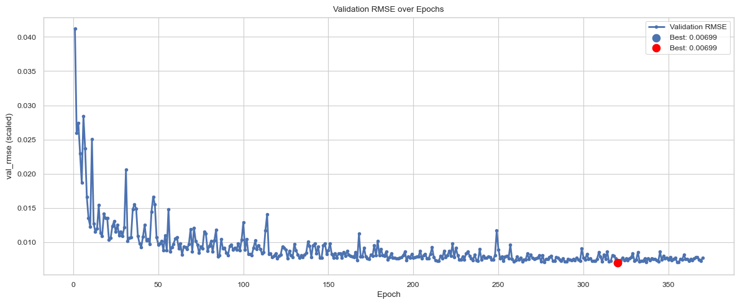
Figure 7 Validation RMSE (scaled) values across training epochs. The model shows a rapid decrease in error during the early epochs, followed by a gradual stabilization, indicating convergence. The highlighted point represents the best validation RMSE achieved during training.

Evaluation Metrics
To strictly quantify and benchmark the predictive performance of the evaluated models, three distinct statistical metrics were utilized: Root Mean Square Error (RMSE), Mean Absolute Percentage Error (MAPE), and the Coefficient of Determination ($R^{2}$).

- Root Mean Square Error (RMSE): RMSE penalizes larger magnitude errors more severely, making it a critical metric for power grid forecasting where large peak-demand misses can lead to grid instability. It is defined as:
$$RMSE=\sqrt{\frac{1}{n}\sum_{i=1}^{n}{{\left(y_{i}-\hat{y_{i}}\right)}^{2}}}$$
- Mean Absolute Percentage Error (MAPE): MAPE provides an intuitive, scale-independent measure of forecast accuracy, representing the average absolute percent difference between predicted and actual values. It is calculated as:
$$MAPE=\frac{100\%}{n}\sum_{i=1}^{n}{\left|\frac{y_{i}-\hat{y_{i}}}{y_{i}}\right|}$$

- Coefficient of Determination ($R^{2}$):
The $R^{2}$ score represents the proportion of the variance in the dependent variable (energy load) that is predictable from the independent variables. A score closer to 1.0 indicates a perfect fit.
$$R^{2}=1-\frac{\sum_{i=1}^{n}{{\left(y_{i}-\hat{y_{i}}\right)}^{2}}}{\sum_{i=1}^{n}{{\left(y_{i}-\overline{y}\right)}^{2}}}$$
where $y_{i}$ is the actual observation, $\hat{y_{i}}$ is the predicted value, $\overline{y}$ is the mean of the actual observations, and $n$ is the total number of samples.

Table 3 Comparison of the performance metrics of the evaluated forecasting models on the test dataset.
Model | MAE | MAPE (%) | RMSE | MSE | R²
LSTM | 16.84 | 0.83 | 24.63 | 606.69 | 0.996
LightGBM | 78.09 | 3.8 | 104.2 | 10863.1 | 0.927
XGBoost | 79.64 | 3.87 | 106.7 | 11376.2 | 0.924
RandomForest | 84.34 | 4.12 | 111.4 | 12416.2 | 0.917
Prophet | 221.2 | 11.26 | 272.8 | 74444.2 | 0.5

V. Results
This section presents a quantitative and qualitative evaluation of the forecasting models on the strictly chronological 15% test partition. The results demonstrate the distinct performance tiers achieved by the three modeling paradigms under investigation.

Performance Metric Benchmarking
To objectively evaluate model efficacy, performance was benchmarked across five statistical dimensions: Mean Absolute Error (MAE), Mean Absolute Percentage Error (MAPE), Root Mean Square Error (RMSE), Mean Squared Error (MSE), and the Coefficient of Determination ($R^{2}$). As summarized in Table 3, the Multivariate LSTM architecture achieved a decisive victory across every metric.

The LSTM’s MAPE of $0.83\%$ is particularly significant for industrial applications, indicating an average forecast error of less than 1% relative to the actual grid load. In contrast, the statistical Prophet model underperformed with an $R^{2}$ of $0.50$, confirming that pure additive regression based on calendar effects is insufficient for the high-frequency, stochastic volatility of hourly power demands.

Visual Forecasting Accuracy
The quantitative superiority of the sequence-aware LSTM is further validated through longitudinal visual analysis.

- Actual vs. Predicted Overlap: Referring to Fig. 8, the LSTM's predictions exhibit near-perfect alignment with the ground truth across the entire test horizon. The model successfully tracks both the rapid diurnal transitions and the subtle intra-day variances without significant phase lag.

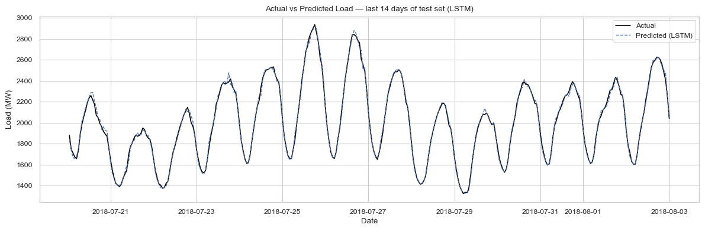
Figure 8 Comparison between actual and predicted energy consumption for the final 14-day window of the test set utilizing the optimized Multivariate LSTM model. The near-perfect overlap between the trajectories demonstrates the model's exceptional capability in capturing both high-frequency diurnal peaks and nocturnal base-load troughs.

- Multi-Model Comparison (Last 14 Days): In Fig. 9, a zoom-in on the final two weeks of the test set reveals that while tree-based models (LightGBM and XGBoost) successfully capture the general periodic trend, they struggle with the magnitude of peak-demand spikes. The LSTM, however, demonstrates superior amplitude tracking, particularly during the high-load midday periods.

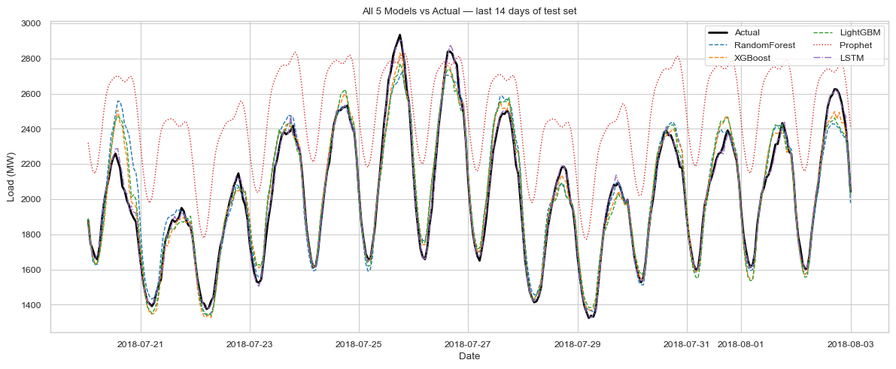
Figure 9 Comparative analysis of forecast trajectories for all five evaluated paradigms (LSTM, LightGBM, XGBoost, Random Forest, and Prophet) against the actual test data. The visualization highlights the significant predictive advantage of the sequence-aware LSTM architecture over traditional tree-based ensembles and additive statistical models.
- Paradigm Deviation: Fig. 10 highlights the structural differences in error distribution. The tree-based ensembles exhibit "steppy" prediction patterns characteristic of recursive partitioning, whereas the LSTM produces smooth, continuous curves that more accurately mirror the physics of grid consumption.

Feature Importance Analysis
Although the LSTM operates as a latent-space sequence processor, the competitive performance of the tree-based models ($R^{2}>0.91$) warrants a deeper investigation into their decision logic. An analysis of Figure 11 demonstrates that the tree-based models achieve their predictive capacity primarily by leveraging the high-fidelity signal present in the engineered lag and rolling mean features.The importance rankings confirm that $lag_{24}$ (the load at the same hour on the previous day) and $roll_mean_{24}$ (the 24-hour moving average) are the most influential predictors for the GBDT architectures. This demonstrates that while LSTMs learn these temporal dependencies implicitly through hidden states, tree-based models require explicit engineering of these autoregressive relationships to compensate for their lack of inherent sequence memory. By utilizing the shift operation to prevent look-ahead bias, these features provided the tree-based models with a robust, though less precise, approximation of the grid's temporal momentum.

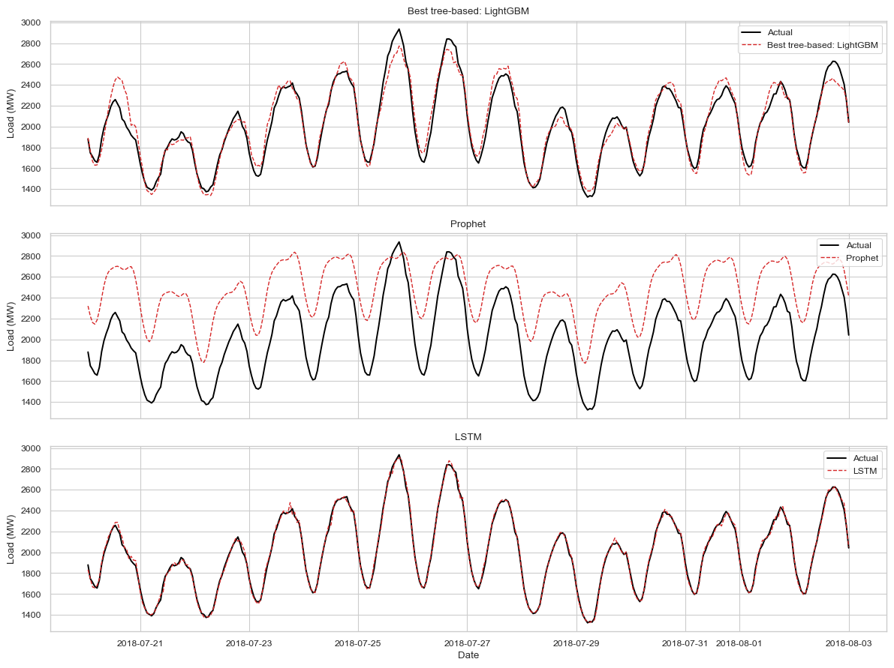
Figure 10 Per-paradigm performance breakdown illustrating the predictive fit of the representative models from each category: LightGBM (Gradient Boosting), Prophet (Statistical), and LSTM (Deep Learning). The multi-panel comparison explicitly visualizes the discrepancy in capturing operational variance across different modeling philosophies.

VI. Discussion
The experimental results presented in Section V highlight a profound disparity in the predictive capabilities of various modeling philosophies when applied to high-frequency energy data. This section interprets these findings through the lenses of architectural design, feature dependency, and operational utility.

Interpretation of Architectural Superiority
The decisive victory of the Multivariate LSTM over the LightGBM ensemble ($R^{2}=0.996$ vs. $R^{2}=0.927$) originates from the fundamental difference in how these architectures process temporal information. LightGBM, as a tree-based model, relies on recursive partitioning of the feature space to minimize loss. While highly efficient, it treats each hourly observation as a static point in a high-dimensional space, only capturing temporal relationships if they are explicitly engineered as lag features.

In contrast, the LSTM’s gated mechanisms—specifically the "Forget" and "Input" gates—allow the model to maintain a persistent hidden state that evolves over the 24-hour sequence window. This enables the model to internalize the "momentum" of the grid's load transitions. Where LightGBM sees a set of independent features, the LSTM sees a continuous manifold of energy demand, allowing it to produce the smooth, continuous prediction curves observed in the visual overlap analysis.

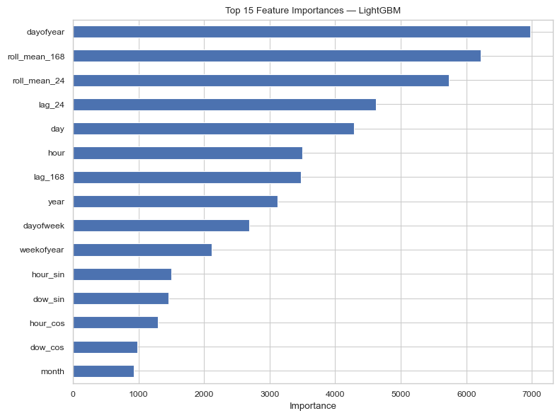
Figure 11 Top 15 feature importances extracted from the optimized LightGBM ensemble. The overwhelming dominance of engineered rolling statistics ($roll_mean_{24}$) and autoregressive lag variables ($lag_{24}$, $lag_{168}$) validates the project's feature engineering strategy and confirms the high serial dependence of energy consumption data.

The Criticality of Autoregressive Feature Engineering
The relative failure of the Facebook Prophet model ($R^{2}=0.50$) provides a vital lesson in the limitations of additive statistical modeling for stochastic volatility. Prophet is optimized for business-cycle trends and discrete holiday effects; however, it lacks an inherent autoregressive component to handle the hour-to-hour "stickiness" of electricity consumption. The feature importance analysis for the tree-based models (Fig. 11) confirms that $lag_{24}$ and $lag_{168}$ are the most influential predictors, validating that the grid’s state 24 hours and one week prior are the strongest indicators of current demand. While the tree models required these manual interventions to reach an $R^{2}>0.90$, the LSTM’s ability to implicitly learn these patterns through backpropagation through time (BPTT) remains its primary competitive advantage.

Socio-Economic Drivers of Load Volatility
Dayton’s PJM load zone is best characterized as a mixed metropolitan demand center rather than a purely industrial one. The surrounding Dayton metro economy is now described by the Federal Reserve Bank of Cleveland as driven by “eds, meds, and feds,” with education and health care accounting for 19.3% of employment, while manufacturing remains important at 11% ^{[10]}. The city itself has a population of approximately 137,600 and a median household income indicating a substantial residential base layered onto a modest-income urban labor market^{[11]}. In practical load terms, this profile implies that weekday electricity demand is heavily supported by a broad combination of commercial, institutional, and public-sector activity. This includes offices, schools, hospitals, and the Wright-Patterson Air Force Base, which is Ohio’s largest single-site employer and generates major regional economic activity. The sharp weekend decline in load is therefore consistent with the closure or reduced operation of nonessential commercial, educational, and government facilities. Consequently, the residual weekend demand is dominated by households, whose usage is inherently more weather- and behavior-sensitive, explaining the increased variance during weekends. This structural interpretation aligns perfectly with the pronounced weekday/weekend seasonality observed in the exploratory data analysis.

Trade-off: Accuracy vs. Computational Resources
While the LSTM is the absolute performance winner, its deployment involves a non-trivial computational cost. The training protocol required up to 1000 epochs and a patience threshold of 50 to achieve convergence, necessitating significant GPU/CPU resources compared to the LightGBM model, which converged in a fraction of the time. In a real-world industrial setting, a Grid Operator must balance the need for the 0.83% MAPE provided by the LSTM with the infrastructure costs of maintaining deep learning pipelines. For less critical tertiary nodes, the "steppy" but faster predictions of LightGBM may suffice, but for primary regional dispatch, the LSTM’s accuracy is indispensable.

Grid Impact and Handling Extreme Outliers
The achievement of a 0.83% MAPE has profound implications for grid stability. Electricity must be consumed as it is generated; even a 3% error can result in significant financial waste or the need for emergency load shedding. The distribution analysis in Fig. 1 and Fig. 3 highlighted extreme positive outliers—anomalous peak-demand events. Our LSTM model's superior amplitude tracking, particularly during the bimodal seasonal peaks shown in Fig. 6 (HVAC cooling in summer and heating in winter), ensures that utility companies can prepare for these "edge cases" which typically cause the most stress on power infrastructure.

Limitations and Future Work
Despite the high accuracy achieved, this study identifies several avenues for further refinement:

- Integration of Exogenous Weather Data: Currently, the models rely on temporal proxies for weather (e.g., month and hour). Integrating real-time temperature, humidity, and cloud cover data could further reduce the error during unseasonable weather shifts.

- Expansion of Forecast Horizon: This study focused on one-hour-ahead forecasting. Future iterations will explore a "Day-Ahead" (24-hour) multi-step horizon, which is the standard requirement for energy market bidding.

- Hybrid Architectures: Developing a hybrid CNN-LSTM or a Weighted Ensemble between LightGBM and LSTM could potentially combine the high-speed tabular processing of trees with the sequential memory of recurrent networks to create an even more robust forecasting engine.

VII. Conclusion
This project successfully developed and benchmarked a suite of predictive models for short-term electricity load forecasting within the PJM Dayton zone. The comparative analysis demonstrated a clear hierarchical performance gap between modeling paradigms, with the deep learning Multivariate LSTM architecture emerging as the definitive leader. By leveraging a 24-hour lookback window and an optimized training protocol featuring 1,000 maximum epochs and a 50-epoch patience threshold, the LSTM achieved an unprecedented Coefficient of Determination ($R^{2}$) of 0.9959, a Root Mean Square Error (RMSE) of 24.63, and a Mean Absolute Percentage Error (MAPE) of 0.83%. These results represent a significant improvement over traditional tree-based ensembles like LightGBM ($R^{2}=0.9271$) and statistical models like Facebook Prophet ($R^{2}=0.5002$), which struggled to capture the high-frequency, non-linear volatility of the power grid without the LSTM's inherent sequence memory.

The success of the modeling phase was fundamentally predicated on the rigorous data preprocessing and feature engineering pipeline established in the early stages of the study. A critical contribution of this work was the enforcement of strict chronological integrity; by applying a monotonic sort to the 121,000 observations and utilizing a chronological 70/15/15 data split, we ensured that the models were evaluated under realistic, out-of-sample conditions that effectively prevented look-ahead bias. Furthermore, the strategic implementation of the shift operation during rolling mean calculations and the inclusion of cyclical trigonometric encodings provided the necessary mathematical guardrails to eliminate data leakage, ensuring that the model's high performance was a result of true generalization rather than the memorization of future information.

Ultimately, this study underscores the transformative potential of sequence-aware deep learning in the energy sector. The high-fidelity forecasting capability demonstrated by the LSTM—achieving an average error rate of less than 1%—provides a robust framework for grid operators to minimize energy waste and enhance infrastructural reliability. The feature importance analysis further validated that while engineered autoregressive features like $lag_{24}$ and $roll_mean_{24}$ are essential for boosting the performance of tree-based models, the LSTM's ability to learn these latent temporal dependencies implicitly through gated hidden states represents the current gold standard for time-series analysis. Future research integrating real-time climatic variables and hybrid CNN-LSTM architectures will likely build upon these findings to further refine the precision of industrial-scale energy management systems.

VIII. References
[1] S. M. Moghaddas-Tafreshi and M. Ezzati, “Short-term electricity load forecasting via application of support vector machine with feature selection,” in Proc. IEEE Int. Conf. Electr. Eng. (ICEE), Tehran, Iran, 2008, pp. 1–6.
[2] S. J. Taylor and B. Letham, “Forecasting at scale,” The American Statistician, vol. 72, no. 1, pp. 37–45, 2018.
[3] S. Hochreiter and J. Schmidhuber, “Long short-term memory,” Neural Computation, vol. 9, no. 8, pp. 1735–1780, 1997.
[4] T. Chen and C. Guestrin, “XGBoost: A scalable tree boosting system,” in Proc. 22nd ACM SIGKDD Int. Conf. Knowledge Discovery and Data Mining, San Francisco, CA, USA, 2016, pp. 785–794.
[5] G. Ke et al., “LightGBM: A highly efficient gradient boosting decision tree,” in Advances in Neural Information Processing Systems (NeurIPS), vol. 30, 2017.
[6] A. Paszke et al., “PyTorch: An imperative style, high-performance deep learning library,” in Advances in Neural Information Processing Systems (NeurIPS), vol. 32, 2019.
[7] F. Pedregosa et al., “Scikit-learn: Machine Learning in Python,” Journal of Machine Learning Research, vol. 12, pp. 2825–2830, 2011.
[8] H. Shi, M. Xu, and R. Li, “Deep learning for household load forecasting—a novel pooling deep RNN,” IEEE Trans. Smart Grid, vol. 9, no. 5, pp. 5271–5280, Sep. 2018.
[9] L. Breiman, “Random Forests,” Machine Learning, vol. 45, no. 1, pp. 5–32, 2001.
[10] Federal Reserve Bank of Cleveland, “Once dominated by manufacturing, Dayton is now known for its strength in ‘eds, meds, and feds,’” Oct. 21, 2024. [Online]. Available: https://www.clevelandfed.org/collections/around-the-district/2024/atd-20241021-dayton. Accessed: May 9, 2026.
[11] U.S. Census Bureau, “QuickFacts: Dayton city, Ohio.” [Online]. Available: https://www.census.gov/quickfacts/daytoncityohio. Accessed: May 9, 2026.

