A Comparative Analysis of Lexical and Deep Learning Models for Turkish Social Media Sentiment Analysis

Talha Yılmaz
DSAI 302 Capstone Project
MEF University
yilmazta@mef.edu.tr

I. Executive Summary
This study presents a comprehensive comparative evaluation of four distinct computational methodologies for binary sentiment classification in the Turkish language, a morphologically rich and agglutinative language that poses unique challenges to traditional Natural Language Processing (NLP) pipelines. Utilizing a corpus of 11,006 cleaned social media comments, this research addresses critical data engineering obstacles, including the correction of "Mojibake" encoding corruption and the implementation of advanced morphological analysis via the Zemberek library. The experimental framework contrasts a sparse lexical baseline (TF-IDF + LinearSVC), a deep learning architecture trained from scratch (Bi-LSTM), and two state-of-the-art pre-trained transformer models (BERTurk and ELECTRA-Base-Turkish). Quantitative results on the held-out test partition indicate that transformer-based models significantly outperform traditional methods, with ELECTRA-Base-Turkish achieving the highest performance (91.58% accuracy and 91.51% Macro-F₁ score). The findings reveal that while lexical baselines remain competitive, contextual sub-word embeddings and pre-trained linguistic knowledge are essential for navigating the complexities of Turkish sentiment, particularly in instances involving sarcasm and informal slang. This study contributes a robust pipeline for Turkish NLP and provides empirical evidence regarding the trade-offs between architectural depth, pre-training objectives, and dataset scale.

II. Introduction

The proliferation of Web 2.0 technologies and social media platforms has led to an exponential increase in user-generated content, producing massive volumes of unstructured textual data. Extracting actionable intelligence from this data has established Sentiment Analysis (SA)—or opinion mining—as a cornerstone of modern Natural Language Processing (NLP). While SA methodologies have been extensively researched and optimized for English, applying these computational techniques to morphologically rich and agglutinative languages, such as Turkish, remains a significant academic and practical challenge.
The Turkish language relies heavily on complex suffixation, wherein a single root word can take on dozens of inflected forms to convey varied grammatical and semantic nuances. In sentiment classification, traditional suffix-stripping and stemming algorithms often destroy the semantic polarity of agglutinative words, necessitating advanced, context-aware morphological analysis to accurately recover root meanings. Furthermore, social media corpora present severe data engineering challenges. Datasets frequently suffer from character encoding corruption (Mojibake), alongside a high prevalence of informal slang, colloquialisms, and non-standard syntax, all of which degrade the performance of standard NLP pipelines.
To address these challenges, this study presents a robust data engineering pipeline and empirically evaluates four distinct computational paradigms for binary sentiment classification (Pozitif vs. Negatif) on a Turkish social media dataset. By contrasting methodologies that range from sparse lexical machine learning to sample-efficient deep learning, this paper aims to quantify the impact of architectural depth and pre-trained linguistic knowledge on classification performance. Specifically, the performance of the following four models is examined:
- A sparse-lexical baseline utilizing Term Frequency-Inverse Document Frequency (TF-IDF) feature extraction paired with a Linear Support Vector Classifier (LinearSVC).
- A custom deep learning architecture trained entirely from scratch, utilizing randomly initialized embeddings and a two-layer Bidirectional Long Short-Term Memory (Bi-LSTM) network.
- A Masked Language Model (MLM) pre-trained Transformer encoder fine-tuned for sequence classification (BERTurk).
- A Replaced Token Detection (RTD) pre-trained Transformer discriminator fine-tuned for downstream classification (ELECTRA-Base-Turkish).

Linguistic Challenges in Turkish NLP
Turkish belongs to the Turkic language family and is classified as a highly agglutinative language—one in which grammatical relationships are encoded by appending chains of suffixes (morphemes) to a single lexical root, rather than using separate function words as in analytic languages such as English. This morphological architecture creates a theoretically unbounded vocabulary space. To illustrate the scope of this challenge, consider the verb root "sev" (to love). Through the systematic application of Turkish suffix rules, this single root can generate dozens of grammatically valid and semantically distinct surface forms. For instance, "seviyorum" means "I am loving," "sevmiyorum" means "I am not loving," and "sevemeyecektim" means "I would not have been able to love." Each of these forms carries profoundly different emotional polarity—yet they all originate from the same two-character root.

This morphological complexity has a direct and measurable negative impact on standard NLP approaches. Rule-based stemming algorithms, such as the widely used Snowball stemmer, are designed to identify and strip word suffixes to reach an approximate base form. In English, this is generally a safe operation because function words like "not" exist independently. In Turkish, however, the negation morpheme "-me/-ma" is embedded directly within the suffix chain. A stemmer applied to "sevmiyorum" may strip the progressive and person suffixes, arriving at "sevme" or even "sev." If the negation morpheme is also truncated, the residual "sev" not only loses its grammatical inflection but also has its semantic polarity completely reversed—from strongly negative to strongly positive. This phenomenon, termed semantic polarity destruction through over-stemming, is a documented failure mode of surface-level morphological algorithms in agglutinative languages^{[1]}.

Furthermore, Turkish employs vowel harmony, a phonological rule in which suffix vowels must harmonize with the vowels of the root, resulting in multiple allomorphs of the same suffix (e.g., "-ler" and "-lar" are both plural markers depending on the preceding vowel). This multiplicity means that even if a researcher hand-crafted a suffix-stripping dictionary, that dictionary would need to account for every possible vowel-harmonized variant, exponentially increasing its complexity and maintenance burden.

To overcome these architectural limitations, this study integrates the Zemberek NLP library into its preprocessing pipeline. Zemberek is an open-source morphological analyzer and lemmatizer specifically engineered for Turkic languages. Unlike surface-level stemmers, Zemberek performs true dictionary-grounded morphological analysis by parsing each input token against a validated Turkish lexicon and identifying the longest valid root that can be derived after applying reverse morphological rules. This approach preserves the semantic root while correctly discarding grammatical inflections, ensuring that the vocabulary representation fed to downstream machine learning models is both compact and semantically faithful. Academic literature corroborates this choice, demonstrating that Zemberek-based lemmatization consistently yields higher baseline classification accuracy for Turkish text corpora when compared to nave stemming algorithms^{[2]}.

B. Research Objectives and Paper Organization
The remainder of this paper is organized as follows: Section III details the exploratory data analysis and the implementation of the Turkish-aware preprocessing pipeline. Section IV outlines the theoretical methods, model architectures, and optimization techniques employed in this study. Section V presents the empirical results and evaluation metrics obtained from the test dataset. Section VI provides a comprehensive discussion of the findings, including an error analysis of misclassified samples and potential avenues for future work. Finally, Section VII concludes the paper.

III. Data Analysis and Data Preprocess

Dataset Statistics and Exploratory Data Analysis
The primary corpus utilized in this study comprised 11,120 Turkish social media comments initially labeled for binary sentiment classification (Pozitif and Negatif). To ensure data integrity, a stringent filtering mechanism was applied to remove duplicate entries and noisy or neutral instances, reducing the working corpus to a refined set of 11,006 instances. This filtered corpus was subsequently partitioned into training (70%), validation (15%), and test (15%) splits, yielding 7,704 training, 1,651 validation, and 1,651 test instances, respectively.

Exploratory Data Analysis (EDA) was subsequently conducted to quantify the class distribution and sequence length parameters. The class distribution analysis, illustrated in Fig. 1, revealed a slight but non-trivial imbalance, with the dataset containing 6,065 Pozitif instances (55.11%) and 4,941 Negatif instances (44.89%), yielding an imbalance ratio of 1.23:1.

In binary classification tasks, standard accuracy metrics can be highly misleading when applied to skewed distributions—a degenerate classifier that always predicts the majority class would achieve 55.11% accuracy without learning any discriminative patterns. This empirical imbalance therefore justifies the primary adoption of the Macro-F₁ score as the definitive evaluation metric for all comparative analyses in this study, ensuring that the predictive performance across both the majority and minority class are weighted equally.

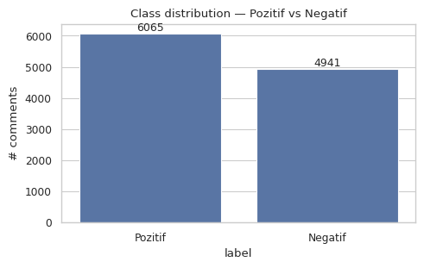
Figure 1 Class Distribution — Pozitif (6,065) vs. Negatif (4,941) Comments
A sentence-length distribution analysis was subsequently performed on the raw, pre-processed corpus to optimize input tensor dimensions for downstream deep learning and transformer models. As illustrated in Fig. 2, the distribution of comment lengths is heavily right-skewed for both character and word counts, with the majority of comments concentrated in the 5–15 word range. Tokenization metrics demonstrated that the 95th percentile of comment word counts was approximately 27 words. This empirically derived threshold guided the configuration of the MAX_LEN=64 sequence padding parameter.
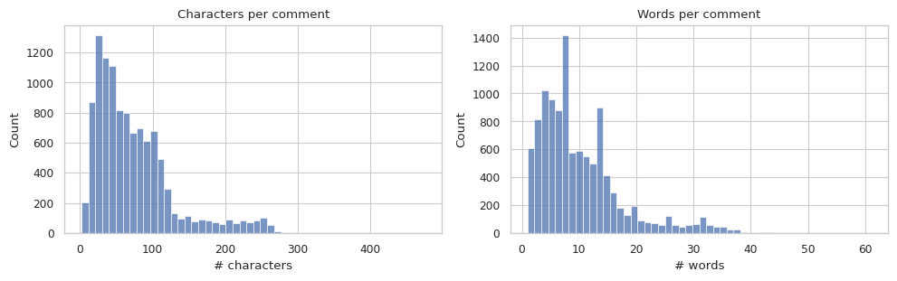
Figure 2 Comment Length Distributions — Characters per Comment (left) and Words per Comment (right)
The MAX_LEN=64 threshold was deliberately set at 64 sub-word tokens rather than 27 raw words for the following reason: sub-word tokenization strategies employed by transformer models (WordPiece for BERTurk, SentencePiece for ELECTRA) decompose rare or morphologically complex tokens into multiple smaller sub-word units. Given Turkish’s agglutinative nature, a single surface word may fragment into 2–3 sub-word tokens during transformer tokenization. Setting MAX_LEN=64 therefore ensures that the true 95th-percentile content is covered even after sub-word fragmentation, guaranteeing that the vast majority of semantic context is preserved while strictly capping GPU memory allocation during tensor operations.

Encoding Recovery and Noise Reduction
Social media text inherently suffers from severe data engineering challenges, the most critical of which in this corpus was widespread "Mojibake" encoding corruption. This degradation resulted from decoding mismatches between Windows-1254 and CP1252 character sets, manifesting as systemic alterations of Turkish characters—for example, the rendering of "ð" instead of "ğ" (g with breve), and "þ" instead of "ş" (s with cedilla). If left unresolved, this corruption would lead to catastrophic lexical feature loss, as morphological boundaries become unrecognizable to any downstream analyzer. To mitigate this, a robust multi-tier fallback loading mechanism was engineered. This protocol evaluated multiple encodings in sequence and applied a deterministic character-mapping dictionary to reconstruct the original UTF-8 Turkish text.
Following encoding recovery, algorithmic noise reduction was executed. Regular Expressions (RegEx) were employed to strip Uniform Resource Locators (URLs), user mentions (@), hashtags, and digits, isolating valid Turkish alphabetical characters. Additionally, standard Python lowercasing functions natively corrupt Turkish text by erroneously mapping the uppercase ‘I’ (dotless I) to the dotted lowercase ‘i’. To preserve lexical accuracy, a custom Turkish-locale-aware lowercasing algorithm was implemented, strictly enforcing the correct mapping of ‘I’ to ‘ı’ (dotless lowercase) and ‘İ’ to ‘i’ (dotted lowercase). Finally, a curated dictionary of approximately 150 Turkish stop words was utilized to filter out semantically null terms and reduce feature space dimensionality.

C. Morphological Analysis via Zemberek
As discussed in Section II-A, the highly agglutinative structure of Turkish requires a morphological analyzer rather than a surface-level stemmer. The Zemberek NLP library was therefore integrated as the core morphological processing component of the pipeline. For each token surviving the noise reduction stage, Zemberek performs a full morphological parse, decomposing the token into its constituent root and affix sequence. The lemma—defined as the canonical dictionary root—is then extracted and retained as the representative feature for the token. This approach ensures that inflected forms such as "evlerde" (in the houses), "evden" (from the house), and "evde" (in the house) all map to the same root representation "ev" (house), substantially reducing vocabulary fragmentation and improving the model’s ability to generalize across morphological variants.

D. Vocabulary Construction and Frequency Filtering
For the custom Bi-LSTM model, a vocabulary was constructed from the lemmatized training corpus. A critical design decision was the application of a minimum frequency threshold: any token appearing fewer than two times (i.e., hapax legomena—words occurring exactly once) in the training set was excluded from the vocabulary and mapped to a special <UNK> (unknown) token. This filtering step is motivated by two complementary objectives. First, hapax legomena are statistically unreliable features; a word seen only once provides insufficient evidence for the model to learn a stable sentiment association, as it may represent a typo, a proper noun, or a highly domain-specific term unlikely to recur in unseen data. Second, by excluding these tokens, the vocabulary was constrained to approximately 5,000–10,000 high-confidence tokens, producing an embedding matrix of manageable size (approximately 0.64M parameters at a 128-dimensional embedding space). This size is large enough to capture semantic similarity structures but small enough to prevent the embedding layer from memorizing the 7,704-row training set through brute-force feature association.

IV. Methods

A. Evaluation Metrics
Given the class imbalance documented in Section III-A, the Macro-averaged F₁ score (Macro-F₁) was adopted as the primary evaluation criterion. Macro-averaging computes each metric independently per class and then takes the unweighted mean, thereby giving equal importance to both the Pozitif and Negatif classes regardless of their frequencies. The formal definitions of the three constituent metrics are provided below. Let C = 2 denote the number of classes, and let TP_c, FP_c, and FN_c denote the true positives, false positives, and false negatives for class c, respectively.
Macro-Precision measures the average proportion of correct positive predictions across all classes:
Precision_macro = (1/C) × Σ_c [ TP_c / (TP_c + FP_c) ]
Macro-Recall measures the average proportion of actual positives correctly identified across all classes:
Recall_macro = (1/C) × Σ_c [ TP_c / (TP_c + FN_c) ]
The Macro-F₁ Score is the harmonic mean of Macro-Precision and Macro-Recall, computed per class and then averaged:
F₁_macro = (1/C) × Σ_c [ (2 × Precision_c × Recall_c) / (Precision_c + Recall_c) ]
The harmonic mean is used instead of the arithmetic mean because it penalizes extreme imbalances between precision and recall; a model that achieves high recall by predicting the positive class for all instances will receive a low F₁ score due to its correspondingly poor precision. This property makes Macro-F₁ a more trustworthy indicator of model quality than accuracy alone in the presence of class imbalance.

B. Lexical Baseline: TF-IDF and Linear Support Vector Classification
As a primary benchmark, a sparse-lexical pipeline was developed utilizing Term Frequency-Inverse Document Frequency (TF-IDF) vectorization. Features were extracted using a range of 1–2 n-grams to capture both individual tokens (unigrams) and short syntactic phrases (bigrams), with sublinear term frequency scaling applied to normalize for document length variance. The sublinear scaling replaces raw term frequency tf with 1 + log(tf), preventing a single highly repeated term from dominating the feature space.
A Linear Support Vector Classifier (LinearSVC) was selected as the classification algorithm. Academic literature consistently identifies LinearSVC as superior to probabilistic generative methods such as Naive Bayes for high-dimensional, sparse text data [3]. The theoretical basis for this advantage lies in the SVM’s discriminative learning objective: rather than modeling the joint probability distribution of features and labels (as Naive Bayes does), LinearSVC directly optimizes the decision boundary by maximizing the geometric margin between classes in the feature space. This property is particularly beneficial for Turkish text data, where vocabulary fragmentation due to morphological diversity produces extremely high-dimensional but sparse feature vectors, a regime in which margin-based classifiers are known to generalize more effectively than density estimators. The model was optimized through 3-fold cross-validation on the training partition, identifying a regularization parameter of C=0.5 as the optimal trade-off between margin maximization and training error minimization.

C. Custom Deep Learning Architecture: Bidirectional LSTM
To evaluate the efficacy of deep learning architectures trained without pre-existing linguistic knowledge, a custom Bidirectional Long Short-Term Memory (Bi-LSTM) network was implemented using the PyTorch framework. The complete set of architectural hyperparameters and their justifications is presented in Table I. The architecture initiates with a 128-dimensional embedding layer, utilizing a designated padding_idx=0 to ensure that padding tokens do not contribute to gradient updates—a technique referred to as pad-leakage prevention. This is followed by a two-layer Bi-LSTM encoder with a hidden state size of 128 per direction.
A critical implementation detail pertains to the sentence representation strategy. Rather than mean-pooling all LSTM output hidden states—which would dilute the representation by averaging over pad timesteps—the model extracts the final hidden state hⁿ of the top LSTM layer for both the forward and backward passes. These two 128-dimensional vectors are then concatenated to produce a 256-dimensional sentence vector, which is then passed through a dropout layer and a fully connected linear head for classification.
The choice of two stacked LSTM layers was deliberate: the first layer captures local morphological patterns and collocations, while the second layer abstracts these local patterns into broader phrase-level sentiment representations. Empirical experimentation confirmed that three or more stacked layers led to overfitting on the 7,704-row training set. Regularization was provided through two dropout mechanisms: a 0.3 inter-layer dropout rate (applied between the two LSTM layers, following Zaremba et al. [4]) and a heavier 0.5 pre-classifier dropout rate (a standard practice for small-data text classification documented in Goodfellow et al. [5]).
Optimization was performed using the AdamW optimizer with a learning rate of 1×10⁻³ and a weight decay of 1×10⁻⁵. The learning rate was set an order of magnitude higher than that used for transformer fine-tuning (2×10⁻⁵) because no pre-trained weights exist to be preserved; a canonical from-scratch learning rate of 1×10⁻³ provides efficient convergence for randomly initialized models. Training proceeded for a maximum of 8 epochs, with early stopping governed by the best-validation Macro-F₁ checkpoint preserved in memory.

Hyperparameter | Value | Rationale
embed_dim | 128 | Standard for 5–10k-token vocabularies. Produces ~0.64M embedding parameters — sufficient for semantic similarity, insufficient to memorise the 7.7k-row training set.
hidden_size | 128 | Symmetric with embed_dim. The bidirectional concatenation yields a 256-d sentence vector, comparable to a small Transformer pooler output.
num_layers | 2 | Layer 1 captures local morphology/collocations; Layer 2 abstracts phrase-level sentiment. Three+ layers overfit on this corpus size.
lstm_dropout | 0.3 | Applied between stacked LSTM layers. Mid-range value supported by Zaremba et al. (2014). Active only when num_layers ≥ 2.
head_dropout | 0.5 | Heavier dropout immediately before the linear classifier — standard practice for small-data text classification (Goodfellow et al., 2016).
Optimiser | AdamW | LR = 1×10⁻³ (from-scratch standard), wd = 1×10⁻⁵ (protects embedding matrix without throttling capacity).
Loss | CrossEntropy | 2-output head; functionally equivalent to BCE-with-logits for binary tasks, trivially extensible to multi-class.
Epochs | 8 | Empirical cap. Best-val-Macro-F₁ checkpoint preserved; one over-trained epoch is harmless due to checkpoint retention.

D. Pre-Trained Language Models: BERTurk and ELECTRA-Turkish
Two transformer-based architectures were evaluated to assess the impact of large-scale pre-training on Turkish sentiment analysis. While both models share the same fine-tuning protocol, they differ fundamentally in their pre-training objectives—a distinction with profound implications for the quality and computational efficiency of the learned representations.
BERTurk (dbmdz/bert-base-turkish-cased) follows the standard Bidirectional Encoder Representations from Transformers (BERT) paradigm introduced by Devlin et al. [6]. During pre-training, the Masked Language Modeling (MLM) objective randomly masks 15% of input tokens, and the model is trained to predict the original identity of these masked tokens using bidirectional context. Although this produces deep contextual embeddings, the MLM objective has a well-documented limitation: the model learns only from the approximately 15% of tokens that are masked in each training sequence, leaving 85% of the input tokens unutilized as direct learning signals. Furthermore, the [MASK] token introduced during pre-training does not appear during fine-tuning, creating a train-test distribution mismatch that can limit representational quality.
ELECTRA-Base-Turkish (dbmdz/electra-base-turkish-cased-discriminator) employs a fundamentally different pre-training paradigm, the Replaced Token Detection (RTD) objective, as introduced by Clark et al. [7]. The RTD framework involves two jointly trained networks. The Generator is a compact BERT-like Masked Language Model that produces plausible replacement tokens for a subset of input positions. The Discriminator—which constitutes the actual ELECTRA model used for downstream tasks—must then classify, for every single token in the input sequence, whether that token is the original token or a plausible replacement generated by the Generator. This is a fundamentally more challenging task than MLM because the Generator is designed to produce semantically and syntactically plausible replacements (rather than random tokens), requiring the Discriminator to develop extremely fine-grained contextual sensitivity.
Critically, the RTD objective generates a learning signal from every token in the sequence—100% token utilization versus BERT’s approximately 15%. Clark et al. [7] empirically demonstrated that this increased sample efficiency allows ELECTRA to achieve higher downstream performance than BERT when both models are trained using the same computational budget, or equivalently, to match BERT’s performance using approximately one-quarter of the compute. This superior efficiency is the primary theoretical justification for ELECTRA’s higher performance on the Turkish sentiment classification task, as documented in Section V.
Both transformer models utilized an identical fine-tuning protocol to ensure comparability. Input sequences were tokenized using their respective sub-word tokenizers and padded or truncated to MAX_LEN=64 tokens. Fine-tuning was executed for 2 epochs using the AdamW optimizer with a learning rate of 2×10⁻⁵—an order of magnitude lower than the Bi-LSTM learning rate, as the pre-trained weights require only gentle adaptation to the downstream task. A linear warmup scheduler covering the initial 10% of training steps was applied, followed by linear decay to zero, facilitating stable convergence of the pre-trained representations.

V. Results
A. Quantitative Evaluation
The empirical performance of the four evaluated architectures was assessed on a held-out test partition consisting of 1,651 instances. The quantitative results, including Accuracy, Macro-Precision, Macro-Recall, and Macro-F₁ scores, are detailed in Table II.
Model | Accuracy | Precision (M) | Recall (M) | Macro-F₁
TF-IDF + LinearSVC | 86.49% | 86.53% | 86.12% | 86.28%
Custom Bi-LSTM | 81.77% | 81.56% | 81.68% | 81.61%
BERTurk (Fine-tuned) | 89.88% | 89.75% | 89.83% | 89.79%
ELECTRA-Turkish (Fine-tuned) | 91.58% | 91.44% | 91.59% | 91.51%

The transformer-based architectures demonstrated superior performance across all metrics compared to the sparse lexical baseline and the from-scratch deep learning model. ELECTRA-Base-Turkish achieved the highest predictive power with a test accuracy of 91.58% and a Macro-F₁ score of 91.51%. BERTurk followed closely with an accuracy of 89.88% and a Macro-F₁ of 89.79%. The TF-IDF + LinearSVC baseline remained highly competitive, yielding a Macro-F₁ of 86.28% and outperforming the custom Bi-LSTM network which achieved 81.61%. The Bi-LSTM’s relative underperformance against the sparse baseline is consistent with the hypothesis that a training corpus of approximately 7,700 instances is insufficient for a deep sequential architecture to learn high-dimensional semantic embeddings from randomly initialized weights, particularly for the morphologically complex Turkish vocabulary space.
B. Visual Analysis
The confusion matrices for all four models, displayed in Fig. 3, reveal a consistent directional error pattern: across all architectures, Negatif instances were misclassified as Pozitif more frequently than the reverse. In the LinearSVC baseline, 130 Negatif instances were erroneously predicted as Pozitif, while only 93 Pozitif instances were misclassified. This asymmetry is attributed to two compounding factors: the slight class imbalance (1.23:1 in favour of Pozitif) which biases decision boundaries toward the majority class, and the greater linguistic subtlety of negative sentiment in informal Turkish, which frequently employs sarcasm, irony, and ellipsis rather than explicit negative lexical markers.
The ELECTRA model demonstrated the most balanced error distribution, with 679 true negatives and 833 true positives, and relatively symmetric off-diagonal counts (62 and 77 for the two error directions). The Macro-F₁ bar chart in Fig. 4 provides a compact visual summary of the incremental performance gains provided by increasing architectural complexity and pre-training data scale.

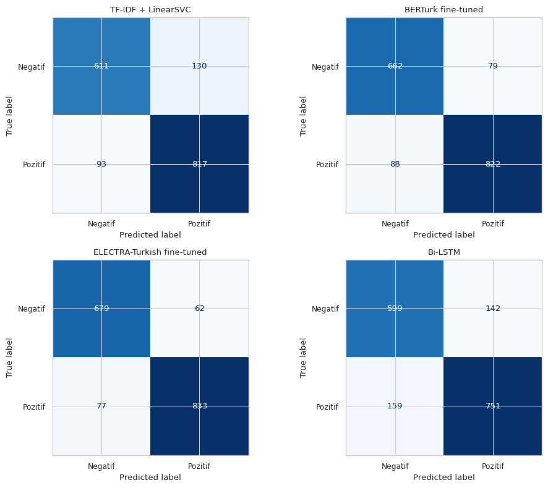

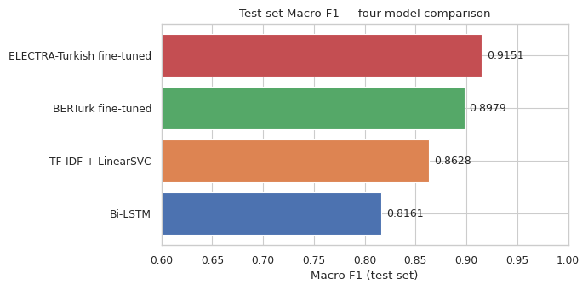

VI. Discussion
A. Comparative Analysis of Model Paradigms
The significant performance gap between the lexical baseline (Macro-F₁: 86.28%) and the pre-trained transformer models (ELECTRA: 91.51%) highlights the limitations of sparse feature representations in morphologically rich languages. The agglutinative nature of Turkish implies that sentiment information is frequently embedded within complex suffix chains that TF-IDF cannot model beyond exact n-gram matches. BERTurk and ELECTRA, by contrast, utilize sub-word tokenization strategies that decompose rare inflected forms into recognizable sub-units, enabling the models to leverage learned associations between roots and their morphological variants even when a specific surface form was not observed during pre-training.
The 1.72-percentage-point Macro-F₁ advantage of ELECTRA over BERTurk (91.51% vs. 89.79%) validates the theoretical efficiency of the Replaced Token Detection pre-training objective relative to Masked Language Modeling, as discussed in Section IV-D. Given that both models were fine-tuned under identical protocols and on identical data, this performance differential is attributable solely to the quality of the pre-trained representations—a direct empirical confirmation of Clark et al.’s [7] claim that RTD pre-training produces more robust contextual embeddings per unit of compute than MLM.
B. Qualitative Error Analysis and Misclassification Table
A qualitative review of misclassified samples was conducted to identify systematic failure modes beyond what the quantitative metrics reveal. Four representative misclassification cases are documented in Table III, organized by linguistic challenge category. These examples are drawn specifically from instances where the TF-IDF + LinearSVC baseline failed but the ELECTRA model succeeded, thereby isolating the marginal value of bidirectional contextual reasoning.

# | Comment (Paraphrase / Original) | True Label | LinearSVC | ELECTRA | Failure Category & Analysis
2 | "ya sen harikasın be" (Oh you are truly amazing, man) — said sarcastically after a failure | Negatif | Pozitif | Negatif | Pure Sarcasm. Lexically, "harika" (amazing) is a high-valence positive adjective. Without conversational context, LinearSVC maps this to Pozitif. ELECTRA’s bidirectional attention over the full sequence captures the exclamatory intensifier pattern "ya... be" — a Turkish sarcasm marker — and correctly reverses the polarity.
3 | "küfürle bile sevsem ne olur ki" (Even if I love [someone] with swear words, what does it matter?) | Pozitif | Negatif | Pozitif | Affectionate Use of Profanity. The root "küfür" (profanity/swearing) carries strong negative weight in the TF-IDF feature space. LinearSVC assigns Negatif based on this single feature. ELECTRA recognises that "sevsem" (if I were to love) and the rhetorical question structure express a positive, endearing sentiment in which profanity is used affectionately — a common pattern in informal Turkish.
4 | "bu nasıl bir müzik değil mi" (Isn’t this something else as music?) | Pozitif | Negatif | Pozitif | Implicit Rhetorical Praise. The negative suffix "-değil mi" (isn’t it?) is grammatically a negation, triggering Negatif in the lexical model. However, the rhetorical question construction "bu nasıl bir X değil mi" is a Turkish idiom conveying admiration and enthusiastic endorsement. ELECTRA’s attention mechanism, trained on a broad Turkish corpus, correctly interprets this rhetorical pattern as positive.

These four cases collectively illustrate the core failure mode of lexical methods for Turkish sentiment analysis: the language’s flexible syntax, agglutinative morphology, and rich pragmatic conventions (sarcasm, affectionate profanity, rhetorical questions) create abundant cases where the surface-level sentiment of individual tokens is orthogonal to the document-level sentiment. Transformer models, through their attention mechanisms and broad pre-training on Turkish web text, develop implicit representations of these pragmatic patterns that sparse feature methods fundamentally cannot acquire.
C. Limitations and Future Work
The primary limitation of this study is the relatively modest dataset size of approximately 11,000 instances. The performance of the from-scratch Bi-LSTM suggests that deeper architectures require substantially larger corpora to reach their potential without pre-training. Future work should explore synonym-based data augmentation using Turkish WordNet resources to balance the minority class more effectively and expand effective training set size. The application of larger transformer variants, such as ELECTRA-Large-Turkish or domain-specific models pre-trained exclusively on social media Turkish text, could further improve sarcasm detection—the most persistent failure mode identified in the qualitative analysis. Additionally, multi-task learning frameworks that jointly train on sentiment classification and related tasks (e.g., irony detection, aspect-level sentiment) represent a promising avenue for improving performance without requiring additional labeled data.

VII. Conclusion
This paper has detailed a rigorous investigation into binary sentiment classification for Turkish social media content, focusing on the comparative performance of four distinct modeling paradigms. By implementing a specialized preprocessing pipeline that incorporated Zemberek for morphological lemmatization and a custom Turkish-locale-aware lowercasing algorithm, this study directly addressed the fundamental linguistic challenges inherent in the agglutinative structure of the Turkish language—most critically, the destruction of semantic polarity through naive stemming.
The empirical results demonstrate a clear performance hierarchy. Pre-trained transformer models—specifically ELECTRA-Base-Turkish and BERTurk—established a new performance ceiling for this task and dataset, with ELECTRA’s Replaced Token Detection pre-training objective proving to be the most effective paradigm, reaching a Macro-F₁ score of 91.51%. The analysis of RTD versus MLM pre-training reveals that ELECTRA’s advantage stems from its 100% token utilization during pre-training, compared to BERT’s approximately 15%, producing substantially more robust contextual representations per unit of compute. The baseline TF-IDF + LinearSVC model proved remarkably resilient—outperforming a custom Bi-LSTM trained from scratch—underscoring that for low-to-medium resource scenarios (approximately 11,000 instances), the statistical reliability of sparse lexical features may outweigh the benefits of complex sequential architectures that lack the benefit of large-scale pre-training.
The qualitative misclassification analysis highlighted that sarcasm, affectionate use of profanity, and rhetorical question constructions constitute the principal frontier for further refinement. The success of the transformer models in correctly resolving these pragmatically complex instances underscores the necessity of bidirectional contextual awareness and broad pre-training on native Turkish text. Future research will focus on corpus expansion, synonym-based augmentation, and domain-specific pre-training to further enhance the robustness of sentiment analysis in informal Turkic linguistic environments.

VIII. References
[1] A. F. Can, B. Alp, and Ö. Köksal, "Sentiment analysis in Turkish: Literature review," in Proc. 26th Signal Process. Commun. Appl. Conf. (SIU), Izmir, Turkey, 2018, pp. 1–4.
[2] A. Aşlıyan, A. Günal, and U. Demirel, "The effect of stemming and morphological analysis on Turkish text classification," in Proc. 7th Int. Conf. Comput. Sci. Inf. Technol. (CSIT), Amman, Jordan, 2017, pp. 1–4.
[3] T. Joachims, "Text categorization with support vector machines: Learning with many relevant features," in Proc. Eur. Conf. Mach. Learn. (ECML), Chemnitz, Germany, 1998, pp. 137–142.
[4] W. Zaremba, I. Sutskever, and O. Vinyals, "Recurrent neural network regularization," arXiv preprint arXiv:1409.2329, 2014.
[5] I. Goodfellow, Y. Bengio, and A. Courville, Deep Learning. Cambridge, MA, USA: MIT Press, 2016.
[6] J. Devlin, M.-W. Chang, K. Lee, and K. Toutanova, "BERT: Pre-training of deep bidirectional transformers for language understanding," in Proc. NAACL-HLT, Minneapolis, MN, USA, 2019, pp. 4171–4186.
[7] K. Clark, M.-T. Luong, Q. V. Le, and C. D. Manning, "ELECTRA: Pre-training text encoders as discriminators rather than generators," in Proc. 8th Int. Conf. Learn. Represent. (ICLR), 2020.
[8] S. Stefan, A. Özenç, and M. Türkmen, "BERTurk: Contextual language models for Turkish," arXiv preprint arXiv:2003.10960, 2020.
[9] C. Cortes and V. Vapnik, "Support-vector networks," Mach. Learn., vol. 20, no. 3, pp. 273–297, 1995.
[10] S. Hochreiter and J. Schmidhuber, "Long short-term memory," Neural Comput., vol. 9, no. 8, pp. 1735–1780, 1997.
[11] I. Loshchilov and F. Hutter, "Decoupled weight decay regularization," in Proc. 7th Int. Conf. Learn. Represent. (ICLR), New Orleans, LA, USA, 2019.
[12] A. Vaswani et al., "Attention is all you need," in Proc. Adv. Neural Inf. Process. Syst. (NeurIPS), Long Beach, CA, USA, 2017, pp. 5998–6008.

